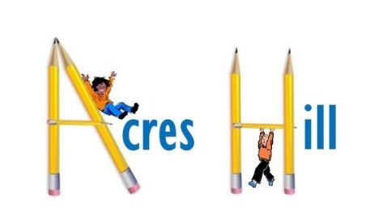

**School Name:** Sheffield South East Trust

Acres Hill Community Primary and Nursery School

**Post Title:** Headteacher

**Salary:** L17 – L23 (£73,819 - £85,529)

**Pupil numbers** – NOR 210 + 26 FTE Nursery + 10 place Integrated Resource

**Closing Date:** 15th April 2025

Sheffield South East Trust seeks a **Headteacher** to start in September 2025, at Acres Hill Community Primary and Nursery School, (PAN 30).

This school serves a diverse and established community in the south east of the city. The school is part of Sheffield South East Trust (SSET), which unites seven local primary schools. These schools work closely together for the benefit of the children and communities they serve. There are many opportunities for support, training and networking between the schools. SSET is closely aligned to Sheffield South East Learning Partnership (SSELP), a renowned locality collaboration of maintained and academy schools, offering quality CPD and further, extensive opportunities.

The school is committed to being highly inclusive and strives to deliver a truly creative curriculum. Alongside other schools in the Trust, Acres Hill has a 10 place Specialist Integrated Resource for pupils with social communication needs. Early Years education is firmly embedded and the school invests in and provides quality FS provision. The school has extensive grounds and utilises them well. Acres Hill Primary is a vibrant and outward-looking school.

Acres Hill Primary was inspected by OFSTED in February 2025 and whilst features of the school were identified as strong, the Inspectors and the school agreed that some areas needed further improvement. The successful candidate will have the opportunity to work with all stakeholders, including a relatively new staff team, to continue to move the school forward, within a supportive local Trust. The Trust aims for schools to grow and flourish, by being individual and closely aligned with the community.

We are looking for a dynamic and resilient Headteacher who has high expectations for all pupils, which will lead to achieving further high standards and pupil progress. The successful candidate will be innovative and resourceful in leadership style, nurturing and challenging to raising the profile of Acres Hill Primary.

In return the School and Trust can offer enthusiastic and motivated pupils who want to learn and achieve, alongside hardworking, dedicated and supportive staff and governors.

Sheffield South East Trust are committed to safeguarding and promoting the welfare of children and young people. Headteachers must ensure that the highest priority is given to following guidance and regulations to safeguard children and young people.

The successful candidate will be required to undergo an enhanced check from the Disclosure and Barring Service (DBS).

Applicants should request an application form and further information by emailing [recruitment@sset.education](mailto:recruitment@sset.education)

Completed forms should be returned to the same address.

Visits to the school are warmly welcomed and encouraged; please could applicants contact the Trust Business Advisor (Angela Fuller) to arrange this - [recruitment@sset.education](mailto:recruitment@sset.education) Tel: 0114 2441512 (Email contact available throughout the school holiday)

To discuss any aspects relating to SSET or the Headship role please contact the CEO Joanne Bradshaw [j.bradshaw@sset.education](mailto:j.bradshaw@sset.education) Tel: 0114 2441512 (Email contact available throughout the school holiday)

***‘Sheffield South East Trust will work with urgency to improve the quality of learning and outcomes for all children’.***

**Closing date:** 15th April 2025

**Assessment Centre and Interview:** 24th and 25th April 2025

Acres Hill Primary and Nursery School

Mather Road

Sheffield S9 4GQ