November 2024

Dear Prospective Candidate

On behalf of the Governors, I thank you for your interest in our Headteacher position at St Anselm’s Catholic Primary School.

We are a small, thriving school and Nursey in the heart of Southall. We are very proud of our school, which needs to be visited to fully appreciate the welcoming environment and calm atmosphere. Everyone who works and studies here is happy and visitors are always keen to come back. We serve a very diverse multicultural community with many pupils speaking English as an additional language. They work hard and are determined to succeed. We have very strong links with the local parish and the Catholic ethos is evident in every aspect of the life of the school.

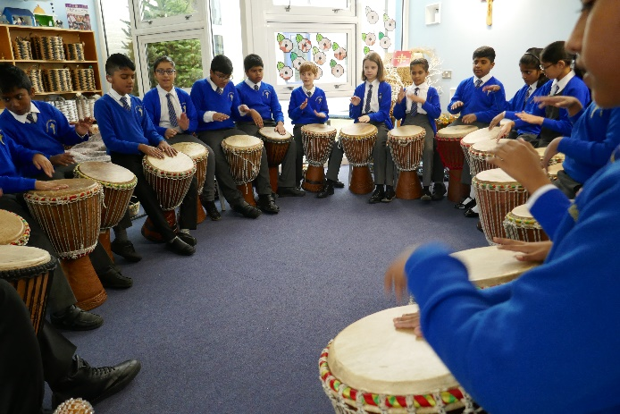

We have a truly dedicated and experienced staff who have high expectations for all pupils to reach their full potential and leave the school, confident and independent learners, ready to make a difference.

Governors are experienced and supportive of the school and parents appreciate the hard work and dedication of both Staff and Governors. The school has strong links with the Ealing Catholic Deanery; the local Southall Quadrant; the Diocese of Westminster and Ealing Local Authority.

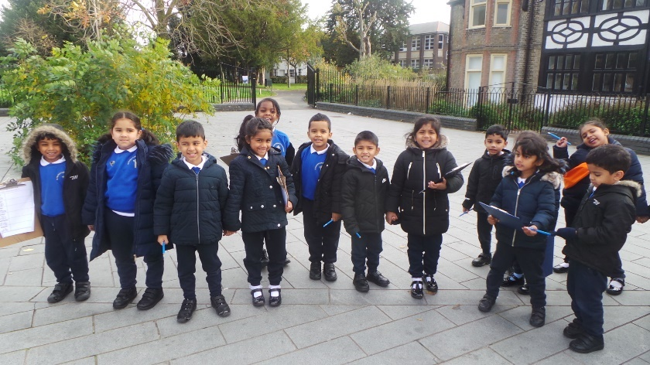We are looking for a strong leader who can continue the growth of the school as a friendly vibrant and exciting place for all pupils. As a Headteacher, you will continue to develop the strong links with parents through nurturing, empathy and compassion.

It is essential to visit the school so that you can experience the warmth of our whole school community and understand our ethos and what we can offer you. Please contact Mrs Susie Debono 020 8574 3906 or [sdebono@st-anselms.ealing.sch.uk](mailto:sdebono@st-anselms.ealing.sch.uk) to arrange a school visit where you will be shown around by a member of the Governing Body.

The school has a large carpark, and is easily accessible by road routes and public transport.

Thank you again for your interest in the post, and we really look forward to welcoming your visit to the school and receiving your application.

Yours faithfully

Mrs Gill Wickham

Chair of Governors

**Application Procedures**

Your application should relate specifically to the person specification.

The school will only accept the Catholic Education Services Application Form.

Please note the closing date for applications is **12pm on Thursday 9th January 2025** and shortlisting will take place the same day

Interviews will take place in school on **Friday 17th January 2025**. References will be taken up immediately after shortlisting. Candidates are asked to ensure that their referees are advised of this.

Completed application forms should be submitted to the Chair of Governors, c/o the SBM Mrs S Debono via email, marked for the attention of the Chair of Governors. Completed application forms should be returned to Mrs Susie Debono: [sdebono@st-anselms.ealing.sch.uk](mailto:sdebono@st-anselms.ealing.sch.uk)

**Safeguarding**

St Anselm’s Catholic Primary School is committed to safeguarding and promoting the welfare of children and young people and expect all staff and volunteers to share this commitment. The post is subject to an enhanced Disclosure and Barring Service (DBS) clearance check. Further information can be found at: <https://www.gov.uk/government/collections/dbs-checking-serviceguidance–2>.

References will be taken up for all shortlisted candidates prior to interview and the successful candidate will be required to sign a Catholic Education Service (CES) contract

The school reserves the right to research shortlisted candidates on social media platforms and the internet, and the recruitment panel may take this information into consideration during the recruitment process.