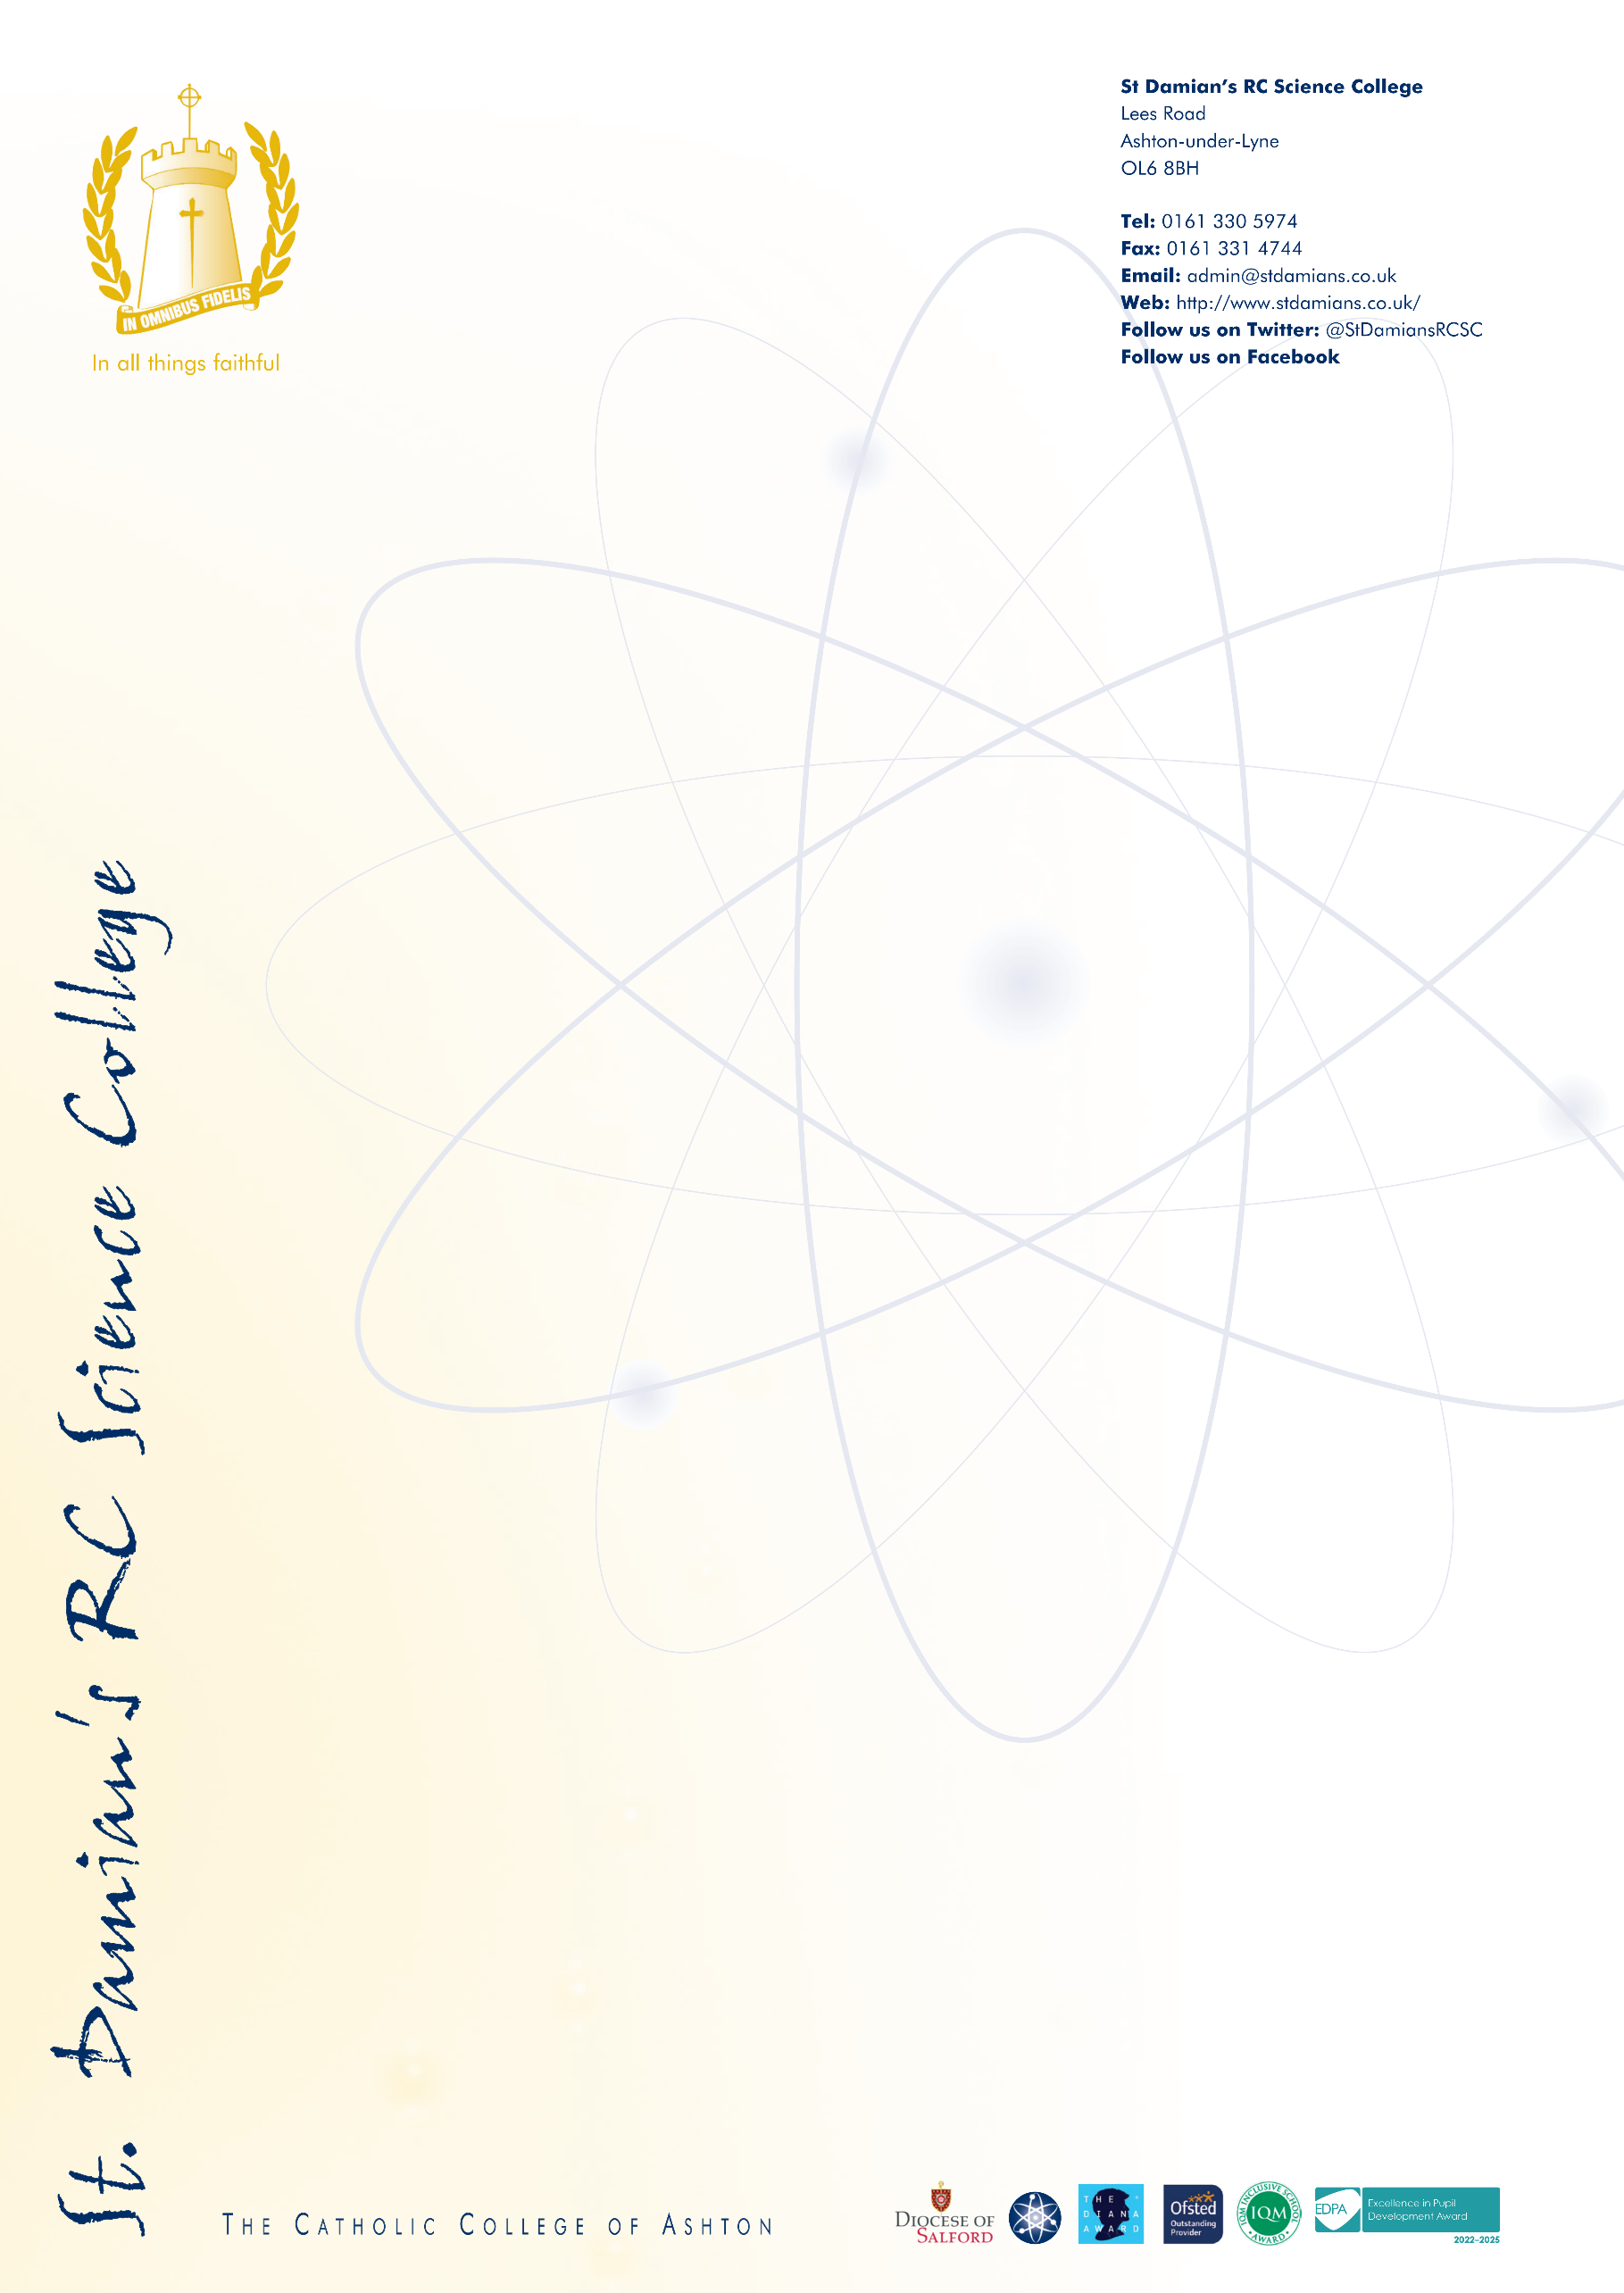

April 2026
Letter to Applicants – Headteacher of St Damian’s RC Science College Recruitment

Dear Applicant,

Thank you for your interest in the position of Headteacher at St Damian’s Roman Catholic Science College. This opportunity arises following the successful appointment of the current post holder to a further headship and represents an exciting moment in the continuing journey of our highly successful and outward facing Catholic school.

St Damian’s is a community defined by moral integrity and ambition. Our vision, “outstanding in all we do,” is not simply a statement of intent but is embedded in everything we do. This is affirmed through sustained external validation, with our last four inspections; Ofsted (2017, 2023) and the Catholic Schools Inspectorate (2016, 2024) all judging the College to be Outstanding in every area. These outcomes reflect resilient, values‑led leadership and an unwavering focus on pupils, even during periods of significant challenge.

The College has also gained strong national recognition for both educational excellence and workplace culture. In 2025, St Damian’s was awarded Silver in the Pearson National Teaching Awards – Making a Difference: Secondary School of the Year, named within the Sunday Times Best Places to Work, and shortlisted for the TES Staff Wellbeing Award. These accolades speak to a school that not only delivers for its pupils, but we also nurture, develop and retain high quality caring professionals.

While proud of our achievements, St Damian’s is not complacent. We remain relentlessly focused on ensuring that every pupil receives the very best Catholic education, encompassing academic success, faith formation, character development and personal wellbeing. High expectations are matched by deep care, and “second best” is never acceptable where children’s outcomes or safety are concerned.

At the heart of this ambition lies our uncompromising commitment to safeguarding. Safeguarding at St Damian’s is intrinsic to leadership, culture and daily practice. Pupils are known as individuals, their voices are heard, and their welfare is paramount. Systems are rigorous, professional curiosity is strong, and safeguarding is understood as a shared moral responsibility across the entire community.

What St Damian’s RC Science College can offer you
- A clear, compelling Catholic vision, rooted in Gospel values and centred on pupils.
- Strong, stable leadership and governance, focused on sustained excellence and safeguarding.
- A distinctive culture “The St Damian’s Way” characterised by ambition, care, equity and trust.
- A highly skilled and committed staff body with strong professional relationships.
- A deep commitment to staff wellbeing and professional development at all stages of career
- Consistently high pupil outcomes, above national averages
- An ambitious, knowledge rich curriculum that meets and exceeds national expectations.
- A heavily oversubscribed school with strong confidence from the local and wider community
- A modern, well designed learning environment that supports high quality provision.

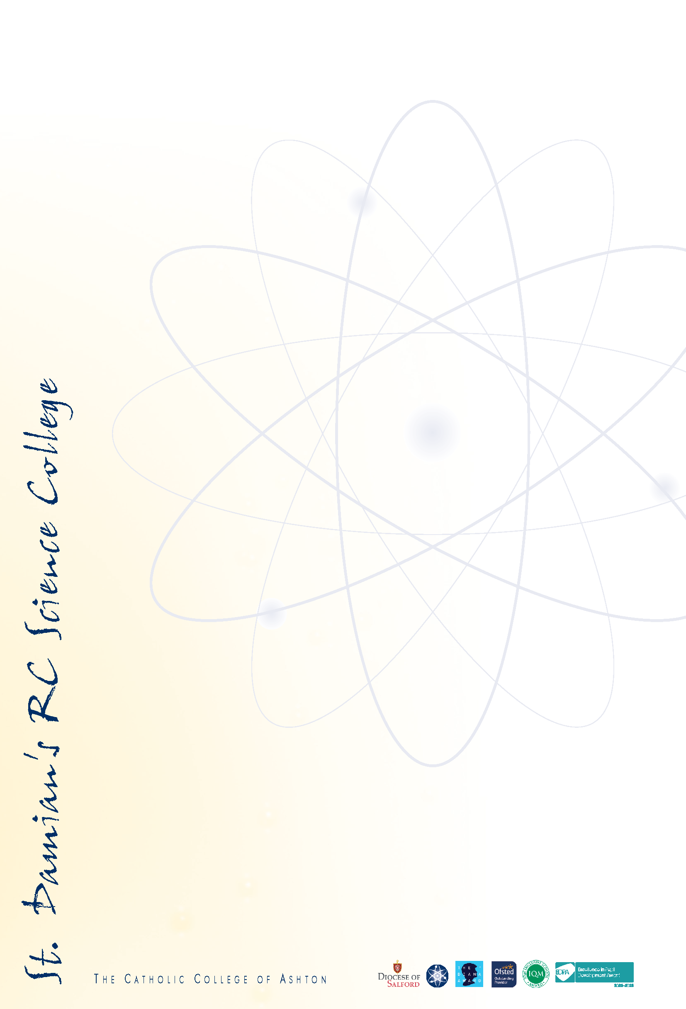
What the Governors Are Seeking
- A strategic, aspirational Headteacher who is a practicing Catholic with the capacity to lead with compassion.
- A leader deeply committed to Catholic education, safeguarding and moral purpose.
- An uncompromising focus on pupils first, ensuring excellence, equality and protection for all.
- Proven ability to sustain high performance while nurturing professional culture and wellbeing.
- The vision and credibility to lead the next phase of the College’s development with clarity and confidence.

As Chair of Governors for over five years, I can say without reservation that St Damian’s is an exceptional place to work. I am privileged to work with staff; support staff, teachers and leaders whose professionalism, humility and dedication to children are extraordinary. Their commitment to collaboration, mutual support and continuous improvement defines the culture of the school and has been particularly evident through recent years of challenge and change.

The successful candidate will join a community where leadership is trusted, values are lived, and children are placed at the very centre of all decisions. St Damian’s offers the opportunity not only to lead an outstanding school, but to do so within a culture of integrity, care and ambition.

Prospective applicants are welcome to contact Angela Ogden on 0161 330 5974 to arrange a visit to learn more about the role and our community.

We look forward to receiving your application.

Yours faithfully,

Loretta Dean
Chair of Governors
St Damian’s RC Science College

Safeguarding Declaration:
St Damian’s Roman Catholic Science College is wholly committed to safeguarding and promoting the welfare of children and young people. Safeguarding is a fundamental priority, embedded within leadership practice, governance oversight and daily school life. All staff and leaders are expected to share this commitment and to uphold the highest standards of professional conduct. Any appointment will be subject to rigorous safeguarding checks, including an enhanced DBS disclosure and other pre-employment checks in line with statutory guidance. On-line checks will be carried out for shortlisted candidates.

