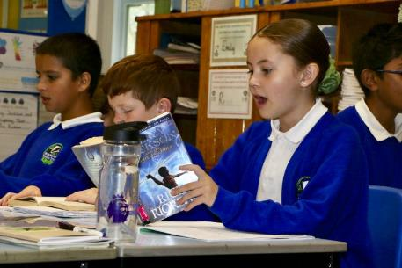

We are looking for a new

Head Teacher to lead Baguley Hall Primary from September 2025

* Salary: L21 – L27 £81,441 - £93,400
* Application Closes: 20th January 2025, 09:00
* Interview: Thursday 6th & Friday 7th February 2025
* Start Date: 1st September 2025

**Safer Recruitment**

We are fully committed to safeguarding and promoting the welfare of children, younger learners and vulnerable adults and we expect all staff and volunteers to share the same commitment. All posts will be subject to enhanced DBS checks, satisfactory references and will be exempt from the provisions of the Rehabilitation of Offenders Act 1974. [DBS Code of Practice which can be viewed here.](https://eur03.safelinks.protection.outlook.com/?url=https%3A%2F%2Fwww.gov.uk%2Fgovernment%2Fpublications%2Fdbs-code-of-practice&data=05%7C02%7Cpaul.marshall%40magairports.com%7C75977077b4304ee8be4408dd188239fc%7Cc098827679784f2abd8f918a37a5c957%7C0%7C0%7C638693670028271997%7CUnknown%7CTWFpbGZsb3d8eyJFbXB0eU1hcGkiOnRydWUsIlYiOiIwLjAuMDAwMCIsIlAiOiJXaW4zMiIsIkFOIjoiTWFpbCIsIldUIjoyfQ%3D%3D%7C0%7C%7C%7C&sdata=P7N2LaE2098iOCGQPbxFxRlIwoPizKOSZQa%2BS41svmI%3D&reserved=0)

**Recruitment selection process:**

Candidates will be shortlisted against the Person Specification based on their application forms and then interviewed with regard to Person Specification and Job Description.

Letter from the Chair of Governors

Dear Applicant,

We invite you to apply for the role of the Head Teacher here at Baguley Hall Primary. We are in an inclusive, inspiring and innovative school that wants the right candidate to join us on our journey.

Our current Head is retiring so the Governors are looking to recruit a new Head Teacher. You will nurture and inspire the vision and ethos of our school and lead and motivate our children and staff.

Baguley Hall Primary is a nurturing, inclusive school, putting our children's needs at the core of everything we do. Supporting our children to not only gain good academic qualifications, but emotional literacy to help them lead well rounded and full lives long after leaving school.

We want our children to reach their full potential and know that the foundation to this is an early development of vocabulary and communication. It is an ever-changing world where our children need to be secure with who they are and can celebrate the differences of people in Britain today.

“REACH”,

is our mission statement. This will be a welcoming, happy place where children feel secure, enjoy their learning, and develop **r**esilience, **e**mpathy, **a**spiration, **c**onfidence and **h**onesty as they grow.

We want an outward looking Head Teacher who wants to progress our children to the best possible outcomes.

All children are entitled to an education with removed barriers for learning, we want our learning without limits mission statement to be at the core everything we do and embedded at every level.

We want a Head who understands adaptive teaching and will give high quality teaching with adaptive styles for all. We want a candidate with a passion for inclusive education and an understanding of SEND running through everything they do. The successful Head will ensure our children’s needs are met through every subject.

If you think that you could propel us forward in this direction and the whole child's development is just as important to you as the grades they receive, then Baguley Hall Primary is the school for you.

I look forward to your application



Paul Marshall

Chair of Governors

Letter from the

Junior Leadership Team

Dear Candidate,

Thank you for being interested in our school. We love to come to Baguley Hall Primary School every day and we think you would like to work here with us because we can offer you:

* Smart, respectful children
* Children who come to school ready to learn
* Fabulous outdoor spaces where we do exciting learning
* A calm school with special calm areas and sensory rooms
* Organised classrooms and hard-working children and staff

We are proud to say to you that we will always try our best, be respectful, communicate effectively and be in the right place at the right time as our school expectations say. We have amazing resources and good food and we are careful with each other, listening respectfully to each other all the time.

We are looking for a Head Teacher who is lovely and kind but firm and fair. We want someone who is responsible but not too strict and who doesn’t give us too much homework!

We look forward to meeting our new Head Teacher. If you think this could be you, please apply.

Yours sincerely

Baguley Hall Primary Junior Leadership Team (School Council)

# A logo with a badger head and leaves Description automatically generatedAbout Us

As a school we offer every child – whatever their own individual characteristics – the chance to achieve their full potential and be ready to embrace the  opportunities ahead.

Every child is treated fairly, listened to and given  the chance to achieve success, take responsibility,  and develop  their self-esteem.

Baguley Hall combines high standards with a broad and rich curriculum delivered in innovative ways. Learning and teaching is matched to the appropriate stage of children’s individual development and considers their physical, mental, social, spiritual, moral and cultural development needs. The learning and teaching is of a high quality, planned and managed so that every child is supported and challenged. Effective assessment for learning informs individual next steps. Teachers and classroom assistants provide a tailored approach to support all groups of children.  We give extra support to the children who need it most.

A curriculum, based on excellence and enjoyment is presented in an interesting, exciting and imaginative manner with lots of opportunities for first-hand experience, practical work, investigation and learning through play. The curriculum is enlivened and enriched by visits, visitors, and extensive use of the environment. The basics are taught well and the creative aspects including art, dance, music and performance enhance our work. We provide activities outside school hours to extend and enrich learning.

We build partnerships with parents and carers by giving good information and by providing them with their own opportunities to develop. We embed the school into the life of the community.

Success is promoted and progress and achievement is rewarded. The school drives its own improvement,  setting its own challenging targets because we recognise that, for the sake of our children, we can always do better.

# The World Around Us

As a school we understand the

ever changing world our children live in:-

It’s a world where our children not only need academic qualifications, but emotional literacy to help them lead well rounded and full lives long after leaving school.

It’s a world where our children need to understand that making mistakes is part of life and helps us learn and develop. To know that they have the power to make a positive impact on their own lives and the world for the better.

It’s a world where our children need to be able to reach their full potential and we know that the foundation to this is an early development of vocabulary and communication skills.

It’s an ever-changing world where our children need to be secure with who they are and can celebrate the differences of people in modern Britain today.

# Visits and Application

**Visits**

To arrange a confidential conversation or a visit, please email the school directly [htrecruitment@baguleyhall.manchester.sch.uk](mailto:htrecruitment@baguleyhall.manchester.sch.uk) or call the school office on 0161 998 2090.

**Application**

Please email all applications to [htrecruitment@baguleyhall.manchester.sch.uk](mailto:htrecruitment@baguleyhall.manchester.sch.uk) for the attention of Paul Marshall.

**Recruitment schedule**

We aim to complete our recruitment process as follows:

|  |  |
| --- | --- |
| **Job Advertisement** | 18th December 2024 |
| **School Visits** | Thursday 9th & Friday 10th January 2025 |
|  |  |
| **Closing Date** | 20th January 2025 at 09:00 |
| **Shortlisting** | Wednesday 22nd & Thursday 23rd January 2025 |
| **Candidates Informed** | w/c Monday 27th January 2025 |
| **Interviews** | Thursday 6th & Friday 7th February 2025 |

Please note we may re-shortlist after interviews on day one.

Location: Baguley, Wythenshawe, Manchester, United Kingdom

Type: Mainstream School

Phase: Primary

Funding status: LA

Gender: Mixed

Age range: 3 - 11 years

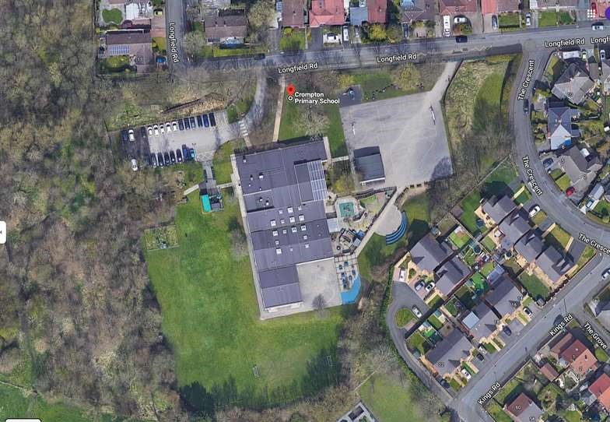

Address: Ackworth Drive, Baguley, Wythenshawe, M23 1LB

Email: [htrecruitment@baguleyhall.manchester.sch.uk](mailto:htrecruitment@baguleyhall.manchester.sch.uk)

Telephone: 0161 998 2090

Website: <https://www.baguleyhall.manchester.sch.uk/>