Longshaw

Community

Infant School and Nursery



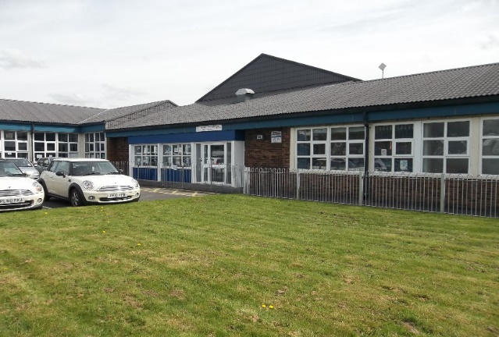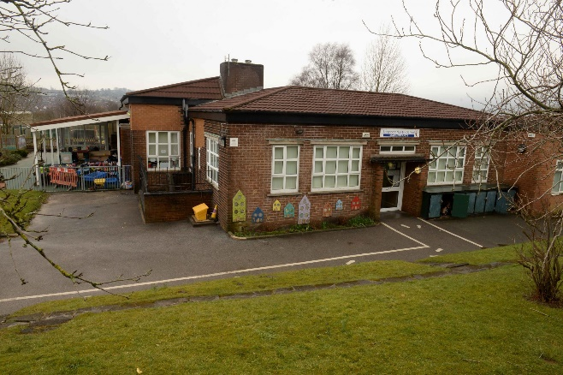

**Our vision is to foster a love of lifelong learning and give every child the opportunity to develop socially, academically, creatively, spiritually and emotionally.  We will provide a broad, balanced and rich curriculum, which will challenge children’s thinking, encourage them to care for others and inspire them to fulfil their individual potential in order to achieve success.**





Dear Headteacher applicant,

Thank you for your interest in the post of Headteacher at Longshaw Community Infant School and Longshaw Nursery. I am very pleased that you are considering applying to lead our unique and wonderful school. The vacancy has arisen as a result of the current Head, Andrea Batley, obtaining a post with Ofsted after six years of successful leadership at Longshaw.

We want to employ somebody who is able to build on the strengths that our outgoing Headteacher and the wider team have achieved; a great school with a strong community ethos that nurtures the whole child and allows each one to be the very best version of themselves that they can be.

Our new Headteacher should be a strong, approachable, compassionate and supportive leader who is passionate and knowledgeable about the pursuit of effective high-quality teaching and learning in schools and has a love of working with children. The person specification provides a more comprehensive list of the qualities we are looking for, but in essence we wish to appoint somebody with the wisdom, experience and confidence to take the school forward; someone who builds on what is currently excellent and ensures we continue to improve by embracing the opportunities and challenges which are offered by a school like ours.

Our children are central to everything we do at Longshaw. On the following page you’ll find some of the things that they have told us they would like to see in their new Headteacher. If you think you are the right person to meet their needs, and exceed their expectations, I’d encourage you to read the additional information provided as part of the application pack which will give you a flavour of the school and an indication of the scope and range of opportunities and possibilities that the post offers. I hope that you find the information that we have provided of sufficient interest that you decide to apply for the post.

I’d also encourage you to visit the school to see the pupils and staff at work. Please contact the School HR Team on 01254 588973 or schoolhrteam@blackburn.gov.uk to make a mutually convenient appointment. I would also like to take this opportunity to reassure you that due to the current situation that we find ourselves in, social distancing rules will be applied and Covid-19 guidance will be adhered to throughout the visit.

I look forward to hearing from you and receiving your application.

Raffat Karimi (Chair of Governors at Longshaw Community Infant School) and Susan Cliffe (Chair of Governors at Longshaw Nursery School)



**Children at Longshaw Community Infant School and Nursery would like a Headteacher who is:**

**Happy – Someone who enjoys being at our school**

**Work Hard – Someone who will keep our school amazing**

**Caring-Someone who will look after everyone in our school**

**Friendly – Someone who laughs all the time**

**Proud– Someone who is proud of our hardwork**

**Smiley-Someone who will smile when we impress them**

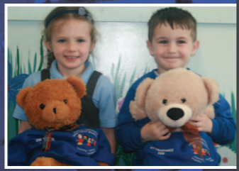

**Special-Someone who loves Longshaw and is just for us!**

**Funny – Someone who tells good jokes**

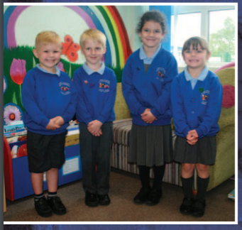

**School Overview**

In September 2018 Ofsted agreed that:

* ***The pupils achieve well and make good progress from their starting points***
* ***The children get a good start to their learning in the Early Years Foundation Stage***
* ***The teaching is good across the school***
* ***Staff know pupils well and there are good relationships all around***
* ***Disadvantaged pupils, disabled pupils and those with special educational needs make good progress and achieve well because they receive high quality support***
* ***Pupils behave well and are keen to learn***
* ***The work the school does to keep pupils safe and secure is OUTSTANDING***
* ***Pupils’ spiritual, moral, social and cultural development is good***

In October 2018 Ofsted returned for a short inspection and were of the opinion that the school demonstrated strong practice and marked improvement in the following specific areas which may indicate that the school has improved significantly overall.

* ***The school continues to be a beacon of hope and care for children and families in the community***
* ***The school environment is warm and welcoming***
* ***Pupils are enthusiastic and eager to learn***
* ***The behaviour of the pupils continues to be a strength and pupils treat each other with respect***
* ***Teachers do their best to make all children feel special, to see their value and purpose irrespective of their background***
* ***Staff and governors give high priority to the social and emotional needs of the pupils***
* ***The curriculum is enriched with many additional experiences.***

In September 2014 we had a very successful Ofsted inspection, when our school was judged to be good in all areas. This was followed by a short inspection in October 2018 where the inspector felt that the next inspection should look at the outstanding features evident in the school.

Longshaw Community Infant School is a friendly, welcoming 3-form entry infant school offering primary education to Foundation Stage and Key Stage 1 children aged 4 – 7 years. The school was built in 1952 and is set in its own grounds at the end of a quiet cul-de-sac. We work very closely with Longshaw Nursery School and Children’s Centre, Longshaw Junior School and nine other schools in our School Improvement Group.

There are currently sixteen teachers, including the Headteacher, and thirty one members of support staff, including classroom based colleagues, catering, cleaning and office staff.

There are spacious hard and grassed play areas, two quadrangles, one a garden and pond area, the other a safe surfaced play area which can be accessed from the Foundation Stage setting and from the main corridor. One playground has been refurbished as a “Zone Parc” with specific areas for ball skills and quiet games.

Within the school there are nine classroom bases plus other working areas. All classrooms have outdoor access. There is also a large school hall, a library, a nurture room, a music room, an oracy room, three smaller rooms for intervention programmes and a separate dining hall and kitchen.

The Foundation Stage classrooms are located around a central resource area.

The school has completed a recent programme of internal redecoration and refurbishment.

The school serves an area of private terraced housing, council owned properties and some private landlord rented property.

We are working hard to improve attendance and we have a Breakfast Club which is extremely popular.

Our numbers on roll are rising stable and we currently have 231 children on roll.

We have worked hard on our curriculum and the learning environment, and we are looking forward to the next exciting stages in our development with a new leader in post.