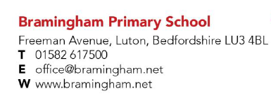
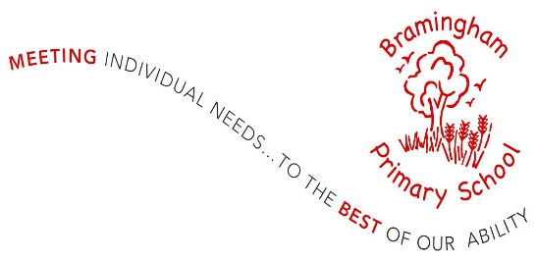

HEADTEACHER
Required for April or September 2021 (depending on availability of candidate)
Group 3
Range 18 – 24*

Bramingham Primary School is a two-form entry school situated on the northern outskirts of Luton; we are proud of the strong links we have with our children and their families, many of whom live outside our immediate catchment area. As a school, we consider ourselves to be unique in many ways. We are a fully inclusive mainstream school, with children from a wide variety of backgrounds. We have resourced provision for children who have physical and medical needs, and our school also includes children with autism and other emotional and behavioural needs. Our overriding aim is to meet the learning needs of all our children to the very best of our ability.
We are looking for an inspiring headteacher who will lead, motivate and develop our highly dedicated staff whilst maintaining the culture and vision of our school.
We can offer you:
- a committed and enthusiastic team of staff
- hardworking and happy pupils
- a fully inclusive school community
- supportive parents, Governing Body and community who want the best for their children
We want a leader who:
- leads visibly, setting high expectations for teaching and learning and pupil behaviour
- is an experienced, creative and innovative leader who puts children and the community at the centre of their vision
- is fully committed to inclusive education
- is able to develop the leadership skills of others and create strong and effective working relationships with staff, governors, and other partnerships
Visits to the school may be possible, depending on Covid restrictions. Enquiries should be made by emailing hr@bramingham.net . Application packs are available from mynewterm.com
Closing date: 22nd February 2021 (9.00am)
Interview date: 25th and 26th February 2021
We are an Equal Opportunities employer and welcome applications from all backgrounds.
This school is committed to safeguarding and promoting the welfare of children and young people and expects all staff and volunteers to share this commitment. The successful applicant will be subject to enhanced DBS check.

