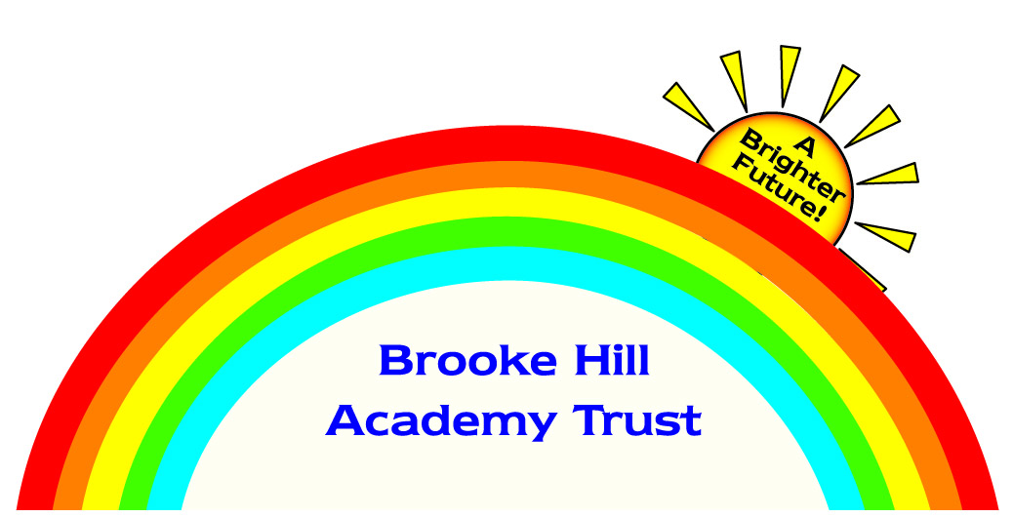

We are looking to recruit two Headteachers to join our Multi-Academy Trust from September 2021.  
This is an exciting and unique opportunity for exceptional, ambitious leaders looking to take the next step in their career at our excellent schools, nestled in the rural heart of the East Midlands.

**Headteacher - to work across two sites in our Academy Trust**

***Edith Weston Academy, Rutland and South Witham Academy, Lincolnshire***

Salary: £59,581 –£70,745 *dependent on experience*

We are looking for a forward-thinking, experienced Headteacher to deliver strategic leadership across two schools situated within 12 miles of each other. The ideal candidate will have a proven track record of school improvement and delivering ambitious outcomes for all children. You will also work collaboratively with the teams across both schools and play an important role in the development of our Multi-Academy Trust.

**Headteacher – Brooke Hill Academy, Oakham, Rutland**

Salary: £59,581 – £70,745 *dependent on experience*

Are you a dynamic and inspirational leader with proven experience and the vision to further develop the lead school in our Multi-Academy Trust? The Headteacher will work with the Executive Headteacher to drive continued improvement through implementing a broad and stimulating curriculum to inspire all of our pupils. This is also a unique opportunity to play a key role in the future development of our Multi-Academy Trust.

**We will offer:**

* A competitive salary
* A successful and supportive Multi Academy Trust
* Friendly, welcoming schools in rural communities
* Opportunities for career and personal development within the Trust
* Schools that celebrate children’s achievements and progress
* A highly competent and motivated staff team
* Strong, active Board of Trustees and Governing Bodies
* An engaged and supportive parental community

**Visits to the schools are encouraged**

**Brooke Hill Academy Trust is committed to safeguarding children and DBS checks will be necessary.**

**Closing date for applications:** Wednesday 10th March 2021 **Interviews to be held:** W/C 22nd March 2021

**Please download an application pack from our Trust website:** [**Brookehillacademytrust.co.uk/job-vacancies**](https://www.brookehillacademytrust.co.uk/job-vacancies/)

**For further information, or to submit your completed application please email: SLT@brookehillacademytrust.education**