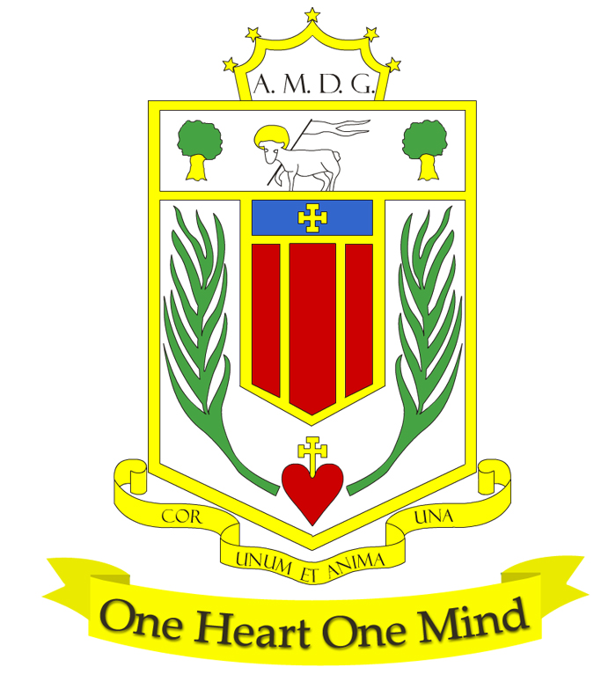

Broughton Hall Catholic High School

HEADTEACHER
Preferred Start Date: January 2025
Salary Range: L33 – L39 (Group 7)

The Governors under the Trusteeship of the Sisters of Mercy are seeking to appoint an inspirational and dedicated Leader with the vision, energy, dynamism and commitment to continue to inspire the whole school community. Our aim is to be an “Outstanding” school in all areas and we are seeking a leader who will continue to move our school forwards and have the highest ambitions for our children. Ofsted rated the school as “Good” in November 2022.
The School Motto, ‘Cor Unum et Anima Una’ – ‘One Heart and One Mind’ – reflects the strong sense of community amongst staff, pupils, parents and governors. The central aim of our School is to provide the very best educational opportunities enabling all our pupils to develop their God-given talents, to grow in confidence and self-esteem and fulfil their potential.

You will:
- Be a committed practising Catholic;
- Have leadership experience to at least Deputy Head level;
- Have successful experience of implementing and managing change;
- Have a passion for developing potential in others and promoting a learning community;
- Have excellent people management and communication skills;
- Have the knowledge, core values, behaviours and qualities needed to be an outstanding leader in our school;
- Command the respect of the whole school community; staff, parents, students and governors.

We offer:
- A school which places the development, care and respect of the individual at the heart of our mission;
- A committed, experienced Governing Board closely involved in all aspects of the school;
- A strong and experienced Leadership Team;
- Talented and innovative staff committed to the development of the potential of each and every student;
- Responsive students and supportive parents;
- Trustees committed to the continuing success of the school;
- Close working links with the Archdiocese of Liverpool and Local Authority.

Application Guidelines:
- An application pack can be downloaded from the school’s website www.broughtonhall.com in the Vacancies Section.
- Please ensure that you address or account for any gaps in your employment history.
- Your supporting statement should be included within the application form to a maximum of 2,000 words. This should detail why you believe your experience, skills, personal qualities, training and/or education are relevant to your suitability for the post advertised and how you meet the person specification applicable to the post. You should pay particular attention to the national standards for the position for which you are applying.
- Please complete the application form and email, together with a covering letter to smithg@broughtonhall.com

Key Dates:
Closing Date for applications: Monday, 14th October 2024 at 12 noon

Shortlisting: Thursday, 17th October 2024
Interviews to be held: Wednesday, 23rd and Thursday, 24th October 2024

Visits to School:

We warmly invite you to visit our school.

Visits can be arranged by telephoning Mrs G Smith, PA to Headteacher on 0151 541 9465 or emailing smithg@broughtonhall.com

Broughton Hall Catholic High School is committed to safeguarding and promoting the welfare of children and young people and expects all staff and volunteers to share this commitment.

