HEADTEACHER

RECRUITMENT PACK

Contents

Job Advert 3
Letter from the Chair of Governors 5
School Vision 6
Ethos & Values 6
Our School 7
School / Community Partnership 8
Extra-Curricular 9
Key Statistics 10
Attainment 2021-2022 11
Job Description 12
Purpose of the Job 12
Main Responsibilities 12
Person Specification 16
Experience 16
Strategic Leadership 16
Management 16
Personal Skills 17
Shaping the Future 17

Job Advert
Chapelfield Primary School
Clough St, Radcliffe, Manchester M26 1GQ
Tel: 0161 723 5519
E mail: chapelfield@bury.gov.uk

Position: Headteacher

Group / Pupils on Role: 2 / 268
Leadership / Salary Range: L15 £62,561 to L21 £72,483 per annum
The governing body is willing to consider the flexibility available within the school teachers’ pay and conditions document 2015.
This is an exciting opportunity to become the headteacher of a well-run and inclusive community school founded on the values of honesty, respect, care and commitment.
The Governing Body is seeking to appoint a new headteacher who is:
- A highly motivated and reflective leader who can exemplify the school values.
- An educationalist with experience of monitoring and tracking staff and pupil performance and exposure to effective budgeting.
- Proven to have excellent interpersonal skills in liaising with staff, pupils and external stakeholders.
- Capable of developing and delivering school strategies and initiative to shape the future success of the school.
- Ready to support challenge and empower the staff to achieve their full potential.
- Passionate to enrich our pupils’ experience and develop their lifelong love of learning.
In Chapelfield you will find a school that:
- Is a community school with established routines and processes and a proven record of strong KS2 attainment outcomes.
- Has a long-standing staff body, who work well as a team, committed and excited to support you in achieving the vision for the school.
- Is fortunate to have pupils with genuine love for their teachers, their peers and engage actively in their learning.
- Has an established and supportive Governing Body.
- Has a growing PTFA who wish to support you in delivering the school vision.
Application Closing Date. 12:00 on 13th April 2023
Visits to the school are warmly welcomed week commencing 27th March 2023. Please contact Suzanne Hannaby, School Business Manager, to arrange a visit by emailing chapelfield@bury.gov.uk.
Interviews are scheduled to be held on 24th and 25th April 2023.
At Chapelfield we are preparing children for a life in a diverse world outside school. We encourage respect, understanding and the celebration of difference in our school and the local and wider community, with particular focus on Rights and Responsibilities.
As our school values and aims indicate, Chapelfield School is committed to promoting the highest possible standards of moral responsibility, learning and achievement for all its children, regardless of gender, culture, race or ability. Equal Opportunities provision features in all our policies, please let us know of any reasonable adjustment that might be needed.
Employees of Chapelfield Primary School have a responsibility for, and must be committed to, safeguarding and promoting the welfare of children and young people and for ensuring that they are protected from harm. Appointment is subject to a satisfactory enhanced disclosure from the Disclosure and Barring Service.

Letter from the Chair of Governors
James Rickard  Chair of Governors  Chapelfield Primary School  Clough Street  Radcliffe  M26 1LH | 13 March 2023
Dear Applicant,
We are looking to appoint a new headteacher from the 1st September 2023.
Chapelfield is a local community primary, rated “good” during its last full Ofsted in 2013, a reputation that was confirmed in a short inspection in 2017 and has been maintained within the local authority. The school has a committed, stable and professional staff body which has ensured that our attainment and attendance are better than the national averages. Our pupils enjoy a structured environment with well embedded routines resulting in positive attitudes to their lessons, teachers and each other.
During a recent walk around the school the pupils expressed to me an interest in a headteacher who can keep them safe, allow them to have the resources to learn, guidelines to support their behaviour and to celebrate their successes inside and outside of school. Views I completely agree with.
The staff are excited for someone who can support them to achieve a shared vision of a school that enriches the children's experience, empowers them inside and outside the classroom and motivates them, the school and pupils to excel.
You will find a governing body who are ready to support you through the application process and, for the right candidate, to settle into their new role in taking Chapelfield forward.
Please feel free to contact the school for more details. I look forward to meeting you.
Sincerely,

James Rickard

School Vision
Our School Vision is:
To equip children with the skills, knowledge and attitudes that will prepare them for life outside school.
We want our school to be a place which:
- Engenders a life-long love of learning
- Has staff, pupils and parents who are passionate for learning, life and play
- Is at the heart of the community of Radcliffe
- Welcomes new ideas and is constantly seeking to develop
- Keeps pace with the changing world

Ethos & Values

Respect
Honesty
Caring
Commitment

- To treat our children as individuals and encourage them to realise their true potential.
- To instil in our children a respect for other people, themselves and the school.
- To offer a secure, stimulating environment for children where learning is enjoyable and challenging.
- To encourage a culture which celebrates success and one in which the children can participate with confidence.
- To foster a partnership between children, parents, governors, staff and the local community which promotes high standards of achievement.

Our School

Situated at the end of a secluded cul-de-sac, approximately halfway along Stand Lane, Chapelfield Primary School was officially opened in June 1981. The traditions of the school and ethos of high standards were built upon a foundation from the two primary schools which Chapelfield replaced.
The school serves a wide area from its position in the south of Radcliffe, adjacent to the Whitefield border. The accommodation, which is for approximately 300 pupils, includes a nursery, hall, eleven classrooms, resource areas, group teaching areas, practical work areas, a Parents’ Room, a large playground and playing field and a well fitted modern kitchen where school meals are prepared each day.
Every Friday afternoon, we hold a Celebration Assembly that parents/carers, whose children are receiving awards and book prizes, are invited to attend. This is a key opportunity for the school to recognise and reward performance both inside and outside school where a pupil has shown to demonstrate our values.

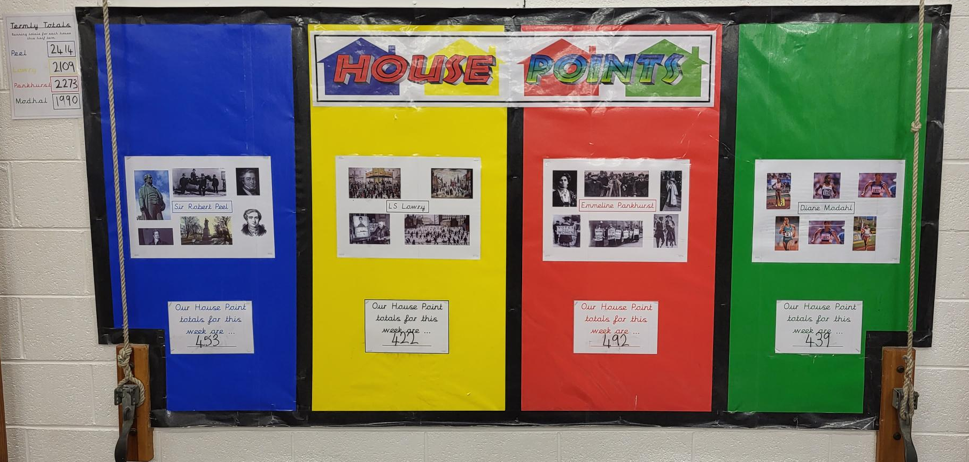
The school day runs from 9:00am until 3:25pm.
Chapelfield has a thriving After School Club and recently opened a Breakfast Club.
On leaving Year 6, our pupils go on to attend several different secondary schools within the Bury area. Some children go to independent schools in Bury, Bolton or elsewhere.

School / Community Partnership
Chapelfield has strong ties with Radcliffe Library, to which pupils are regular visitors. The school has excellent relationships with the librarians who visit regularly to present the latest holiday reading challenges in assembly.
Chapelfield welcomes feedback from parents and holds Parent Forums twice a term during which parents/carers can raise any whole-school concerns. We also regularly take feedback from parents and children via questionnaires and use this information to influence and define school policy.
Chapelfield is fortunate to have an active PTFA (Parent-Teacher and Friends Association), made up of roughly equal numbers of parents/carers and staff. The PTFA members organise at least one event per term and raise in excess of £2,500 a year to subsidise extra-curricular visits and the purchase of additional classroom resources.

Extra-Curricular
Our children have the opportunity to participate in a broad range of extra-curricular activities including choir, drama, animation, art, cross country, French and various sports.

Our school choir has recently reformed and recently took part in the Hansel and Gretel production organised by Bury Music Service at the Bury Met. Children are able to take advantage of Bury Music Service peripatetic teaching to learn to play a selection of brass, woodwind, percussion and string instruments. Brass lessons are provided weekly to upper KS2 as part of our Pupil Premium provision. There is a wide variety of opportunities for children to rehearse and perform musical and dramatic activities, both within the school curriculum, and as extra-curricular groups. All children take part in productions at Christmas and/or the end of the school year.

Key Statistics
Type of school | Community Primary
Age range | 3 - 11
Location | Radcliffe, Bury
Current OFSTED rating (June 2017) | Good
Children on roll | 284
Attendance (As of Spring 2023) | 93.41%
% of children eligible for free school meals | 35%
% of children with SEND support | 24%
% of children with English as an additional language | 6.7%
Number of teachers | 14

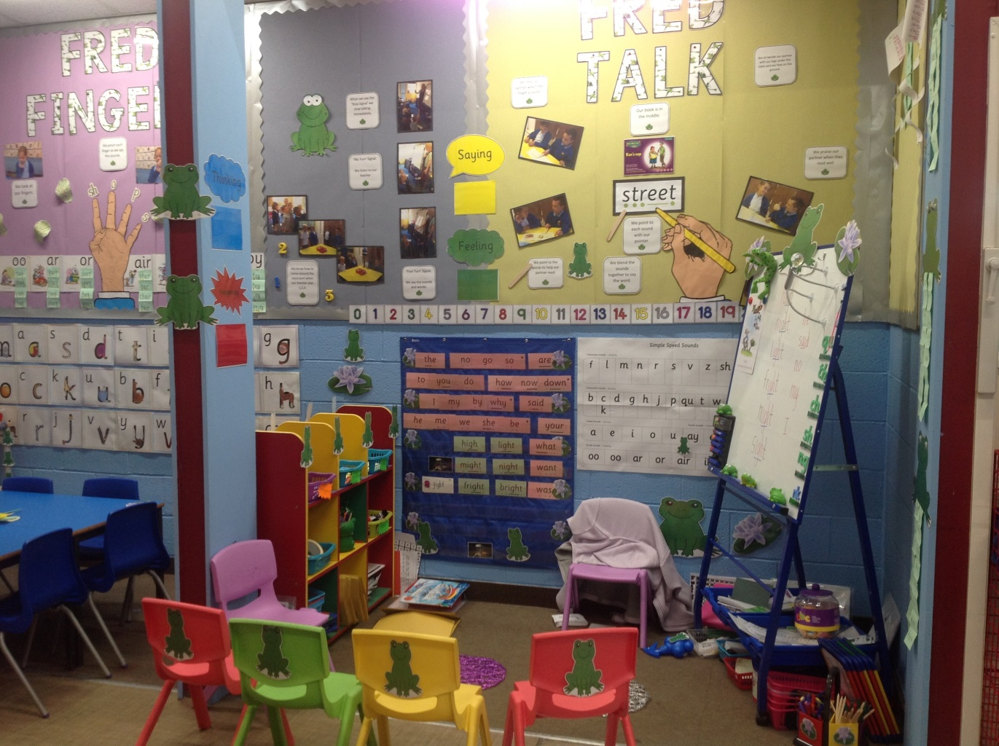

Attainment 2021-2022

Key Stage 2
Percentage of children achieving expected standard
Maths | 78%
Reading | 83%
Writing | 68%
GPS | 73%

Key Stage 1
Percentage of pupils achieving expected standard (Teacher Assessment)
Maths | 43%
Reading | 50%
Writing | 46%

Year 1 Phonics Screening
85% of our children passed the phonics screening test.

EYFS
63% of our children achieved a good level of development.

Job Description
Job Title: Headteacher
Group: 2
Leadership Pay Range: L15-L21
To whom responsible: The Governing Body of the school and Bury Local Authority

Purpose of the Job
Leadership and management of the school to promote effective education for all children within the framework provided by the policies of the Governing Body and the Local Authority with regards to all statutory requirements, aligned to the school’s strategic plan and vision.

Main Responsibilities
- Those duties listed in the School Teachers Pay and Conditions document.
- To ensure the school fulfils the requirements of the relevant legislation.
- To develop and maintain an educational environment which encourages excellence in all aspects and equality of opportunity for all.
- To plan, with the Governing Body, the annual school budget and manage financial delegation on behalf of the Governing Body.
- To formulate a School Improvement Plan in consultation with Governors and staff.
- To fulfil the expectations within the Headteachers’ Standards 2020 and the Teachers’ Standards

Specific Responsibilities

Shaping the Future
To work with the Governing Body to create a shared vision and strategic plan.
To promote and sustain improvements, with strong visible leadership.
Ensuring the vision is shared and understood by creating opportunities for engagement with staff, pupils and parents, focusing on developing a passion for learning, life and play.
Advising the Governing Body on developments in educational thinking and national initiatives, by proactively keeping pace with our changing world.
Being an innovative leader in the field of education, through empowerment and delegation to your team.
Enabling change by creating opportunities to develop new ideas and creativity to achieve excellence, through continuous development.
Challenging, influencing and motivating others to fulfil their potential, through supportive leadership.

Policy and Strategy
Enabling schemes and processes for the whole school, staff and curriculum development.
Co-ordinating school self-evaluation through the management team and curriculum action plans.
Co-ordinating structures of management and finance through meetings with the Governing Body and the Senior Leadership Team.
To formulate policy with the Governing Body and communicate this through the School Development Plan.
Implement and monitor strategies that secure the highest standards of attendance and behaviour.
To ensure that the school website is current and kept up to date to meet all statutory requirements.

Curriculum
To ensure regular reviews of curriculum policy, and the resources available to support learning.
To formulate and monitor the development and evaluation of curriculum action plans.
To establish a successful learning culture which leads pupils to see themselves as effective, independent and lifelong learners.

Staff
To be responsible for the recruitment, selection and appointment of all teaching and non-teaching staff excluding the posts of headteacher and deputy headteacher.
To ensure that personnel and employment policies are in place and reviewed regularly.
To ensure the development of staff through Continuing Professional Development, including staff training and performance management.
To monitor the deployment of supply staff.
To be responsible for Health and Safety.
To promote an inclusive environment that promotes wellbeing.
To monitor, evaluate and review classroom practice and act appropriately to challenge underperformance and secure improvement.

Finance and Resources
To monitor and control spending plans [staffing, resources and premises related costs] established with the Governing Body, ensuring funding and staffing match educational priorities.
Ensure that the range, quality and use of all available resources is monitored to improve the education offered and provide value for money.

To promote effective information systems, databases, spreadsheets for staff, pupils’ assessment, inventory and continuing professional development.

To monitor the maintenance, security and supervision of buildings, their contents and supervision of the school grounds.

Relationships/Liaison/Communication
To work closely with the Governing Body and attend meetings, committees and training sessions.
To organise regular staff meetings and Senior Leadership Team meetings.

To support and engage with the PTFA.

To promote active involvement of parents in their child’s learning and school activities through parents' evenings; reports to parents; newsletters; admissions/secondary transfer, etc.

To work with support agencies including SEND, Child Protection, Health and Safety, and School Attendance.

To ensure that child safeguarding practices including PREVENT are fully embedded.

To work with Local Authority officers on school performance evaluation.

To promote successful relationships with the community – parents, police, religious and cultural groups, sporting organisations, local industry, local residents, work experience students and volunteers - enriching the school’s value to the wider community.

To promote and develop collaborative links with other schools for the benefit of pupils and staff at Chapelfield.

Review
The job description may be amended at any time after discussion with the Governing Body, but in any case, will be reviewed each academic year.

Person Specification
E=Essential D=Desirable a = Application i = Interview r = Reference

Experience
1 | Proven record of successful headship, deputy headship or assistant headship in primary education | E | a, r
2 | Evidence of recent professional development beneficial to the role of headteacher | E | a
3 | Successful track record of implementing strategies which have impacted significantly on raising attainment and accelerating progress throughout the school | E | a, i, r
4 | Experience of school development planning, assessment, self-evaluation and monitoring | E | a, i
5 | Experience of working with other agencies for the well-being of pupils | E | a
6 | Broad teaching experience across the primary age range | E | a, r
7 | Experience of responsibilities in the management of a school budget | D | a, i

Strategic Leadership
8 | A highly motivated, reflective leader who can exemplify the school values and aims. A visible leader who is consistent and promotes positive relations between pupils, staff, parents and governors | E | i
9 | Experience in developing and articulating a clear vision and plans | E | a, i
10 | To have a good understanding of legislation and safeguarding procedures and to lead the school in all safeguarding matters | E | a, i
11 | To support the Governing Body to deliver its functions effectively | E | a, i
12 | Knowledge of Inclusion, Diversity and Equal Opportunity policies in schools | E | a

Management
13 | Knowledge and experience of how performance data can be used to support, monitor and evaluate teaching and learning throughout the school | E | a, i
14 | How to use Performance Management and ongoing appraisals to ensure the highest possible teaching standards | E | a, i
15 | Knowledge of Pupil Premium funding to “diminish the difference” | E | a, i
16 | Knowledge of SEND funding to obtain the best possible outcomes | E | a, i
17 | Effective contributions to the production of Self Evaluation Summaries and School Development Plans, and using these to address school priorities and improve outcomes | E | a, i
18 | To be up to date with current Ofsted requirements | E | i
19 | Evidence of improving attendance and punctuality | E | a, i

Personal Skills
20 | Exceptional interpersonal skills, to be able to communicate effectively with pupils, staff, parents and stakeholders | E | a, i
21 | Demonstrate a passion for creating a positive team environment where the high expectations can be achieved | E | i
22 | To manage complaints and resolve conflict with sensitivity and professionalism | E | a, i
23 | Experienced, compassionate leader and mentor | E | a, i
24 | Commitment to continuous professional development | E | a, i

Shaping the Future
25 | A desire to work in collaboration with other schools to support each other and share best practice | E | a, i
26 | To have a knowledge of current Government education policies | E | a, i
27 | To shape the current and future teaching staff at Chapelfield through high-quality in-house training and sustained professional development | E | i
28 | Through delegation to the deputy headteacher, Senior Leadership Team and others, help to prepare the school leaders of the future | E | i
29 | Experience of managing change and the introduction of new ideas | E | a, i
30 | Experience of enriching pupils’ educational and learning opportunities. | E | a, i

