Daisyfield
Primary School

HEADTEACHER APPLICATION INFORMATION

Autumn 2022

Contents

Welcome letter from the School Council Page 3

Welcome letter from the Chair of Governors Page 4

Agreed timetable for the appointment Page 5

Agreed pay range Page 5

Advertisement Pages 6 - 7

Job description Pages 8 - 13

Person specification Pages 14 - 17

Attendance statement Page 18

The children at Daisyfield Primary School have shared the attitudes and values they would like from a new headteacher.

Dear Applicant

Thank you for your interest in the important post of Headteacher at Daisyfield Primary School. I hope you find the enclosed information beneficial in your application.

The school was graded ‘Good’ in our last OFSTED inspection in November 2017 and through rigorous and robust self-evaluation and improvement, we have continued to achieve excellent outcomes for our children.

The children are a delight, with exemplary behaviour and conduct and I continue to be impressed with their confidence, love of learning and their engagement in all the school has to offer.
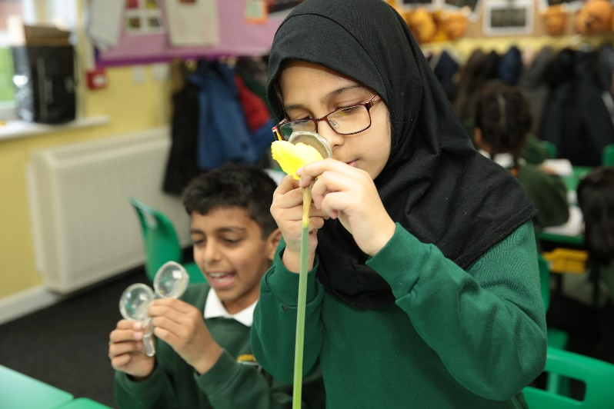
Daisyfield is a very popular community primary school which caters for children aged between 2 and 11 years old. We pride ourselves in having a team of hardworking and committed professionals who strive to achieve the highest standards for our pupils. The Governors are seeking to appoint a Headteacher with vision and energy to continue to build on our outstanding achievements and successes.

The successful candidate will continue to promote a high-quality education, underpinned by our ethos and values whilst inspiring, motivating and empowering the SLT, staff and the whole school community.

You will be able to find more information on our school website at https://www.daisyfieldprimary.org and you will also find a few words from some of our children in the application pack.

We very much welcome prospective applicants to visit the school, where you will experience a safe, loving school that is full of learning. If you wish to arrange a visit, please contact our current Headteacher Joanne Ramsbottom on 01254 52108 or email: joanne.ramsbottom@daisyfield.blackburn.sch.uk.

Yours sincerely,

Riyaz Patel
Chair of Governors

Agreed timetable for appointment of

Headteacher at Daisyfield Primary School

Autumn 2022

Closing dates for applications Monday, 10th October, 2022.

Shortlisting meeting Thursday, 13th October, 2022

Interview day 1 Monday, 14th November, 2022

Interview day 2
Formal Interviews and appointment Tuesday, 15th November, 2022

New Headteacher takes up post Beginning of Summer Term 2023

Agreed Pay Range for appointment of

Headteacher at Daisyfield Primary School

Spring Autumn 2022

IPR (Individual Pay Range for Headteacher)

Agreed as L14 to L21 (£58,135.00 to £68,347.00)

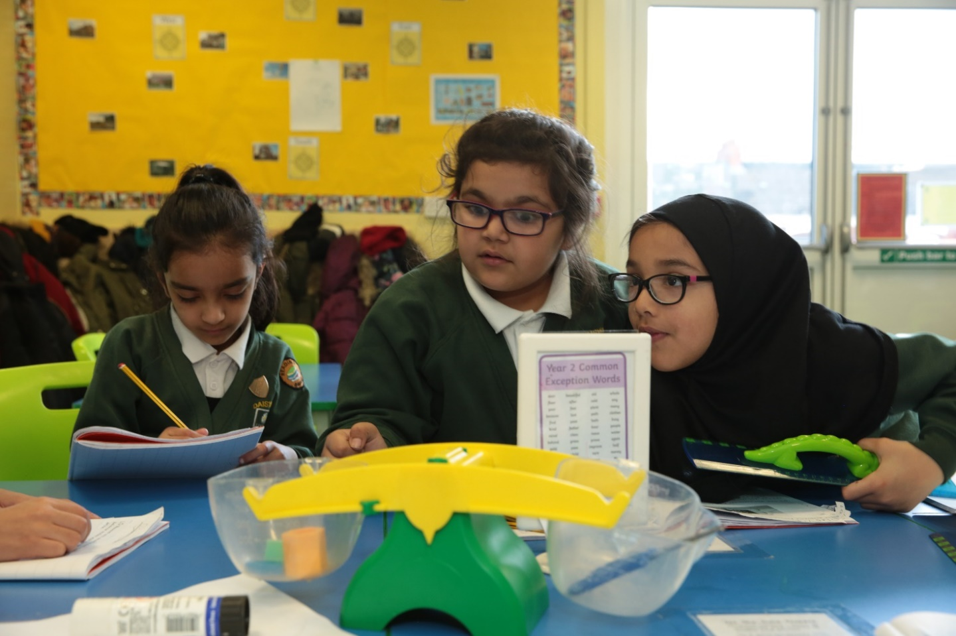

Daisyfield Primary School

Headteacher Job Description – September 2022

This appointment is with the Governing Body of the school.

This job description reflects the National Standards of Excellence for Headteachers (2020). These standards are built upon The Teaching Standards (2011) which apply to all teachers, including Headteachers.

The appointment is subject to the current conditions of employment of Headteachers contained in the School Teachers’ Pay and Conditions (2020) document and other current educational and employment legislation, including that of the Department for Education.

In carrying out his/her duties, the Headteacher shall consult, where appropriate, with the Local Authority, the Governing Body, the staff of the school, its pupils and the parents of its pupils.

Headteachers are leading professionals and role models for the communities they serve. Their leadership is a significant factor in ensuring high quality teaching and achievement in school and a positive and enriching experience of education for pupil. Together with those responsible for governance and they are custodians of the nation’s schools.

Parents and the wider public rightly hold high expectations of Headteachers, given their influential position leading the teaching profession and on the young people who are their responsibility. The Headteachers’ standards set out how Headteachers meet these high expectations. The standards are an important benchmark not only for Headteachers and those who hold Headteachers to account, but also for those who train and develop school leaders.

These standards replace the national standards of excellence for Headteachers 2015. They are non-statutory and intended as guidance to be interpreted in the context of each individual Headteacher and school. They are designed to be relevant to all Headteachers.

The standards can be used to:

- shape Headteachers’ own practice and professional development within & beyond the school
- support the recruitment and appointment of Headteachers, including the development of job descriptions and person specifications
- underpin frameworks for the training of school leaders, including current and aspiring Headteachers
- inform the performance management of Headteachers

Relationship to the Teachers’ Standards

The teachers’ standards (2011, as amended), including the personal and professional code of conduct which applies to teachers, provide a foundation upon which the standards for Headteachers are built.

Headteachers, like other teachers, are expected to meet the teachers’ standards. The Headteachers’ standards articulate how Headteachers can meet both the additional responsibilities of headship and the requirements of the teachers’ standards.

The first section of the Headteachers’ standards outlines the ethics and professional conduct expected of Headteachers. This is developed from part 2 of the teachers’ standards. As such, they consist of statements that define the behaviour and attitudes which should be expected of Headteachers.

The second section sets out 10 Headteachers’ standards. The first 6 standards build on the teachers’ standards, whereas the other 4 standards focus on leadership responsibilities specific to Headteachers. There is no hierarchy to the standards; the numbering below is only to aid identification.

- School culture (builds on teachers’ standard 1)
- Teaching (builds on teachers’ standards 2 and 4)
- Curriculum and assessment (builds on teachers’ standards 3 and 6)
- Behaviour (builds on teachers’ standard 7)
- Additional and special educational needs (builds on teachers’ standard 5)
- Professional development (some match to teachers’ standard 4)
- Organisational management
- School improvement
- Working in partnership
- Governance and accountability

Domains

The ethics and professional conduct section is at the core of the standards. This outlines the ethics and professional conduct expected of Headteachers. It consists of statements that define the behaviour and attitudes which should be expected of Headteachers.
The standards in section 2 cover interlinked domains of the Headteachers role all underpinned by the governance and accountability domain.

Culture and Ethos

- school culture
- behaviour
- professional development

Curriculum and Teaching

- teaching
- curriculum and assessment
- additional and special educational needs

Organisational Effectiveness

- organisational management
- school improvement
- working in partnership

Section 1: Ethics and Professional Conduct

Headteachers are expected to demonstrate consistently high standards of principled and professional conduct. They are expected to meet the teachers’ standards and be responsible for providing the conditions in which teachers can fulfil them.

Headteachers uphold and demonstrate the Seven Principles of Public Life at all times. Known as the Nolan principles, these form the basis of the ethical standards expected of public office holders:

- selflessness
- integrity
- objectivity
- accountability
- openness
- honesty
- leadership

Headteachers uphold public trust in school leadership and maintain high standards of ethics and behaviour. Both within and outside school, Headteachers:

- build relationships rooted in mutual respect, and at all times observe proper boundaries appropriate to their professional position
- show tolerance of and respect for the rights of others, recognising differences and respecting cultural diversity within contemporary Britain
- uphold fundamental British values, including democracy, the rule of law, individual liberty and mutual respect, and tolerance of those with different faiths and beliefs
- ensure that personal beliefs are not expressed in ways which exploit their position, pupils’ vulnerability or might lead pupils to break the law

As leaders of their school community and profession, Headteachers:

- serve in the best interests of the school’s pupils
- conduct themselves in a manner compatible with their influential position in society by behaving ethically, fulfilling their professional responsibilities and modelling the behaviour of a good citizen
- uphold their obligation to give account and accept responsibility
- know, understand, and act within the statutory frameworks which set out their professional duties and responsibilities
- take responsibility for their own continued professional development, engaging critically with educational research
- make a positive contribution to the wider education system

Section 2: Headteachers’ Standards

1. School Culture

Headteachers:
- establish and sustain the school’s ethos and strategic direction in partnership with those responsible for governance and through consultation with the school community
- create a culture where pupils experience a positive and enriching school life
- uphold ambitious educational standards which prepare pupils from all backgrounds for their next phase of education and life
- promote positive and respectful relationships across the school community and a safe, orderly and inclusive environment
- ensure a culture of high staff professionalism

2. Teaching

Headteachers:
- establish and sustain high-quality, expert teaching across all subjects and phases, built on an evidence-informed understanding of effective teaching and how pupils learn
- ensure teaching is underpinned by high levels of subject expertise and approaches which respect the distinct nature of subject disciplines or specialist domains
- ensure effective use is made of formative assessment

3. Curriculum and Assessment

Headteachers:
- ensure a broad, structured and coherent curriculum entitlement which sets out the knowledge, skills and values that will be taught
- establish effective curricular leadership, developing subject leaders with high levels of relevant expertise with access to professional networks and communities
- ensure that all pupils are taught to read through the provision of evidence-informed approaches to reading, particularly the use of systematic synthetic phonics in schools that teach early reading
- ensure valid, reliable and proportionate approaches are used when assessing pupils’ knowledge and understanding of the curriculum

4. Behaviour

Headteachers:
- establish and sustain high expectations of behaviour for all pupils, built upon relationships, rules and routines, which are understood clearly by all staff and pupils
- ensure high standards of pupil behaviour and courteous conduct in accordance with the school’s behaviour policy
- implement consistent, fair and respectful approaches to managing behaviour
- ensure that adults within the school model and teach the behaviour of a good citizen

5. Additional and Special Educational Needs and Disabilities

Headteachers:
- ensure the school holds ambitious expectations for all pupils with additional and special educational needs and disabilities
- establish and sustain culture and practices that enable pupils to access the curriculum and learn effectively
- ensure the school works effectively in partnership with parents, carers and professionals, to identify the additional needs and special educational needs and disabilities of pupils, providing support and adaptation where appropriate
- ensure the school fulfils its statutory duties with regard to the SEND code of practice

6. Professional Development

Headteachers:
- ensure staff have access to high-quality, sustained professional development opportunities, aligned to balance the priorities of whole-school improvement, team and individual needs
- prioritise the professional development of staff, ensuring effective planning, delivery and evaluation which is consistent with the approaches laid out in the standard for teachers’ professional development
- ensure that professional development opportunities draw on expert provision from beyond the school, as well as within it, including nationally recognised career and professional frameworks and programmes to build capacity and support succession planning

7. Organisational Management

Headteachers:
- ensure the protection and safety of pupils and staff through effective approaches to safeguarding, as part of the duty of care
- prioritise and allocate financial resources appropriately, ensuring efficiency, effectiveness and probity in the use of public funds
- ensure staff are deployed and managed well with due attention paid to workload
- establish and oversee systems, processes and policies that enable the school to operate effectively and efficiently
- ensure rigorous approaches to identifying, managing and mitigating risk

8. Continuous School Improvement

Headteachers:
- make use of effective and proportional processes of evaluation to identify and analyse complex or persistent problems and barriers which limit school effectiveness, and identify priority areas for improvement
- develop appropriate evidence-informed strategies for improvement as part of well-targeted plans which are realistic, timely, appropriately sequenced and suited to the school’s context
- ensure careful and effective implementation of improvement strategies, which lead to sustained school improvement over time

9. Working in Partnership

Headteachers:
- forge constructive relationships beyond the school, working in partnership with parents, carers and the local community
- commit their school to work successfully with other schools and organisations in a climate of mutual challenge and support
- establish and maintain working relationships with fellow professionals and colleagues across other public services to improve educational outcomes for all pupils

10. Governance and Accountability

Headteachers:
- understand and welcome the role of effective governance, upholding their obligation to give account and accept responsibility
- establish and sustain professional working relationship with those responsible for governance
- ensure that staff know and understand their professional responsibilities and are held to account
- ensure the school effectively and efficiently operates within the required regulatory frameworks and meets all statutory duties

How the Standards Apply to Different Leadership Roles

The Headteachers standards cover the full breadth of leadership responsibilities within a single school. For most Headteachers in maintained schools or academies in single academy trusts this means that all of the standards should be relevant to them, though it is anticipated that they will meet some standards through the successful leadership and management of teams and individuals within their schools.

There can be a range of job roles and titles for those leading individual schools, particularly where a school is working within a group, such as in a multi-academy trust. Job roles and titles are various, including Head of School, and Associate Head, as are the governance arrangements to which Headteachers are accountable. In some settings Headteachers are responsible for leading more than one school. There are also instances of shared headship through co-headship or job-shares. Employers, in such instances, will therefore want to decide which standards are applicable to roles in these contexts.
The applicant will be required to safeguard and promote the welfare of children and young people. The Headteacher is expected to demonstrate this commitment to safeguarding and promoting the welfare of children and young people and is expected to hold all staff and volunteers accountable for their contribution to the safeguarding regulations.

This job description forms part of the contract of employment of the person appointed to the post. It reflects the position at the present time only and may be reviewed in negotiation with the employee in the future. The appointment is subject to the current conditions of employment in the School Teachers’ Pay and Conditions Document as they relate to Headteachers.

Person Specification/Selection Criteria for
Headteacher at Daisyfield Primary School
September 2022

The applicant will be required to safeguard and promote the welfare of children and young people

Selection decisions will be based on the criteria below. At each stage of the process an assessment will be made by the appointment panel to determine the extent to which the criteria have been met and the ability to fulfil the job description for the post.

Candidates failing to meet any of the essential criteria will automatically be excluded at any stage of the process.

The appointing panel will use a combination of assessment tools to determine each candidate's suitability and the extent to which the criteria have been met. These assessment tools include (but are not limited to) the application form, supporting statement, information gathered during the interview process and references.

[A] Qualifications

Qualification requirements | Essential/Desirable
Qualified teacher status | E
Degree | E

[B] Professional Development

 | Essential/Desirable
Evidence of recent and appropriate professional development for the role of headteacher | E

[C] School leadership and management knowledge and experience

 | Essential/Desirable
Successful leadership as a Headteacher | D
Successful leadership as a Deputy Headteacher or Assistant Headteacher | E
Evidence of successfully leading school improvement | E
Evidence of the application of strategies to review, evaluate and improve teaching and learning | E
Experience of curriculum leadership and development | E
Experience of working constructively and collaboratively with parents/ carers | E
Experience of monitoring staff performance | E
The ability to provide work effectively with the governing body to enable it to meets its responsibilities | E
An understanding of strategic financial planning, effective budget management and financial analysis in relation to its contribution to school improvement and pupil achievement | E
To have had experience of guiding, coaching, mentoring or training individuals to improve their practice | E
Maintains good awareness of current and evolving national education policy and strategy | E

[D] Experience and knowledge of teaching

 | Essential/Desirable
Successful teaching of pupils in the Primary phase | E
Can effectively analyse school data and identify appropriate actions which then form part of the school improvement plan | E
Commitment to ensuring inclusion and addressing diversity positively | E
A sound understanding of how children learn, how teachers can best teach and how to raise achievement for all pupils | E
A commitment to providing a rich and broad curriculum which enables children to be the best version of themselves | E

[E] Professional Attributes

 | Essential/Desirable
Strong behaviour management skills | E
An ability to communicate effectively, both orally and in writing, with a range of audiences | E
To be a leader of learning; demonstrating, promoting and encouraging excellent classroom practice | E
A commitment to professional development for all staff, and self | E
Have a good commitment to sustained attendance at work | E
To have good judgement; able to assess and balance risks and opportunities | E
The ability to plan and prioritise and organise self and others | E
The ability to work collaboratively with partner schools | D

[F] Personal Qualities

 | Essential/Desirable
A passion for achieving the very best outcomes for all children | E
A clear vision for an innovative, progressive and forward thinking school | E
The ability to communicate the clear vision for the school to all stakeholders | E
The capacity to provide inspirational, enthusiastic and innovative educational leadership | E
A caring and considerate attitude towards children, which values each child's potential and recognises each child as an individual | E
Flexibility, initiative and drive to maintain a positive attitude in the face of a challenging and demanding job | E
An ability to establish and model effective working relationships with a wide and diverse range of people including pupils, parents/ carers, governors, colleagues, other professionals and wider community | E
The ability to perform effectively under pressure | E
Demonstrate initiative | E
Be aware of their own strengths and areas for development. Reflect constructively and act upon as appropriate, feedback from others | E
A commitment to recognise the health and well-being of yourself, the staff and the pupils | E

[G] Safeguarding

 | Essential/Desirable
Display commitment to the protection and safeguarding of children and young people | E
Form and maintain appropriate relationships and personal boundaries with young people | E
Have up to date knowledge and understanding of relevant legislation and guidance in relation to working with and protection of children and young people | E
Co-operate and work with relevant agencies to protect young people | E

[H] Professional Skills

Each candidate will be expected to demonstrate knowledge and understanding of the National Standards of Excellence for Headteachers 2020 which also forms the basis of the Job Description. Candidates will be expected to show evidence of having applied this knowledge and understanding in their current setting as well as an awareness of how this will be applied in School.

[I] Confidential References and Reports

Positive recommendation from all referees, including current employer and Local Authority and/or CEO | E

[J] Application Form and Supporting Statement

The application form must be fully completed and legible. The supporting statement should be clear, concise and related to the specific post (no more than 1,500 words.) These should both be emailed to schoolhrteam@blackburn.gov.uk. Please do not submit a CV.

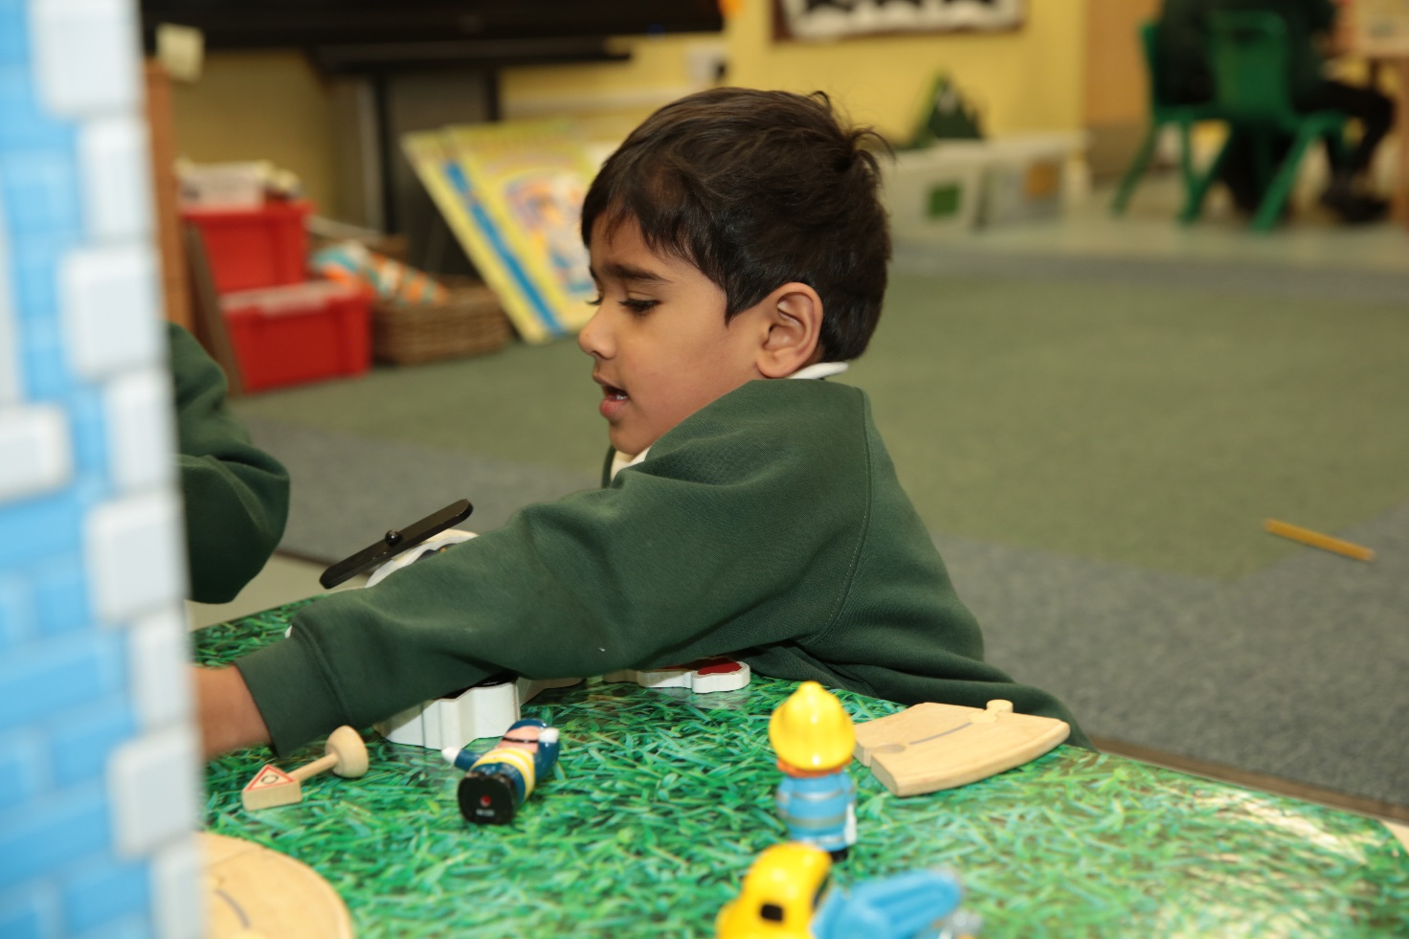

Attendance Policy Statement

Daisyfield Primary School is committed to achieving and maintaining a high level of attendance from all employees through the application of good management practice. All employees must recognise the importance of good attendance and ensure that any sickness absence is kept to a minimum.

Whilst supporting employees during periods of sickness, the school’s leadership team monitors levels of sickness absence in school regularly and takes action in accordance with the guidelines adopted by the school to deal with unacceptable levels and frequency of sickness absence.

Good attendance enhances the service delivered by the school, minimises staffing difficulties and ensures best value to the school. All employees in this school must understand the importance of good attendance to the operation, performance and image of the school and must show a commitment to achieving and maintaining a high level of attendance.

