

HEADTEACHER RECRUITMENT PACK
2021

DORCHESTER LEARNING CENTRE

PUPIL REFERRAL UNIT WITH SEMH PLACES



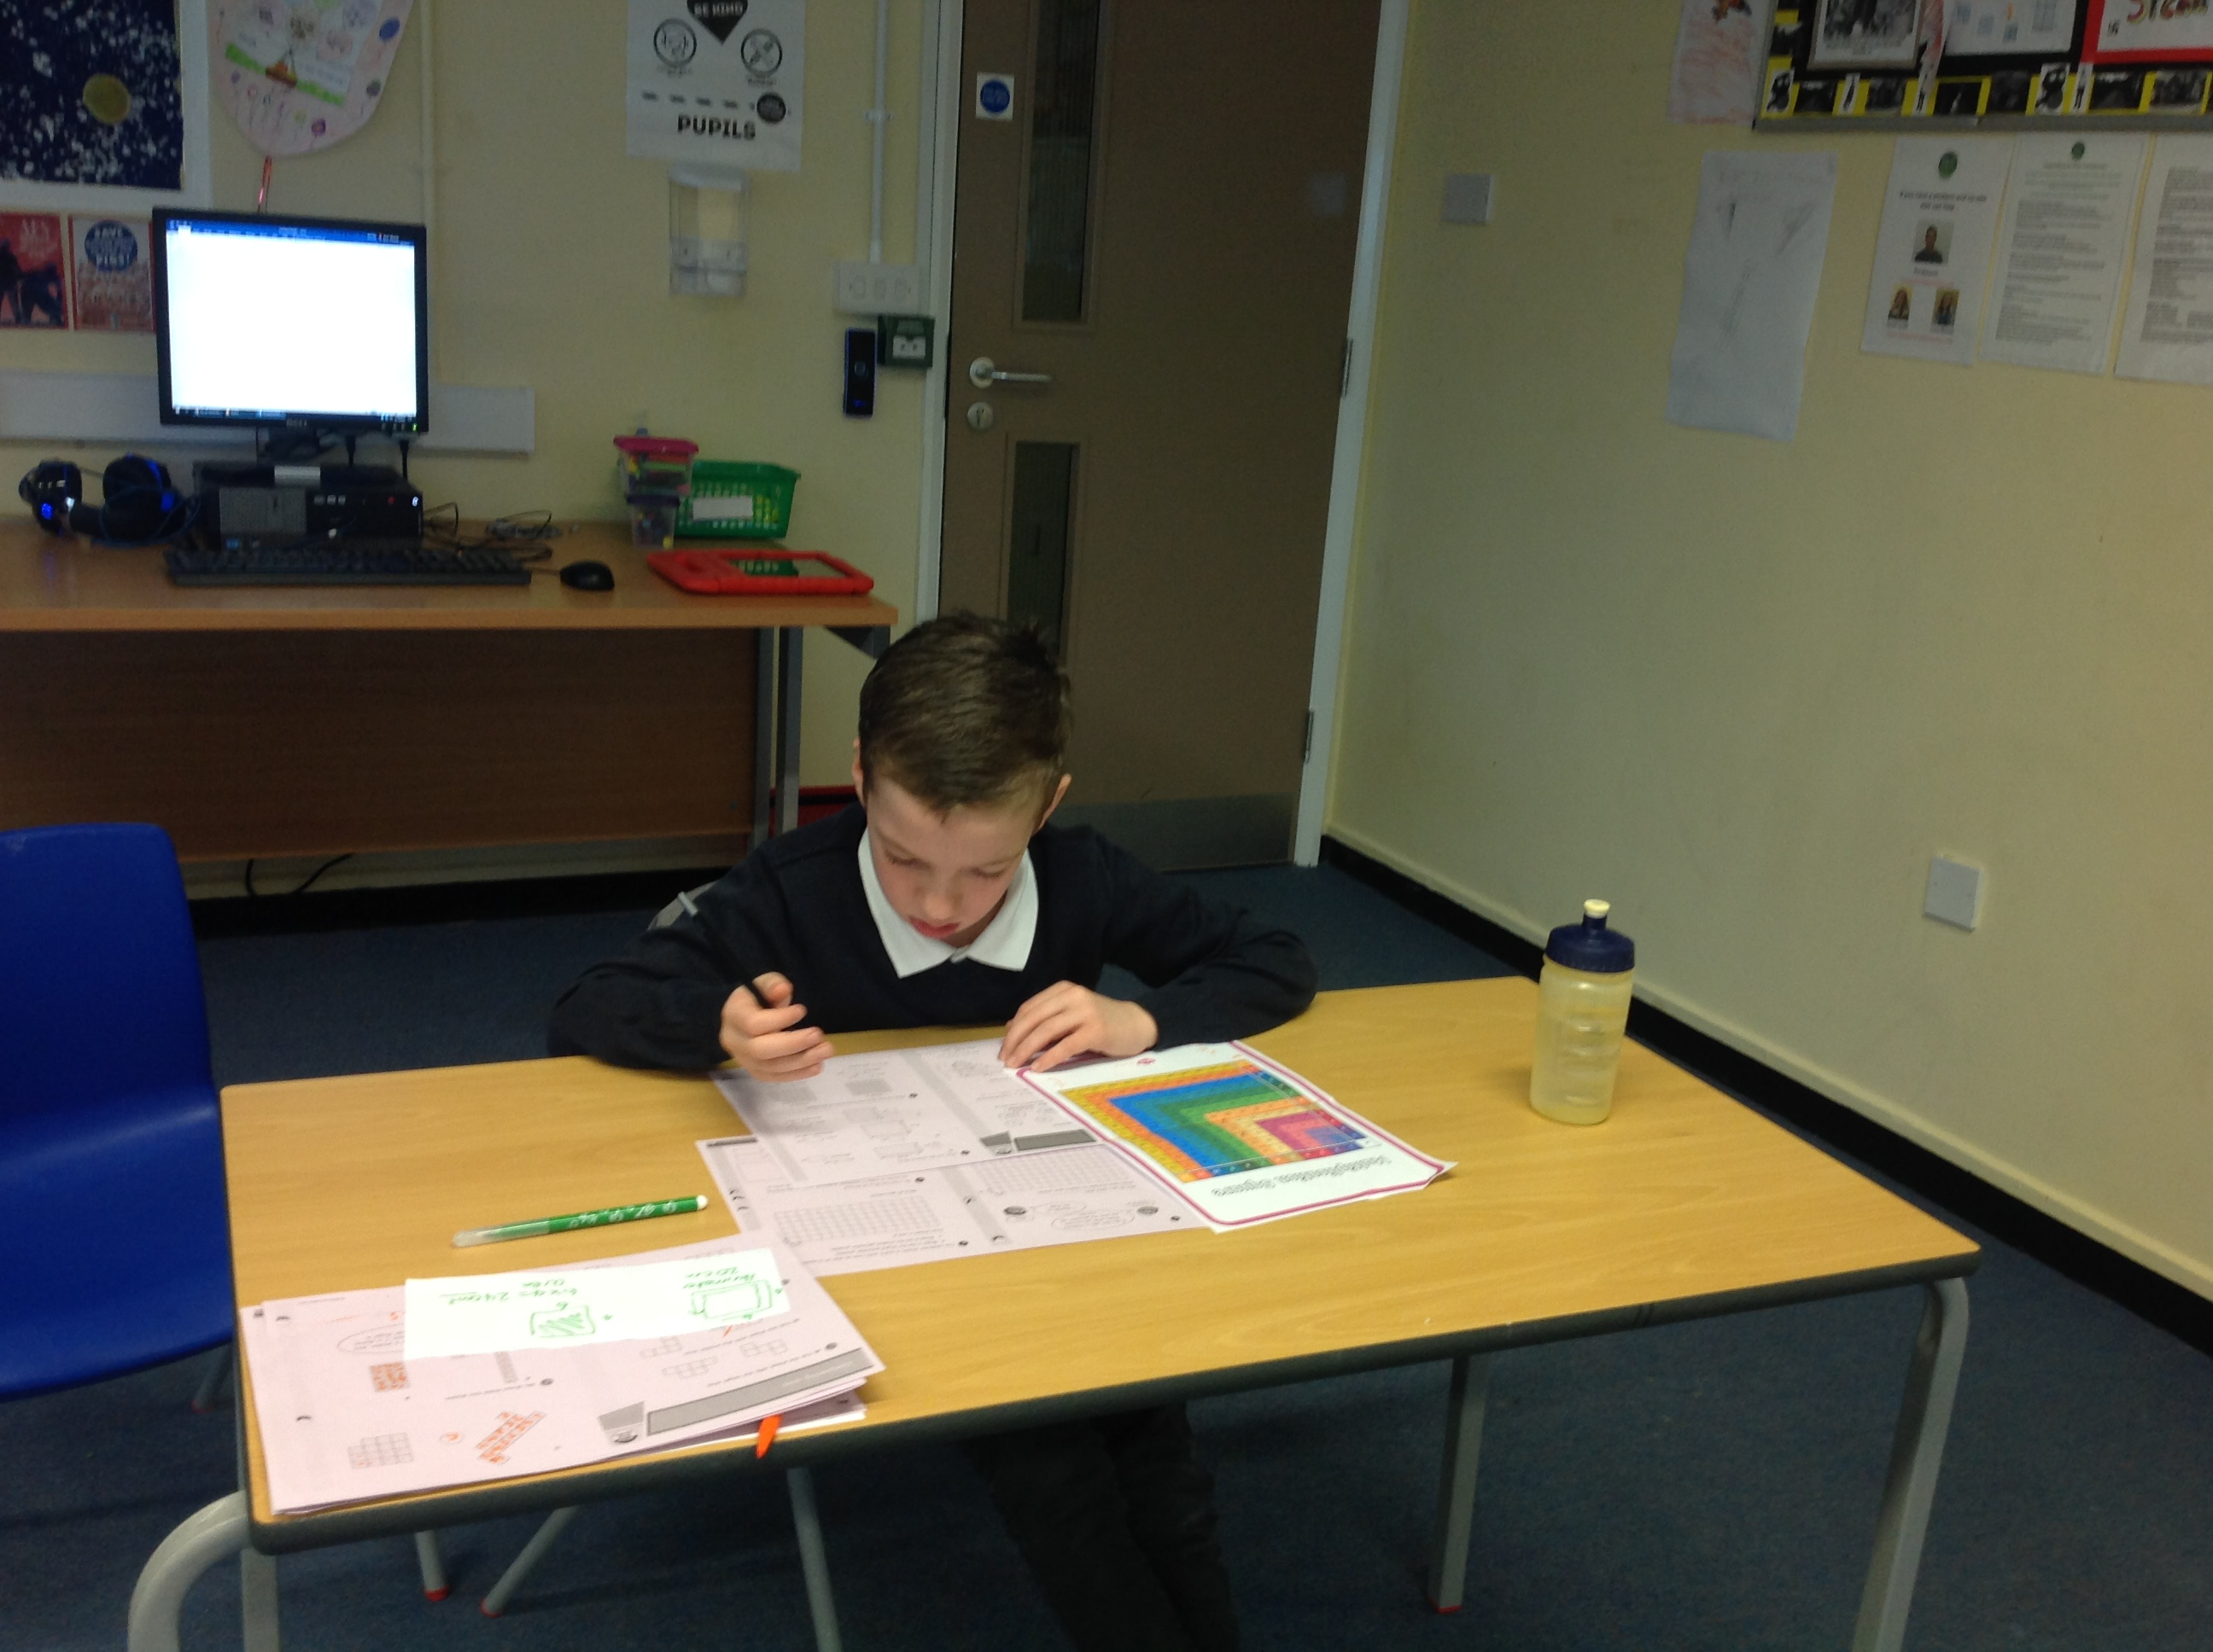

Monkton Park
Winterborne Monkton
Dorchester
Dorset DT2 9PS
Tel: 01305 261213
Email: d.guyler@dlc.dorset.sch.uk
Website: www.dlconline.co.uk

Monkton Park
Winterborne Monkton
Dorchester
Dorset DT2 9PS
Tel: 01305 261213
Email: d.guyler@dlc.dorset.sch.uk
Website: www.dlconline.co.uk

CONTENTS PAGE

Introduction
Letter from the Chair of Governors
Advertisement
What is The Dorchester Learning Centre
Job Description

Person Specification

Applications

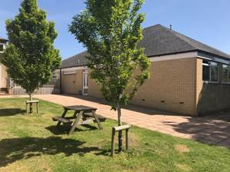
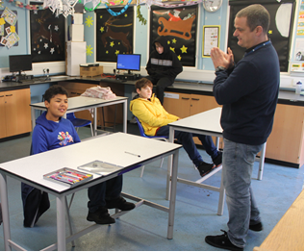



INTRODUCTION

Thank you for your interest in the position of Headteacher of the Dorchester Learning Centre, a Pupil Referral Unit with SEMH places located in Dorchester, Dorset.

We hope that this information pack will provide potential applicants with all the information and guidance that you need to apply.

If you need any further information please do not hesitate to contact Deborah Guyler, School Business Manager, on 01305 261213, email: d.guyler@dlc.dorset.sch.uk. Due to Covid-19, visits to the school will be limited. However, we realise the importance of potential applicants wanting to visit and we do encourage and welcome this. Therefore in order to comply with our Covid-19 control measures, we will be conducting visits after pupils have gone home, on the following dates and times:

12, 15 and 22 January between 3pm and 5 pm. Please call to make an appointment.

MAP

Please use the link below for directions to Dorchester Learning Centre.
https://www.google.com/maps/@50.6984644,-2.4484179,17z


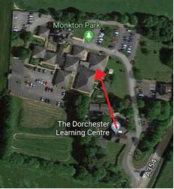

WELCOME FROM THE CHAIR OF GOVERNORS

January 2021

Dear Applicant

Appointment of Headteacher to The Dorchester Learning Centre

Thank you for your interest in the post of Headteacher at The Dorchester Learning Centre.

It is an honour to be Chair of Governors. The opportunity to be involved in a school that gives the majority of students a “second chance” at education is amazing. We play a significant role in supporting the most vulnerable in society.

Ofsted awarded a grading of ‘good’ to The Dorchester Learning Centre at our last inspection. We are now looking for an inspirational new leader to bring a long-term vision to the school and continue the journey to being an outstanding alternative education provider.

The Centre has undergone significant restructuring and moved to a newly refurbished premises in order to equip ourselves in our current role to provide PRU and SEMH provision for children with complex needs. We now seek someone with substantial leadership experience, high expectations and inspirational qualities to join us at this exciting time, to consolidate the transformational work already undertaken and to work with our dedicated and experienced staff to deliver outstanding outcomes.

The Governors are pleased to provide you with this application pack which we hope you will find useful. If there is any further information that you require please do not hesitate to contact us.
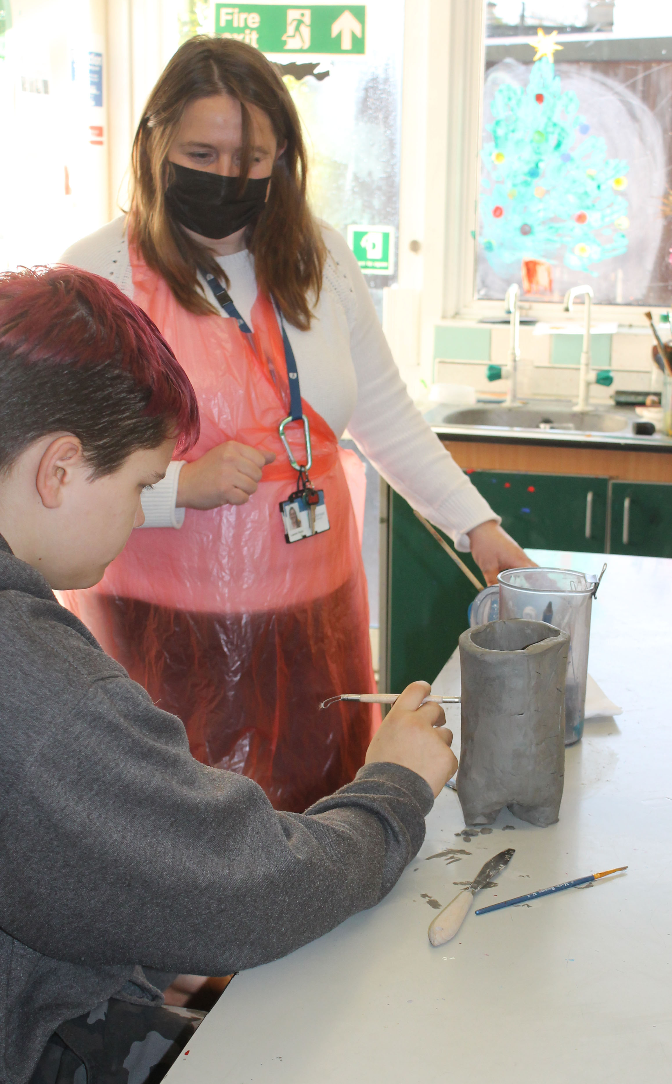
We will be pleased to show you around the centre and to answer any questions you may have. Please contact Deborah Guyler on 01305 261213 to arrange your visit on the proposed dates.

Thank you again for your interest. If you truly feel you can make a difference, we very much look forward to hearing from you.

Yours faithfully

Ian Roe
Chair of Governors

ADVERT FOR HEADTEACHER POST

Org Type: Alternative Provision PRU
Funding Status: LA – Higher Needs Block
Gender: Mixed
Age Range: 5 - 16 years
NOR: 64

HEADTEACHER
Group 2 (starting salary L16 – L19, £61,167 - £65,736, with progression to L21, £69,031)
Are you resilient, innovative, enthusiastic and passionate about improving children’s life chances?
Are you ready to lead our inspirational school from being a Good to an Outstanding PRU?
Required for Easter 2021 or September 2021, depending on notice period.
This is an exciting opportunity to be Headteacher at a Good PRU with SEMH places based in Dorchester, Dorset and one which aspires to be Outstanding. Our team of dedicated teaching and support staff are keen to provide outstanding learning experiences for children and young people referred from local mainstream schools for help with social, emotional and behavioural learning needs.
We are looking for a talented leader who has a track record of inspiring young people to overcome their particular challenges and engage with education in positive ways. The staff and governors recognise that our ambitious agenda requires outstanding leadership to build on what has already been established. We are looking for a leader who is innovative and has the confidence and abilities to evolve and implement a long term vision for the school. The starting salary will be between L16 – L19 dependent upon experience, however there is scope for progression within the Group 2 scale to L21.
Information about the school:

The Dorchester Learning Centre has a main teaching base close to Dorchester (Monkton Park) and also a classroom at the local hospital. Students who attend the centre come from a variety of backgrounds – dual registered, permanently excluded, SEMH needs and children who can’t attend mainstream school for medical reasons. Our current pupil number is 64 and the cohort ranges in age from 5 - 16, with 40 AP places and 24 SEMH places.

Visits to the school are encouraged and will take place under our current Covid-19 control measures. Please don't hesitate to ring Deborah Guyler, School Business Manager, on 01305 261213 to make an appointment for either the 12th, 15th, 22nd January between 3 pm and 5 pm.

As we take the commitment to safeguarding children very seriously, the successful candidate will be required to have an enhanced Disclosure and Barring Service check in line with the Government’s safer recruitment guidance. The school values the diversity of our workforce and welcomes applications from all sectors of the community.

Closing date: 24 January 2021 Interviews: 9 and 10 February 2021

Alternative Provision School (PRU)
Org Type: Alternative Provision PRU)
Funding Status: LA – High Needs Block
Gender: Mixed
Age Range: 5 - 16 years
Denomination: Non-denominational
The Dorchester Learning Centre, created in September 2000, is an Alternative Provision School for students based all over Dorset. The Headteacher is also responsible for the management of the schoolroom on the children’s ward at Dorset County Hospital, Dorchester. This unit is staffed by two full-time posts consisting of a teacher and teaching assistant.
Students are referred to Dorchester Learning Centre for a variety of reasons. Some have been permanently excluded from their mainstream school, others are children who can’t attend mainstream school for medical reasons, some have an EHCP and are SEMH referrals. All need to be re-engaged with education through nurture and care. The core curriculum subjects are taught as far as GCSE level and the students sit public examinations. There are also a range of extra curricular subjects including bike mechanics, sports, cooking and music production.
Dorchester Learning Centre views safeguarding as an absolute priority. A significant number of our pupils present with complex ACEs (adverse childhood experiences). We place a high value on the pastoral support that we provide to pupils and their carers. There is a well-established pastoral and safeguarding team who work hard to support the pupils. We work closely with other agencies, often taking the lead in escalating concerns and developing strategies and safeguarding plans for pupils and their carers.
In September 2018, Dorchester Learning Centre also became an SEMH base for pupils from the age of 5 up to 16. This has involved a new model of provision for both PRU students and SEMH pupils. At the same time we moved into bigger, newly refurbished premises on Monkton Park.

We have also set up a successful primary unit and created a new school that we are very proud of.



The Dorchester Area Schools Partnership is a learning and development association of schools in the Dorchester area which together form a learning pyramid. Children start at one of the thirteen first schools, progressing to one of the three middle schools and thence to the single upper school. The aim is to provide a coherent and seamless educational model for the area’s children by promoting close collaboration between schools, and in this the partnership has been spectacularly successful.

DASP has an executive steering group with an executive director (the Headteacher of one of the member schools, who is appointed on a rolling two-year contract) plus a number of cross-cutting groups drawn from the member schools.

Dorchester Learning Centre is proud to be a member of DASP.



HEADTEACHER JOB DESCRIPTION
Job Title: | Headteacher (Pupil Referral Unit) | Job Ref:
Job Family: | Education
Location: | The Dorchester Learning Centre (PRU) | Grade: | Group 2 (L13 – L21)
Reports to: | Chair of Governors

Main job purpose

- The Headteacher shall carry out the duties of a Headteacher as set out in the current School Teachers Pay and Conditions Document and any subsequent document which may replace it.

- The Headteacher has overall strategic leadership of, and management responsibility for:

- Strategic leadership and planning of developments
- Internal organisation
- Day to day management
- Control of the school – in accordance with the current Teachers Pay and Conditions Document, the policies of the governing Body (including the budget), applicable legislation and local government policies.

- The Headteacher, working with the Governing Body will:

- Develop a strategic view for the school and its community
- Analyse and plan for its future needs, development and improvement
- Ensure effective management in the context of School and LA policies

- Work in partnership with the LA, schools, Academies and other agencies to respond to the needs of children placed in learning centres against agreed targets for outcomes, progression and attendance.

Main job role

- Lead and manage a PRU, including the leadership and management of a diverse teaching and support team;

- Establish and sustain an effective partnership with the Governing Body and its Chair and facilitate and support its meetings, providing appropriate support to its Clerk.

Main responsibilities and duties

- Lead teaching and learning and promote the acquisition of appropriate qualifications and accreditation by students;

- Promote improved attendance, re-integration to school and progression to further education and training;
- Promote and safeguard the welfare of children and young people in accordance with the centre’s safeguarding and child protection policy;

- Promote socially responsible behaviour;

- Ensure effective delivery of educational services to each student (some of whom may be home based) against an agreed Educational Plan.

- Ensure that the performance of the centre is effectively measured against transparent targets so that strategic planning is based on reliable data and shared knowledge;

- Ensure that working in partnership with other professionals is maximised, so that students have their needs addressed by the appropriate involvement of other agencies;

- Participate in and personally conduct common systems of performance management and appraisal and set performance indicators that will promote continuous improvement against evidenced outcomes;

- Ensure that conduct or capability proceedings are taken forward in a timely and appropriate manner;

- Ensure that all activities operate in accordance with statutory obligations and appropriate commissioning, especially where third party agencies are engaged;

- Have regard to all DfE Statutory Guidance concerning PRUs and provision for students with medical difficulties and work to ensure compliance with legislation concerning full-time provision;

- Have responsibility for the management of a fully delegated budget in accordance with financial regulations, the schools’ funding framework and LA protocols for the funding of students in the high needs block;

- Ensure, with other learning centre Headteachers, that there is equality of access to learning centre provision;

- Take part in arrangements for admission to learning centres at both local and county level;

- Prepare for external inspection (including Ofsted, the Audit Commission);

- Promote a culture of collaborative working between learning centres;

- Be responsible for ensuring data quality and as such the integrity of management information through the proper use and safekeeping of data and record systems both
manual and computerised;

- And other reasonable duties commensurate with the nature and grade of the post.

Supervision & management

- Provide line management, supervision and support, either in person or through agreed management structures, to all centre staff.

Resources

- Ensure safe and efficient use of learning centre and other hired or leased premises;

- Deploy staff and learning resources effectively, ensuring value for money.

- Be responsible for a fully delegated budget.

Working Environment

Predominantly centre and classroom based but with travel to learning centres, schools and other provisions and to work with other agencies.

Attendance may be required at a range of meetings within and occasionally beyond the county.
Contacts & relationships

The post holder will have daily contact with children and young people, many of whom will have experienced difficulties in conducting themselves appropriately in educational settings. The post holder will need to engage positively with disengaged children and young people and those with significant educational needs and be creative and child-centred in approach.

There will be significant contact with members of teams from Children’s Services and other agencies and with other stakeholders, including headteachers and school inclusion leaders.
Work Demands

Conflicting demands and challenging deadlines are a regular feature of the post.

Pupil referral units experience high levels of student mobility; the post holder must be ready to change and adapt planning on a frequent basis.

Progression in Post (if applicable)

Progression will be governed by STP&C and by the decision of the Governing Body. The post holder will be subject to annual performance management in line with DfE requirements and the Appraisal Policy adopted by the centre Governing Body.

Job description prepared by: Ian Roe
Designation: Chair of Governors Date: December 2020

This job description should be read in conjunction with:
- The Teacher’s Standards – Guidance for school leaders, school staff and governing bodies July 2011 (introduction updated June 2013)
- The National Standards of excellence for Headteachers – Departmental advice for Headteachers, governing boards and aspiring Headteachers, 2020

PERSON SPECIFICATION (Method of Evidence for each criteria: 1) Application, 2) Presentation of original Documents, 3) Testing through assessment process, 4) Interview, 5) References
Job Title: Headteacher: Location: Dorchester Learning Centre Grade: L16 – L21 (starting salary L16 £61,167 – L19 £65,736)
Criteria | Essential | Desirable | Assessment/Evidenced From: Application, References, Documents (originals) Selection task, Interview
Qualifications and Knowledge | Honours Degree  Qualified Teacher Status  Further degree or additional relevant professional qualifications  A high level of Financial acumen  Current knowledge and experience of safeguarding and relevant associated policies/practice for SEND and current statutory requirements for SEN. | NPQH | Application form, documents
Experience | - Significant leadership role in current educational setting.  - High expectations and aspirations for students’ achievement and behaviour with experience of working with pupils with behavioural and learning difficulties.  - Proven leadership skills and ability to motivate and inspire others, demonstrating a clear commitment to school improvement.  - Experience of self-evaluation to shape improvement with up-to-date knowledge of emerging issues in school leadership. | Experience of working in an Alternative Provision school or a special school.  Knowledge of legislation and DfE Statutory guidance relating to Alternative Provision  Has implemented whole school strategies that have impacted positively on pupil performance.  Line management of Core subjects  High level of data literacy to analyse trends across school and initiate effective responses  Delivery of staff training, with regard to outstanding teaching and assessment | Application form  Letter of application  Selection process  References
Ethics and professional conduct | - Effective communicator with confident and effective presentational skills during public speaking.  - Effective personal management style, balancing clear leadership with good humour and warmth.  - High professional standards that command a high level of credibility and respect from all.  - High degree of Emotional Intelligence. | Ability to remain outcome focused. | Letter of application  Selection process  References
School Culture and Behaviour | - A vision for The Dorchester Learning Centre as an outstanding school.  - An excellent communicator with strong interpersonal skills with a clear commitment to school improvement.  - A clear understanding of the strategies required to establish consistently high standards of results and behaviours in a challenging school/ PRU and a commitment to relentlessly leading in and instilling these strategies.  - Genuine belief in and the skills to unlock the potential of every student. | Evidence of being accountable for the work of a sizable team whose impact has in turn had a positive effect on a school | Letter of application  Selection process  References  Selection task
Leading Teaching, Curriculum and Assessment | - Place learning at the heart of the school and further improve the quality of teaching and learning.  - Implementation of intervention programmes that have a sustained impact on attitude and attainment.  - Delivering a vision for assessment that supports outstanding teaching and learning.  - Devise a curriculum that is inspirational and allows all students to achieve their next steps in education.  - Understand what outstanding teaching practice looks like, be able to diagnose weaknesses and to deliver coaching and mentoring to improve it. | Conducting lesson observations and other forms of work scrutiny as tools for improvement | Letter of application  Selection process  References
Organisational Management and school improvement | - Resilience and motivation to lead the centre through day to day challenges whilst maintaining a clear strategic vision, staying positive and focusing on key priorities.  - Can demonstrate a clear understanding of leadership and is willing to support and challenge colleagues as required.  - Has experience of financial management of whole school budgets and delegated line management  - Can demonstrate clear analytical skills and apply strategic thinking to whole school improvement | Strategic and analytical thinking and the potential to adopt an entrepreneurial approach to the role. | Letter of application  Selection process  References
Governance and Accountability | - Delegate but still take responsibility and accountability  - Establish and sustain professional working relationship with those responsible for governance and be prepared to uphold their obligation to give account and accept responsibility. | Evidence of working with governing bodies. | Letter of application  Selection process  References
Working in partnership | - Be an excellent ambassador for the school in all dealings with the community and stakeholders and instil confidence in the work of the centre within the wider community.  - Skilful management and maintenance of working relationships with all stakeholders. |  | Letter of application  Selection process  References
Safeguarding Children | - Commitment to safeguarding and promoting the welfare of children and young people |  | Letter of application  Selection process  References
APPLICATIONS

Completing an application form
Please complete all parts of the application form, carefully considering the requirements of both the job description and person specification as you do so. The application form is the main source of information used to decide whether you will be selected for further consideration.
You also need to complete the equal opportunities information sheet and submit it with your application form. This information is used only for statistical monitoring purposes and will be separated from your application. It will not be considered during the shortlist selection process or be seen by any manager involved in making the appointment.
As we need the same range of information from all candidates we are not able to accept CVs or testimonials in place of an application form.

Referees
Applicants are requested to supply the names and addresses of two referees on the application form, one of whom should be the applicants’ current/latest employer.

Short-listing
Short-listing of applicants will be based on the extent to which their experience, qualifications and skills match the selection criteria listed in the person specification. Please ensure that you fully complete the application form ensuring you have demonstrated your true capacity and return before the closing date.
Selection techniques that the Governing body may wish to employ include:
- Presentations
- Meetings with school students / staff members
- Data/finance analysis exercise or in-tray exercise
- Sub-panel interviews (finance/resources/curriculum/pupil/staff)

Further details will be supplied if you are shortlisted. You will also be requested to bring evidence of identity, eligibility to work in the UK and qualifications including QTS. Please note that as part of the Safeguarding arrangements it will be necessary during the course of the interview to ask applicants questions relating to their personal application.

Rehabilitation of Offenders Act 1974 and Disclosure and Barring Service
This post involves working with children and / or vulnerable adults, and for such posts the successful candidate will be subject to an Enhanced Disclosure and Barring Service checks.

Interview expenses
If you are invited to interview you may be eligible to travel and subsistence allowances. Details will be provided with your invitation to interview letter.

Medical clearance
Candidates invited to interview are required to complete a Pre-Employment Medical Questionnaire. All appointments are subject to medical clearance. Details of any sickness absence during the previous three years will be requested from previous / current employers in taking up references.

Appointment documentation
Candidates will be requested to provide the following:
• Qualification certificates
• Driving licence (where required)
• Documentary evidence of the right to work within the United Kingdom as required by the Asylum and Immigration Act 1996 (as amended).

Probation
A six month probationary period may need to be completed. During this time employees will be expected to demonstrate their suitability for the role.

THE APPLICATION PROCESS

Applications should be made via Dorsetforyou, using the online application process.

Or by post marked for the attention of Deborah Guyler, School Business Manager at the following address:

The Dorchester Learning Centre
Winterborne Monkton
Dorchester
Dorset
DT2 9PS

Only applications made using the Dorset Council application form will be considered. Please email d.guyler@dlc.dorset.sch.uk if you would like an application form emailed to you.

TIMETABLE
Important dates for this recruitment are as follows:

Visits to the School 12, 15 and 22 January 2021, between 3pm and 5 pm
Closing date Midnight 24 January 2021
Shortlisting meeting Tuesday 26 January 2021
Interview Date Tuesday 9 and Wednesday 10 February 2021

