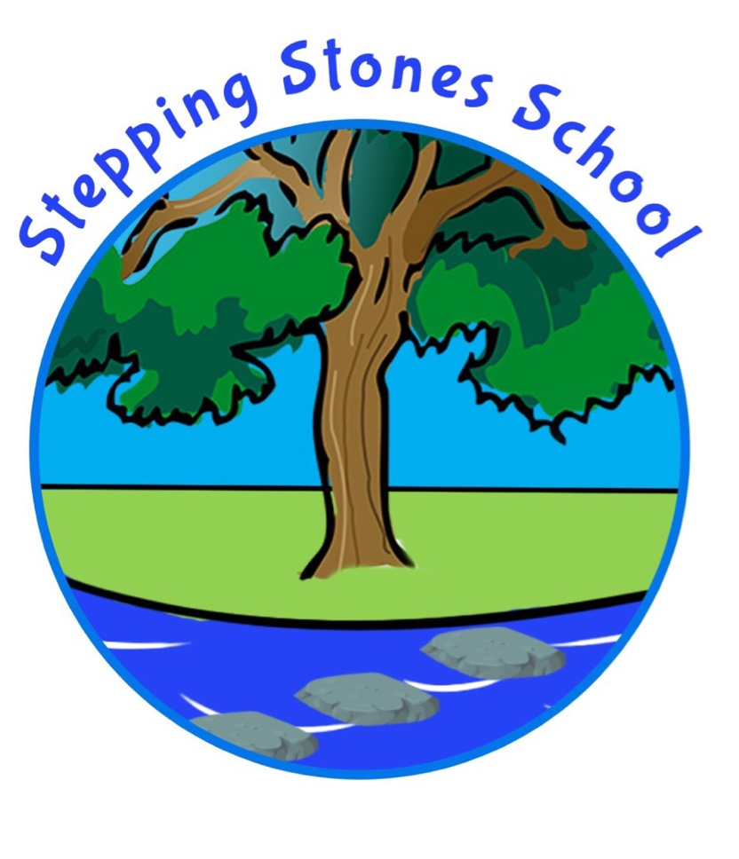
Tel: 01524 67164
Email: bursar@steppingstones.lancs.sch.uk
Date: 30 July 2026

Dear Applicant

On behalf of Stepping Stones Short Stay School, We would like to thank you for your interest in the role of Head Teacher.

Stepping Stones is a primary pupil referral unit. The school is based in Lancaster although covers the areas of Lancaster, Morecambe, Carnforth, Wyre and Fylde. The school provides educational placement for up to 32 primary pupils aged between 5-11 who have been permanently excluded or at great risk of permanent exclusion.

The school is proud of its work and was graded as an Outstanding school by Ofsted (March 2015 and March 2019). We are especially proud of our Positive Mental Health strategy and Values Based curriculum.
Children educated at Stepping Stones are respectful, kind, tolerant, committed and confident. They are taught the importance to both trust and to be trustworthy within their school community. The School works in close partnership with parents/ carers and the communities in which it serves to prevent pupils from exclusion and to promote inclusion.
The Management Committee at Stepping Stones are wishing to appoint a Head Teacher with strategic vision, enthusiasm and determination to continue moving the school forward on its journey of excellence.
Visits to school by appointment are welcome and we look forward to hearing from you.

Stepping Stones School Management Committee

