

Headteacher
Recruitment 2025
Welcome Pack
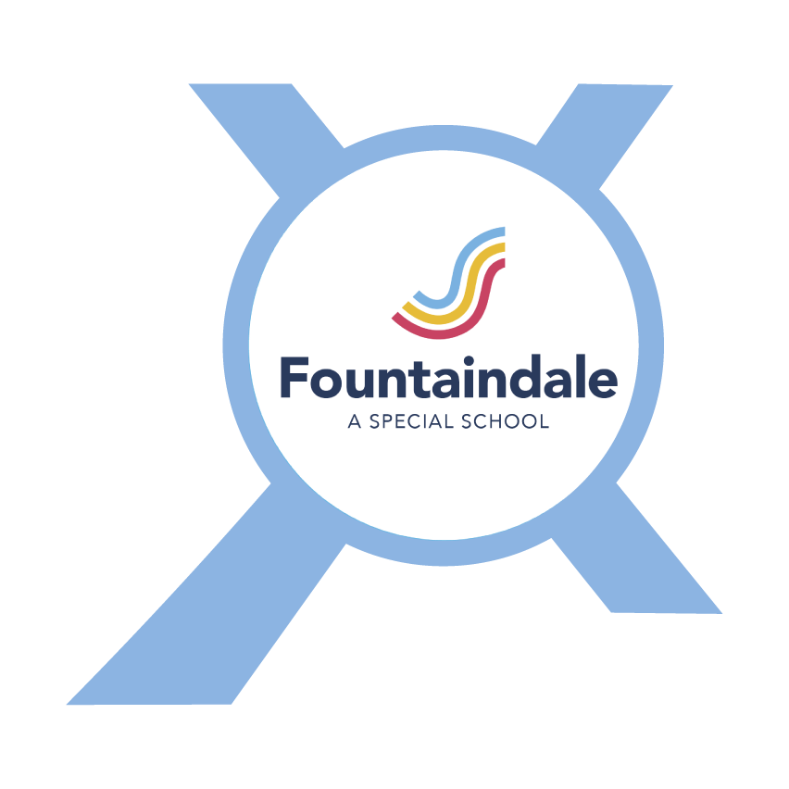


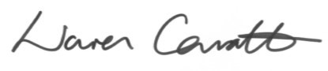
Thank you for taking an interest in our Headship...

We are proud to have Fountaindale School as part of Nexus Multi Academy Trust. Serving the needs of 97 children and young people aged 3 - 18, Fountaindale can be described as a truly family focused school.
The school has recently been judged as good in all areas by Ofsted, and we are very proud that there is an incredibly strong relationship with our pupils and our families, where children feel safe and loved at school.
Our most recent Ofsted report from June 2025 shows how well positioned the school is to continue moving forward, and we are now seeking an inspirational leader to become the new Headteacher of our wonderful school and lead Fountaindale through the next phase of its development.
Supported by an ethical MAT that has financial resilience and innovative approaches to developing its schools, the new Headteacher of Fountaindale School will report to an experienced Executive Regional Director and be supported and held to account by an experienced Academy Council, on behalf of the Trust Board of Directors.
We hope you find this recruitment pack and associated documents helpful and we look forward to receiving your application.

Warren Carratt
Chief Executive Officer Nexus MAT

Our story
Fountaindale School meets the needs of 97 pupils, with the majority placed by Nottinghamshire County Council and a small number of pupils placed by other bordering councils.
Around 40% of our pupil population are eligible for Pupil Premium funding. Our attendance rates have been steadily rising over recent years and although we have a number of children and young people with medical conditions, our attendance is now regularly above the average for special provision.
We employ 80 staff, which equates to 65 FTE
employees. The majority of these are teaching assistants and personal care assistants who play a key role in enabling pupil learning and meeting the personal care needs of our children.
We have two experienced Deputy Headteachers, an Assistant Headteacher and School Resource Manager.
At Fountaindale School we want everyone to: “Be the best we can be”
We do this by:



Vision
° Putting the needs of our students first;
° Working in partnership with families and professionals;
° Creating opportunities to achieve and enjoy;
° Having a personalised curriculum;
° Developing our skilled and experienced staff;
° Treating all with care, respect and dignity;
° Being open, clear and honest;
° Developing practical life and social skills for a better future.


Our community


Based in Mansfield, Nottinghamshire, Fountaindale sits in the middle of Harlow Wood with excellent transport links, being close to the M1, whilst also being only a few miles from Nottingham and Bassetlaw.
We work closely with the other academies in our MAT, and with the other special schools in the borough. We also have excellent relationships with our post-18 partners and Portland College is just across the road.

Sacha Schofield Chair of Academy Council

Our curriculum
At Fountaindale we have developed a series of curriculum pathways. This ensures that all learners follow a rich, relevant and rewarding curriculum at an appropriate level.
We are currently reviewing our assessment systems in school in order to ensure that more emphasis is placed on meeting EHCP targets for individual learners.
We have five curriculum pathways:
- EYFS for our youngest learners
- Pre formal/sensory for learners who are not ready for subject specific learning
- Semi formal for learners who are beginning to participate in some subject specific learning
- Formal for learners who are following subject specific learning
- Post 16 to prepare learners for life after Fountaindale, preparing for adulthood
*For detailed information on our curriculum please see the school website




Working with Nexus MAT
The Headteacher of Fountaindale School will be an employee of Nexus MAT and line managed by the one of the Trust's Executive Regional Directors. The Board of Directors commission the CEO to ensure there are robust local governance arrangements in place, and Fountaindale School has an Academy Council which is accountable to the Board of Directors via the CEO. The school has an annual budget of around £4m.
Operating across South Yorkshire and Nottinghamshire, Nexus MAT is an award winning, growing Trust that has a strong track record of working in collaboration with schools to affect improvement. The Trust is commissioned by the Department for Education to support schools across the country, and we can only fulfil these obligations by working with our schools to share the amazing work we do there.
The Trust has a Collaborative School Improvement Framework which outlines the pivotal role Headteachers play in determining school improvement priorities and turning those priorities into actions, in partnership with the Trust’s quality assurance team.
The Trust does not operate a policy of workforce allocation/reallocation, with individuals moving only where this is something they and the school support: in that regard, we place a high value on opportunity creation and, where the Trust can help to enable and facilitate this, we do.
The Trust adheres to the Burgundy Book for school teacher pay and conditions, and we also adhere to the Green Book for our non-teaching staff.
We have high retention rates across our schools, and our website includes a plethora of information to help inform why we are a successful employer of choice. We choose to publish a Workforce Engagement Statement, which summarises what we have done and are doing to support our most valuable asset.
All of our schools look and feel different: we don’t have a corporate brand that we expect our schools to comply with. It’s deeper than that. Rather, we have shared values that unite all our schools, and those schools are given the freedom and nurture to manifest their offer in diverse ways, rooted in the communities and families we serve and led by their Headteacher.

