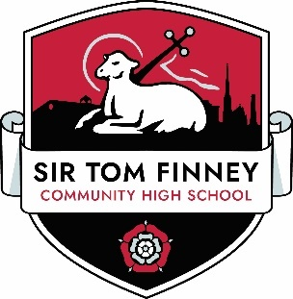

**Chair of Governors Applicant welcome**

December 2024

Dear Applicant,

Thank you for your interest in the position of Headteacher at Sir Tom Finney Community High School. This exciting opportunity has arisen due to the retirement of our current long standing Headteacher.

Sir Tom Finney Community High School is a Lancashire’s largest secondary and post 16 maintained special school for students presenting with a wide and varied range of learning difficulties and complex needs. It is well respected and judged as remaining a ‘Good’ school – OFSTED March 2023.

The school has grown year on year from its opening in 2008 and has seen substantial investment and development leading to the current excellent purposely designed provision, facilities and resources.

We are now looking for a highly motivated, impactful and visionary leader, who will continue to build on our high standards, achievements and forward thinking approach; demonstrating high ambition and aspirations for all our learners irrespective of the complexity of their needs.

In return we offer you a dedicated, experienced and skilled team; young people, who enjoy learning; supportive governors and a welcoming community.

Please visit our school website at www.stfch.lancs.sch. uk for further information.

Informal, pre-application visits will take place on Thursday 9th January only at either 9.30am-11.30am or 1pm -3pm and can be arranged by telephoning the school office on 01772 795749.

I look forward to receiving your application

Yours faithfully,

Garry Harper

Chair of Governors

Sir Tom Finney Community High School