Godwin Primary School
Headteacher Recruitment Pack

Godwin Primary School
Finnymore Road, Dagenham
Essex, RM9 6JH
Telephone: 0208 270 3150

Email: office@godwin.bardaglea.org.uk

Website: Godwin Primary School - Welcome to Godwin Primary School!

Sept 2025
  - Welcome to our school
An introduction to Godwin Primary School
Letter from Chair of Governors | 3
About our School
School Information | 4
Our Values | 5
Our Strategic Vision and Direction for the School | 6
Headteacher Job Description
Core purpose | 7
Shaping the future | 8
Leading learning and teaching | 9
Developing self and working with others | 10
Managing the organisation | 11
Securing accountability | 12
Strengthening the community | 13
Headteacher Person Specification | 14-15

INTRODUCTION
Letter from the Chair of Governors

Dear Applicant

Thank you for your interest in the position of headteacher at Godwin Primary School. This opportunity has arisen due to the retirement of our previous headteacher.

The Governing Board are looking for an inspirational leader for the school to ensure it continues to provide a healthy and happy environment in which children can thrive.

We are a school that welcomes new ideas and philosophies, and we are proud that our colleagues are flexible and adaptable and relish the challenge that change brings. We foster an environment where everyone can get involved and make a difference and, as a team, we are continually striving for school improvement.

We need a leader who can navigate the changing baseline of children coming into our school from the local area. An increasing number of our intake have Special Educational Needs and Disabilities, and this presents its own challenges in supporting and getting the best outcomes across such a diverse pupil base.

You are welcome to visit the school to meet our children and the staff. You would be hosted by a member of the governing board, and any such visit is, of course, not part of the selection process. Details of how to arrange a visit and more information about our school are contained in the job advert, together with details of how to apply for the role of Headteacher. You will also find a wealth of information on the school’s website at Godwin Primary School - Welcome to Godwin Primary School!.

We hope you find the information contained in this pack useful and that it will help you to decide whether you might be the right person to lead our school.

On behalf of the Governing Board, thank you again for your interest in Godwin Primary School.
Yours sincerely,

Adela Kay
Chair of Governors

ABOUT OUR SCHOOL
School Information
Godwin Primary is a thriving two-form entry school serving children from Nursery to Year 6, including our specialised NARP provision. We’re located in Dagenham with excellent transport links to London and Essex, we're proud to be at the heart of our diverse, vibrant community.
We are an ambitious, successful and inclusive community school, seeking to appoint a dynamic and inspirational Headteacher, who will maintain high standards and strive for improvement. We believe in a rich and diverse curriculum that offers our children enjoyment and excellence. In the summer term 2025 we had a visit from Ofsted and we have maintained our status as ‘Good’ school.
We believe every child deserves an exceptional education that prepares them for success in our modern world. Staff work hard together to ensure they deliver a broad and balanced curriculum in each year group, that stimulates the children and broadens their understanding of the world and their place in it.

Our school is a multi-cultural school that reflects the local community. Like many Inner London schools, a significant number of our children speak English as an Additional Language and we work hard to ensure this in no way holds them back. We welcome and celebrate all forms of diversity, including children with disabilities and Special Educational Needs and Disabilities.

At our school every child matters. We have very high expectations of the children, and they strive to meet them. Our energies are focused on their development as critical thinkers as well as academic achievers. They respect each other, staff and visitors and they are proud of their school.

Our Values
Our values are at the heart of everything we do:

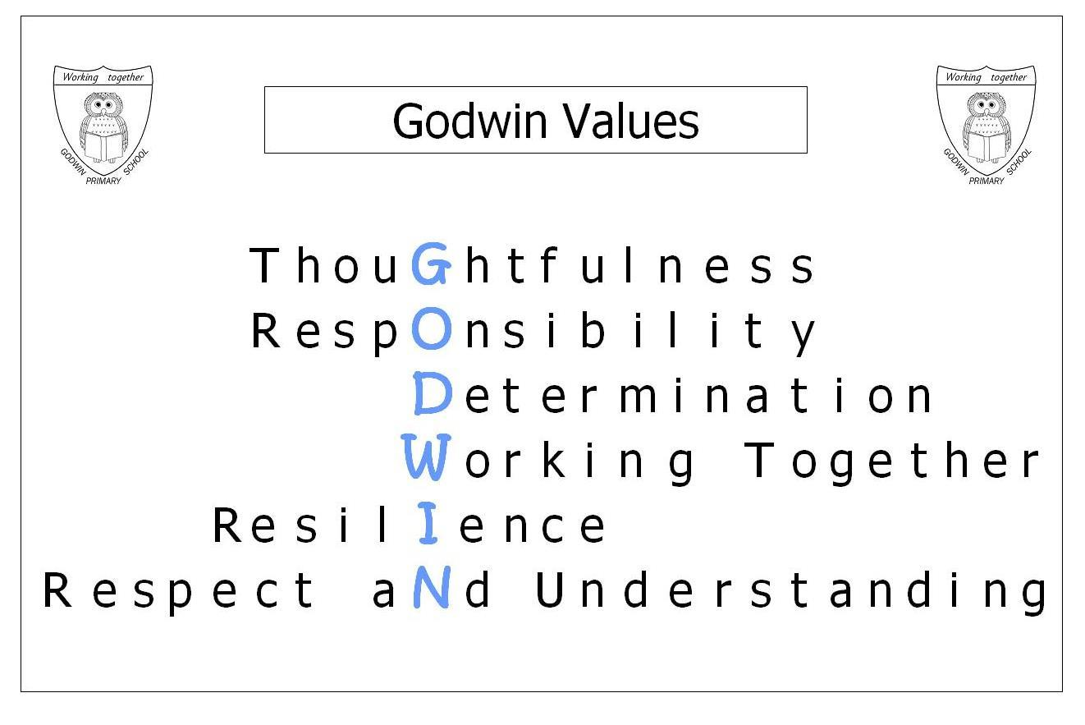

Our strategic vision and direction for the school
At Godwin we believe:

Ethos, Culture and Values:
- in putting our children at the heart of everything we do;
- in the importance of our school values and of British values;
- that children should be rewarded for having integrity and doing the ‘right’ thing;
- in leading by example, modelling reflective learning behaviours through our own professional development;
- in continuously reflecting, evaluating and adapting our practice so that it is the best for the children we have at the moment;
- that for change to have a meaningful impact it needs to be research-led and strategically planned and evaluated;
- and, that a smile, listening ear and calm approach can lead to the positive resolution of most conflicts and issues.

Teaching and learning:
- that children are entitled to a broad curriculum, giving them a wide range of opportunities and experiences;
- that all our children deserve high-quality teaching and, by working collaboratively, we ensure consistency and equality;
- that reading is a key to success now and in the future;
- in expanding our children’s vocabulary in each and every lesson;
- and, in preparing children for the next stage of learning and their future.

Inclusion:
- that all children can achieve, whatever their background;
- that every child deserves a champion and needs nurturing;
- that poor behaviour choices indicate a child in need, while each new day represents a fresh start;
- in ‘keep up’ not ‘catch up’ to minimise gaps from opening or growing;
- and, in celebrating our differences, ensuring that all children see themselves represented in the curriculum and resources we use.

Community
- that staff and children’s wellbeing and positive mental health should be central to decisions, change and future plans;
- in being mindful of the wellbeing and welfare of our pupils, staff and families;
- and, that building and maintaining positive relationships with children and their families is fundamental to each child achieving their best.
- of most conflicts and issues.

Job Description

Job Title: Headteacher

Responsible to: The Governing Body of the School
Responsible for: The Headteacher carries out duties in line with the conditions of employment as set out in the current School Teacher’s Pay and Conditions document, the National Standards for Headteachers and the policies and procedures of the Governing Body.
This job description will be subject to annual review as part of the performance management cycle.

Core Purpose
The Headteacher’s core purpose is to provide professional leadership and management for the school. This will promote a secure foundation from which to achieve high standards in all areas of the school’s work. To gain success, a Headteacher will be able to:

• Manage learning and teaching effectively

• Promote excellence, equality and high expectation for all pupils

• Provide vision, leadership and direction

• Evaluate school performance and identify priorities for continuous improvement

• Deploy resources to achieve the school’s aims

• Carry out day-to-day management, organisation and administration

• Secure the commitment of the wider community

• Create a safe and productive learning environment which is engaging and fulfilling for all pupils

• Work effectively with the school’s Governing Body
In accordance with National Standards, the successful candidate will be expected to provide leadership in the following core areas:

Job Description continued

Shaping the Future

The Headteacher will work with the Governing Body and others to create a shared vision and strategic plan for the school. This plan should inspire and motivate pupils, staff and all other members of the school community and develop the ethos of the school linked to its core aims and values.

Some typical activities might include:

• Developing a clear vision and ethos for the school

• Formulating the aims and objectives of the school

• Developing policies and strategies for implementing the aims and objectives

• Formulating the School Development Plan

• Encouraging others within the school community to share in developing and delivering the vision for the school

• Advising the Governors on developments in educational thinking and local and national initiatives that might benefit the school

Job Description continued

Leading Learning and Teaching

The Headteacher will be responsible for raising the quality of teaching and learning and for ensuring pupil achievement within the school. Working with the Governing Body, the Headteacher will develop staff with the necessary skills and knowledge to promote equality, respect diversity and challenge stereotypes in order to promote the rights of children and young people.

Some typical activities might include:

• Demonstrating personal enthusiasm for and commitment to the learning process

• Determining, organising and implementing an appropriate curriculum for the school

• Identifying the needs, experience, interests, aptitudes and stage of development of the pupils through listening and responding to children and those caring for them

• Utilising the resources available to the school in order to best meet the needs of the pupils

• Developing an ethos that supports an inclusive approach for all members of the school community

• Ensuring that all members of the school community promote excellence, equality and high expectations for all pupils

• Ensuring that the school has an effective behaviour policy which promotes pupils’ self-discipline, proper regard for authority and encourages good behaviour

• Initiating and supporting research and debate about effective learning and teaching and develop relevant strategies for performance improvement

• Acknowledging excellence and challenging poor performance across the school

Job Description continued

Developing Self and Working with Others

The Headteacher is responsible for developing effective relationships and communication, which underpin a professional learning community that enables everyone in the school to achieve. This will involve building a successful organisation through effective collaboration with others.

Some typical activities might include:

• Advising and assisting the Governing Body in carrying out their duties

• Acting as a key professional adviser to the Governing Body

• Reporting to the Governing Body on performance management and the professional development of all staff

• Fostering an open, fair, equitable culture and managing conflict

• Developing, empowering and sustaining individuals and teams

• Collaborating and networking with others within and beyond the school

• Challenging, influencing and motivating others to fulfil their potential

• Giving and receiving effective feedback and acting to improve own Performance

• Accepting support from others including colleagues, governors and the Local Authority

• Maintaining effective working relationships with the school community and staff representatives

• Ensuring there are appropriate continuing professional development opportunities for all staff that feed into both personal development and school improvement

Job Description continued

Managing the Organisation

The Headteacher is responsible for providing effective organisation and management of the school, seeking ways to improve outcomes and performance based on rigorous self-evaluation. This includes ensuring a safe learning environment, which sets the safety of children, young people and the whole school community at the heart of its working practices.

Some typical activities might include:

• Leading the school in raising standards and school improvement

• Creating a positive culture in which everyone is valued and respected

• Establishing and sustaining appropriate structures and systems

• Preparing plans and policies for consideration by the Governing Body

• Delegating management tasks and monitoring their implementation

• Prioritising, planning and organising themselves and others

• Ensuring the collection of a detailed and accurate set of data to review and understand the strengths and weaknesses of the school

• Ensuring that the outcomes of performance review feeds into the School’s Development Plan (SDP)

• Making professional decisions based on informed judgements

• Thinking creatively to anticipate and solve problems

• Ensuring that child safeguarding practices are fully embedded

• Maintaining good order and discipline among the pupils and safeguarding their health, safety and well-being.

• Ensuring effective people management practices are in place and fully utilised

• Ensuring effective financial management, monitoring, planning and reporting is in place

Job Description continued

Securing Accountability

The Headteacher is legally accountable to the Governing Body for the School, its environment and all its work. The Headteacher must also fulfil wider accountabilities in relation to pupils, parents, carers, the Local Authority and other relevant groups.
Some typical activities might include:

• Demonstrating through action and behaviour the ethos of the school and encouraging others to act as positive role models

• Ensuring that the whole school community is engaged in systematic, rigorous self-evaluation of the work of the school

• Providing relevant information to the Governing Body to support governors in carrying out their statutory duties

• Working closely with the Governing Body, and others to ensure that effective school self-evaluation informs school improvement priorities

• Combine the outcomes of regular school self-review with external evaluations in order to develop the school

• Communicating with children, parents and carers on their general progress and well-being

• Consulting children, parents, carers and other members of the wider community on the future direction of the school

• Ensuring the school is well prepared and able to respond positively to external inspection and review e.g. by Ofsted and the local authority

• Developing the pupil voice e.g. through the School Council

Job Description continued

Strengthening the community through collaboration and partnership

The Headteacher will engage with the internal and external school community to secure equity and entitlement. This includes collaborating with other schools, parents and carers, and other organisations to improve the life chances of all children and young people. This will include developing extended services to meet the needs of the community.

Some typical activities might include:

• Recognising and championing opportunities for developing a rich and diverse school community, which respects the rights, responsibilities and dignity of all

• Engaging in a dialogue which builds partnerships and community consensus on values, beliefs and shared responsibilities

• Listening to, reflecting and acting on community feedback

• Building and maintaining effective relationships with parents, carers, partners and the community to enhance the education of all pupils

• Looking for opportunities to foster collaboration with other schools and organisations for the benefit of enhancing teaching and learning

• As a community leader, contributing to building a strong, cohesive and sustainable community.

The Governing Body and London Borough of Barking and Dagenham Local Authority are committed to safeguarding and promoting the welfare of children and young persons and Headteachers must ensure that the highest priority is given to following guidance and regulations to safeguard children and young people. The successful candidate will be required to undergo an Enhanced Disclosure from the Disclosure and Barring Service (DBS).

Godwin Primary Person Specification

Post: Headteacher
 |  | Essential | Desirable
Qualifications & training
Qualified teacher status and substantial teaching experience
Degree-level education
National professional qualification for headship (NPQH)
A good record of on-going professional development and training relevant to leadership in education and to the Headteacher role
Strategic direction & school development
Ability to develop and implement a clear, ambitious vision for the school’s future
Skilled in managing change and fostering a positive school culture
Experience of contributing to policy and decision making at whole-school level
Proven ability to analyse school performance data and use insights to inform decision-making
Solution-focused with the ability to demonstrate innovation, adaptability and resilience in responding to educational challenges
Committed to high standards of teaching, learning and behaviour
Leading teaching & learning
Strong understanding of pedagogy, curriculum development, and effective assessment strategies across all three key stages in the primary phase
Commitment to ensuring high-quality teaching in an inclusive learning environment that meets the needs of all learners.
Ability to promote a culture of continuous improvement in pupil progress, attainment, and personal development
Leadership & management of staff
Experience in building and leading an effective team, motivating, challenging and inspiring others to achieve excellence
Ability to support professional development, coaching, and mentoring for all staff
Strong leadership in managing performance, ensuring accountability, and driving improvement
Commitment to promoting wellbeing and positive working relationships among staff
Securing accountability
Ability to ensure rigorous self-evaluation and continuous improvement
Skilled in monitoring school effectiveness and ensuring high standards of teaching and learning
Experience in working with governors, parents, and external agencies to achieve accountability
An understanding of strategic financial planning and budgetary control
Strengthening community
Puts children at the centre of all decisions and actions
Ability to promote strong positive relationships within and beyond the school, promoting diversity, inclusion, and equal opportunities
Experience of working effectively with parents, including the more challenging ones
Ability to be outward-facing, working and collaborating closely with others who might enhance students’ learning, wellbeing and opportunities
Personal qualities
Excellent interpersonal skills with the ability to enthuse and motivate others and develop effective partnerships
Good organisation and time-management skills (meets deadlines)
Approachable to parents, pupils and staff and able to promote positive partnerships
Reflective practitioner, committed to own professional development
Love of working with children and strives to improve their life chances, believing that all children can achieve
Flexibility and adaptability – able to problem-solve – with a sense of humour
Calm, optimistic and positive – able to be the ‘swan on water’
Willingness to contribute to the wider life of the school, including extra-curricular provision
Aware of how to support and maintain the wellbeing of children, staff and self
A children’s champion
Love of reading
Interests beyond school
Commitment to continuous professional and personal development.
Safeguarding
Be committed to safeguarding and promoting the welfare of children.

Equal Rights
Our school is an equal rights employer. We require our governors and employees to follow our equality policies and to follow all statutory requirements concerning age, race, religious, sex, sexual orientation and disability discrimination. We respect and protect the rights of people with disabilities both in terms of equal opportunity for employment and access to the school's services.

Disabled Applicants
Disabled applicants are guaranteed an interview if they meet the essential requirements of the Personnel Specification. As an equal rights employer our school is committed to make any necessary reasonable adjustments to the selection process, the job role and the working environment that would enable access to employment opportunities for disabled people. Where a disabled applicant is being assessed the selection panel's decisions will be based on an assessment of that person's expected capabilities once reasonable adjustments have been made.

