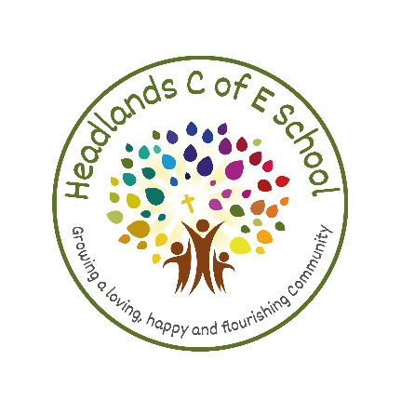Headlands CE (C) Junior, Infant & Nursery School
Liversedge, West Yorkshire

POSITION: Headteacher

HOURS: Full Time and Permanent Position

SALARY: L18 to L24 depending on experience

START DATE: 1 January 2024 (if candidates are available for and interested in a start date of 1st September 2023, please do advise us of this in your application letter)

APPLICATION CLOSING DATE: Friday 16 June 2023 (12:00pm)

(* candidates who are available and interested in

Are you an experienced Headteacher or Deputy Headteacher looking for a new challenge in a happy, inclusive and successful school?

Do you share our passion for helping every child to achieve their potential in a fun, nurturing and innovative environment?

Does our school vision of “Growing a loving, happy and flourishing community” resonate with you?

We are looking for someone who:
- Will build on the many existing strengths of the school and seize the opportunity to make us even better.
- Has excellent inter-personal skills and a natural talent for engaging with and developing open, warm and empathetic relationships with staff, parents and children.
- Will provide clear but also supportive leadership for all our staff, inspiring them, helping them to develop their skills and empowering them to try new ideas.
- Is a forward-thinking leader who is creative and willing to innovate to explore new opportunities for helping our children to achieve their potential, through for example: the development of our curriculum; increasing the use of technology in school; and further developing our forest school/outdoor learning provision.
- Will continue the school’s dedication to good teaching and learning and encourage a warm, calm environment with high expectations of behaviour and positive relationships.
- Is excited at the opportunity to develop relationships outside our school with the Parish Church and Diocese, the Local Authority and the wider community.
- Recognises the fundamental importance of having a strong Christian vision and values to ensure Headlands is a successful and supportive School.

We can offer:
- A welcoming environment with a large and diverse cohort set in the heart of its local community.
- The support of a dedicated and experienced team of staff and committed Governors who want to support the school on its journey to excellence
- An opportunity for you to bring your own ideas and creativity to the school.
- Children whose kind and courteous behaviour contributes to a calm, pleasant atmosphere.
- A school with ‘Good’ Ofsted and SIAMS ratings and a deep commitment to quality learning and teaching.

If you are excited about this opportunity to become our next Headteacher and would bring positivity, energy and fresh ideas to our school we would love to hear from you.

We encourage you to visit our school before applying and are offering the opportunity to come and look around between 5 and 16 June. Please call Mrs Ashleigh Dunn (Headteacher) or Mrs Steph Walker (School Business Manager) on 01924 767066 to arrange a time. To find out more about our school beforehand do visit our website: https://www.headlandscofeschool.co.uk/

Closing Date: Friday 16 June 2023 (12:00pm)

Assessments and Interview Dates: Wednesday 28th and Thursday 29th June 2023

We are committed to safeguarding and promoting the welfare of children and young people and expect all staff and volunteers to share this commitment. All staff are subject to an enhanced DBS check. A conviction may not exclude candidates from appointment but will be considered as part of the recruitment process.

