**Headteacher Pack**

December 2021

**Heene Church of England (Aided) Primary School**

***‘Learning together, loving others, guided by God’***



**Table of Contents**

Welcome to Heene 3

About Heene………………………………………………….... 4

What We Need From You 5

Headteacher’s Person Specification 6

Headteacher’s Job Description 7

How to Apply 8

Heene CE (Aided) Primary School is committed to safeguarding and promoting the welfare of children and expects all staff to share in this commitment.

We welcome applications from all sections of the community, regardless of gender, race, religion, disability, sexual orientation or age.

**Heene CE (Aided) Primary School**

Norfolk Street

Worthing

West Sussex

BN11 4BB

01903 201386

[**www.heeneprimary.co.uk/web**](http://www.heeneprimary.co.uk/web)**site**



**Welcome to Heene**

Thank you for your interest in the Headship of our school. Heene is a lively and caring community with a strong Christian ethos. We are looking to appoint an experienced and inspirational leader to become Headteacher from September 2022 to continue the school improvement journey we are currently on.

In 2018, Ofsted judged the school to Require Improvement overall, having been judged Outstanding in 2006. Following the departure of the previous Headteacher at the end of the summer term 2020, the school is being led by two experienced Interim Co-Headteachers who, with the Senior Leadership Team, are leading a period of rapid improvement. Heene has hard working, committed staff and dedicated Governors who are responding well to this, particularly in the light of the challenges of the last two years.

In 2017, the school completed the transition from a first school to a two form entry primary school with an annual intake of 60 children. Most of our children live within easy walking distance of the school and we serve an area of considerable diversity where Heene continues to be a popular choice.

There is a close relationship to both St Botolph’s Church, in the neighbouring Parish of Heene (where the school was originally established back in the 19th century) and the nearby St Matthew’s Church in whose Parish the school sits. The incumbents of both churches play an active part within the school and foundation governors are drawn from both churches. The environment is acknowledged to be very caring and behaviour in school is good and the life of the school is shaped and formed by our Christian ethos. The school plays an active part in the wider community, in addition to having links with local schools.

We very much look forward to meeting you and talking to you about the huge potential the school undoubtedly has. Heene has been through an unsettled period of time and we are looking for a leader who has the vision to lead us forward with confidence and clarity. The Governing Body is mindful of securing the best possible future for the school and this includes a very exploratory conversation with the CEO of the Diocese of Chichester Academy Trust.

We recognise that being a Headteacher today is a challenging and demanding role and we take the well-being of our Headteacher, Senior Leadership Team and whole staff community very seriously.

If you would value an informal conversation about this post before you proceed further, please contact the school office who will put you in contact with our Co-Headteachers, Mrs Julia Sherlock and Miss Joy Waelend.



Mrs Freda Wimble Mr Chris Skilton

Co-Chair of Governors Co-Chair of Governors



**About Heene**



**Children’s ages: 4 - 11 | Current school roll: 384**

Heene is a friendly, caring and welcoming Church of England School, based in the coastal town of Worthing in West Sussex. <https://discoverworthing.uk/> Worthing offers the sea, the South Downs and easy access to Brighton and London. Most people agree it is a delightful place to live and grow up and work and be part of a local community.

The current school grew from purely infant provision to a two form entry primary school in 2017. At the heart of the school is our strong Christian ethos in which we strive to enable each child to individually thrive, and flourish, to grow in recognising their worth as a child of God and develop their potential to the full  
so they have every opportunity available to them moving forward.

In 2018, the school was judged to Require Improvement and we are anticipating a re-inspection by Ofsted before too long. As a result of this 2018 judgement and following the departure of the substantive Headteacher in September 2020, it was led by an Interim Headteacher for much of 2020-21. For 2021-22 it is being led by two experienced Interim Co-Headteachers, Mrs Julia Sherlock and Miss Joy Waelend.

Our current Co-Headteachers each describe Heene as a lovely school with great potential. The school has many strengths; it is a distinctive Christian community supported by two local churches; the delightful pupils embrace their Heene way of learning; there is good mix of SEND, EAL and PP children well supported by our new inclusion team; the staff are seeking to embed the new curriculum, which has allowed several teachers to begin to discover middle leadership talents. Staff have worked under three leadership models over the past two years and have put in place a range of good practice to seek to raise standards.

The school is on a rapid journey of improvement and we are keen to ensure that this momentum is continued. We now seek someone to draw all the strands together and provide the school with vision, stability and direction, to ensure that these developments are consistently embedded across the school.



**What We Need From You**

We are looking to appoint a confident, inspirational, experienced leader for our Christian school community. Our new Headteacher will have proven and demonstrable experience of taking a school on a journey from a point of fragility to a point of strength; someone who can recognise exactly what our school needs, quickly get to know the team, and continue the journey.

We want to appoint a candidate who has discovered more about Heene and sees the genuine potential this school has to be so much more than it is; one who is able to show us the ambition and the vision to enable an outstanding quality of education to be offered to the children.

The new Headteacher of Heene will be an authentic leader, rooted in integrity. They will be a leader who is confident in their own ideas but with the humility to be able to ask questions and collaborate. Their ability to communicate positively and effectively means they know how to address two hundred parents and how to speak to someone one-to-one. We want someone who listens, sees the potential of our school and the momentum already in place and demonstrates a coherent vision for how this school could massively impact a community of 400 children; they will be a genuine inspiration to all.

The new Headteacher must be able to understand the school’s recent journey, to know that the 2018 Ofsted report accurately reflects where Heene has come from and where it has to get to. They will then continue the post Ofsted journey, providing the new Headteacher with an opportunity to hit the ground running, with energy, purpose, inspiration and humility.

We want a Headteacher that will make the voice of every child at Heene heard. We want someone who is positive about the vital partnership with parents and who listens to them.

We want a Headteacher who will be a clear presence around the whole school, with a practice of being in and out of the teaching environment. This is not a job that can be carried out from the Headteacher’s office alone.

As the new Headteacher of Heene you will need to be motivated and decisive, energetic and focussed. You need to have a vision and a clear moral and spiritual purpose for wanting to be the Headteacher of Heene. You will know how to challenge people and nurture them. You are confident, approachable and personable, committed to accepting help and support where necessary. You have proven organisational and management skills, you are self-aware, emotionally strong and outward looking across the whole school and wider community. You know how to look after your staff, and you have superb diplomatic and interpersonal skills. The wellbeing of children and staff is second nature to you, and your grasp of safeguarding culture is profound. You want to develop the Christian character of Heene and immerse yourself in our local Church community.

If this is you, then please come and visit us to see if being the next Headteacher of Heene CE (Aided) Primary School might just be for you! We look forward to meeting you.



**Headteacher’s Person Specification**

Candidates need to have the vision and leadership qualities to transform the lives of children at Heene and to bring the staff along on the challenging journey to making the school outstanding. In your personal statement of no more than 1,500 words, **please clearly outline your vision for our school and how you would plan to deliver this,** as well asaddressing the individual aspects of the Headteacher role at Heene.

|  |
| --- |
| EXPERIENCE |
| Detail your proven track record in moving a school from a position of fragility to strength, especially how you have identified and implemented change impacting the whole school. |

|  |
| --- |
| SHAPING THE FUTURE |
| Communicate to us your clear vision for how Heene might fulfil its true potential as a place of high quality teaching and learning whilst living out what it means to be a church school with a strong Christian tradition. The Headteacher would be fully supportive of moving the Christian ethos forward and will be responsible for leading all aspects of the SIAMS process. Show us evidence of where you have done this or something relevant to this in the past. |

|  |
| --- |
| LEADING TEACHING AND LEARNING |
| Show evidence of how you have led school wide improvement which has had a positive impact on the teaching and learning and life outcomes for all pupils, including how your own time teaching in the classroom has been part of this. |

|  |
| --- |
| MANAGING THE ORGANISATION |
| Detail your experience and strong understanding of all the elements that go in to running and maintaining a safe, strategically focused and financially compliant organisation. |

|  |
| --- |
| SECURING ACCOUNTABILITY |
| Evidence a willingness and an ability to be accountable for driving with passion and vision the sustainable success of the school, which all the stakeholders in the school community embrace and which will be partly evidenced from external scrutiny. |

|  |
| --- |
| STRENGTHENING COMMUNITY |
| Communicate to us your ability to get to know the community and demonstrate how the school will be a central part of that wider community. |

|  |
| --- |
| SAFEGUARDING |
| Show evidence of your record in running a school with a profoundly strong and all-pervading safeguarding culture. |

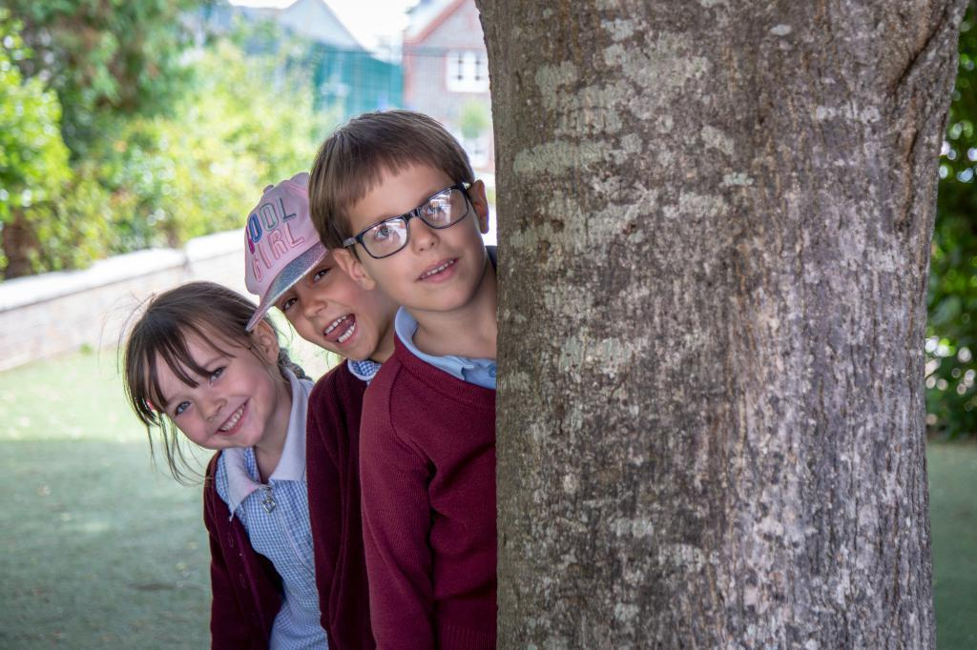

**Job Description**

To carry out the professional duties of a Headteacher as described in part seven of the School Teachers’ Pay and Conditions document.

To be responsible for the leadership, internal organisation, management and control of the school and to consult appropriately in doing so.

To promote and safeguard the welfare of all children and young persons the Headteacher is responsible for or comes into contact with.

**To immediately address the following five priorities at Heene:**

|  |
| --- |
| EYFS |
| To improve the quality of education provided in Early Years to ensure pupil outcomes improve further, building on the work undertaken in recent months. |

|  |
| --- |
| THE QUALITY OF EDUCATION |
| To improve the children’s learning experience, making it memorable for them. To challenge them and build their resilience. To work with the staff to meet the needs of all of our children, of all abilities. To ensure the quality of education as defined by Ofsted continues to rapidly improve and becomes outstanding over time. To ensure that learning is inclusive for all – that all may flourish and thrive. |

|  |
| --- |
| TO RAISE THE EXPECTATIONS OF THE SCHOOL COMMUNITY AS TO WHAT WE ARE ABLE TO ACHIEVE TOGETHER |
| The current expectations of the children across the school are too low. We are lifting them and this will absolutely need to continue following the appointment of a new Headteacher. We need to become far better than current assessment and the last set of data show and everyone needs to believe that. |

|  |
| --- |
| STRENGTHENING OUR LEADERS’ ABILITY TO LEAD |
| To continue to develop a growing team of committed senior and middle leaders at Heene so that in time, the staff team will contain a large number of strong and visionary leaders who are able to secure improved outcomes for all in their areas of responsibility. |

|  |
| --- |
| VISION AND VALUES |
| The new Headteacher at Heene must take the creative lead in discussion and re-evaluation of the school’s core values in the context of the whole school community and building on the Heene Way. They must lead the application of these across every aspect of school life, recognising that Christian faith is the golden thread which runs through everything we do. |



**How to Apply**

|  |  |
| --- | --- |
| Salary | Group 3  L16 – L22  £61,116 - £70,745 |
| Number on Role | 384 |
| Closing Date for Applications | **Midday on 7th January 2022** |
| Shortlisting Date | 13th January 2022 |
| Interview Dates | 27th and 28th January 2022 - to be held in school with social distancing measures in place. You do need to be available on both dates. |
| Start Date | 1st September 2022 |

* Application forms can be found on the West Sussex jobs pages along with this pack or by contacting our Business Manager, Diane Cann at [sbm@heeneprimary.co.uk](mailto:sbm@heeneprimary.co.uk)
* Your application form should be submitted with a personal statement of no more than 1,500 words as outlined on page 6.
* **Please do not send a CV, we will only consider application forms and statements as detailed above.**
* School visits are warmly welcomed. To arrange this please contact the school office on 01903 201386 or email [sbm@heeneprimary.co.uk](mailto:sbm@heeneprimary.co.uk) Individual tours of the school will be available or alternatively a Zoom call can be arranged by request.
* All enquiries will be dealt with confidentially.
* Completed applications should be emailed to [sbm@heeneprimary.co.uk](mailto:sbm@heeneprimary.co.uk) or posted to the school address and marked Confidential for the attention of Diane Cann, Business Manager. Applications must be received by the closing date. You will receive an acknowledgement of your application.

***We expect you to bring to interview a portfolio of evidence of where you have made a difference in your current and previous roles. We want to see evidence of what you have done and the sort of Headteacher you are. Feedback from staff, parents, children, Local Authority, OFSTED - anything that tells us about you and your impact. We do not want a PowerPoint presentation. This is about you. What you have done and what you can bring to our school.***

References will be sought for shortlisted candidates prior to the interview date. This post is subject to enhanced Disclosure and Barring Service (DBS) clearance.