Thank you for your interest in the Holy Ghost Catholic Primary School. We are situated in a quiet corner of Nightingale Square, in the leafy London Borough of Wandsworth. We are a single form entry, Ofsted outstanding Catholic Primary school, where children attain exceptionally high academic standards, and are provided with a well-rounded education of the highest quality.
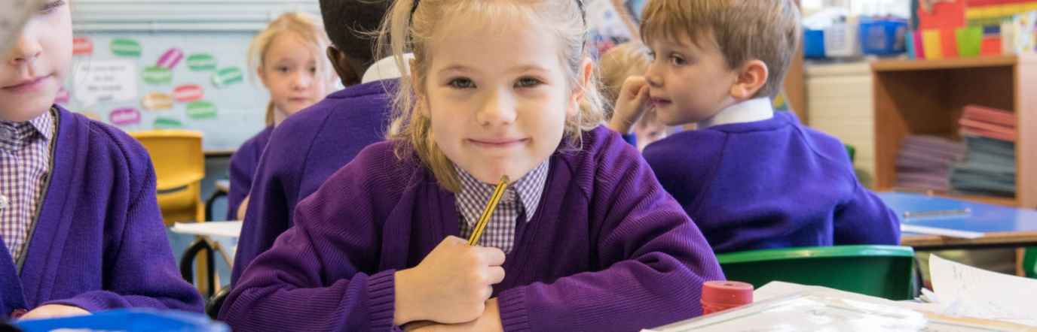
Founded in 1897 with a major refurbishment to the estates in 2001 there has been continuous improvement of school facilities with further developments to provide a new Early Years Learning Centre, a Learning Lab and a “Splat Studio”, named by the children, for practical subjects, such as art, science, and cookery.
The dedication and excellence of the teaching team, teaching assistants, administrative and premises teams, and the sharing of the skills and expertise we enjoy from our close liaison with Governors and parents, enables us to enhance the learning experiences of the children, and improve school facilities.
Our children benefit especially from our very strong faith community. Central to our aim as a Catholic school, is to ensure that we work in a spirit of partnership with our parents, developing our respective roles and responsibilities - to deepen children’s relationship with God, and their respect for each other.
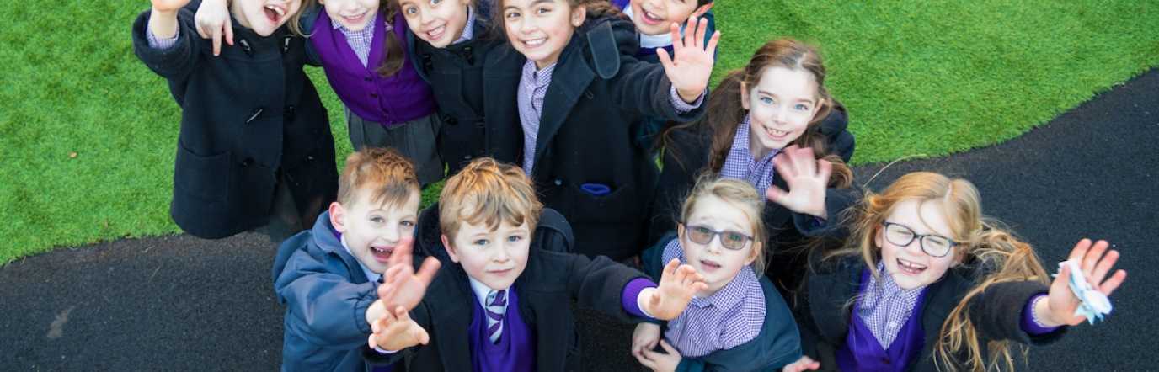
We are a UNICEF “Rights Respecting School” working to uphold the rights of every child in our daily work. This dovetails with our teaching in both Religious Education and Personal, Social, Health Education (PSHE). Based on the values, attitudes, beliefs, and practices of our Catholic faith, we promote the British values through our education for social, moral, spiritual, and cultural development.
The development of our buildings, and outdoor space, has helped us maximise access to a rich curriculum and deepen children’s engagement with art, music, drama, and sport - within and beyond the school day.
The children at Holy Ghost know they are a source of great pride to us; they respond to the high standards set for them. At the heart of our ethos is the desire to stimulate each child as a learner, to fully engage them, developing their natural talents, and allowing them to discover their own great potential.
Our dedicated staff forge warm relationships with children and parents, and we seek to provide a happy, supportive environment where our Catholic mission is lived each day. Through creative teaching approaches, and a broad curriculum, we develop critical thinking across the range of subject areas, challenging children to excellence, whilst at the same time honing positive attitudes and behaviour.
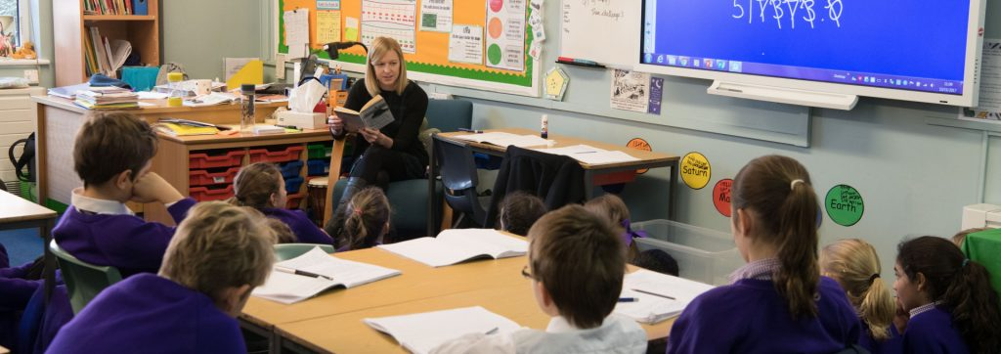
Building on children’s innate capabilities, we ensure full participation in all aspects of learning, irrespective of capability, and this is nowhere more evident than in the school’s provision for sport. Children, when they enter Key Stage 2, represent the school across a range of sports; and participate competitively at borough and national levels.
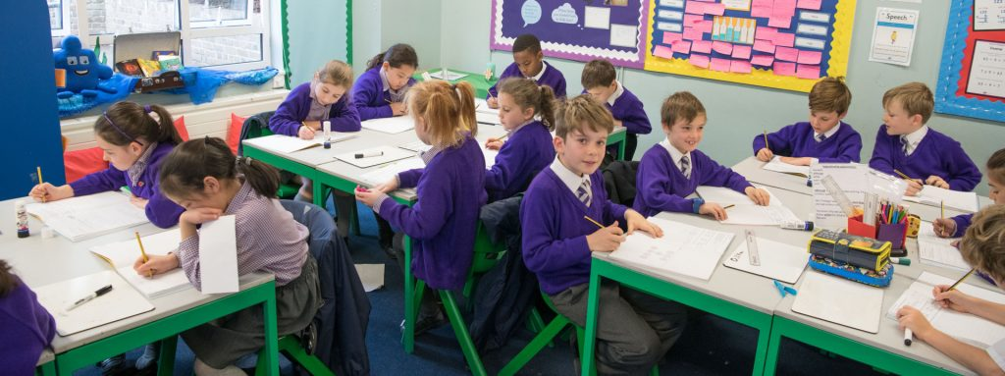
In addition to the core subjects of Religious Education, Literacy, Numeracy and Science we believe that children should learn the joy of life, the exhilaration of music, the excitement of sport and the beauty of art. We pride ourselves on the use of drama; the school’s musical provision; the teaching of Spanish, and the exploration of “Forest Schools”, which is our newest initiative. Our children learn the value of life: what it is to be responsible citizens who give something back to their community.
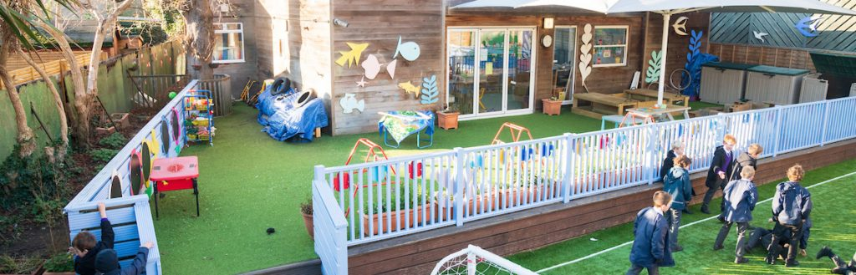
The children are encouraged to have a voice and to steer school improvement, especially those directly relating to playtimes. The re-design of the playground has been the most recent project led by the children.
We invite you to visit our website www.holyghost.wandsworth.sch.uk and join us on our journey.

