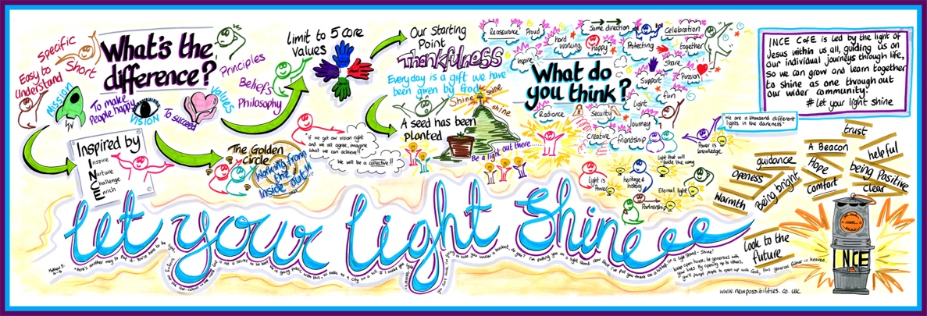

Vision: Ince Church of England Primary and Nursery School is led by the light of Jesus within us all, guiding us on our individual journeys through life, so that we can grow and learn together to shine as one throughout our wider community. #Let your light shine
As a Church of England School, our vision and Christian values are at the heart of everything we do and play a vital part in our pupils’ education.
The intent of The Pastoral Team at Ince Church of England Primary and Nursery School is to keep our children, staff, families and community safe and happy.
At Ince Church of England Primary and Nursery School we are an inclusive school, supporting our children to develop the 7 C’s throughout their time: Confidence, Curiosity, Creativity, Collaboration, Communication, Craftsmanship and Commitment by instilling a sense of belonging and worth.
Our school family includes Children, staff and parents/carers. Every member of our family deserves the same level of commitment in keeping them safe and happy.
We will listen, act and do everything in our power to keep our Children safe.
This will include
Listening without judgment in a safe environment.
Act upon the information shared, speaking to parents/carers or seeking advice from external agencies.
Ensuring compliance with report writing and following our safeguarding procedures.
Follow up to ensure appropriate sharing of information has been completed and advocate on the behalf of our children if we do not think the correct steps have been taken.

Safeguarding our children is our top priority and we ensure their safety in a number of ways which include:
Making sure the school site is safe and secure
Greeting the children on the gates in the morning with a smile and welcoming presence
Maintain accurate registers and following up any non-attenders with phone calls and welfare visits.
Monitor children’s wellbeing (clothing, diet, sleep)
Listen to the pupil’s voice and represent them by attending Early Helps, Core Groups and conferences.
Work closely with internal and external professionals such as Teachers, Designated Teacher for Looked after children, Start Well and Social Workers.

We will listen, act and do everything in our power to keep our families safe.
This will include
Listening without judgment in a safe environment.
Act upon the information shared and seek advice from external agencies.
Ensuring compliance with report writing and following our safeguarding procedures.
Follow up to ensure appropriate sharing of information has been completed and advocate on the behalf of our families if we do not think the correct steps have been taken.
Good working relationships between staff and families to build trust

We will listen, act and do everything in our power to keep our staff safe.
This will include
Listening without judgment in a safe environment.
Act upon the information shared and seek advice from Senior Leadership Team and external agencies.
Ensuring compliance with report writing and following our safeguarding procedures.

Follow up to ensure appropriate sharing of information has been completed and advocate on the behalf of our staff if we do not think the correct steps have been taken.
Build trust and friendship within our team
We will be creative in our approach to problem solving due to current circumstances.
We have an invested interest in our Ince family and will keep up morale through genuine engagement, listening and support.
We will support our school family.
Our children need to believe in themselves, recognise their own self value and we will help and support them in order for them to reach their full potential.

