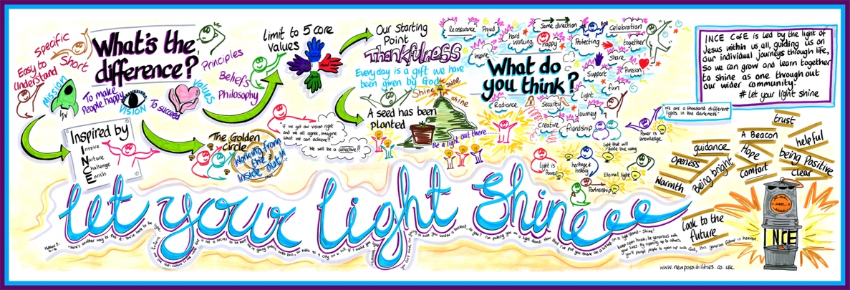

Recruitment Vision and Values: Who do we want?

- Strives to embody Christian values at all times
- Is honest, transparent, and trustworthy
- Loves children and the Ince community and wants to work hard to improve their lives
- Loyal to the school vision ‘Let Your Light Shine’ and the challenges and opportunities it brings
- Conducts themselves with integrity at all times
- Thankful and finds the joy in their work
- Not afraid to have courageous conversations if it based on school vision and values
- See themselves as a learner who is committed to personal and professional development
- Acts as a role model in all aspects of life
- Strives to have a spirit of excellence in all that they do

