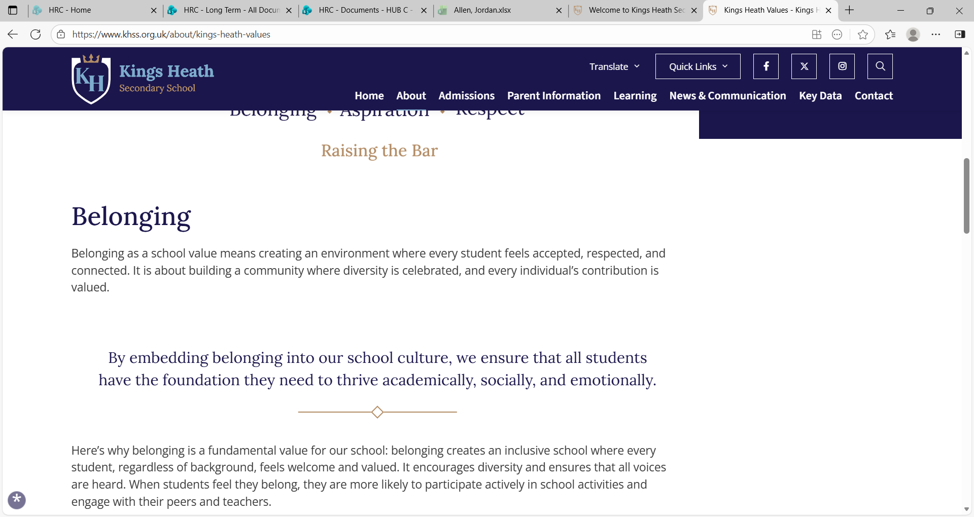
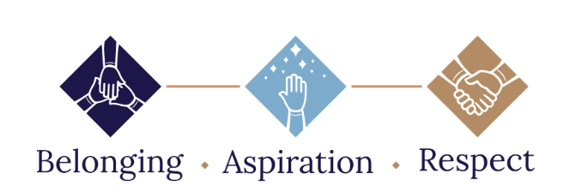

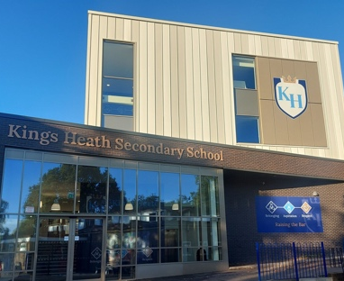

HEADTEACHER

Kings Heath Secondary School
Start Date: September 2026 as the ideal start,
but clearly welcome January availability

Salary: Group 6 L29 – L35, Salary £103,030 - £119, 350, subject
to September pay award

Location: Chamberlain Road, Birmingham, West Midlands
Contract type: Full Time
Contract Term: Permanent

ARE YOU A MOTIVATING LEADER READY TO MAKE MEANINGFUL IMPACT?

The Governing Board are seeking to appoint an outstanding and passionate Headteacher to inspire and lead the future of Kings Health Secondary School. Should you be a strategic leader who is fully committed to educational excellence who is able to bring the skills, experience, and knowledge necessary to provide inspirational leadership aligned with our values and aspirations, we invite you to express your interest.

The successful applicant will need to display that they have integrity and are able to inspire and lead. They must be able to demonstrate that they are an exceptional leader with a wide-range skill set with extensive experience, including a deep understanding of the educational landscape and strong expertise in financial and governance frameworks. They will passionately embrace and champion our vision and ethos of Belonging, Aspiration and Respect, driving excellence for all our pupils and staff.
Kings Heath Secondary School is proud to be a vibrant, inclusive and ambitious school with a talented, skilled and committed team. Currently we have 803 pupils on roll and have successfully transitioned into a co-educational school, with girls in years 7 & 8. Our school is well resourced with excellent facilities with partnership being a strong core value, evidenced by our membership with both Birmingham South Area Network and also Challenge Partners.
Kings Heath Secondary School was judged as ‘good’ in the last two Ofsted inspections. In the most recent Ofsted inspection, they described our pupils as being ‘happy and considerate they value their schooling and take care to be polite and well behaved.’ Ofsted described our teachers as ‘Teachers provide many opportunities to deepen pupils’ personal development’ ‘They shape tasks to encourage reflection as they study new knowledge’.

WE CAN OFFER THE SUCCESSFUL CANDIDATE:
- Opportunities for personal and professional growth and development
- A strong, innovative, and dedicated team of teachers and support staff who take pride in being part of Kings Health Secondary team family
- A committed Senior Leadership Team with high expectations for themselves, staff, and pupils
- Well-behaved and polite pupils with excellent attitudes to learning and pride in their school
- Engaged parents who value the school’s support and celebrate their children’s progress
- A highly committed and forward-thinking Governing Board providing vital support and challenge
WE WANT A CANDIDATE WHO:
- Can create a welcoming, motivating, and inclusive workplace culture
- Is a visionary leader who can inspire staff, pupils, and the wider community with a clear and ambitious direction.
- Is passionate about teaching and learning, with deep expertise in curriculum, assessment, and strategies that raise achievement.
- Has a proven track record of leadership in education, driving improvement and achieving results.
- Is an exceptional communicator who builds strong, positive relationships with staff, pupils, parents, and governors.
- Is a champion of safeguarding and pupil wellbeing, ensuring every child thrives in a safe, supportive environment.
- Can lead by example with integrity, resilience, and professionalism, inspiring trust and confidence at every levels.
Please refer to the recruitment documents before completing your application form, as well as accessing information from the school website: https://khss.org.uk
Potential candidates are welcome and strongly encouraged to visit the school. To arrange a visit please email Jo Phelan, PA to the headteacher on: j.phelan@khss.org.uk

CLOSING DATE: Friday 8 May 2026 – 12 noon, any application received after this time will not be accepted.

School Visits: Tuesday 28 April and Wednesday 6 May 2026

SHORTLISTING: Wednesday 13 May 2026

ASSESSMENT: Day 1 – Tuesday 19 May 2026

INTERVIEWS: Day 2 – Wednesday 20 May 2026 (to be confirmed after Day 1 shortlisting)

LOCATION: Kings Heath Secondary School, Chamberlain Road, Birmingham B13 0QP

To apply, please submit your application to j.phelan@khss.org.uk

We are committed to safeguarding and promoting the welfare of children and expect all staff and volunteers to share this commitment. The school follows safer recruitment practices and, if your application is shortlisted, you will be asked to complete a criminal records declaration form which should be submitted before your interview. As part of due diligence and, in accordance with Keeping Children Safe 2025, an online search will also be carried out on all short-listed candidates. The successful applicant will be subject to all necessary pre-employment checks including an enhanced Disclosure and Barring Service check. We are proud to be an Equal Opportunities employer.
This post is exempt from the Rehabilitation of Offenders Act 1974 and the amendments to the Exceptions Order 1975, 2013 and 2020) which means that, when applying for certain jobs and activities, certain spent convictions and cautions are ‘protected’. They do not need to be disclosed to employers and, if they are disclosed, employers cannot take them into account. Further information about filtering offences can be found at:
https://www.gov.uk/government/publications/new-guidance-on-the-rehabilitation-of-offenders-act-1974

