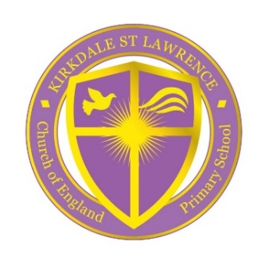
Headteacher
Vacancy Advert

Jeremiah 29:11 The Lord says,
For I know the plans I have for you ... plans to give you hope and a future.

The Role: Headteacher
The Salary: Group 2 L15 – 21 (GBP £59,581 - £69,031 pa)
Salary is determined by the school group on National pay scales within Teacher’s Pay and Conditions Document 2021

NOR: 253 pupils (3-11 years)
Contract: Full Time, Permanent
Start date: Thursday 1st September 2022 [earlier if possible]
Closing Date: By noon on Friday 11th March 2022
Interviews: Wednesday 30th and Thursday 31st March 2022

Due to the current Headteacher’s decision to retire after dedicated service to our school, the Governors seek to appoint a passionate and inspirational leader to join us and lead us on our continued journey to ‘outstanding’.
We are an average sized Voluntary Aided Church of England school located in Kirkdale, North Liverpool. We are passionate about inspiring, challenging and preparing our pupils for the next stage of their education. Our vision is expressed through the message of Jesus and through faith, service, prayer and worship together. Our children learn in preparation to lead full and purposeful lives which will contribute to the common good, in an ever changing and challenging world.
The school prides itself on our pastoral care for all pupils and we are proud to have thriving partnerships. We enjoy close links with our parish churches, St. Lawrence’s and also St. Paul’s both at the heart of our community. As a school we have our own chaplain and close links with the Diocese of Liverpool. Other active partnerships include close links with the Local Authority and other local networks.
The new Headteacher will have a confident leadership style, the ability to plan strategically for future success and to drive innovation whilst being deeply committed to the further development of an inclusive Anglican Christian church school ethos.
We expect you will:
- Have a clear vision and strategy for keeping up with developments and good practice in education
- Be outward looking, curious and innovative
- Be a passionate leader, who values challenging development opportunities
- Be committed to helping our pupils flourish and exceed to their full potential
- Have proven outstanding leadership and management skills along with highly effective interpersonal and organisational attributes
- Be someone who welcomes the opportunity to live the distinctive Christian character of our school

We Can Offer:
- A welcoming school
- A dedicated and enthusiastic team of staff committed to our school and our pupils
- A Governing Body who are dedicated and will support your leadership
- A commitment to your own continuing professional development
- The opportunity for you to continue to drive our school forward, improving on our ‘Good Ofsted’ (January 2018) status and ‘Outstanding SIAMS’ (November 2015) judgement.
Interested candidates are invited and encouraged to visit the school.
To arrange an appointment to visit (to be carried out in line with COVID regulations) and a discussion with the current Headteacher, please contact Mrs S Griffiths, Administration and Finance Manager on 0151 922 2775.
Applications should include an application statement/letter, which should be no longer than 2 sides of A4 paper and no smaller than font size 11. In this letter, applicants are encouraged to include details of their skills, strengths and experience and how their educational philosophy and Christian values will lead our church school.

Once completed, applications are to be sent via email to:
kirkdale-ao@kirkdale.liverpool.sch.uk for the attention of The Chair of Governors, or by post to:
Rev. Captain M Griffin, C/O Kirkdale, St. Lawrence CE VA Primary School, Fonthill Road, Kirkdale, Liverpool L4 1QD. Please mark your envelope ‘Private and Confidential’.

Kirkdale, St. Lawrence CE VA Primary School is committed to safeguarding and promoting the welfare of children and young people. Our school has an equal opportunities policy for selection and recruitment in accordance with its safeguarding policy, the successful candidate will be required to have an enhanced DBS check along with a check against the DBS children’s barred list (formerly known as a list 99 check).

