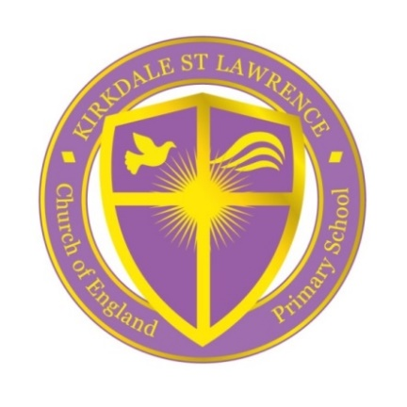

A Voluntary Aided Church of England Primary School

FONTHILL ROAD TEL: 0151 922 2775
LIVERPOOL
L4 1QD
E-mail: kirkdale-ao@kirkdale.liverpool.sch.uk

Monday 31st January 2022

Dear Applicant,
Governors thank you for your interest in the role of Headteacher of Kirkdale, St. Lawrence Voluntary Aided Church of England Primary School.
Our Headteacher has decided to retire and the governing body now wish to recruit a Headteacher to lead our Church of England School from 1st September 2022. We believe this is an exciting opportunity, and the successful applicant will be joining a friendly and welcoming school with a strong, caring Christian ethos.
Our school is a unique place, we are a school of average size but with big ambitions, and we work closely with Liverpool Diocese, with Liverpool local authority, a local consortia of schools for special needs and disabilities and the Link network of local schools. These effective partnerships enhance the opportunities for our children.
Building on the work of the previous Headteacher, we are looking for someone who is dedicated, hardworking and passionate about leadership, who likes to follow up on or initiate creative ideas. As Headteacher you will continue to engage with other schools and organisations to achieve more, and you will seek to continue your own professional development.
The school benefits from being in close partnership with our churches, St. Lawrence’s and St. Paul’s and we are lucky to have our own school chaplain. Our ideal candidate will have highly developed emotional intelligence and leadership skills with the ability to challenge positively and lead change effectively.
As Headteacher you will have a clear appreciation of the Christian values that shape our daily life in school, demonstrated through your personal qualities. Our school leadership is driven by a moral purpose which underpins our approach and philosophy. We have high aspirations for our children because we expect the very best for every single one of them.
If you are interested in this vacancy and would like to visit our school, please contact the school office. I look forward to receiving your application for this fantastic opportunity of school leadership.
If you wish to visit please contact Mrs Sharon Griffiths, Administration and Finance Manager at the school to arrange an appointment on 0151 922 2775 or at kirkdale-ao@kirkdale.liverpool.sch.uk.
Statements/letters accompanying the application form should be no longer than 2 sides of A4 paper and no smaller than font size 11. In this letter, applicants are encouraged to include details of their skills, strengths and experience and how their educational philosophy and Christian values will lead our church school.
Applications should be submitted by 12.00 noon on Friday 11th March 2022, marked ‘confidential’ for the attention of the Chair of Governors.
Yours faithfully
Rev.Capt. Mike Griffin
Chair of Governors

