**Headteacher Recruitment Pack**

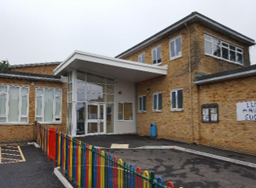

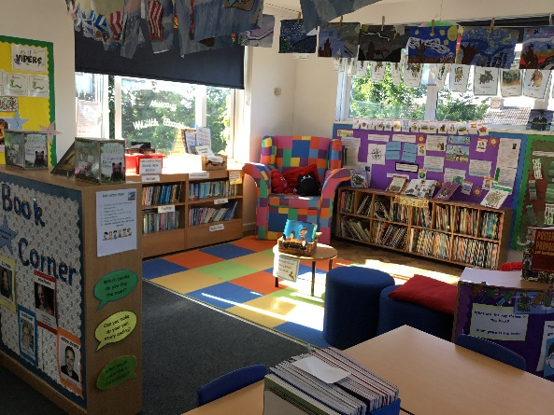 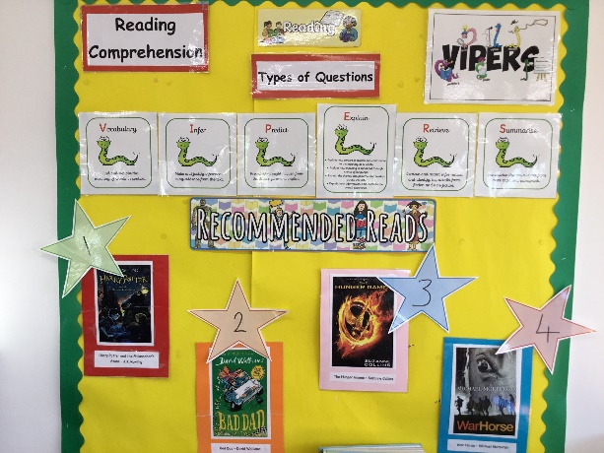

**Contents**

**Welcome Letter Page 3-4**

**Ludgershall Town and Church Page 5-8**

**Our School Page 9-11**

**Visions Page 12**

**Aims Page 13**

**School Improvement Plan Page 14**

**Job Description Page 15-25**

**Selection Process Page 26**

**Safeguarding Page 27**

**What our children say Page 28**

**Chair of Ludgershall Castle Primary School Governing Body**

**Welcome**

Dear Applicant

Welcome to Ludgershall Castle Primary School and thank you for your interest in leading our wonderful team. After nearly 20 very happy years with us, our current Headteacher is hanging up his headteacher hat and moving onto exciting new challenges.

Ludgershall Castle is a popular primary school boasting a vibrant and positive environment for children to learn and realise their potential. The school caters for the education and needs of a diverse range of children and families from the surrounding area. We are an inclusive school, and we provide exemplary support to those who need extra help and our culture and approach to inclusivity and diversity is something to be admired.

We have a highly skilled and well-established workforce that includes specialist practitioners and mentors and a good balance between those who have been at the school for some time and newer recruits including Early Career Teachers. The leadership is experienced, committed and hardworking and will provide tremendous support for any incoming Headteacher. All staff work tirelessly to teach and support our children. They are committed to the inclusive ethos in our school and seek out opportunities to develop their own practice and share learning with others.

We are at the heart of the local community and we are proud of our involvement in and contribution to the local community and area. Ludgershall is a thriving and growing town. We encourage parents to be involved in the life of the school and work hard with them to support their children and the values of our school. We share with parents by welcoming them to open parents meetings, school productions and up-to-date communication via Class Dojo.

Our children are proud of the school and are encouraged to contribute to the life of the school by taking on additional responsibilities. Our School Council contribute to school development and are central to gathering views and ideas from children across the whole school. Our Subject Ambassadors meet with Subject Leaders and Governors and join subject walks to ensure subjects are being taught throughout the school. Our ‘Good’ OFSTED was awarded in March 2023. Together with a newly implemented curriculum, this provides the perfect springboard for an incoming Headteacher. We welcome applications from strong leaders with demonstrable experience of managing change whilst balancing the demands of school improvement with staff wellbeing. The successful applicant will enjoy considerable autonomy but will also work closely with a supportive, effective and knowledgeable Governing Body.

We enclose further information about our school. Please consider carefully the specification of the candidate we seek for the role. We would encourage a visit to school to experience first-hand our culture and ethos as well as the modern teaching and learning facilities we offer the children and staff.

Thank you for your interest in our school and we look forward to hearing from you.

Yours faithfully

Sharon Kirwan

Chair of Governors

Ludgershall

Ludgershall, recorded in the Domesday Book as Litlgarsele, has a long and well-recorded history. Superficially, a ‘corn and sheep’ village on the edge of Salisbury Plain, a Royal Castle was built here sometime before the beginning of the 12th century. By 1103 AD Henry 1 was in residence in the castle. It continued in Royal hands with many of the Kings and Queens of England visiting there to transact business, oversee local repairs and to enjoy hunting parties in the nearby Royal Forest of Chute, until it was neglected and said to be ‘clene down’ in 1546. The castle was excavated in the years 1964-1972 and is now in the care of English Heritage. It is open to visitors at all times.  
  
Although a mainly agricultural settlement, Ludgershall gained the title of an ancient borough when it began to be represented in Parliament in 1295 by two members. They brought wealth and influence to the town that grew up in the grid of streets to the south of the castle. An annual fair and a weekly market were held in the High Street flowing out and around the Medieval Preaching Cross. There is in existence, a seal of the town of Ludgershall that was attached to a grant of ‘burgage’ or tenure of land in the High Street and is dated 1405.

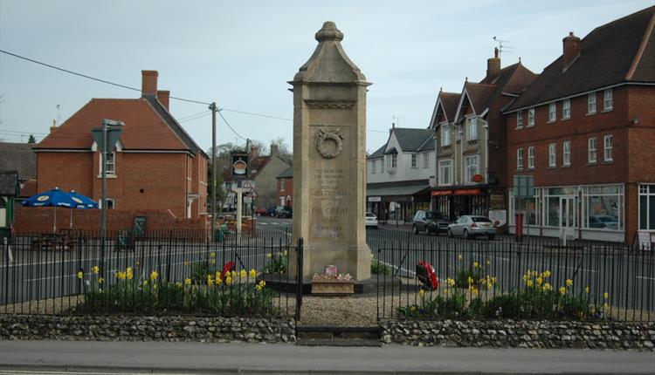

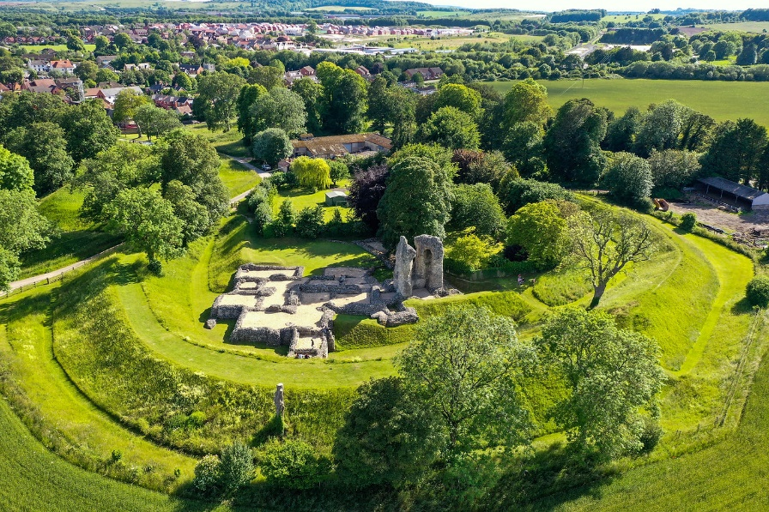

The Church of St. James was built in the 12th century and it contains the splendid Tudor Tomb of Sir Richard Brydges and his wife Lady Jane, formerly a Spencer and ancestor of the late Princess Diana. Sir Richard was M.P. for Ludgershall in 1533 and was knighted at the coronation of Mary Tudor. He owned the manor, town & park of Ludgershall. Yet another famous M.P. for the town was General John Richmond Webb, hero of the Battle of Wynendael in 1708 during Queen Anne’s reign. He was subsequently promoted to Commander of Britain’s Land Forces in 1712. He purchased the estate at Biddesden in 1711 and rebuilt the house. He and members of his family are also buried in the Church.  
  
With the passing of the Reform Act in 1832, Ludgershall lost its representation in Parliament and the men of wealth and influence moved away. The later 19th century with a rural population numbering less than five hundred, saw poverty and hunger in the town until the coming of the railway in 1882, introduced a new skilled work force into the area and provided employment. The second most important factor in the development of Ludgershall, was the coming of the Army firstly for summer manoeuvres and then to build permanent garrisons. Ludgershall station became the busiest station on the line during both World Wars as troops were conveyed into and out of the camps on the Plain.  
  
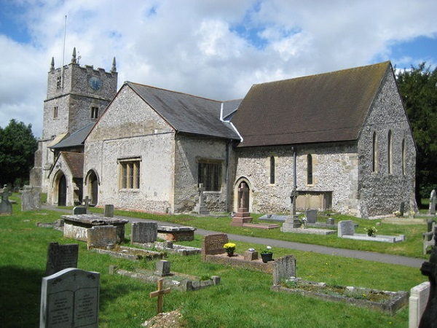

Ludgershall has once again resumed the title of town with all the usual amenities. Both Primary and Secondary schools, two medical practices, a post office, a variety of shops, two public houses; The Queens Head being 16th century & The Crown Inn being 17th century and a half-hourly bus service to nearby towns. It continues to attract many ex-service personnel to live in the newly built attractive homes. The high rate of employment encourages a growing number of young people to join the thriving town, which acts as a focal point for a lively and expanding population.



**OUR SCHOOL**

Our school was opened on its present site in 1978. It is situated in pleasant surroundings within a short distance of Ludgershall town centre, yet within close proximity to Collingbourne Woods. We have eleven well-sized classrooms and are fortunate enough to have a large amount of space both inside and out. All Foundation Stage and Key Stage One classrooms have direct access outside to enhance learning. We also have six classrooms upstairs, a dedicated music room, a meeting room for School Council and other groups, a community room and a well-equipped art and DT room. In 2024 we were fortunate to open a dedicated Forest School area which ALL children have access to.

We are lucky to have a child-friendly dining hall as well as a large sports hall, which is also used for drama and assemblies. We have a fitness trail, an outdoor classroom, sports field, nature garden, two playgrounds and a large grassy area for children to play on. We are proud of the facilities we are able to provide and are committed to a continuous programme of further improvements. Through the school fund children access two school trips per year.

We are dedicated to providing children with opportunities before they leave Year 6. We are always open to new suggestions and ideas as to how to make the school even better - parent and pupil opinions are very important to us.

The school has also recently embarked on an ‘Affordable Schools’ programme ensuring we make all elements of the children’s education and growth affordable and accessible to all families.

**About us**

Age Range: 4-11 years

Location: Ludgershall, Wiltshire

Type of School: Foundation School

Organisation: Headteacher

Current Teaching Staff: 14 Teachers (Full and Part Time)

Non Teaching Staff: Assistant Head/DSL/SENCo/

16 Teaching Assistants

1 Forest School Lead

1 ELSA

2 Reception/Premises Assistants

1 Admin and Finance officer

5 Cleaners

Number of children on roll: 277

Average Class Size: EYFS 17

Key stage 1 24

Lower key stage 2 26

Upper key stage 2 30

Classes: 11 classes plus Forest School

Attendance 2023/24: 93.7%

% of children on FSM: 27.3%

% of children with SEN: 15.1%

% of children with EAL: 5.9%

**Results**

Ofsted Rating: Good – March 2023

<https://reports.ofsted.gov.uk/provider/21/126489>

EYFS Data 2023 GLOD: 56.7%

Phonics Screening 2024: 51.3%

Key Stage 2 Results:

Reading: 67.4%

Writing: 67.4%

Maths: 65.2%

RWM: 60.9%

**Vision:**

Our shared vision for Ludgershall Castle Primary School is of a happy, **vibrant learning community**, improving together. We are working with pupils, parents and the wider community to create the supportive atmosphere of trust and mutual support in which we **all** thrive.

»Our main focus will be  to raise pupils' achievement.

» There will be a culture of continuous improvement and innovation.

» The curriculum will be broad, balanced and forward-looking and prepare pupils for active citizenship.

**'LEARN, HAVE FUN AND SUCCEED'**

are carefully chosen words that encapsulate the aims of our school.



**AIMS:**

‘LEARN / HAVE FUN / SUCCEED’ are carefully chosen words that encapsulate the aims of our school.

• We want learning and teaching to be fun for all.

• We always ‘have a go’ and try our best; we celebrate our successes.

• We want to care for and respect everyone in our school; everybody matters.

• We want school to be a safe place for everybody.

• We know that learning is for life, not just for children.

• We all want to be good citizens.

Our shared vision for Ludgershall Castle Primary School is of a happy, vibrant learning community, improving together. We are working with pupils, parents and the wider community to create the supportive atmosphere of trust and mutual support in which we all thrive.

• Our main focus will be on raising pupils’ achievement.

• There will be a culture of continuous improvement and innovation.

• The curriculum will be broad, balanced and forward-looking and will prepare pupils for active citizenship.

**Ludgershall Castle Primary School**

**School Improvement Plan 2024**

The School Improvement Plan (SIP) has been completed for 2024-2025 and is available as a separate document for you to look through. It is a comprehensive plan looking at the quality of education at the school, behaviour and attitudes, personal development and leadership and management.

The SIP has been completed with the whole school and school community in mind, ensuring everyone is involved and that we are working towards the same aims.

**Ludgershall Castle Primary School Job Description and Requirements for the Role of Headteacher**

Salary: L15-L19

Starting Date: September 2025

**Role Purpose**

• To provide strategic leadership and management that has a positive impact on outcomes for children.

• To be responsible for the day-to-day management, organisation and administration of the school

• To develop policies and practices and to ensure that resources are efficiently and effectively used to achieve the school’s aims and objectives

• To ensure high quality education and a productive learning environment by effectively managing teaching and learning

• To establish a culture that promotes excellence, equality and high expectations

• To secure high standards of behaviour and safe-guarding

• To provide strong financial management

• To evaluate school performance and determine improvement priorities

• To ensure staff and pupil wellbeing

**Responsibilities**

**School culture**

1. Establish and sustain the school’s ethos and strategic direction in partnership with those responsible for governance and through consultation with the school community

2. Create a culture where pupils experience a positive and enriching school life

3. Uphold ambitious educational standards which prepare pupils from all backgrounds for their next phase of education and life

4. Promote positive and respectful relationships across the school community and a safe, orderly and inclusive environment

5. Ensure a culture of high staff professionalism

**Teaching**

1. Establish and sustain high-quality, expert teaching across all subjects and phases, built on an evidence-informed understanding of effective teaching and how pupils learn

2. Ensure teaching is underpinned by high levels of subject expertise and approaches, which respect the distinct nature of subject disciplines or specialist domains

3. Ensure effective use is made of formative assessment

**Curriculum and assessment**

1. Ensure a broad, structured and coherent curriculum entitlement which sets out the knowledge, skills and values that will be taught

2. Establish effective curricular leadership, developing subject leaders with high levels of relevant expertise with access to professional networks and communities

3. Ensure that all pupils are taught to read through the provision of evidence-informed approaches to reading, particularly the use of systematic synthetic phonics in schools that teach early reading

4. Ensure valid, reliable and proportionate approaches are used when assessing pupils’ knowledge and understanding of the curriculum

**Behaviour**

1. Establish and sustain high expectations of behaviour for all pupils, built upon relationships, rules and routines, which are understood clearly by all staff and pupils

2. Ensure high standards of pupil behaviour and courteous conduct in accordance with the school’s behaviour policy

3. Implement consistent, fair and respectful approaches to managing behaviour

4. Ensure that adults within the school model and teach the behaviour of a good citizen

**Additional and special educational needs and disabilities**

1. Ensure the school holds ambitious expectations for all pupils with additional and special educational needs and disabilities

2. Establish and sustain culture and practices that enable pupils to access the curriculum and learn effectively

3. Ensure the school works effectively in partner-ship with parents, carers and professionals, to identify the additional needs and special educational needs and disabilities of pupils, providing support and adaptation where appropriate

4. Ensure the school fulfils its statutory duties with regard to the SEND code of practice

**Professional development**

1. Ensure staff have access to high-quality, sustained professional development opportunities, aligned to balance the priorities of whole-school improvement, team and individual needs

2. Prioritise the professional development of staff, ensuring effective planning, delivery and evaluation which is consistent with the approaches laid out in the standard for teachers’ professional development

3. Ensure that professional development opportunities draw on expert provision from beyond the school, as well as within it, including nationally recognised career and professional frameworks and programmes to build capacity and support succession planning

**Organisational management**

1. Ensure the protection and safety of pupils and staff through effective approaches to safeguarding as part of the duty of care

2. Prioritise and allocate financial resources appropriately, ensuring efficiency, effectiveness and probity in the use of public funds

3. Ensure staff are deployed and managed well with due attention paid to workload

4. Establish and oversee systems, processes and policies that enable the school to operate effectively and efficiently

5. Ensure rigorous approaches to identifying, man-aging and mitigating risk

**Continuous school improvement**

1. Make use of effective and proportional processes of evaluation to identify and analyse complex or persistent problems and barriers which limit school effectiveness, and identify priority areas for improvement

2. Develop appropriate evidence-informed strategies for improvement as part of well-targeted plans which are realistic, timely, appropriately sequenced and suited to the school’s context

3. Ensure careful and effective implementation of improvement strategies, which lead to sustained school improvement over time

**Working in partnership**

1. Forge constructive relationships beyond the school, working in partnership with parents, carers and the local community

2. Commit their school to work successfully with other schools and organisations in a climate of mutual challenge and support

3. Establish and maintain working relationships with fellow professionals and colleagues across other public services to improve educational outcomes for all pupils

**Governance and accountability**

1. Understand and welcome the role of effective governance, upholding their obligation to give account and accept responsibility

2. Establish and sustain professional working relationship with those responsible for governance

3. Ensure that staff know and understand their professional responsibilities and are held to account

4. Ensure the school effectively and efficiently operates within the required regulatory frame-works and meets all statutory duties

**Headteacher Person Specification**

The following are the main attributes the Governors wish to see in the successful headship.

Measurements: A = Application I = Interview R = Reference

|  |  |  |  |  |
| --- | --- | --- | --- | --- |
|  | **Essential** |  | **Desirable** |  |
| Qualifications | * Degree and Qualified Teacher Status | A | * NPQH or other Headship qualification * Further relevant leadership and management qualifications | A  A |
| Training | * Evidence of continuing professional development (CPD) relating to school leadership and curriculum development * Safeguarding Children and Young People | A  A | * CPD in Budget Management * Safer Recruitment | A  A |
| Experience | * Significant recent strategic leadership and management experience within the Primary Phase in a school (or schools) including Early Years, Key Stage 1 and Key Stage 2 * Successful record of developing outstanding inclusive practice to raise achievement for all children * Proven record of working with a wide ability range including Able and Talented and SEND children to deliver a differential curriculum * Sustainable record of assessing and evaluating teaching standards and staff performance * Experience of effective communication with, and managing expectations of, parents including dealing with parental complaints * Proven experience of working with Governors and the wider community * Experience of effective financial planning, budget management and use of resources to achieve the schools vision * Ability to maintain high levels of behaviour to support pupils’ learning, social and emotional development * Demonstrate experience in managing change in a school environment | A  A,I,R  A,I,R  A,I  A,I  A,I  A,R  A,I  A,I | * Practising Headteacher or comparable role * Experience of working in a highly transient setting, or deprived area * Experience of leading a major curriculum area through an OFSTED inspection * Experienced Safeguarding lead, including experience of Multi Agency working * Experience of developing curriculum continuity and progression between key stages * Experience of serving on a Governing Body * Experience of developing and implementing a whole school vision | A  A  A  A  A  A  A,I |
| Knowledge and Skills | * In depth knowledge of the statutory framework for education and current educational development * Excellent understanding of how children learn and of effective, inspiring teaching and assessment methods * Knowledge of Early Years, Key Stage 1 and Key Stage 2 * Working knowledge of budgetary control * Working knowledge of Safeguarding procedures * Knowledge of OFSTED Inspection procedures and the post OFSTED leadership planning process * Expert knowledge of school self-evaluation and improvement planning processes * Proven skills in use of school and comparative data to tackle issues and set challenging targets * Effective communication skills with staff, children, parents, governors and other stakeholders * Flexible leadership skills and a wide portfolio of management approaches * ICT Skills relevant to headship and sound knowledge of the role of ICT in teaching and learning across the curriculum * Ability to plan, allocate, delegate, support and evaluate work undertaken by individuals and teams | A,I  A,I  A,I  A,I  A,I  A,I  A,I  A,I  A,I  A,I  A,I  A,I | * Use of new and emerging technologies to enhance organisational effectiveness * Current knowledge and understanding of education and school systems nationally and globally | I  I |
| Personal Qualities | * A positive, motivational leader and role model * Strong personal motivation with versatile and resilient can-do attitude * Ability to assimilate into and challenge existing structures to improve outcomes * Ability to recognise own and others weaknesses and value strengths * High expectations of self and others * Ability to build, maintain and manage positive relationships with a wide range of stakeholders and to protect the school positively * Ability to establish a productive rapport and appropriate boundaries with children and parents * Passion for a productive learning environment which is engaging and fulfilling for children and staff * Strong organisation and management, with an open and collaborative style of leadership * Ability to lead in a joyful, kind and highly effective manner * Clear values and moral purpose * Financially astute * Positive leadership qualities coupled with an enthusiastic team approach to management * Ability to create, develop and lead a high performance team * Ability to set challenging targets, meet deadlines and work under pressure * Strong commitment to ensure equality and celebrating diversity | A,I  A,I  A,I  A,I  A,I  A,I  A,I  A,I  A,I  A,I  A,I  A,I  A,I  A,I  A,I  A,I | * Stamina and optimism for long term future of school | I |
| Interests and Motivation | * Up-to-date knowledge of educational trends * Support an enriched curriculum | A,I  A,I | * Interests other than Education * Imaginative approach to community involvement * Encourages collective involvement in extra curricular activities | A,I  I  I |
| Commitment | * A commitment to a productive learning environment which is engaging, enjoyable and fulfilling for children * Evidence of an understanding that primary education needs to encompass security and emotional development for children as well as academic progress in order to be successful * Evidence of commitment to the pastoral care and wellbeing of the children and staff of the school * Passion for raising standards * Commitment to the school and its links with the wider community * Commitment to equality of opportunity and inclusion | A,I  A,I  A,I  A,I  A,I  A,I |  |  |

**Selection Process**

**Selection Process**

If you are interested in applying for this fantastic opportunity to lead our school we would encourage you to visit our school during these dates, Friday 7th February, Tuesday 11th February, Wednesday 19th February and Thursday 27th February 2025.To arrange this please contact Danielle Cummins Clerk of Governors via [clerk@ludgershallcastle.wilts.sch.uk](mailto:clerk@ludgershallcastle.wilts.sch.uk).

The preferred method of application is online and applications should be made at http://jobs.wiltshire.gov.uk/.

For information not available on the website, please contact the Danielle Cummins Clerk of Governors via [clerk@ludgershallcastle.wilts.sch.uk](mailto:clerk@ludgershallcastle.wilts.sch.uk).

The deadline for applications is Tuesday 4th March 2025.

Applicants will be shortlisted on the 6th March 2025. Interviews will take place over two days and these are scheduled for 24th and 25th March 2025. Please confirm your availability to attend both interview days in your covering letter.

**Safeguarding and safer recruitment**

Ludgershall Castle Primary School is committed to safeguarding and promoting the welfare of children and young people and expects all staff and volunteers to share this commitment. Ludgershall Castle Primary School is committed to safer recruitment and will follow all relevant safer recruitment processes including the relevant sections of the Keeping Children Safe in Education.

All applicants will be subject to a Disclosure and Barring Service check before an appointment is confirmed.

**What do the children say?**

**Children were asked what qualities they believe a Headteacher should have – this is what the Ludgershall Castle Primary School Council have said:**

* Nurturing
* Kind
* Aware of each child and what is happening in their lives
* Keeps everyone safe
* Includes everyone
* In school a lot of the time
* Sense of humour
* Fun
* Mature
* Calm
* Is fair to all
* Helpful
* Trips – everyone can go
* ‘Bossy but fun’
* Understanding
* Respectful
* Listens to everyone – ‘both sides of the story’