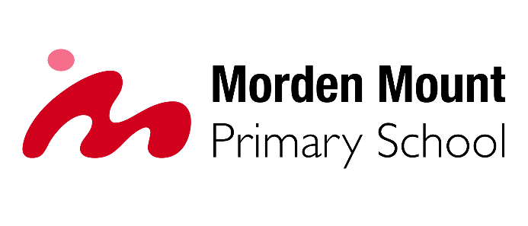

Headteacher recruitment
Information

Date written
January 2026

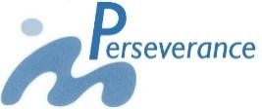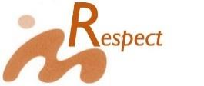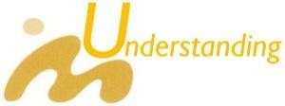
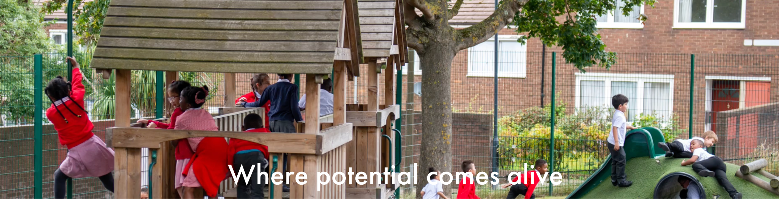

WELCOME TO OUR SCHOOL

We are an inclusive, ambitious, friendly maintained primary school set on the border of Greenwich and Lewisham, close to the heart of Maritime Greenwich.

Inclusive Ambitious Collaborative

If these 3 words fully align with your vision for primary education, then please read the rest of this pack to find out more about our school and the role we are advertising.

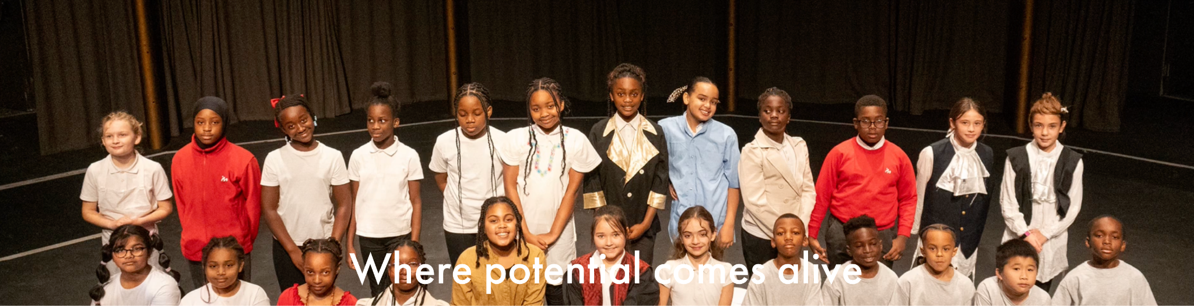

Our school
We are a medium sized school with 2 forms of entry in each year group. We also have a nursery class and an on-site locally resources specialist provision for children with additional needs.

Our values
Every aspect of our work as a school is driven by our 5 PROUD values. These help us shape our approach, evaluation our impact and consider our next steps.
We want every child to leave our school being PROUD of their achievements.
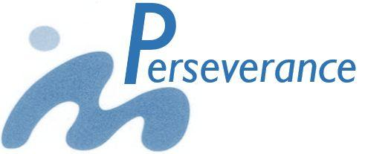 | Our children are confident learners, they work hard to succeed with every challenge.
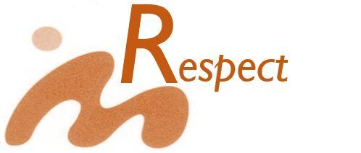 | Our children show respect for themselves and other people in our community, our country and our world.
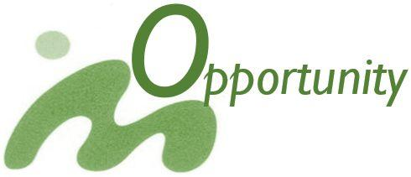 | Our children love learning and are keen to learn in our school, at home and in the future.
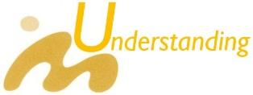 | Our children have strong core skills in communication (reading, writing, speaking and computing), mathematics and have a good understanding of topics across the whole curriculum.
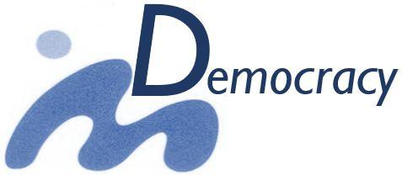 | Our children are confident to share their views, listen to other people’s ideas and opinions and make decisions that help everyone achieve.

Our partnerships
We are an outward-looking school and we are active members of a number of strong partnerships that support our school and its development. We are also committed to supporting system-wide development working with others to help grow the quality of education, through a partnership approach, across our locality.
Our partnerships include:

Federated schools
We are in a soft federation with 2 other schools under the shared leadership of our Executive Headteacher.
  Heronsgate Primary School  a 4-form primary school operating over 2 buildings in Woolwich |   James Wolfe Primary School  a 4-form primary school operating over 2 buildings in Greenwich

Family of schools

We are active members of the Greenwich Community School Partnership. This is a group of maintained schools from all phases (nursery, primary, secondary, special) from across Greenwich. This group works to develop practice and share resources so promoting an inclusive approach to education.

Local Authority
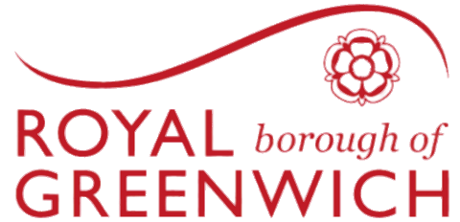
We work closely with our Local Authority, Royal Borough of Greenwich. This partnership supports our external review through the Improvement Partner programme and we support the authority by helping it shape its services to schools.

Other partnerships
We work with a number of other organisations who enrich our curriculum. Currently we have links with Punch Drunk Theatre, Bow Arts project and we are exploring how we can make use of the new Woolwich Works organisation.

Links with our community
We recognise that the school is important resource for our local community both in terms of offering support for families and making our buildings available for local events. Through our extensive lettings programme, we offer facilities for a number of Greenwich based groups bringing a wide range of activities to our neighbouring families.
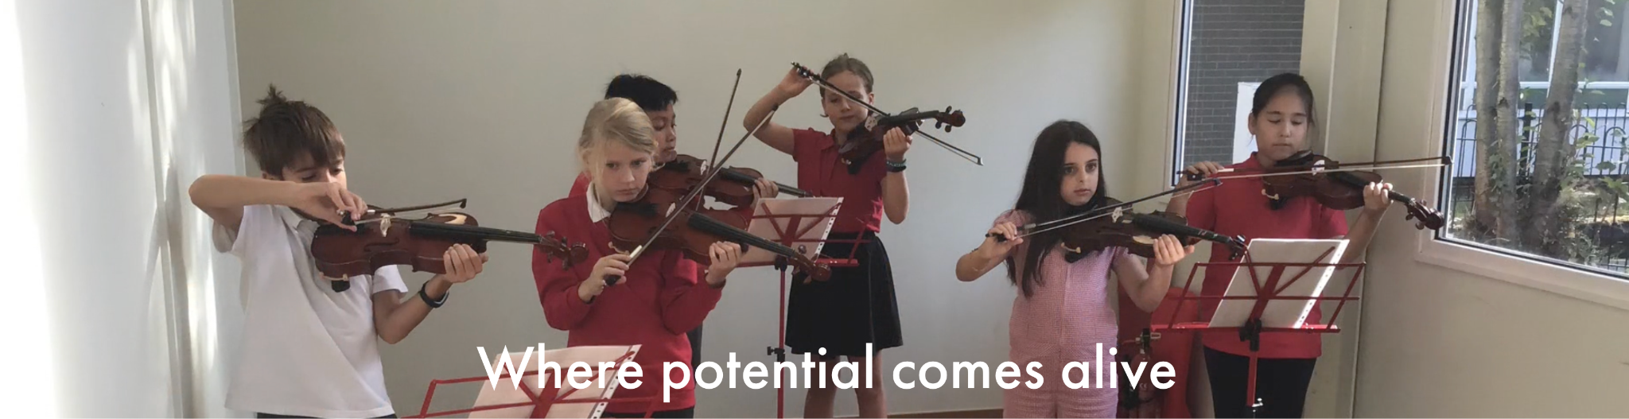

Our curriculum

Curriculum intent
Our intent is to provide a progressive curriculum that builds on skills and knowledge in a planned sequence as children move through our school.
We are also committed to providing a wide range of experiences across different subject areas, so that our children can learn new skills, grow their knowledge and develop a love for different disciplines. Our aim is that this will enable children to develop their enthusiasm for learning that they will take forward into their next school.

Wider experiences
Our curriculum reaches beyond the taught lessons in the school day and we are proud of our wider work. We aim to offer an extensive range of clubs, including wrap around care, working with different partners to give high quality experiences for our children.
We are close to the amazing location of Maritime Greenwich and our curriculum reflects this. We include many trips to our local area making full use of the World Heritage that many schools travel miles to access. We also make good use of our grounds through our forest school and our current project is the development of outdoor classrooms.
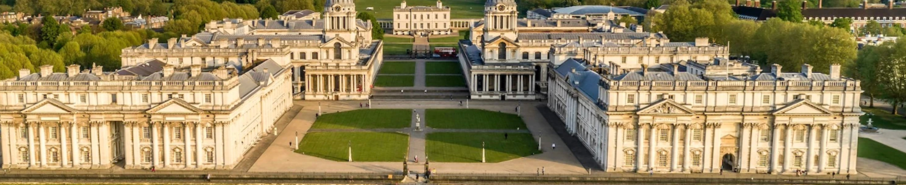

We are looking for
We are looking for a headteacher who, with the existing headteacher, will lead Morden Mount Primary School during its next phase of its development.
This is an exciting time to join our school, we have an established experienced team of leaders and excellent staff who provide a high quality of education.
We are looking for a headteacher who will:
- place children and their development at the centre of everything they do
- lead the development of an innovative and creative curriculum offer
- inspire staff to reflect on, and grow their practice
- work with the existing headteacher to shape the development of our school

What our children want
We asked our children what they want from their headteacher.
They have asked us to find people who:
- are kind
- are respectful and helpful
- makes good decisions about our school
- listens to children and their ideas
- can help us to sort out difficulties by being fair and making sure everyone is ok at the end of it
- are fun

What we offer
We offer:
- a fully inclusive setting where staff are committed to helping every child succeed
- professional development opportunities tailored to the aspirations of the successful candidate
- support and mentorship from an experience Executive Headteacher
- committed governors who empower leaders to meet the governing board’s aspirations for our children
- and … importantly … over 400 amazing children.

