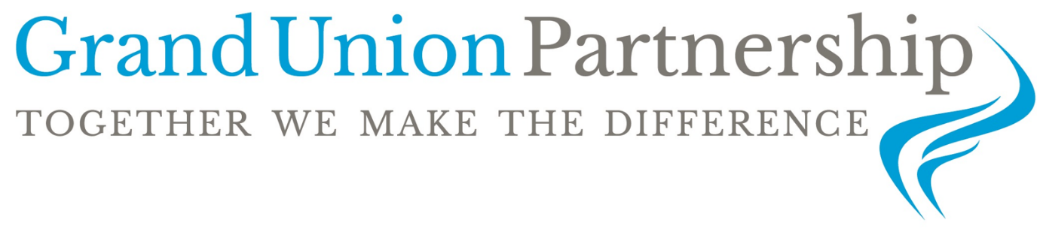
BOUNTY STREET, NEW BRADWELL
MILTON KEYNES, MK13 0BQ
Tel: (01908) 312244 Fax: (01908) 222869
e-mail: ceo@grandunionpartnership.org

Chief Executive Officer: Mr Philip Webster Chair of Trustees: Mr Andrew Brodie

Looking for a Head Teacher role, that is both challenging and exciting?

School New Bradwell School
Pay scale Leadership Scale 24-29

We are seeking a high-quality Head Teacher, to lead New Bradwell School on the next phase of its journey.

As an inspirational leader, you will have an impressive track record of delivering results. You’ll also have excellent people management and communication skills that can make a positive difference for our children and get the best out of our staff team.

This is a challenging, yet exciting role and we want to hear from you if you are an experienced Head Teacher or a Deputy Head Teacher looking for your first headship. In addition to a competitive salary and knowing you’re bringing the highest standards of learning and achievement to all the pupils at our school, you’ll also receive development and support from our experienced CEO.
.
Why join us?

New Bradwell is based in the North of Milton Keynes, covering the areas of New Bradwell, Blue Bridge, Oak Ridge Park, Stantonbury Farm Park and the northern part of Bancroft. The school is at the heart the local community. Over the years, the school has expanded significantly, and we now cater for around 630 children from Reception through to Year Six. The school also has its own nursery attached. The school also runs a department for twenty-four children with ASD diagnosis on another site.

We are part of the Grand Union Partnership which is a Multi-Academy Trust currently including four primary schools operating in Milton Keynes and South Northamptonshire. Trustees have a clear vision which promotes excellence, equality and high expectations for all pupils.

How to apply

If you think you have the qualities that we are looking for then please e-mail requesting an application pack to recruitment@grandunionpartnership.org

Closing date: 24th February 2023
Interview date: 7th March 2023 & 8th March 2023
Start date – to be discussed following interview

The trust is committed to safeguarding children.
The successful applicants will require an enhanced DBS check.

