NEW BRADWELL SCHOOL

Inspiring the learner in you

Information about the school

New Bradwell School is situated in Bounty Street, New Bradwell, in the north of Milton Keynes. The school caters for children aged between 3 and 11 years, which include 52 part-time children in the nursery department. New Bradwell itself is an established community which has been incorporated into Milton Keynes. It originally provided small cottage and terrace housing for workers in the nearby Wolverton railway works. Our catchment area includes New Bradwell, Blue Bridge and the northern parts of Bancroft.
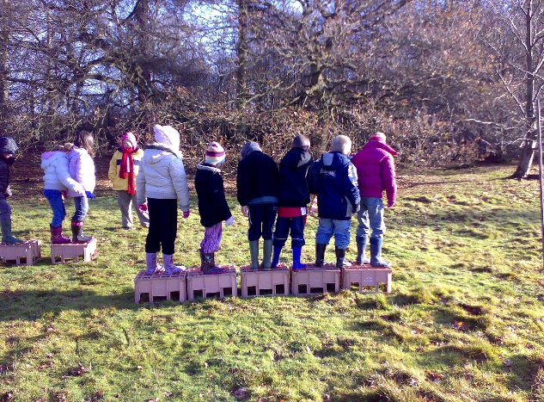
The school has a long history dating back to 1883, when it was founded as a church school. It moved to its present location in 1970 and became a combined school (infants and junior) in 1975. In 2002 the school became a Foundation School.

Extensive buildings were added to provide additional facilities and classrooms appropriate to a developing school of this type. We also have a dedicated Foundation Stage area Children’s Centre and Acorn day care provision all on the school site, which is working within the community of New Bradwell.

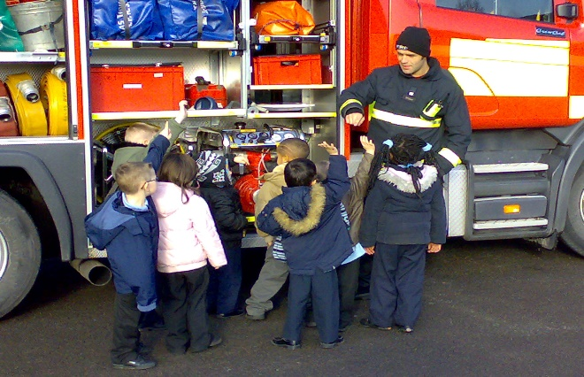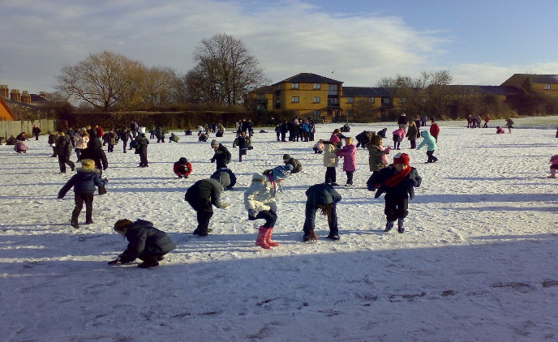
Our catchment area reflects a cross section of society with a mixture of council and privately owned accommodation with a well established population. The school has an active School Association (PTA) and parents are very welcome to contribute to the school by supporting children and staff in classrooms, on school visits and with a whole range of different activities. We have a strong community involvement at the school, with the church and other organisations. We also undertake a wide range of educational day and residential visits and activities.
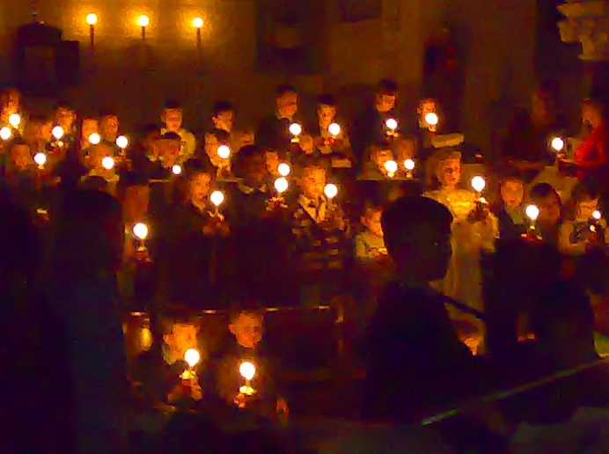
New Bradwell School is very proud to put the children and their welfare as the most important aspect of our school life, and with this in mind we aim to work with parents to ensure that the children reach their full potential.

During our previous inspection in May 2012 the key findings were as follows:
- This is an outstanding school. The strong vision of the headteacher, staff and governors and their ambition to excel are very successfully translated into provision that ensures that pupils make outstanding progress.

- From starting points that are generally well below those expected for their age, all groups of pupils make outstanding progress. As a result, by the end of Year 6, their attainment is above average.

- As a result of the school’s particularly effective focus on children’s spiritual, moral, social and cultural development, pupils’ ability to consider others, and to be thoughtful and compassionate is extremely well developed. This results in outstanding behaviour.

- Teachers hold high expectations of both their pupils and of themselves.

- Outstanding leadership and management, including the management of performance, have created a school that is both reflective and forward looking.

We warmly welcome anyone who would like to look round the school, and we look forward to receiving your application.
Philip Webster
Head Teacher

