NORTH YORKSHIRE COUNCIL CHILDREN AND YOUNG PEOPLES SERVICES
OTLEY STREET COMMUNITY NURSERY SCHOOL





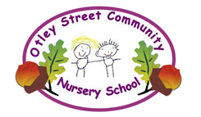
Otley Street
Skipton
North Yorkshire
BD23 1ET

01756 793075

admin@otleystreet.n-yorks.sch.uk
www.otleystreet.n-yorks.sch.uk

9th January 2026
Dear Applicant,

On behalf of our Pupils, Staff and Governors at Otley Street Community Nursery School, I would like to thank you for your interest in the position of Headteacher at our school. I hope that you find the accompanying information useful and that it inspires you to find out more about us.

Otley Street Community Nursery School is a unique setting, it is one of three maintained nursery schools in the whole of North Yorkshire. Housed in a stand-alone building, we have been a cornerstone of the Skipton community for over 80 years. We believe Skipton is a unique place to grow up or work as it is situated on the border of the Yorkshire Dales National Park and serves both our town and rural communities.

We currently have approximately 40 children on roll and they access variable hours depending on their family’s requirements. Pupils aged three years or over can access 15 or 30 hours of funded care and from January 2026 we have launched our two-year-old room. All sessions run term time and in line with the school day. Organisational Management is well supported by our School Administration Officer and we have a highly skilled and committed staff team.

As Governors we are extremely proud of the nursery. In the stable, caring, supportive and family environment our children love their learning. We are a highly inclusive nursery and support a significant number of children with a wide range of complex needs. We recommend that you look at our school website, Instagram and Facebook pages to inform your understanding of our pedagogy and ethos. All our policies are available on our website.

Further information can be accessed in our Ofsted Inspection reports –available on the Ofsted site or school website.

We are looking for an enthusiastic and highly effective leader who understands the sheer joy of teaching in the Early Years. They will aim to build on our current success, nurture our children and further our aspirations. As part of the application process, we warmly welcome pre-arranged visits and should you need any additional information please contact the nursery school.

We look forward to receiving your application and wish you every success.

Yours faithfully,

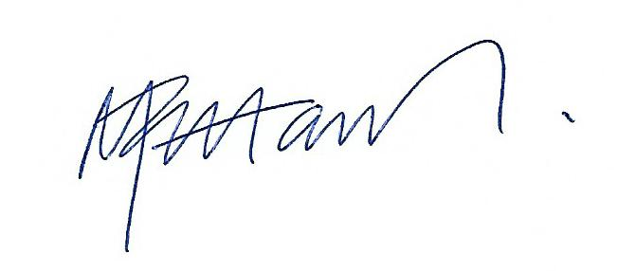
Michael Pettavel
Chair of Governors

