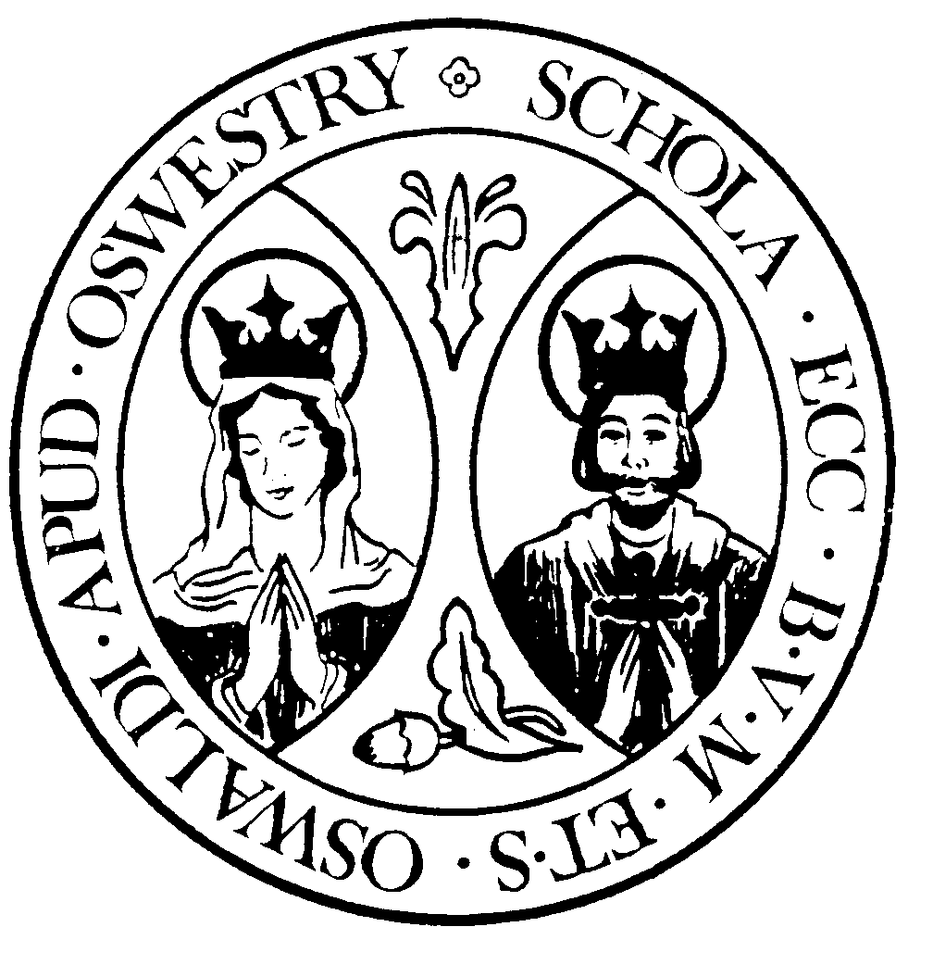  Head Teacher: Mrs N O’Dwyer  ‘Through Christ we Inspire and Flourish’ |   OUR LADY & ST. OSWALD'S CATHOLIC PRIMARY SCHOOL |  | Upper Brook Street  OSWESTRY  Shropshire  SY11 2TG  Tel: 01691 652849  E-mail: admin@osoprimary.co.uk  Website: www.osoprimary.co.uk

3 February 2025

Welcome Letter from the Chair of Governors

Dear Applicant,

On behalf of the Governing Board, I would like to thank you for your enquiry about this exciting position at Our Lady & St. Oswald’s Catholic Primary School.

We take great pride in our school that holds Christ at our centre; a caring school that challenges and motivates all to reach their potential. We are a school that values everyone, with empathy and support by creating an environment where lifelong learners and citizens of the future are created; who model respect, honesty and understanding.

We are looking to appoint a strong and dedicated leader to work closely with all involved in our school community. The successful candidate should be able to embrace our ethos, values and vision and look to use their experience and passion to build on our successes and introduce new initiatives to support our vision. With the support of our talented team, the school will continue to be a dynamic place of learning where every child is supported and encouraged to reach their full potential.

Our school has a strong focus on professional development which has offered many opportunities to staff. The enhanced skills and knowledge that the teaching staff have been able to bring back to the class room has seen important improvements in the way in which children interact with each other and learn.

The successful candidate will join the school at an exciting time as Governors look to implement Bishop Mark’s vision for education that all diocesan schools become members of a Catholic Multi Academy Trust. Governors are actively engaged in the process as we consider the options and opportunities of becoming part of Our Lady Help of Christians Catholic Academy Trust.

I hope you find the information pack on the school website useful in getting to know our lovely school. We would very much welcome a visit, so you can find out more about our school and we can answer any of your questions. You are invited to visit the school to meet with myself and have a chance to meet with the teaching team and the children.

Please contact the Office Administrator, Mrs Heather Birch, on telephone 01691 652 849 to arrange a visit on one of the following dates:

11 am or 1.30pm on 7 February 2025
1.30pm on 12 February 2025
11 am or 1.30pm on 13 February 2025
11 am or 1.30pm on 14 February 2025

The closing date for completed applications is noon on 24 February 2025 and interviews will be held on 12 March 2025

Yours sincerely,

Amanda Ali

Mrs Amanda Ali (Chair of Governors)

