HEADTEACHER RECRUITMENT PACK
PARK BROW PRIMARY SCHOOL
Welcome From Our Chair of Governors

Dear Applicant,

Thank you for your interest in the role of Headteacher at Park Brow Community Primary School.
The Governors are seeking an inspirational and dynamic leader with vision, passion and drive who is
ambitious for our pupils, staff and school community. Our last inspection was in July 2021 where we continued to maintain our long history of being a ‘Good’ School. We want to recruit a leader with the desire to lead us from good to outstanding who will continue to build on this good work and lead us into an exciting and successful future. Are you the person to do this?

I hope that you find the information in this pack of interest, for further details about our school,
you may wish to visit our school’s website, www.parkbrowprimary.co.uk. I welcome and encourage you to make an appointment to visit us before completing your application, details of which can be found within the job advert.

We are a larger than average primary school serving pupils aged 2 -11. We have higher-than-average SEND and Pupil Premium numbers. The school works hard and often going above and beyond, to ensure our wonderful pupils thrive and achieve their full potential.

Park Brow is a successful school and an exciting place to grow as a pupil, teacher or as a leader. This is underpinned by our 5 core values, which are supported throughout the curriculum - Respect, Potential, Pride, Happy, Caring. We recognise these as the basis of our relationships with each other, with the local community and with the world around us, and they support our school mission statement of ‘Together we can make a difference.’

It is our belief that when our children leave to take the next steps in their lives that they take with them a love of learning, a curiosity about the world, the ability to care about others and a confidence that they can reach their future aspirations.

We are a popular and successful school. Our new school building was opened in 2011 and has lots of modern facilities including a recent refurbishment of classroom furniture and IT equipment. In addition to Teaching and Support Staff the school is well staffed to ensure the needs of our pupils are fully met, including full time Attendance Officer, Safeguarding Lead, SEND Lead, Pupil Premium Teacher and SEMH Lead.

We have a caring ethos towards the well-being of our pupils and all of those who are
involved with the school. We are at the heart of the community, and encourage a sense
of belonging for all pupils, staff, families and governors, as we work together with one aim, to make
our school the best it can be.

The successful candidate will need to support this and continue to develop systems to ensure that partnerships remain strong and effective, where all our children achieve the very best outcomes.
The Governing Body is wholeheartedly commited to working together as part of the Kirkby Collaborative of Schools both now and in the future.

The governing body is proactive and supportive. It consists of a dedicated group of people who have a range of skills and experiences. It strives to be as effective as it can in its role of monitoring the progress of the school, to continuously raise the standards for all pupils and the quality of the education.

On behalf of the governing body, I hope that you find this information useful and that it encourages you to visit and apply to our school.

Yours sincerely,
Anna Truesdale
Chair of the Governors
Our School Building:

Opened in 2011, our school was built to provide the Communities of Southdene and Kirkby with state-of-the-art facilities designed to enhance the learning experience and enable local children to succeed.

The school has a variety of IT equipment ranging from iPads to Chrome Books, allowing pupils to work independently on the wider curriculum and build their knowledge of Computing. The school was recently refurbished with new classroom furniture and interactive teaching resources.

When it comes to protecting the planet, we do our bit to help the environment. As a relatively new build school, we use biofuels to heat our building, with carbon dioxide monitors and automatic regulation of air quality in our classrooms to enhance learning.

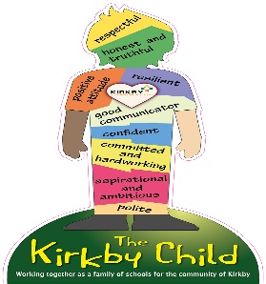
The school is housed in a double storey building with sixteen classrooms, a dedicated music room, a sports hall, community room, inclusion room,
sensory room, learning pods, senior leadership room, 2 x MUGA and large
playing fields.

Our school is more than just a splendid building with state-of-the-art equipment; our expert staff and wonderful pupils bring the place to life, creating an atmosphere that is second to none. We offer a vibrant, modern and unique 21st century learning environment.
About us:
‘Pupils say that everyone in their school is ‘MAD’, which means that they are all ‘making a difference’. Pupils recognise that all adults in school want them to become ‘their greatest self’. Pupils try their best to achieve these high expectations.’
OFSED July 2021

Park Brow Community Primary School amalgamated with Cherryfield Primary School in 2009, with both schools moving into a brand-new building in 2011. The building was designed to serve the community of Southdene and Kirkby.

We are a popular two form entry primary school, taking children from the age of 2 on their learning journey through to Year 6.

At the age of eleven most of our pupils
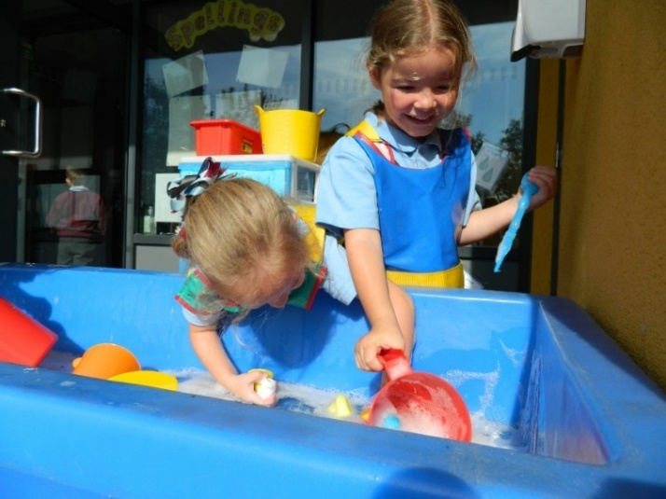
transfer to one of the two, local secondary schools in Kirkby; Kirkby High School or All Saints Catholic High School.

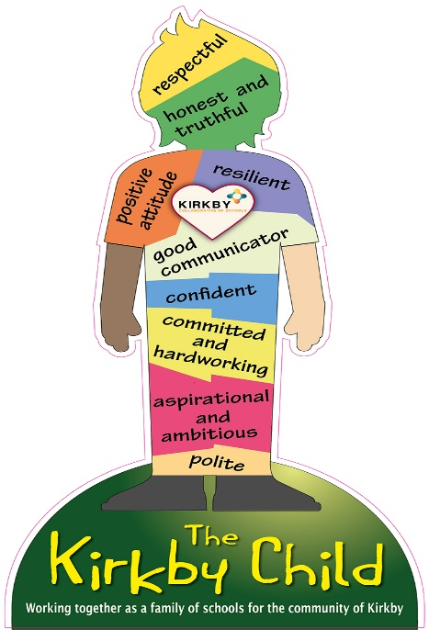
We are also privileged to house our 2-year-old provision (Starfish), providing
our pupils with a good start to our 30- hour Nursery Provision.

Our School is a member of the Kirkby Collaborative of Schools working together for the best possible outcomes for the children and families of Kirkby.

This allows for collaborative working between our schools, sharing good practice, providing support, celebrating success and delivering targeted CPD for staff and leaders.
We also aim to instil the values of ‘The Kirkby Child’ both within school and our community.

‘Staff feel well supported by leaders. They work together as a team. Staff also work in close partnership with other schools in the area. They benefit from the many training opportunities that this partnership provides.’
OFSTED 2021
The school has a well-planned progressive
curriculum with our curriculum drivers at its
heart- Key elements that form a consistent thread that run through our curriculum. These were devised by teaching staff to meet the wider needs of our children specifically as they go forward in their lives. These threads are, Possibilities, Knowledge of the World and Emotional Awareness.
Providing enrichment activities is at the heart of our curriculum. Further details can be found on our website
A Creative Curriculum – Park Brow Primary School
Newsletters – Park Brow Primary School
Reading is delivered through our ‘Supersonic
Phonic Scheme’, ‘Steps to Read’ and ‘Power of
Reading.’ This is to ensure our pupils are taught
all aspects of word reading and comprehension through high-quality fiction, non-fiction and poetry texts. Reading sessions explicitly teach our pupils reading skills and strategies in a cumulative way.
Our school works alongside Kirkby Library allowing pupils access to a wide range of books and bringing author visits to school.

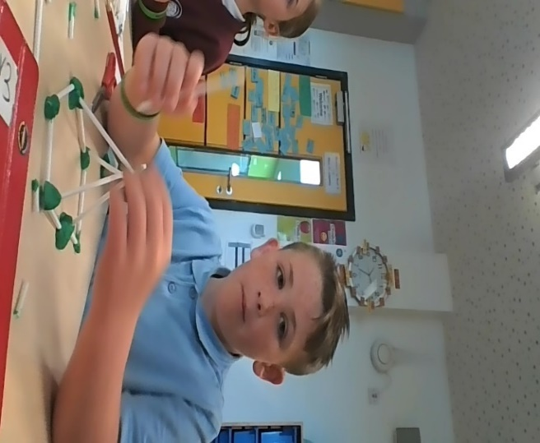
In Writing, the school utilises ‘Read to Write.’ The units of work centre on engaging, vocabulary-rich texts, with a wealth of writing opportunities. This Supports our pupils’ long-term memory by having strong thematic links to the Science, History and Geography curriculum. This means they know more and remember more.

The school has adopted ‘Power Maths.’ Focussing on Maths Mastery and aligned with White Rose Maths, it aims to spark curiosity, excitement and
nurture confidence in Maths. We are currently
part of the NW Maths Hub.

SEND provision is a strength of our school. We work with a range of external agencies who support our staff and pupils. To support Speech and Language we commission ‘Chatty Therapy.’ For our pupils with additional needs we commission time from Central Support. Further details can be found on our website.

As part of the wider curriculum, we have a traded service for Music, Computer
Science and Physical Education.
What our children want:

‘We want a Headteacher who is kind and caring living up to our special words’

‘It is important that we have a Headteacher who is sporty or who loves sports so that they can encourage us to keep healthy’

‘A Headteacher who is experienced and knows how to look after us and make sure we are learning’

A Headteacher who helps us to be the best we can be.
‘We would like someone who smiles and is happy, they stand out and say hello to us in the morning’
‘To really listen to what we have to say so that we can make improvements together’

We want our Headteacher to smile, be caring and happy.

‘Not too strict but someone who is fair and can help us to recognise how we can be the best we can be’
‘Someone who has faith and confidence in our teachers to do the very best for us’

Park Brow Primary School Job Description

The job description is guided by the National Standards for Headteachers 2015

Duties: This job description is subject to the general conditions of service for a Headteacher as set out in the current School Teachers Pay and Conditions Document.

Main Purpose: The Headteacher will work alongside the school’s Senior Leadership Team (SLT) to provide professional leadership, vision and strategic direction for the school in order to maintain its success. You will ensure the highest quality learning opportunities are available for our children as we continue our development and journey towards ‘outstanding’.

At Park Brow we believe that ‘Together we can make a difference’ We are seeking an inspirational leader who will espouse this belief and who will work in partnership with the governing body and other key community services, enabling all to reach their maximum potential in all areas of learning, primarily through the following key areas:

Vision, Values and Core Purpose

1. Articulate clear values, ethical and moral purpose, inclusive leadership of Park Brow Primary School, focused on providing a first-class education for our pupils.
2. Model positive relationships and attitudes to our students and engage parents, governors and members of the local community with the aim of constant improvement in all that we do.
3. Demonstrate emotionally intelligent leadership, modelling effective communication, conflict management and clean feedback with ease.
4. Ensure that the education, interests and safety of our children are at the centre of everything we do at Park Brow Primary School.
5. Inspire our children to develop a love of learning and commit wholeheartedly to nurturing every child.
6. Communicate compellingly the school’s vision and drive the strategic leadership, empowering all students and staff to think creativity and to excel.
7. As a Designated Safeguarding Lead you will ensure that everyone follows safeguarding policies that protect our children. You will work sensitively in partnership with school staff and other agencies to promote the welfare of all pupils and to keep our children safe from potential harm.

Improving learning and achievement in the classroom

1. Lead the improvement and development of Park Brow Primary School on the basis of sound evidence and knowledge about effective practice, promoting a strong culture of continuous professional development for our staff.
2. Demonstrate political astuteness in promoting the interests of our school in the context of our core objectives, translating opportunities arising from local and national policy into the school’s context.
3. Ensure that Park Brow Primary School’s development as a school is consistent with our core objectives and seeks further to serve our local community.

4. Demand ambitious standards for all students, turning disadvantage into advantage and advancing equality, whilst instilling a strong sense of accountability in staff for the impact of their work on pupils’ outcomes.
5. Demonstrate a clear understanding of the implications and issues for children in the school as a result of high free school meals, EAL, high SEND, challenging attendance and other impending social and educational changes. Have a clear strategic pathway to ensure that any child experiencing these barriers has the support and tools to turn the disadvantage to advantage.
6. Demonstrate the acumen and balance to ensure that outstanding teaching and learning is matched by excellent facilities
7. Maintain and secure outstanding teaching for all students through a clear understanding of the features of successful classroom practice, curriculum design and assessment.
8. Utilize evidence-based decision making, both within the classroom and in response to learner needs.
9. Promote and develop effective teaching and learning strategies for accelerated progress and smooth transition.
Leadership and Management

1. Promote the sharing of best practice between all staff and a culture where less-than-good practice is challenged and improved with clear, strategic planning.
2. Provide and maintain a safe, calm, inclusive, well-ordered and happy environment for all pupils and staff, focused on safeguarding pupils and developing their exemplary behaviour as they mature from children into young people.
3. Create an ethos within which all staff are motivated and supported to develop their own skills and subject knowledge and to support each other.
4. Foster a performance culture where everyone supports everyone. Where the collective works as one team for the good of all.
5. Identify emerging talents at all levels in Park Brow Primary School, developing current and aspiring leaders in a climate where excellence is the standard, leading to strong, smooth succession planning.
6. Hold all staff to account for their own professional conduct and professional practice.
7. Ensure that the school’s systems, organisation and processes are well considered, efficient and fit for purpose, upholding the principles of transparently, integrity and probity.
8. Establish, implement and maintain rigorous, transparent and honest systems for managing the performance of all staff, addressing under-performance, supporting staff to improve and value their individual journeys towards excellent practice.
9. Welcome strong governance and challenge. Actively support the governing body to deliver its functions ever more effectively – in particular its functions to set school strategy and hold the headteacher to account for safe-guarding, student, staff and financial performance.
10. Exercise strategic, curriculum-led financial planning to ensure the equitable deployment of budgets and resources, in the best interests of achievement for the children and the school’s sustainability.

This is not an exhaustive list and is in conjunction with the current conditions of service for Headteachers contained in the School Teacher’s Pay and Conditions document and other current education and employment legislation. In carrying out headteacher duties, the headteacher must consult, where appropriate, the Governing Body, the Local Authority, the staff within school, the parents of the pupils, and the children themselves. The governing body is committed to safeguarding and promoting the welfare of children and young people and expects all staff and volunteers to share this commitment.

Park Brow Primary School

“Together we can make a difference”.

Headteacher Person Specification

The person specification below shows the key abilities and skills we are looking for in our new Headteacher. The selection panel will shortlist candidates on the basis of how well they meet the requirements of this person specification.

We are looking for candidates who demonstrate knowledge and understanding of each area, and show evidence of having applied (or awareness of how to apply) this knowledge and understanding in a school context, to provide the vision and leadership for the school; creating, maintaining and developing the conditions which enable pupils and teachers to achieve effective learning, so that the school’s aims and objectives are implemented in accordance with the policies of the governing body and national and local educational strategies.

Selection Criteria |  | Essential (E) /  Desirable (D) | Shortlisting | Interview | Tasks | Presentation
Qualifications | Qualified teacher status. | E | $√$
 | National Professional Qualification of Headship (NPQH). | D | $$√$$
 | Further qualification in a related area e.g. M.Ed., M.A. | D | $$√$$ | $$√$$
Experience | Substantial and successful experience as a deputy head, Interim Headteacher or Headteacher. | E | $$√$$ | $$√$$
 | Successful teaching experience of the age range served by the school. | E | $$√$$ | $$√$$
 | Evidence of managing or making a substantial contribution to the effective management of change. | E | $$√$$ | $$√$$ | $$√$$ | $$√$$
Strategic Skills:  Direction and Development of the School | Ability to provide clear educational vision and direction and lead by example, developing and improving our already thriving school. | E | $$√$$ | $$√$$ | $$√$$ | $$√$$
 | Ability to formulate aims, policies and plans and monitor, evaluate and review the impact of these. | E | $$√$$ | $$√$$
 | Ability to work in partnership with the governing body. | E |  | $$√$$
 | Knowledge of current educational developments. | E |  | $$√$$ | $$√$$ | $$√$$

Selection Criteria |  | Essential (E) /  Desirable (D) | Shortlisting | Interview | Tasks | Presentation
Strategic Skills:  Direction and Development of the School | Evidence of initiating and managing effective strategies for improvement in pursuit of higher standards and strategic objectives. | E | $$√$$ | $$√$$ | $$√$$ | $$√$$
 | Knowledge of statutory requirements. | E |  | $$√$$ | $$√$$ | $$√$$
 | Evidence of successful implementation of strategies to improve teaching and learning to raise standards of achievement for all pupils. | E | $$√$$ | $$√$$ | $$√$$
 | Create a convincing vision for the school | E |  | $$√$$ |  | $$√$$
 | Create an outward-facing school which works with other school and organisations - in a climate of mutual challenge - to champion best practice and secure excellent achievements for all. | E |  | $$√$$ | $$√$$ | $$√$$
 | Use numerical and financial data with confidence to make decisions based upon analysis and interpretation | E | $$√$$ | $$√$$ | $$√$$
Communication Skills:  Leading and Managing Staff | Ability to lead, manage and motivate the whole school community, in a happy and supportive learning environment, to achieve the highest standards in every aspect of school life. | E | $$√$$ | $$√$$ | $$√$$
 | Ability to plan, allocate, delegate, support and evaluate work undertaken by groups, teams and individuals. | E | $$√$$ | $$√$$ | $$√$$
 | Think creatively and imaginatively to anticipate and solve problems. | E | $$√$$ | $$√$$ | $$√$$
 | Create a climate of open communication where people feel able to express opinions and know their views will be respected. | E | $$√$$ | $$√$$ | $$√$$
 | Successful experience of leading in-service training for staff. | E | $$√$$
 | Ability to consult and negotiate effectively with different stakeholders involved with the school, including pupils. | E | $$√$$ |  | $$√$$
 | Demonstrate reasoned judgement in difficult circumstances. | E | $$√$$ | $$√$$ | $$√$$

Selection Criteria |  | Essential (E) /  Desirable (D) | Shortlisting | Interview | Tasks | Presentation
Communication Skills:  Leading and Managing Staff | Deal sensitively with people with very different and demanding expectations, demonstrating the ability to avert and resolve conflict | E | $$√$$ | $$√$$ | $$√$$ | $$√$$
 | Identify and nurture talent, coaching current and aspiring leaders, to enable effective leadership development in a climate where excellence is the standard, leading to clear succession planning | E | $$√$$ | $$√$$
 | Hold staff to account for their professional conduct and practice, addressing any under-performance, supporting staff to improve and valuing excellence. | E | $$√$$ | $$√$$ |  | $$√$$
Standards | Experience of raising standards | E | $$√$$ | $$√$$ | $$√$$
 | Ability to collect, analyse and use data on pupils’ progress and performance to raise standards, using appropriate systems including ICT. | E | $$√$$ |  | $$√$$
 | Ability to set and achieve challenging targets for the school, cohorts, teachers and pupils. | E | $$√$$ | $$√$$ | $$√$$ | $$√$$
 | Ensure professional standards and duties are fulfilled, as specified in the Terms and Conditions of Service, including those for the Headteacher | E | $$√$$ | $$√$$
 | To promote and develop the good reputation of the school within the local and wider community | E | $$√$$ | $$√$$ |  | $$√$$
Teaching and Learning | Understanding of the principles of effective teaching and learning and the ability to promote a culture or learning throughout the school. | E | $$√$$ | $$√$$ | $$√$$ | $$√$$
 | Understanding of the principles of how to engage children through an exciting child centred curriculum. | E | $$√$$ | $$√$$ | $$√$$ | $$√$$
 | Successful experience of reviewing and developing the curriculum. | E | $$√$$ | $$√$$ | $$√$$
 | Understanding of the role and impact of assessment in children’s’ learning. | E | $$√$$ | $$√$$

Selection Criteria |  | Essential (E) /  Desirable (D) | Shortlisting | Interview | Tasks | Presentation
Teaching and Learning | Successful experience of monitoring, evaluating and improving the quality of teaching and learning in order to set and meet challenging, realistic targets for achievement. | E | $$√$$ | $$√$$ | $$√$$ | $$√$$
 | Successful experience of promoting the personal, social, moral, cultural and spiritual development of pupils. | E | $$√$$ | $$√$$
 | Develop and maintain effective links with the wider educational and local community, including business and industry, to extend the curriculum and enhance teaching and learning. | E | $$√$$ | $$√$$
 | Secure excellent teaching through the analytical understanding of how pupils learn and of the core features of successful classroom practice and curriculum design, leading to rich curriculum opportunities | E | $$√$$ | $$√$$ | $$√$$ | $$√$$
Ethos and Inclusion | Ability to create and maintain an environment which promotes good behaviour, discipline and celebrates success. | E | $$√$$ | $$√$$ | $$√$$ | $$√$$
 | Understanding of the factors which create barriers to learning and ability to implement appropriate strategies for reducing inequalities and promoting social inclusion. | E | $$√$$ | $$√$$ |  | $$√$$
Relationship with Parents and the Wider Community | Successful experience of creating and maintaining effective partnerships with parents and the community, to enhance pupils learning. | E | $$√$$ | $$√$$ |  | $$√$$
 | A clear understanding of the implications and issues to families and children in the school as a result of high free school meals, EAL, challenging attendance, mobility, overcrowding, poverty and other impending social and educational changes | E | $$√$$ | $$√$$ | $$√$$ | $$√$$
Suitability to work with children | Ability to form and maintain appropriate professional relationships with children and young people. | E | $$√$$ | $$√$$ | $$√$$
 | Experience of working with challenging behaviour. | E | $$√$$ | $$√$$ | $$√$$ | $$√$$
Selection Criteria |  | Essential (E) /  Desirable (D) | Shortlisting | Interview | Tasks | Presentation
Suitability to work with children | Appropriate use of authority and ability to maintain discipline. | E | $$√$$ | $$√$$ | $$√$$ | $$√$$
Effective and Efficient use of Staff and Resources | Ability to set, interpret, monitor and manage the annual budgets in order that school secures its objectives . | E | $$√$$ | $$√$$
 | Ability to manage, monitor and review the use of all available resources, ensuring best value. | E | $$√$$ | $$√$$
 | Experience of recruiting, selecting and deploying staff. | E | $$√$$ | $$√$$
 | Working closely with the School Business Manager, office staff and Site Manager, manage and organise the building and grounds efficiently and effectively to ensure the needs of the curriculum and health and safety regulations are met at all times. | E | $$√$$ | $$√$$
 | Ensure the school's system, organisation and processes are well considered, efficient and fit for purpose, upholding the principles of transparency, integrity and probity. | E | $$√$$ | $$√$$
Personal Effectiveness | Prioritise and manage time appropriately, able to work to deadlines | E | $$√$$ | $$√$$ | $$√$$ | $$√$$
 | Demonstrate effective performance against the job description when under pressure and/or in challenging circumstances, showing courage, vigour, pragmatism, resilience and perseverance. | E | $$√$$ | $$√$$
 | Create a strong, positive personal impact, conveying authority, confidence, approachability, warmth, humour and trust. | E | $$√$$ | $$√$$ |  | $$√$$
 | Be self-motivating to achieve and take full responsibility for challenging own professional development | E | $$√$$ | $$√$$ | $$√$$ | $$√$$
 | Demonstrate enthusiasm for, and commitment to, the role: along with reliability, integrity and a passion for creative problem solving. | E | $$√$$ | $$√$$ | $$√$$ | $$√$$
 | Seek advice and support where necessary | E | $$√$$ | $$√$$ | $$√$$ | $$√$$

Selection Criteria |  | Essential (E) /  Desirable (D) | Shortlisting | Interview | Tasks | Presentation
Accountability | Work closely with the Governing body and its sub-committees to secure positive relationships with all Governors | E | $$√$$ | $$√$$
 | Provide information, objective advice and support to the Governing Body to enable it to meet its responsibilities – in particular its functions to set school strategy and hold the headteacher to account for pupil, staff and financial performance – recognising that the Governing Body is accountable for the success of the school. | E | $$√$$ | $$√$$ | $$√$$ | $$√$$
 | To create and develop an organisation in which staff recognise that they are accountable to the Governors for the success of the school | E | $$√$$ | $$√$$
 | To lead or deputise as the designated Safeguarding lead and be accountable for all the elements of this role. | E | $$√$$ | $$√$$
Other Skills and Abilities | A detailed knowledge of new technologies and their potential impact. | E | $$√$$ | $$√$$ |  | $$√$$
 | Effective interpersonal, communication and presentation skills; both written and oral. | E | $$√$$ | $$√$$ | $$√$$ | $$√$$

