Finham Park

Multi Academy Trust

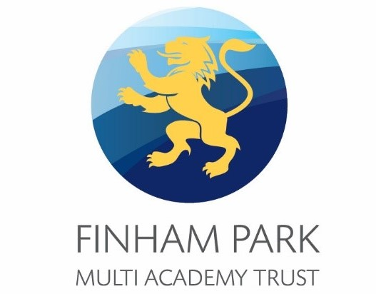

Pearl Hyde Community Primary School

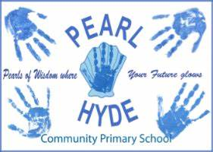

Headteacher’s Application Pack

January 2023

Contents

Letter from the Executive Headteacher………………….……………………….4
Letter from the Chair of Trustees 5
Pearl Hyde Primary School Overview 6
Latest Ofsted Report 7
Local Area and Location 8
Application Process 9
Selection Process 9

Letter from the Executive Head Teacher- Mark Bailie

Dear Candidate,

I am thrilled that you are interested in our Pearl Hyde Primary School Head Teacher vacancy.

Finham Park Multi Academy Trust was created in March 2015, with the aim of creating a small Coventry/West Midlands based Multi Academy Trust that pioneers, innovates and delivers a “World Class” education for all children from the age of 3-19, where the artificial barriers of stage and age are removed.

Our Trust aims to exceed the highest national and international benchmarks for academic achievement, whilst ensuring young people develop a passion for learning in all its contexts and are ready to take their place as active members of our global community.

Our vision is to move beyond collaboration and into co-construction – ensuring our education is developed with and by all members of the Trust to reflect the needs of our children, their families and the wider community.

We are immensely proud of our schools, which include a vibrant mix of Primary and Secondary schools, representing a diverse range of communities that we are honoured to serve.

We are in a very fortunate position where we have exceptionally strong and talented teams in each school and across the Trust. Staff well-being, welfare and professional development are priorities which are underpinned by our academy core values of collaboration, equity, achievement and trust. In addition, working towards a work life balance is something we strive to do. We fervently believe that if we get it right for staff, we then get it right for pupils.

I very much look forward to hearing from you.

Mark Bailie

Executive Head Teacher
Finham Park Multi Academy Trust

Letter from the Chair of Trustees
Dear Candidate,

We are writing to thank you for your interest in the vacancy for a Headteacher at Pearl Hyde Primary School. We sincerely hope that this letter, together with any additional supporting documentation and opportunities to visit the school will inspire and encourage you to want to work with us. This unique and exciting opportunity has become available due to the retirement of the current Headteacher.

Pearl Hyde Primary School converted to become an academy as part of Finham Park Multi Academy Trust in September 2019. The family of schools within our Trust currently comprises Finham Park School; Finham Park 2, our Free School; Finham Primary School, Lyng Hall School, Pearl Hyde Primary School, Lillington Primary School and Meadow Park School. The Trust’s vision is summarised below:

“Schools in the Finham Park MAT will set out to pioneer, innovate and deliver a “World Class” education for all children from the age of 0-19 where the artificial barriers of stage and age are removed. Our education will aim to exceed the highest national and international benchmarks for academic achievement, whilst ensuring young people develop a passion for learning in all its contexts and are ready to take their place as active members of our global community.”

Despite the pressures of a global pandemic, the school has continued to make significant progress toward improvement priorities identified as part of our annual review and self-evaluation activity. These priorities currently include a review and relaunch of the phonics and reading curricula, and a review of Foundation subject curricula to ensure they draw on the very best practice available at the time of writing. We are hopeful that the next Headteacher will lead our school towards our stated ambition of being a “World Class” school – somewhere that our pupils experience an education that rivals the very best around the globe and reflecting our desire to be a leading organisation on the national and international stage. To this end we are not a community that rests on its laurels; rather we are constantly striving to improve the experience we offer our pupils and, whilst proud of our track record and history, recognise that there is much still to do.

We want to appoint an inspirational headteacher for Pearl Hyde Primary School – a leader with charisma, expertise, and the skills to motivate both adults and children to achieve the very best for themselves and their school community.

We feel we can offer many things to a successful applicant. These would include the support of an experienced governing body; the collegiate support of other headteachers from both primary and secondary phases; the guidance of our Executive Headteacher, Mark Bailie (also a National Leader of Education and Ofsted Inspector) and a MAT Central Support Service (Finance, Human Resources, Estates, IT and School Improvement departments) that allows our Headteachers to focus on the most important things – opportunities for children! Pearl Hyde is fortunate in possessing an excellent team of teachers and support staff. There are many opportunities to develop the links and networks that a school needs not just to be successful in its own right, but also to support and learn from other partner organisations – In our view, this is an exceptional opportunity for the right person to develop our school and develop themselves as a school leader.

Thank you for your interest. We hope to receive an application from you in due course if you feel Pearl Hyde Primary School may be an exciting and vibrant place to work.

Mr Peter Burns MBE Mrs Melissa Wyatt
Chair of Finham Park Multi Academy Trust Chair of Pearl Hyde Primary Local Governing Body

Pearl Hyde Primary School Overview

Pearl Hyde Primary school is an exciting, friendly and supportive school based on the East side of Coventry, near Junction 2 of the M6 and adjacent to the Coventry University Hospital. We began serving the community in September 1974 and converted to Academy Status, joining the Finham Park Multi Academy Trust in September 2019.
Pearl Hyde MBE became a Labour Councillor in 1939 and stood in the Walsgrave Ward of Coventry for 18 years. She became a senior member of the City Council and was Chairman of several important committees. In 1957 she became the first Lady Lord Mayor of Coventry and requested that her daughter-in-law, Betty Hyde, was her Lady Mayoress.
During the Second World War Pearl Hyde was the organiser of the Coventry WRVS, arranging food and shelter for people who had lost their homes during the Blitz. Sadly Pearl Hyde was killed in a motoring accident in Scotland in 1963. In her memory our school, and a canal boat, are named after her.
There are 310 places in our school which we organise into 10 classes, working tirelessly to provide a stimulating environment, which invites enquiry. Our aim is to make sure every child is able to access the fabulous learning opportunities available to them, that they are enthusiastic, independent, curious leaners always ready to ‘have a go’. We are very proud of them all and of what they achieve both academically and personally. Everyone in the Pearl Hyde family works collaboratively to ensure all children are given every opportunity to enjoy learning and to thrive in our happy, stimulating and vibrant community school. This approach is enhanced even more though our work with the Finham Park Multi Academy Trust, developing the Co-Construction model across all the schools in the organisation.

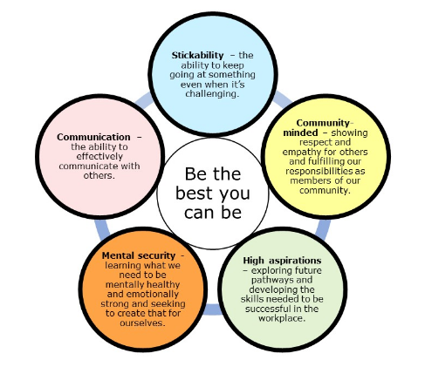

Latest Ofsted Report
Pearl Hyde Primary School was rated ‘Good’ by Ofsted on 10th March 2015

To View the Ofsted Report Please click here

Autumn Census 2021 Data
Pupils on roll | Total
 | 264
Gender | Mixed

Local Area and Location
Local Travel

Pearl Hyde Primary can be found off the A46 in the East of Coventry. With close links to the A4600/A45 and nearby M6/M69.

This means it is easy to reach Midlands towns and cities and their attractions including:

Birmingham - NEC, NIA, Cadbury World, numerous theatres, shops and sporting venues

Leicester – Resting place of Richard III, New Walk Museum, Abbey Park, Cultural Quarter

Warwick- Royal Leamington Spa and Shakespeare’s Stratford-upon-Avon.

Birmingham Airport can be reached within 30 minutes’ drive and good rail links include
London Euston which is just over an hour away.
Coventry

Coventry grew to become one of the most important cities in England during the Middle Ages due to its booming cloth and textiles trade.

The city was noted for its part in the English Civil War, and later became an important industrial city during the 19th and 20th centuries, becoming the centre of the British bicycle and later motor industry.

The devastating Blitz in 1940 destroyed much of the city centre, and saw its rebuilding during the 1950s and 60s. In the new millennium the city, along with many others saw significant urban renaissance and in 2017

The city was awarded the title of
2021 UK City of Culture

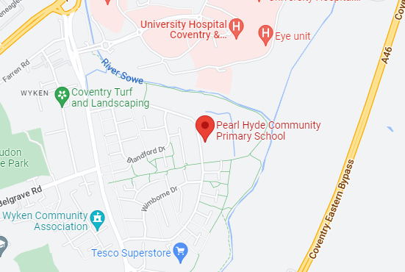

Pearl Hyde Primary School
Dorchester Way, Coventry CV2 2NB

Application Process

Closing date for applications: 6th February 2023
Interview dates: W/C 27th February 2023

Please return your application by email to: hr@finhamparkmat.co.uk

Selection Process
Stage 1

Applicants should send their completed
application form along with a covering letter
including a supporting statement evidencing how you fulfil the Person Specification to the HR Department by 6th February 2023

Please use the application form
provided.
Stage 3

TBC when interviews will take place

Candidates will take part in a number of recruitment activities, an unseen presentation and a formal interview.
Stage 2

Applications will be
reviewed and a short list produced for interview. Short listing will take place at 7th February 2023

Successful applicants will be notified by email and by telephone.

We welcome and strongly encourage informal visits to the school by prior arrangement.

Please telephone Sam Jannaway, PA to the Executive Headteacher on 02476 840803 or email s.jannaway@finhampark.co.uk, to arrange a visit. The following dates have been made available:
25th January (4pm), 31st January (School Day), 3rd February 2023(School Day)
We very much look forward to meeting you.

