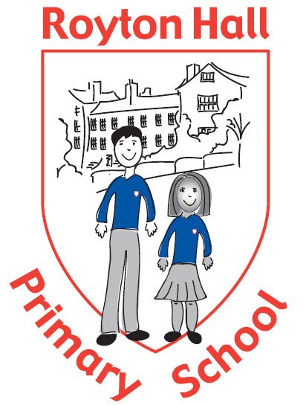

**HEADTEACHER**

**ROYTON HALL PRIMARY SCHOOL**

**HIGH BARN STREET**

**ROYTON**

**OL2 6RW**

**Permanent from September 2025**

**Job Details**

**Employer Royton Hall Primary School**

**Location Royton, Oldham**

**Number on Roll 330**

**Salary L15 – L21 (£70,293 - £80,634)**

**Contract type Full time**

**Contract term Permanent**

**Closing date 31st January 2025**

**Interview Date 24th and 25th February 2025**

Following the retirement of a long serving headteacher, the Governing Body of Royton Hall Primary School wish to appoint a dynamic and inspirational professional to lead their school.

Serving the Royton area of Oldham Royton Hall Primary School work with parents to encourage each child to fulfil their potential by means of high standards within a broad and well-rounded education. As a ‘Good’ school Royton Hall Primary equips each child with the skills, attitudes, and values to develop them into responsible citizens. Children learn effectively in a safe, secure, modern, high-quality environment where there is a happy, positive, and inclusive school culture. Everyone at Royton Hall Primary School is made to feel welcome.

Could you be the new leader to take our school forward? If so, you would:

• Be aspirational in your approach to the quality of teaching and learning and of the achievement and wellbeing of every child

• Be a role model who inspires and motivates the whole school community through their commitment, enthusiasm, and dedication to raising standards

• Be a highly effective leader who can manage and organise the personnel, financial and professional needs of the school’s resources and staff

• Be a leader with the interpersonal skills to develop strong working relationships with staff, children, parents, governors, the local community, and partner schools

• Be a skilled communicator who can share and develop their vision of what makes a good school with the school’s stakeholders.

• Build on the success that is already in place across the school

We can offer you:

• Wonderful, enthusiastic, and well-behaved children who are eager to learn and love their school

• A modern well-resourced school with outstanding facilities and equipment

• A supportive and committed Governing Board who work closely with school leaders

Visits to Royton Hall Primary School are encouraged and strongly recommended.

Please contact Keeley Black, School Business Manager to arrange a mutually convenient date at [keely.black@roytonhall-pri.oldham.sch.uk](mailto:keely.black@roytonhall-pri.oldham.sch.uk)

You can apply for this post on Greater.jobs where you can obtain additional information regarding the post. For further information about the school please visit the school’s website at [www.roytonhall-pri.oldham.sch.uk](http://www.roytonhall-pri.oldham.sch.uk)

Completed applications should be returned to [keely.black@roytonhall-pri.oldham.sch.uk](mailto:keely.black@roytonhall-pri.oldham.sch.uk)

The school is committed to safeguarding and promoting the welfare and safety of children and young people. We operate a strict safeguarding policy, with procedures being rigorously and consistently applied.

This position is subject to a criminal record check from the Disclosure and Barring Service which will require you to disclose all criminal convictions.