

**St Andrew’s Church of England Primary School - Crawley**



**Recruitment Pack - Headteacher**

**“Growing Learners to Live in God's World”**

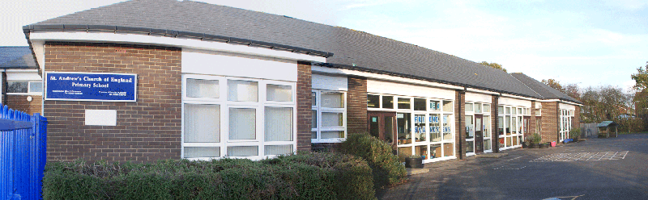

### Letter from Chair of Governors – Page 3

Key information – Page 4/5

What our children say – Page 6

Our locality – Page 7

Job Description – Page 8/9

Person Specification – Page 10/11

Application Process – Page 12

#### 

Dear Applicant,

**Re: Post of Headteacher: St Andrew’s C of E Primary School, Crawley**

We are delighted that you are considering applying for the post of Headteacher at St Andrew’s Primary School, Crawley. The whole school community has contributed to the application pack to help you gain a better understanding of our school and our aspirations for the future. Everyone is excited by the prospect of our new Headteacher arriving and the governing body is committed to selecting the best person for the job. We really hope you will share our enthusiasm for what the future holds and feel inspired to apply to become the leader of our school.

Our Christian ethos is at the heart of all we do at St. Andrew’s Primary School. We work in close partnership with St Andrew’s Church community who worship at the adjoining Church. Our mission is “Growing learners to live in God’s world”. We are looking for a visionary Headteacher who will work with St Andrew’s Church to make this mission a reality.

We are on a continuous improvement journey. Our last Ofsted report confirmed that we are a ‘Good’ school, but we are not complacent. We strive to become a beacon of outstanding Christian based education in Crawley. Our aim is to be a centre of excellence for primary teaching where staff are proud to develop their talents in a cutting-edge learning environment. To achieve this ambitious future for our school we need an energetic, innovative and determined leader with a passion for delivering the very best education for our children. As we look to develop new ways of working and ensure St. Andrew’s Primary continues to provide for the needs of our children and their families, we need a Headteacher who can ‘think big’ and has a hunger to push us to even greater achievements.

For further information about our school community please visit our Headteacher recruitment video on YouTube and search for “St Andrew’s Primary Crawley Headteacher Recruitment 2021”

If you feel you have the skills, experience and enthusiasm we are looking for, then we would welcome your application. In your application form and supporting statement, please address the person specification and provide evidence of impact.

Your letter should be no more than two sides of A4 when typed.

We would welcome informal visits to the school. We have scheduled Friday afternoons for visits, however if this is not convenient for you, we would be happy to arrange an alternative time. If you would like to visit, please contact the school office on:-

Telephone: 01293 529006 or email: [office@stap.school](mailto:office@stap.school)

The closing date is Monday 1st March 2021 at 08:00.

We will be contacting shortlisted candidates shortly after this date.

We look forward to receiving your application.

Yours sincerely,

Richard Quirk

Chair of Governors



St Andrew’s Church of England Primary School

Key Information

Type of School Voluntary Aided

Number of teaching staff 15

Number of Staff 39

Number of children on roll (September 2020) 203

Attendance (2018-2019) 95.49%

% SEND 21%

% EAL 26%

% eligible for Pupil Premium 19%

Latest Ofsted Report (June 2017) [www.ofsted.gov.uk](http://www.ofsted.gov.uk/)

Latest SIAMS Inspection Report (October 2015) [www.churchofengland.org](http://www.churchofengland.org/)

|  |  |  |  |  |
| --- | --- | --- | --- | --- |
| **KEY STAGE 1 RESULTS 2019** | | | | |
| **Result** | **Reading** | **Writing** | **Maths** | **Science** |
| **GDS** | 21 | 7 | 18 | n/a |
| **EXS** | 71 | 79 | 71 | 89 |
| **WTS/HNM** | 7 | 14 | 11 | 11 |
| **PK4 – PK1** | 0 | 0 | 0 | n/a |
| **BLW** | 0 | 0 | 0 | n/a |
| **D** | 0 | 0 | 0 | n/a |
| **A** | 0 | 0 | 0 | n/a |

|  |  |  |
| --- | --- | --- |
| **KEY STAGE 2 TEACHER ASSESSMENTS 2019** | | |
| **Result** | **Writing** | **Science** |
| **GDS** | 23 | n/a |
| **EXS** | 53 | 83 |
| **WTS/HNM** | 23 | 17 |
| **PK6 - 1** | 0 | 0 |
| **BLW** | 0 | n/a |
| **D** | 0  0 | n/a |
| **A** | 0 | n/a |

|  |  |  |  |  |  |  |  |  |
| --- | --- | --- | --- | --- | --- | --- | --- | --- |
| **KEY STAGE 2 TEST RESULTS 2019** | | | | | | | | |
| **Percentage at outcome** | | | | | | | | |
|  | **B** | | **Not Achieved Standard** | **Achieved Standard** | **Exceeded Standard** |  | **U** | **A** |
| **Grammar Punctuation & Spelling** | | 0 | 20 | 60 | 20 |  | 0 | 0 |
| **Reading** | | 0 | 37 | 47 | 17 |  | 0 | 0 |
| **Mathematics** | | 0 | 20 | 57 | 23 |  | 0 | 0 |

What our children say about our new Headteacher



lays the Guitar

# Friendly MAkes us LAugh

Forgiving

Likes football

# Understands us

**Exciting**

**Funny**

creative Reasonable



St Andrew’s Church of England Primary School

Caring

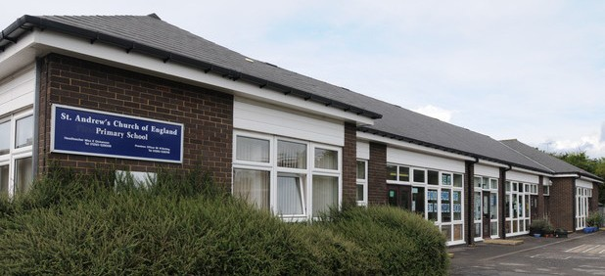

## Our locality

#### How to find us

St Andrew’s Church of England Primary School Weald Drive

Furnace Green Crawley

West Sussex, RH10 6NU

#### The Local Area

Furnace Green is a neighbourhood of Crawley in West Sussex, England. It is one of the 13 designated neighbourhoods of Crawley. Furnace Green is located to the east of the town centre. It is bordered by Tilgate to the south west, Three Bridges to the north and Maidenbower to the east (on the other side of the London-Brighton railway line).

The name Furnace Green is a reference to the iron smelting which is reputed to have taken place in Roman times - the local public house is the Charcoal Burner.

There is a Nature Reserve and flood plain named Waterlea Meadow lying between Norwich Road and Waterlea. It is split by a meandering stream and has several ponds and footpaths. The stream is largely fed from the lake at Tilgate Park.

Crawley’s only full-scale theatre is located on the northern edge of Furnace Green. The Hawth takes its name from the large area of woodland to its rear.

Crawley is a town and borough in West Sussex, England. It is 28 miles (45 km) south of Charing Cross (London), 18 miles (29 km) north of Brighton and Hove, and 32 miles (51 km) northeast of the county town of Chichester, covers an area of 17.36 square miles (44.96 km2) and had a population of 106,597 at the time of the 2011 Census.

The area has been inhabited since the Stone Age and was a centre of ironworking in Roman times. Crawley developed slowly as a market town from the 13th century, serving the surrounding villages in the

Weald; its location on the main road from London to Brighton brought a passing trade, encouraging the development of coaching inns. It was connected to the railway network in the 1840s.

Gatwick Airport, now one of Britain’s busiest international airports, opened on the edge of the town in the 1940s, encouraging commercial and industrial growth. After the Second World War, the British Government planned to move large numbers of people and jobs out of London and into new towns around South East England.

The town comprises thirteen residential neighbourhoods radiating out from the core of the old market town and separated by main roads and railway lines. Economically, the town has developed into the main centre of industry and employment between London and the south coast of England.

A large industrial area supports industries and services, many of which are connected with the airport, and the commercial and retail sectors continue to expand.

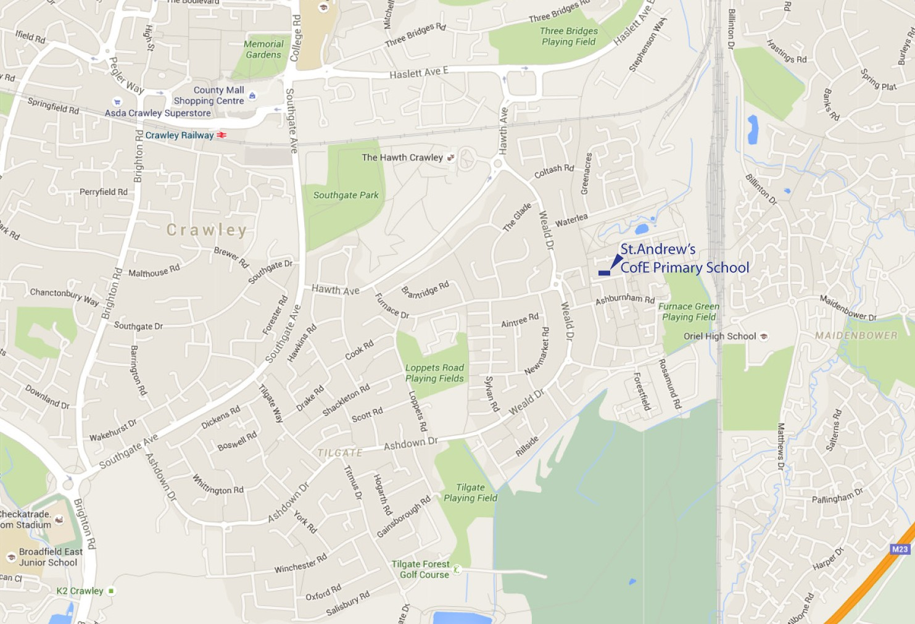

## Job Description

#### St Andrew’s Primary School, Crawley

POST: HEADTEACHER GROUP 2

NUMBER ON ROLL: 203

PAY RANGE: ISR L13 – L19

RESPONSIBLE TO:

The governors of the School and West Sussex County Council/Chichester Diocese

#### Main purpose of the job:

To provide professional leadership for the school, which secures its success and improvement, ensuring high quality education which inspires and motivates its pupils and improves standards of learning and achievement. To work with and through others to secure the commitment of the wider community to the school.

Demonstrate Christian vision and values in everyday work and practice

To be responsible for the leadership, internal organisation, management and control of the school and consult appropriately in doing so.

To promote and safeguard the welfare of children and young persons she/he is responsible for or comes into contact with.

Additionally, Headteachers are required to carry out the duties set out in the School Teachers’ Pay and Conditions Document1. SHAPING THE FUTURE



* 1. Ensure the vision for the school is clearly articulated, shared, understood and acted upon effectively by all
  2. Work within the school community to translate the vision into agreed objectives and operational plans which will promote and sustain school improvement
  3. Demonstrate the vision and values in everyday work and practice
  4. Motivate and work with others to create a shared culture and positive climate
  5. Ensure creativity, innovation and the use of appropriate new technologies to achieve excellence
  6. Ensure that strategic planning takes account of the diversity, values and experience of the school and community at large
  7. Work in partnership with St Andrew’s Church to secure a shared vision for the Christian development of the children, the school and the community.
  8. Ensure strategic planning is rooted in Christian values.

1. LEADING TEACHING AND LEARNING
   1. Ensure a consistent and continuous school

-wide focus on pupils’ achievement, using data and benchmarks to monitor progress in every child’s learning

* 1. Ensure that learning is at the centre of strategic planning and resource management
  2. Ensure a culture and ethos of challenge and support where all pupils can achieve success and become engaged in their own learning
  3. Demonstrate and articulate high expectations and set stretching targets for the whole school community
  4. Determine, organise and implement a diverse, flexible curriculum and implement an effective assessment framework
  5. Monitor, evaluate and review classroom practice and promote improvement strategies
  6. Challenge underperformance at all levels and ensure effective corrective action and follow-up
  7. Determine and ensure the implementation of a policy for the pastoral care of the pupils and securing that the standard of behaviour and attendance of the pupils is acceptable

1. DEVELOPING SELF AND WORKING WITH OTHERS
   1. Treat people fairly, equitably, with dignity and respect to create and maintain a positive school culture
   2. Build a collaborative learning culture within the school and actively engage with other schools to build effective learning communities
   3. Develop and maintain effective strategies

and procedures for staff induction, professional development and performance review

* 1. Ensure effective planning, allocation, support and evaluation of work undertaken by teams and individuals, ensuring clear delegation of tasks and devolution of responsibilities
  2. Acknowledge the responsibilities and celebrate the achievements of individuals and teams
  3. Report to the chair of governors annually on the professional development of all teachers

at the school and advise the governing body on the adoption of effective procedures to deal with capability issues

* 1. Regularly review own practice, set personal targets and take responsibility for own personal development by participating in arrangements made for the appraisal of Headteacher performance
  2. Manage own workload and that of others to allow an appropriate work/life balance

1. MANAGING THE ORGANISATION
   1. Create an organisational structure that reflects the school’s values, and enable the management systems, structures and processes to work effectively in line with legal requirements



* 1. Produce and implement clear, evidence-based improvement plans and policies for the development of the school and its facilities
  2. Manage the school’s financial and human resources effectively and efficiently to achieve the school’s educational goals and priorities
  3. Recruit, retain and deploy staff appropriately and manage their workload to achieve the vision and goals for the school
  4. Manage and organise the school environment efficiently and effectively to ensure that it meets the needs of the curriculum and health and safety regulations

1. SECURING ACCOUNTABILITY
   1. Develop a school ethos that enables everyone to work collaboratively, share knowledge and understanding, celebrate success and accept responsibility for outcomes
   2. Ensure individual staff accountabilities are clearly defined, understood and agreed and are subject to rigorous review and evaluation
   3. Work with the governing body, providing information, objective advice and support to enable it to meet its responsibilities
   4. Develop and present a coherent, understandable and accurate account of the school’s performance to a range of audiences including governors, parents and carers
   5. Liaise and co-operate with the officers of the local authority, reporting in connection with discharge of Headteacher functions as they

may properly require and seek their advice when necessary.

## Headteacher – St Andrew’s Primary School, Crawley PERSON SPECIFICATION

|  |
| --- |
| **CRITERIA** |
| A committed Christian who is an active member of a church belonging to Churches Together in Britain  and Ireland or the Evangelical Alliance. |
| **ATTAINMENTS AND EXPERIENCE** |
| National Professional Qualification for Headteachers (NPQH) |
| Qualified Teacher Status |
| Good honours degree |
| Evidence of recent and relevant continuous professional development |
| An in-depth understanding of effective primary teaching and learning |
| A proven track record of successful strategic leadership and management as a Headteacher or deputy Headteacher. |
| Successful experience of raising achievement |
| **SHAPING THE FUTURE** |
| **Knowledge of or commitment and ability to:** |
| Understand and discuss local, national and global trends |
| Think strategically, by building, communicating and implementing a shared vision of excellence, equity  and high standards for every pupil |
| Communicate and model vision and values both within and beyond the school |
| Lead change, create and innovate so that others carry the vision forward |
| Set and achieve ambitious, challenging goals and targets |
| Use appropriate new technologies |
| Understand & practise educational inclusion so that all have the opportunity to be the best they can be |
| Ability to understand the school’s current strengths and challenges and the ways in which these may be further developed |
| **LEADING TEACHING AND LEARNING** |
| **Knowledge of or commitment and ability to:** |
| Implement strategies for raising achievement and achieving excellence for pupils, staff and self |
| Use appropriate models and principles of effective learning and assessment for learning, informed by research |
| Lead the management of behaviour and attendance |
| Be strategic in ensuring inclusion, diversity and access |
| Lead curriculum design and management |
| Implement strategies for developing effective teachers to ensure the entitlement of all pupils to effective teaching and learning |
| Ensure choice and flexibility in learning to meet the personalised learning needs of every child |
| **DEVELOPING SELF AND WORKING WITH OTHERS** |
| **Knowledge of or commitment and ability to:** |
| Develop interpersonal relationships, adult learning and models of continuing professional development (CPD) |
| Promote individual and team development and sustaining a learning community that impacts on school improvement |
| Share leadership and accountability for goals and standards |
| Manage change, conflict and empower individuals and teams |
| Collaborate and network with others within and beyond the school |
| Give and receive effective feedback and act to improve personal performance |
| Accept support from others including colleagues, governors and the LA |

10

|  |
| --- |
| **MANAGING THE ORGANISATION** |
| **Knowledge of or commitment and ability to:** |
| Apply principles and practice of dispersed leadership & accountability |
| Apply principles and strategies of school improvement |
| Plan and manage projects for implementing change |
| Create policies, through informed decision-making, consultation and review |
| Carry out strategic financial planning, budgetary management and apply principles of best value |
| Apply good practice in performance management |
| Understand legal issues relating to managing a school including Child Protection Procedures, Equal  Opportunities, Race Relations, Disability, Human Rights and Employment legislation |
| Manage equitably staff and resources |
| Developing and sustaining a safe, secure and healthy school environment by understanding personnel,  governance, security and access issues |
| Think creatively to anticipate and solve problems |
| Manage the school efficiently and effectively on a day-to-day basis |
| Delegate management tasks and monitor their implementation |
| **SECURING ACCOUNTABILITY** |
| **Knowledge of or commitment and ability to:** |
| Abide by educational frameworks, including governance |
| Abide by public services policy and accountability frameworks, including self-evaluation and multi- agency working |
| Use a range of evidence, including performance data and external evaluations to improve aspects of school life, including challenging poor performance |
| Apply principles and practice of quality assurance systems, including school review, self-evaluation,  performance management and stakeholder and community involvement. |
| Lead the team effectively and efficiently towards the academic, spiritual, moral, social, emotional and cultural development of all pupils |
| Hold other relevant staff members to account for pupil learning outcomes |
| **STRENGTHENING COMMUNITY** |
| **Knowledge of or commitment and ability to:** |
| Demonstrate political insight and anticipate trends that impact on the school community |
| Utilise rich and diverse resources within local communities |
| Articulate and promote Christian ethos in the school community |
| Project the school in a positive way and establish the school at the heart of the  Community |
| Utilise the wider curriculum beyond school and the opportunities it provides for pupils and the school community |
| SAFEGUARDING CHILDREN: SAFE RECRUITMENT AND SELECTION |
| In addition to candidates’ ability to perform the duties of the post, the interview will also explore issues relating to safeguarding and promoting the welfare of children including:   * Motivation to work with children and young people * Ability to form and maintain appropriate relationships and personal boundaries with children and young people * Emotional resilience in working with challenging behaviours and attitudes to use of authority and maintaining discipline |

**Application Process**

**School Visits**

Visits to the school are welcomed. Please contact the school directly on telephone: 01293 529006 or e-mail:[office@stap.school](mailto:office@stap.school%20) to arrange a visit.

Closing Date: Monday 1st March 2021 at 08:00

Please send your completed application form and supporting letter in Word format (not PDF) to: -

Schools Recruitment Team

Job Reference No: 16366

Email:[HRSchoolAdverts@westsussex.gov.uk](mailto:HRSchoolAdverts@westsussex.gov.uk)

Candidates will be shortlisted against the criteria within the Person Specification. Short listed candidates will be informed soon after the 8th March 2021 and will be informed of the requirements and timings of the interviews. References will be taken up and proof of identity and qualifications will be required.

Interviews: 23rd and 24th March 2021

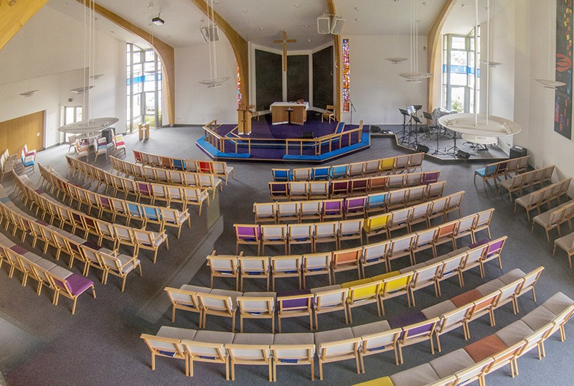

St Andrew’s church sanctuary

Interviews will take place over 2 days and will be held at St Andrew’s Primary School and St Andrew’s Church.

## Pay Scale

#### L13 – L19

**Safeguarding**

The Governing Body, Local Authority and Chichester Diocese are committed to safeguarding and promoting the welfare of children and young persons. Headteachers must ensure that the

highest priority is given to following guidance and regulations to safeguard children and young people. The successful candidate will be required to undergo an enhanced disclosure from the disclosure and barring service (DBS).

## Contact Details

St Andrew’s Church of England Primary School Weald Drive

Furnace Green Crawley

West Sussex RH10 6NU

Tel. 01293 529006

Web [www.st-andrews-crawley.w-sussex.sch.uk](http://www.st-andrews-crawley.w-sussex.sch.uk/) e-mail [office@stap.school](mailto:office@stap.school)