The Governing Board of St Blaise CE (Controlled) Primary School is looking to recruit an outstanding Headteacher to lead our successful and expanding school, starting September 2024.
St Blaise is located in Milton Heights, just off the Milton A34 interchange.
NoR 142 Group size 1, Salary range: 12-18 (£61.882 - £71,019)

This is an exciting time to lead St Blaise as we continue our journey to become a one-form entry school (with possible further development to a 2-form entry). School expansion has meant we enjoy a new, spacious EYFS and KS 1 building and enlarged grounds. This development complements original classrooms now used for KS2, a large hall, outdoor learning and science garden. The community of Milton Heights is expanding with much new housing: ensuring present and new communities come together in harmony is a key priority. Pupils’ attainment is at or above national averages; progress is good and often well above that which can be expected.

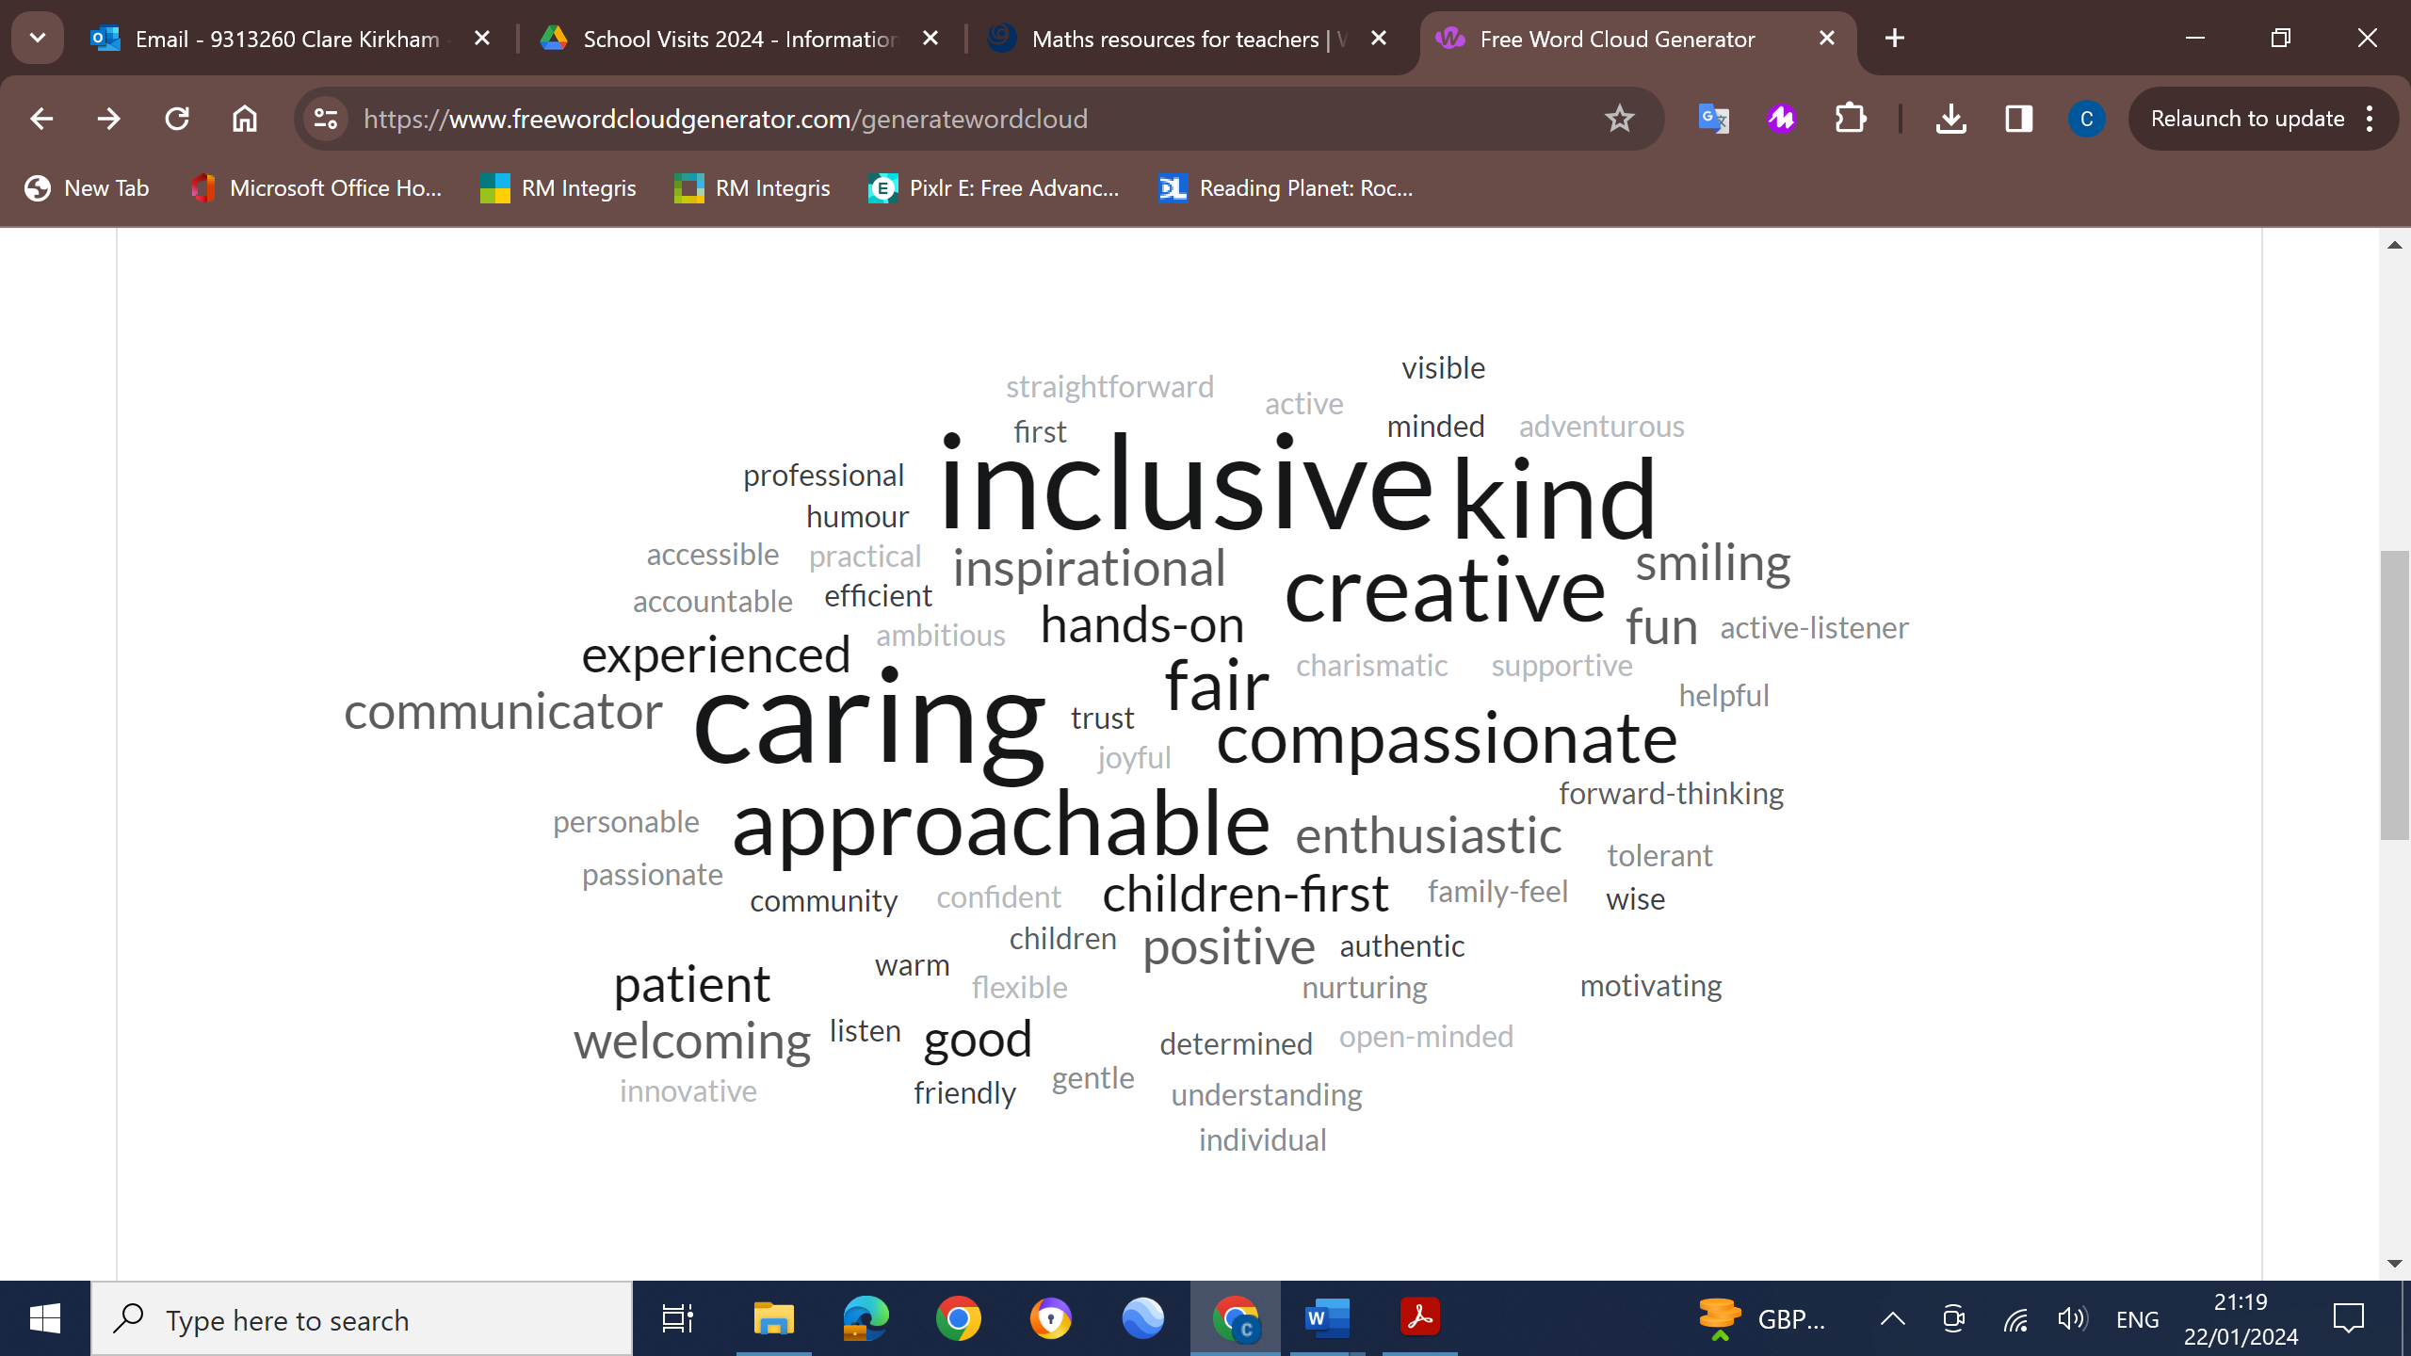
Pupils, parents and carers and staff say what they would like for their next headteacher:
We can offer you:
(Loads actually, but in a nutshell)
- Enthusiastic pupils, who love learning
- Supportive and committed parent body
- A team of creative teachers with a good mix of experienced and newly trained
- Skilled and dedicated support staff
- A hard working, knowledgeable and supportive governing body
- A school well-respected within the wider community
- A financially stable school
- An expanding school with opportunities to appoint new staff and the challenge of bringing new communities together
- A chance to grow and develop in your headteacher role

A Headteacher Information Pack– with procedures, an application form, job description and person specification, is available to download from the school website, www.st-blaise.oxon.sch.uk or by contacting the school office.

Application Procedure
Visits to the school are encouraged, please contact the school office.
Completed applications (application form and letter of application, 2 sides of A4 maximum) should be returned to the Chair of Governors at the school address or electronically chair.3260@st-blaise.oxon.sch.uk with the title Head Teacher Recruitment in the subject line.

The closing date for applications is midday on Wednesday 21st February 2024 Shortlisting will take place on Thursday 22nd February 2024 Further details will be sent to those candidates called for interview. The selection process will take place on Tuesday 5th and Thursday 7th March 2024.
Should you have any questions please contact the school:
Telephone: 01235 831 368 or email office.3260@st-blaise.oxon.sch.uk

Safeguarding
We are committed to safeguarding and promoting the welfare of children and young people and expect all staff and volunteers to share this commitment.
The successful applicant for any position will be required to undertake an enhanced disclosure via the DBS (disclosure and barring system) and appropriate Right to Work clearances in line with our recruitment and selection practices.

School address: School Lane, Milton Heights, Abingdon, Oxon, 0X14 4DR

