


Our Aspirations and Dreams…

What we want for our children:

- to be happy and grow up believing in themselves
- to have dreams and goals
- to feel a sense of achievement
- to be good, caring, kind and forgiving human beings who think about people and the world we live in
- to be resilient and determined; to keep trying
- to be respectful, tolerant and considerate citizens, enjoying individual liberty whilst engaging in the democratic systems of our society
- to grow up with the desire to make the world better
- to be creative and playful
- to be courageous explorers who confidently and enthusiastically accept challenges
- To be living witnesses of Christ to the world

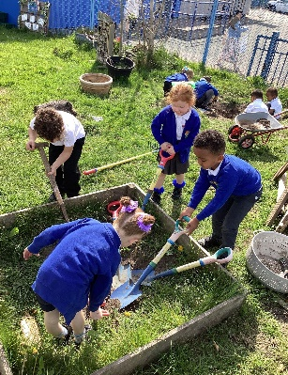
Do you have love, joy, energy, kindness and patience and are you a practicing Catholic with the drive and enthusiasm to lead our school? Due to the retirement of our current and well respected Headteacher, the children, staff and governors are seeking a new Headteacher, who is committed to building an exceptional and caring learning environment where all members of the school community can thrive.

St Brigid’s is a warm, friendly and diverse inner-city school located near the Etihad Stadium.
We are a truly passionate team seeking to recruit someone inspirational to help us continue to grow and live out our mission so our children can be the best that they can be. As a Catholic school, Christ is at the centre of all we do.

At St Brigid’s our values permeate all areas of school life and are reflected by the school’s simple motto:
DREAM IT. BELIEVE IT. ACHIEVE IT.
Our school mission statement celebrates our school’s vision and values.
Happy, kind people
Flourishing, resilient learners
Playful, courageous explorers
A faithful, thriving community
Filled with the spirit
To be the best we can be
As shining examples of God’s love
In short, our children are truly incredible and our greatest endeavour is to give them the opportunities to thrive and to be the best they can be.
We believe that our school belongs to the community it serves and therefore children can create legacies for each other. The children contributed to the design of the school logo, the wonderful outdoor space, the children’s chapel- created for children by children and the library which the children also helped to design, along with other parts of the school environment.

St Brigid’s RC Primary School
Headteacher
(Leadership spine points L15 to L21)
Grey Mare Lane, Beswick, M11 3DR 0161 223 5538 NOR 235/PAN 249
www.st-brigids.manchester.sch.uk Required for 22nd February 2026



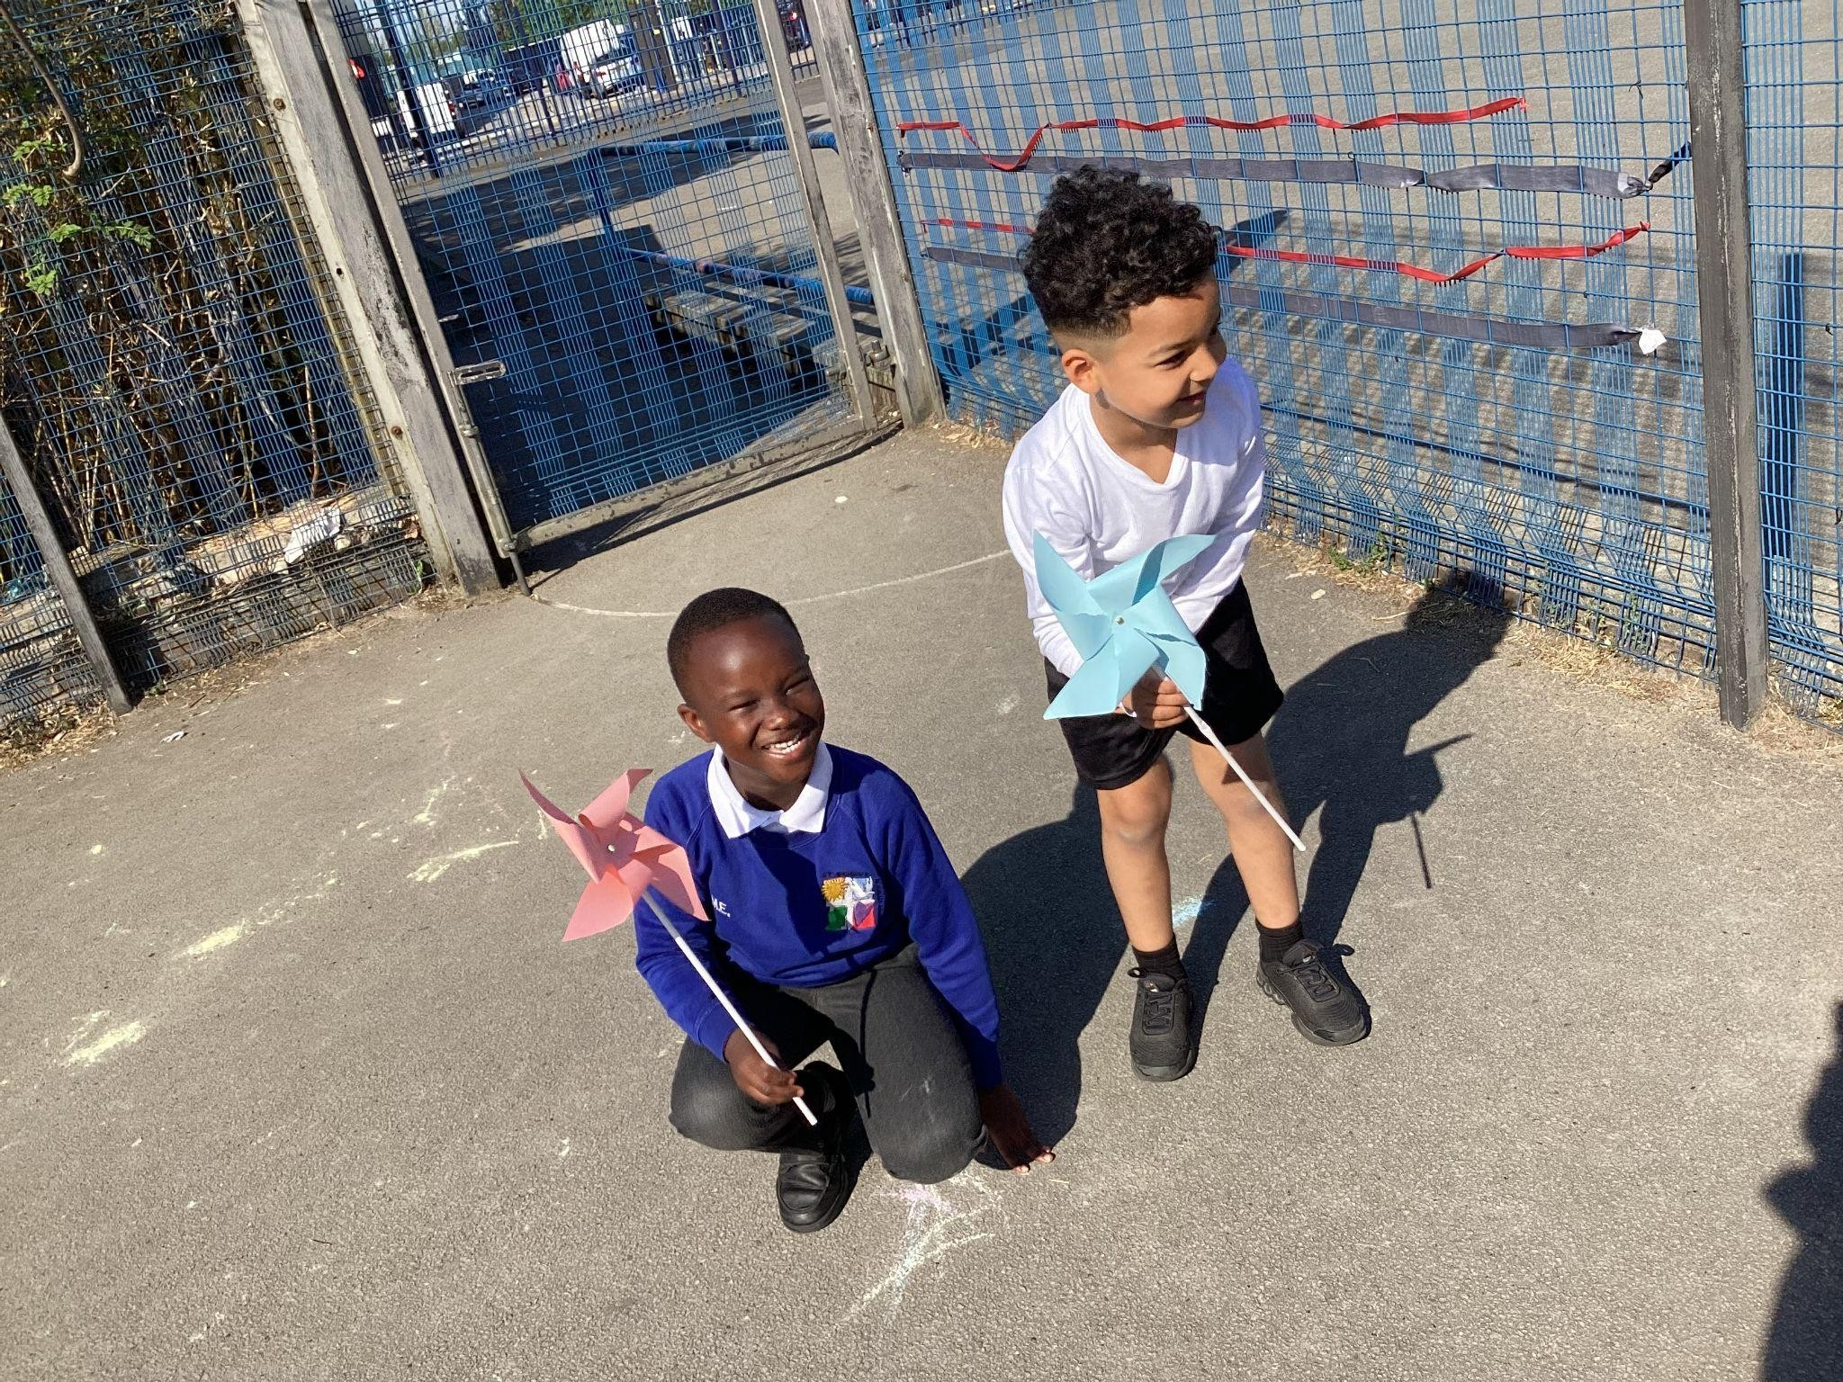

What we are looking for:

We are looking for a strong, dynamic and inspirational leader who:

- will support our Catholic ethos
- has the vision and dedication to take on the challenge of leading this outstanding school
- works with mission integrity for the benefit of all within the school community
- will really care about the children in our school
- has a clear strategic direction
- will challenge and empower staff to be the best they can be
- is able to inspire and motivate our children
- will foster the fabulous learning culture across our school
- will continue to inspire learning whilst ensuring high levels of achievement
- has excellent communication skills
- is able to lead a team and be a true team player
- understands the challenges of an inner-city school
- is solution-focused and resilient
- will support the respectful and inclusive ethos of our school

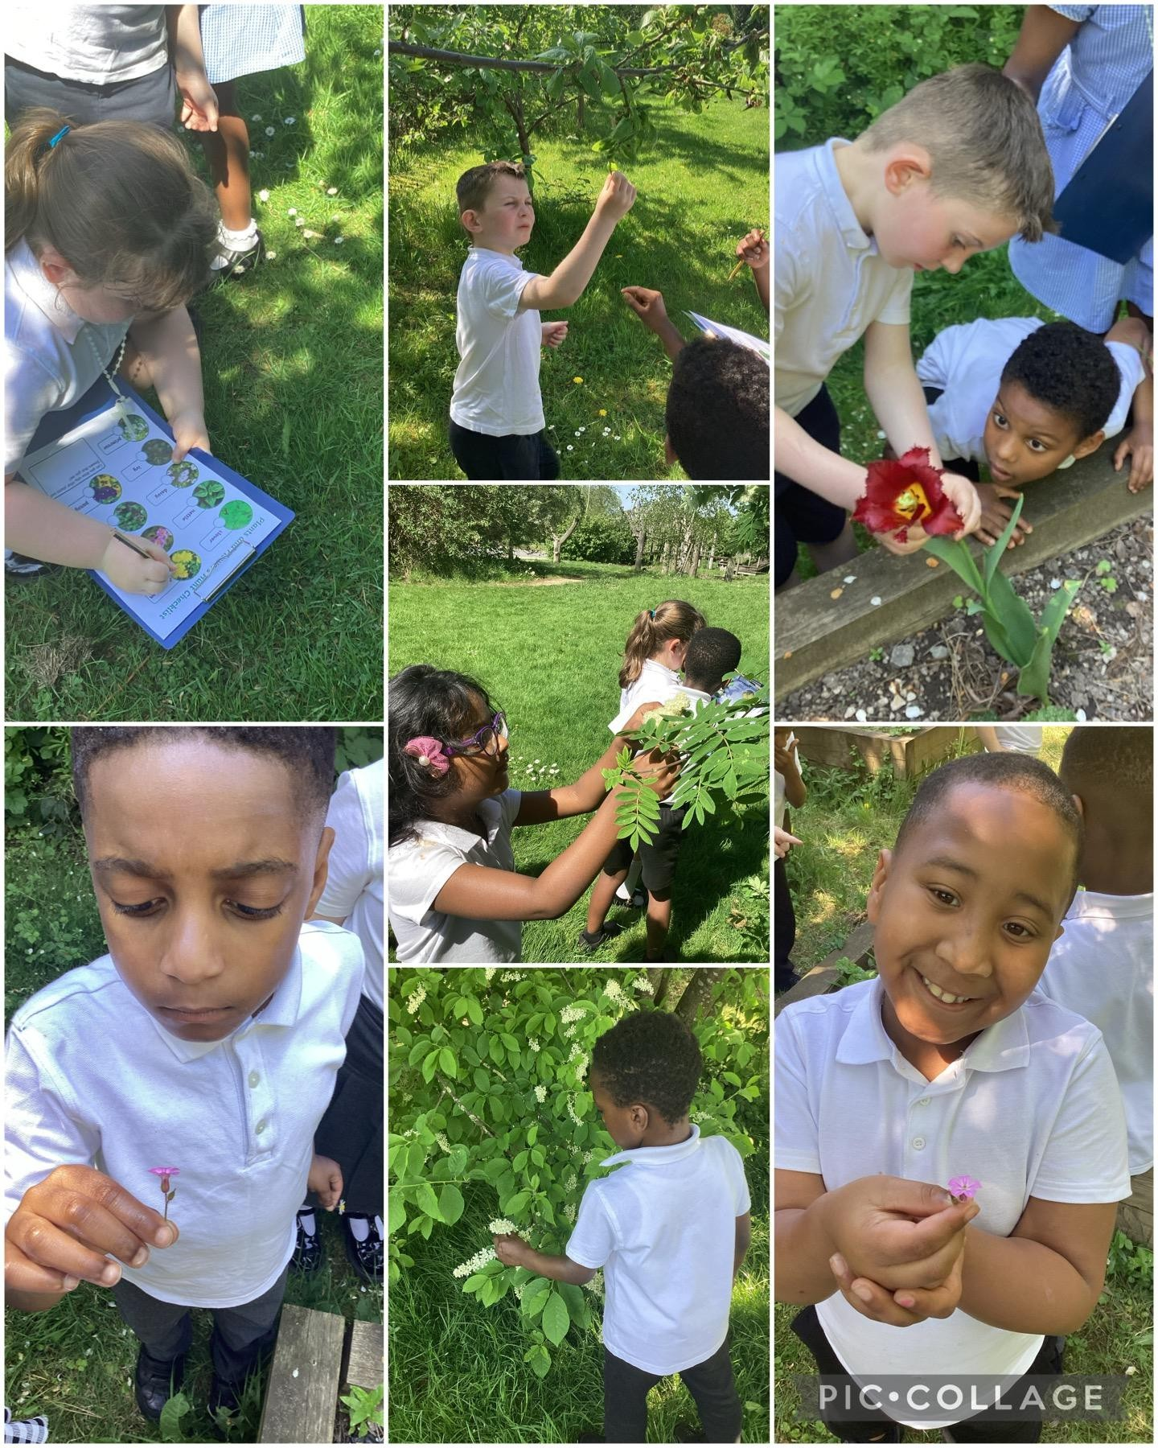

We offer:

- beautiful children who are eager to learn
- a welcoming, all-inclusive Catholic ethos
- a Governing Board which is fully committed to the school and whole community
alongside with a caring and sharing approach
- a happy, positive and supportive team to work alongside
- a great environment both indoors and outdoors
- a creative and developed curriculum
- strong teaching and learning pedagogy
- a team who celebrates the uniqueness of everyone
- a hands-on SLT
- the opportunity to utilise your strengths and passions
- new experiences and continued professional development
- support from both the Diocese and Local Authority as well as a supportive community
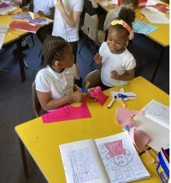
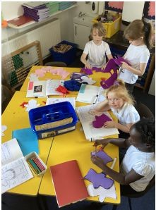

Applicant information
St Brigid’s is committed to safeguarding and promoting the welfare of children and young people and expects all staff to share this commitment.
The successful applicant will be required to undertake an enhanced DBS check and participate in a safer recruitment process.

Visits to the school are warmly welcomed and encouraged, they will take place on the morning of 18^{th July} & 11th September 2025. This can be arranged by contacting Mrs Grimshaw in the school office; Tel: 0161 223 5538
e.grimshaw@st-brigids.manchester.sch.uk

Closing Date: 16th September at midday
Shortlisting: 18th September
Interviews: 25th & 26th September

Applications forms should be returned to: recruitment@st-brigids.manchester.sch.uk

Our Values

At St Brigid’s RC Primary School, we strive to ensure that our learning is enjoyable and we try to make it as much fun and as meaningful and relevant as possible. We offer children an excellent education in a safe, calm, creative, inclusive and nurturing environment.
Every child is valued as an individual- unique and made in God’s image; we aim to grow well rounded, respectful and confident children who will develop skills for life-long learning.
We nurture our children on their journey and encourage them to be creative, unique, open-minded and independent people, respectful of themselves and of others in our school, our local parish and community and the wider world.
We are deeply committed to developing children’s faith and we take our responsibility to prepare children for life in modern Britain and in the global context very seriously. We ensure that the fundamental British Values are introduced, discussed, explored and lived out through the ethos and work of our school.
APPLY TODAY!
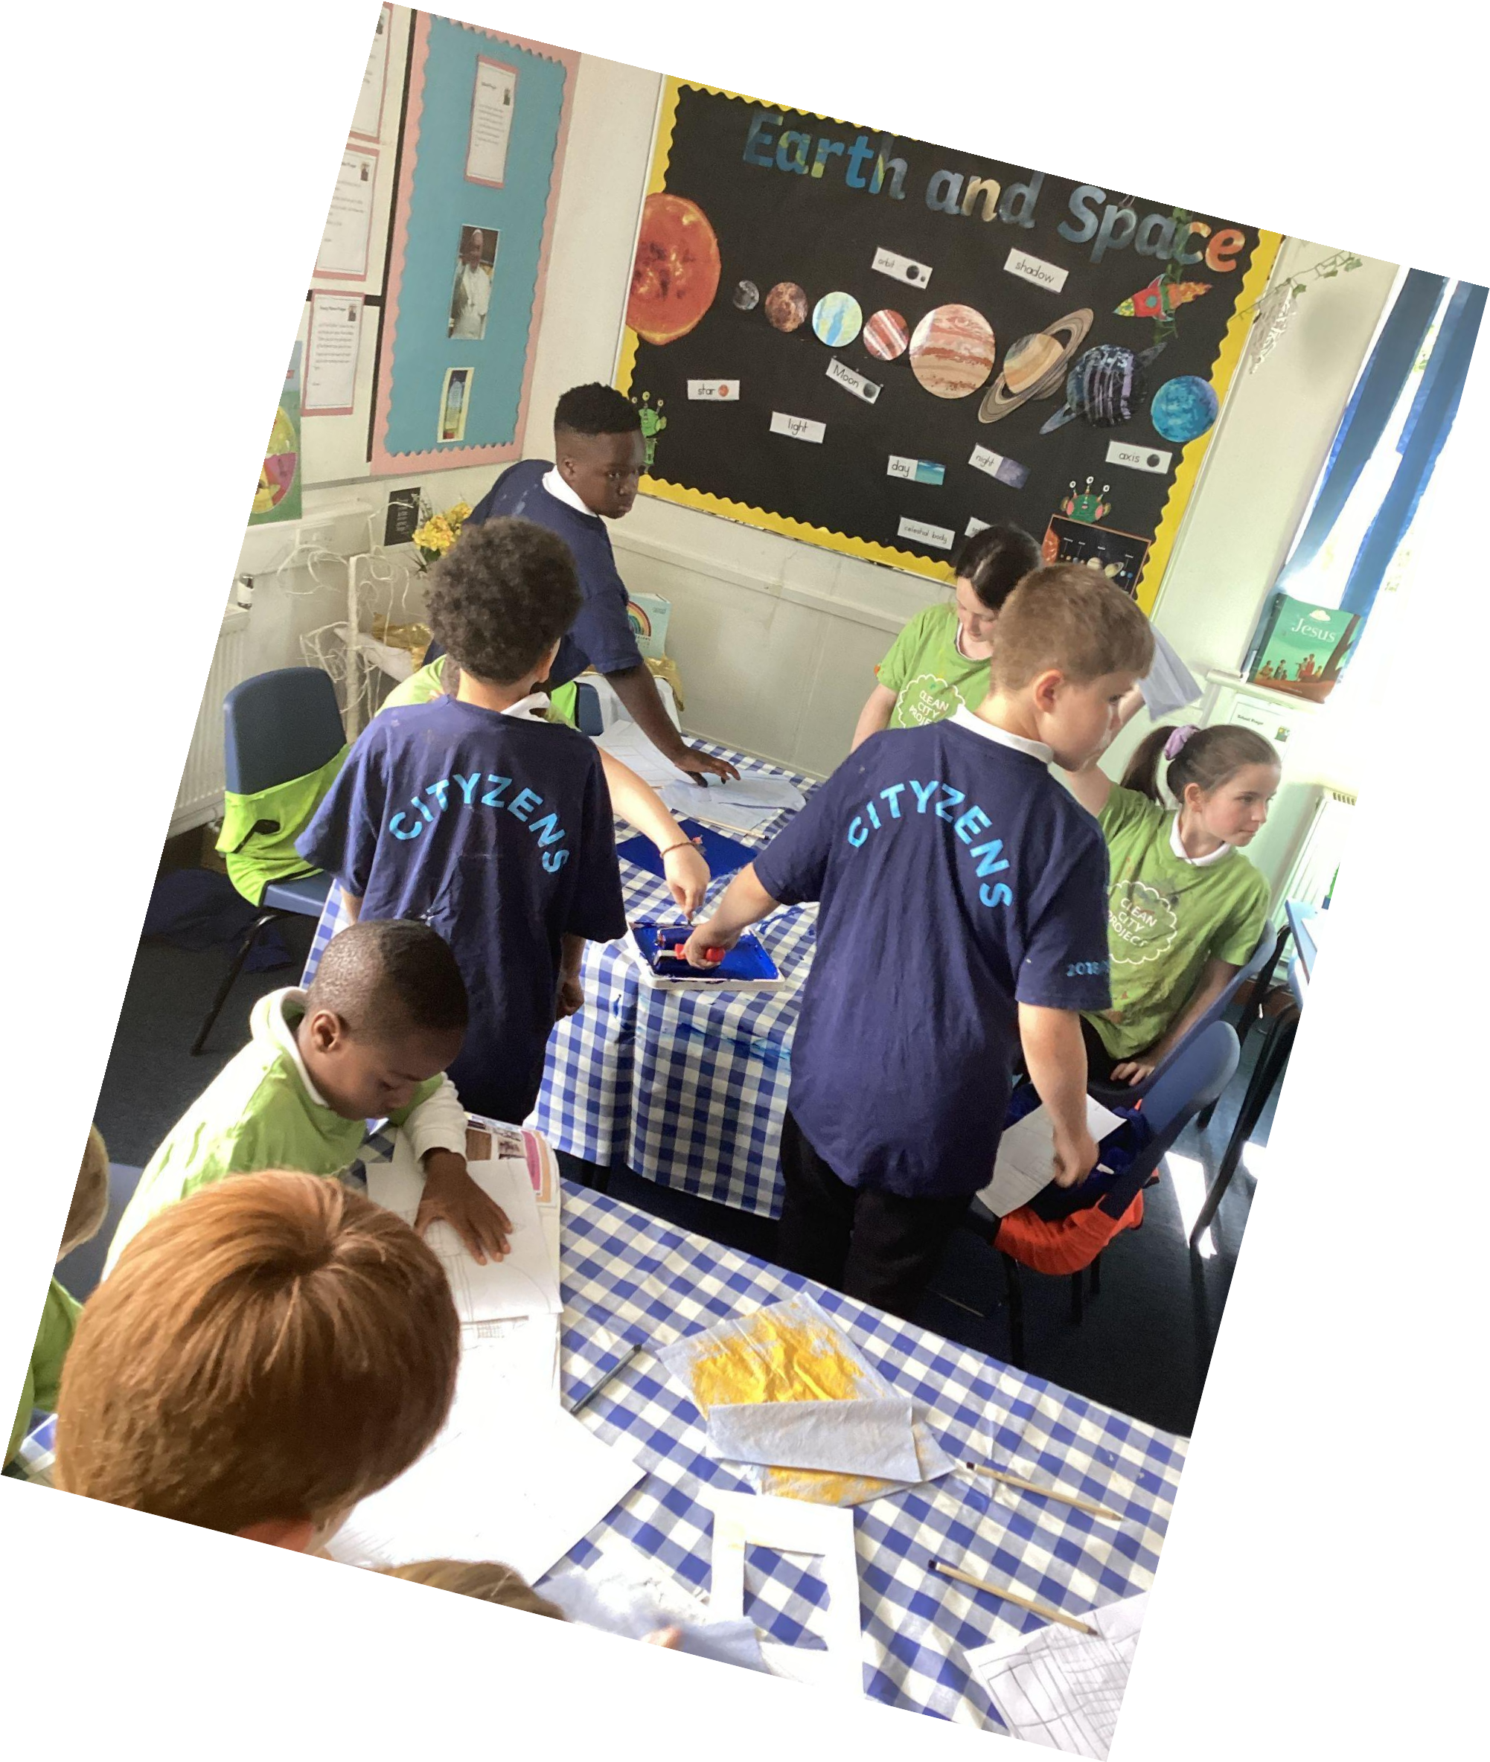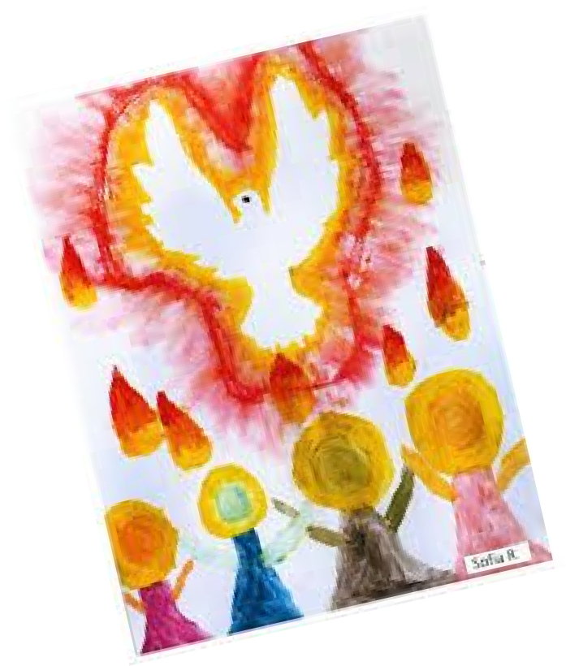

The Chaplains have led prayers this week with their door of hope proudly on show. As they lead prayer for the rosary, they are continually thinking about WWJD… what would Jesus do? Our children are truly connected to Jesus.

