St. Clare’s Catholic Primary School

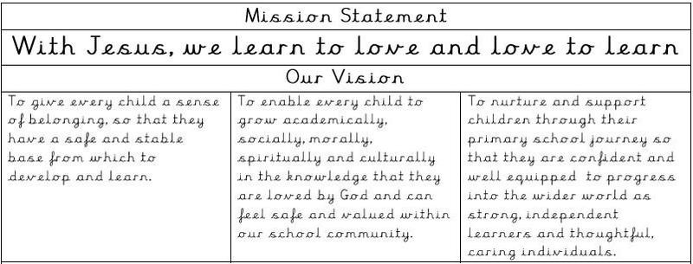

PERSON SPECIFICATION
Appointment of Headteacher for St Clare’s Catholic Primary

Please write your supporting statement/letter giving evidence of how you meet each of the essential criteria.

 | Essential |  | Desirable
Qualifications and Training
- Practising and committed Catholic in good standing with the Church | √  R |  | Evidence of participation in parish or Catholic community life
- Degree + QTS | √  AD
- Evidence of continuing professional development as a HT | √  AD |  | NPQH  Post Grad level qualification  MA in Catholic School Leadership
- Catholic Certificate in Religious Studies (CCRS) |  |  | √  D
- Willingness to undertake CCRS within 2 years of appointment | √  AI
Experience
- A record of substantial, successful teaching experience, including teaching more than 1 Key Stage | √  ARI |  | Experience in a variety of schools
7. Experience as a successful Deputy Headteacher | √  ARI
8. Experience of effecting change in teaching, learning or curriculum either at phase or whole school level | √  ARI
Professional Knowledge and Understanding
10. Understanding the expectations in the new Ofsted Framework about what makes an effective school. | √  AI |  | Understanding of the expectations of Catholic School Inspection
11. Working knowledge of school planning, evaluation, assessment and accountability | √  ARI |  | The ability to role model excellent teaching
12 Ability to analyse data, develop strategic plans, set targets and achieve desired outcomes | √  ARI
13 Ability to develop policies and procedures that demonstrate the Catholic ethos of the school and a commitment to equal opportunities for all | √  ARI
Promoting the welfare of children
14. A good understanding of up to date policy and practice with regard to Safeguarding. Commitment to the safeguarding and well-being of staff and pupils |  | √  I
Professional Skills and Abilities
15. Evidence of working effectively with the staff, governors and parents |  | √  ARI
Personal Qualities
16. Evidence of leading by example, demonstrating good interpersonal skills, with the ability to enthuse and motivate others and develop effective partnerships. |  | √  RI
17. Stamina and resilience; confidence |  | √  RI
Other
18. Understand and support the Catholic ethos of our Catholic School, including the spiritual development of the pupils and the school’s role within the community. |  | √  AIR
19. Evidence of a strong commitment to Catholic education; |  | √  AIR

A – Application form
D – Documents
I – Interview
R - References

References
- Positive and supportive reference from the Priest where the applicant regularly worships; in good standing with the Church; reference without reservation.
- Positive recommendations in professional references, without reservation.

