

**Headteacher**

**Application Pack**

**St Clement’s CofE Primary School**

Start date: 1st September 2022



Salary: L11 – L18

dependent on experience

Introduction from the Chief Executive, Kate Brunt

On behalf of the Board of Trustees, I would like to thank you for your interest in the exciting role of Headteacher at St Clement’s CofE Primary School within the Rivers CofE Academy Trust. This is a vitally important appointment and one which will have significant influence in further establishing the work of our trust. I hope that having read the information, you will feel excited and inspired to take your interest further and submit your application.

Presently the school is being led by Catherine Atkinson, our trust School Improvement Executive, who will be returning to her substantive role in September. The successful candidate will have the opportunity to further improve the strong foundations which have already been established and will be integral in ensuring excellent outcomes for pupils. We feel that this appointment will not only strengthen the community of the school but will also be a valued member of the senior executive team and our wider Rivers family.

The role will suit a creative and influential leader who has ambitions to place the school at the heart of the community. Most importantly, this is an exciting opportunity to work alongside a team of trusted colleagues and develop a professional partnership which reflects the trust’s values, aims and objectives.

We are looking for highly driven individuals with the qualifications, skills and experience to fulfil what will be a key role within the trust’s leadership structure.

We would be delighted to hear from you if you are interested in this exciting opportunity to make a real difference to the pupils and schools of the Rivers CofE Academy Trust.

You can find out more about Rivers on our website [www.riverscofe.co.uk](http://www.riverscofe.co.uk) If you would like to arrange a tour of St Clement’s CofE Primary School and have the opportunity to meet with me then please contact Julia Carter, Executive Assistant to CEO at [jcarter@riverscofe.co.uk](mailto:jcarter@riverscofe.co.uk) or 01905 953855.

Kate Brunt

**CEO**

The Rivers CofE Academy Trust



Key Dates

|  |  |  |
| --- | --- | --- |
| **Item** | **Date** | **Notes** |
| Closing date for applications | 10pm  Wednesday 2nd February 2022 | Applications received after this date and time will not be accepted. |
| Short-listing for interview | w/c Monday 7th February |  |
| Interview process | 16 February 2022 |  |
| Panel decision | TBC | Subject to references and ratification |

Please return your completed application form to:

Julia Carter

Executive Assistant to CEO

North Worcester Primary Academy

John Comyn Drive

Worcester

WR3 7NS

[jcarter@riverscofe.co.uk](mailto:jcarter@riverscofe.co.uk)

01905 953855

About us

The Rivers CofE Academy Trust began in October 2014 as a multi-academy trust with sponsor status and is a family of 'Good' and 'Outstanding' schools, all varying in size, economic and social backgrounds and religion, spread across Worcestershire.

We are specialists in primary provision with fifteen good and outstanding primary, first, pre-school and nursery settings and a thriving teaching alliance. We share the same aim which is to ensure that every child leaves us fulfilling their maximum potential and is ready for the next stage of their learning journey.

Children are at the heart of everything we do and education provision across all our schools and pre-schools is closely matched to the specific needs of our learners, particularly the most vulnerable and their families. Our aim is to enable all children to lead healthy and happy lives and to prepare them for life and the next stage of their education. We place great emphasis on high expectations and quality first teaching to ensure that no child gets left behind.

Our Vision and Values

The Rivers CofE Academy Trust’s vision is encapsulated in the words **‘Love, Learn, Live’**.

Our vision is to teach children to love, learn, live as global citizens in an ever-changing world.

Our staff are encouraged to live by this vision so that every individual is respected, valued and able to achieve their potential.

While each individual school’s character is celebrated within our family of schools, we are united through our shared core principles and values.

Our ‘STARS’ values: **Sharing, Trust, Achievement, Respect, Safety** help staff and pupils strive for high standards, focus on making the right decisions and help us fulfil our vision.



Why Join Us?

We are a trust of choice with a very strong educational track record. We believe that positive and constructive collaboration is at the heart of our success. Every member of staff is valued, challenged and given the opportunity to continuously develop, raising aspirations for all. To ensure our staff achieve their full potential we aim to provide staff with an inspiring environment, supportive culture and career opportunities.

All staff and pupils within Rivers CofE Academy Trust benefit from staff sharing expertise and good practice; collaboration is one of the benefits of working in our forward-thinking trust. We are committed to developing all of our staff by offering experience and secondment opportunities across the trust and externally. Our staff are able to access high-quality training, external conferences and CPD programmes through a variety of providers. Within our trust, the Rivers Teaching Alliance (TSA) is a training provider for the NPQ suite of qualifications and a wide variety of other training activities. In partnership with the University of Worcester, the TSA delivers training and support to our own School Direct students.

What we can offer you:

* Competitive salary
* Valuable access to Education Mutual Healthcare (access to a range of healthcare benefits –Physiotherapy, Mental Health, 24/7 GP Healthline)
* Family friendly policies including flexible working, occupational maternity and paternity pay
* Great employer pension scheme
* Access to professional and personal development

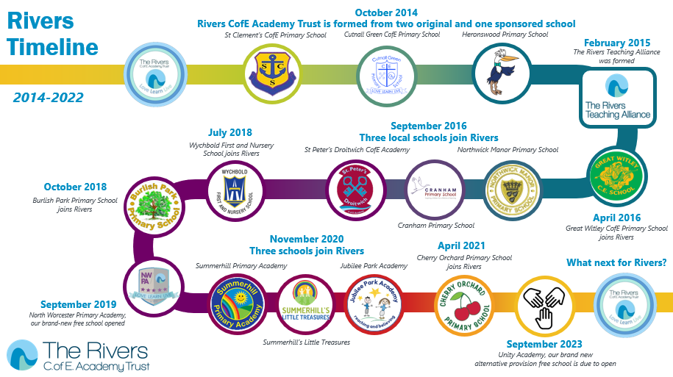

**St Clement’s CofE Primary School**

**Headteacher Recruitment Information**

**Spring 2022**



## **About our School**

St Clement’s CofE Primary school is a one form entry school in the city of Worcester. We serve a mixed demographic with 24% of children entitled to Pupil Premium, 13% SEND and 16% EAL.

The school has a Headteacher and two assistant Headteachers who share a class when they are teaching. The existing onsite external pre-school is currently in the process of becoming part of the main school which in turn will lead to extra opportunities for developing early years practice. The school has extensive grounds and a supportive community including staff, families and governance.

Each teacher leads at least one curriculum subject in addition to other roles and responsibilities.

## **Christian Distinctiveness**

***“Love, Learn, Live”***

**"Love your neighbour as you love yourself" Luke 10: 27**

As Jesus taught us, at St Clement’s we place a huge emphasis on our community and the importance of valuing and respecting one another as cherished individuals. It is through the story of “The Good Samaritan” that our children are able to make links to their lives and truly welcome others into their lives, which in turn helps them to flourish. If we love and are loved, together, we learn, following in Jesus’ footsteps.

## **Values**





## **Current staff profile**

**Mrs Kate Brunt -**CEO of Rivers Multi Academy Trust / Executive Principal

**Mrs Catherine Atkinson**-**Interim** Headteacher, Pupil Premium Lead, Designated LAC / PLAC Lead, Worship Lead, Curriculum Lead

**Mr Adam Morgan -** Assistant Head, DSL, Access and Inclusion Lead (SENDCo), Year 2 Teacher, Joint PE Lead & Music Lead and School Council Lead

**Mrs Sarah Price** - Acting Assistant Head, DSL, English Lead, Year 2 teacher, Sustainable Development Goals Committee Lead, Science Lead, Geography Lead

**Miss Rosie Slocombe -**Reception Class Teacher & EYFS Lead and PSHE Lead

**Mrs Abigail Wilkinson -**Year 1 Teacher, Art Lead, Phonics Lead, Joint PE Lead

**Miss Hannah Thatcher-**Year 3 Teacher (ECT)

**Mrs Julie Jones -**Year 4 Teacher, History Lead & MFL Lead

**Mrs Mandy Mason -**Year 5 Teacher, RE/SIAMs Lead & Maths Lead

**Mrs Sara Stevenson -**Year 6 Teacher, Computing Lead & DT Lead

**Miss Steph Butler** - Assistant Head currently seconded to School Improvement Team

**Teaching Assistants Team:**  
Mrs M Arr, Mr P Bradshaw, Mrs C Brookes, Mr M Evans, Mrs S Lloyd, Mrs A Wong, Mrs A Thomas, Mrs J Wells, Mr J Gregory, Miss C Ashcroft, Miss S Mobberley and Miss N Rossi

**School Office Team:**  
**Office Manager**- Mrs Rachel Bishop

**Secretaries** - Mrs Tracy Bagg and Mrs Gail Sheldon

**Lunchtime Team:**

Mr M Evans, Mrs M Johnson, Mrs A Thomas, Mrs J Wells, Mrs L Jones, Mr P Bradshaw, Mrs C Brookes and Mr J Gregory

**Cleaning Team:**

Mrs L Jones, Mrs T Preen, Mrs M Heywood, Mrs N Lane and Mrs S Ruff.

**Site Manager:**

Mr S Kilminster

## **Curriculum**

Our dedicated staff team work hard to deliver a creative, inspiring curriculum that engages our learners to help them to reach their true potential.

We strive to foster a warm and welcoming environment which allows our pupils to feel safe, secure and prepared to take risks in their learning.

We have recently reviewed our framework and are currently working with our wider MAT family to deliver a cohesive curriculum that is rooted in our vision to teach children to love, learn, live as a global citizen in an ever-changing world. Specialists, including teachers from St Clement’s have come together over the past year to design and write progression documents and planning for each year group. Thirteen schools within the Rivers family are now following this curriculum, meaning that we can pool our expertise and share best practice across our schools.

The wheel below outlines our approach to the curriculum, which has the UN sustainable development goals embedded throughout and 6 key concepts which develop through the years.

## **What makes St Clement’s special?**

Staff at St Clement’s CofE Primary school believe that their school is special as a result of its welcoming and nurturing Christian ethos. We believe in a friendly approach and recognise that there should be no barriers between a child and their aspirations. St Clement’s is a values led school that focuses on the trusts ‘STARS’ values of Safety, Trust, Achievement, Respect and Sharing. The pupils are at the centre of the decisions that are made: our school truly puts the pupils first.

## **What are our unique selling points?**

Being a one form entry school means we can really get to know every one of our children and families. We are a school that is outward looking and we are keen to embrace new ideas. We base our decisions on research, evidence and what is best for our children. We have a strong team within St Clement’s, which enables us to offer expertise in a number of different fields. We are blessed with fantastic grounds that the children can enjoy and explore.  We are also close to Worcester city centre, meaning that we can walk to many places of interest to further enrich our curriculum.

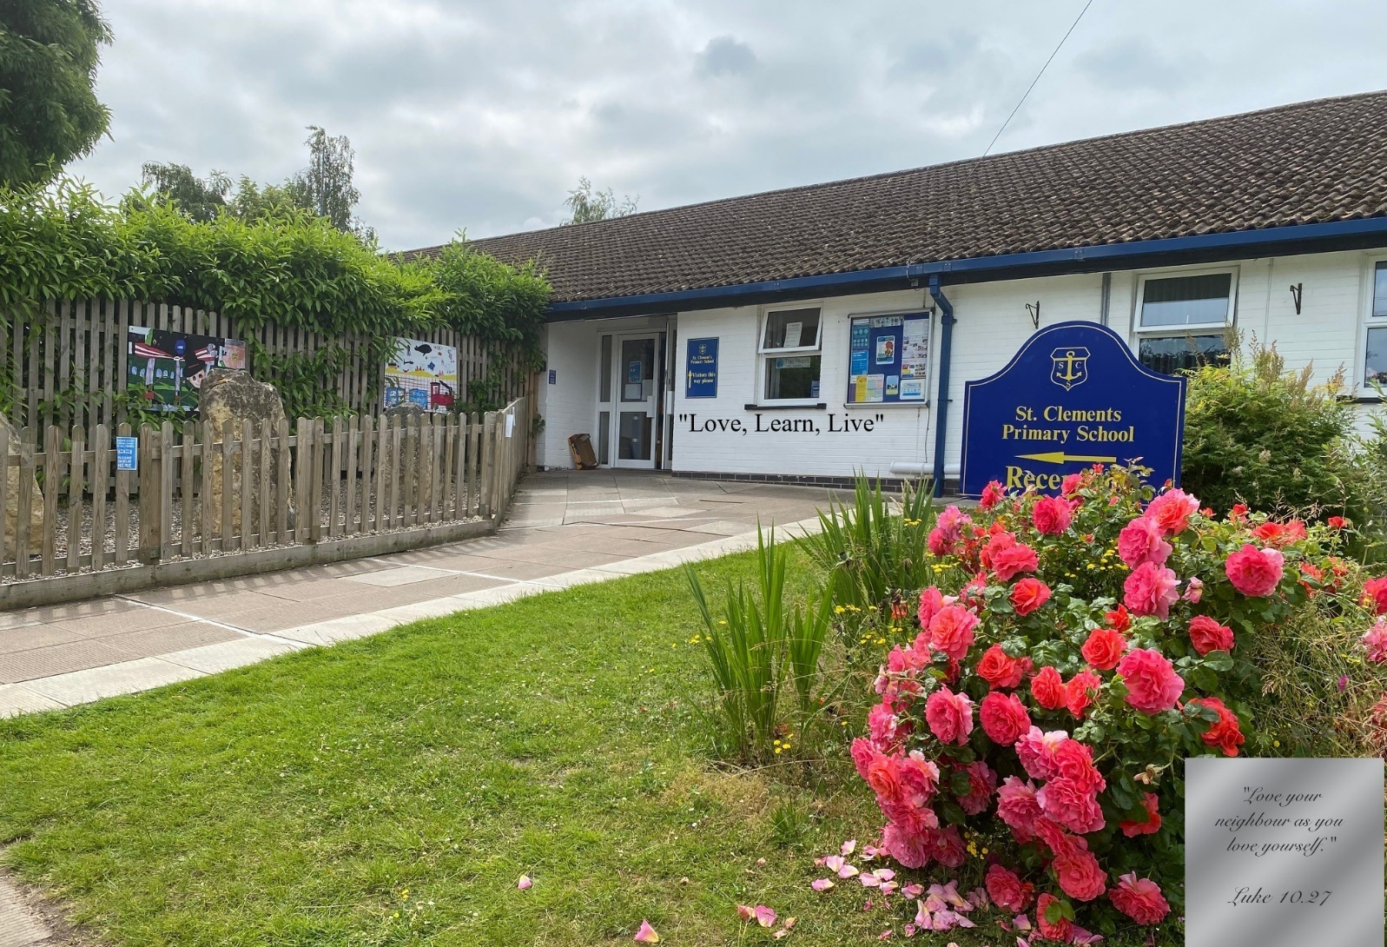



**Headteacher - Job Description**

**Salary Range:** L11 – L18 (dependent on experience)

**Contract:** Permanent – full time

**Reports to:** Chief Executive Officer (CEO)

**Key Purpose:**

The Headteacher will support and promote the Christian distinctiveness and ethos of the school with all stakeholders, ensuring that Christian values underpin all aspects of their roles and responsibilities. The Headteacher also provides high quality professional leadership and management of the School Development Plan priorities, securing success and driving continuous improvement. The postholder will ensure the highest possible standards of education through the promotion of effective teaching and learning, a balanced curriculum, the provision of excellent pastoral care and support for pupils and a rich extra-curricular programme which reflects the school’s development priorities.

The post holder will exercise strategic, curriculum led financial planning to ensure the equitable deployment of budgets and resources, in the best interests of pupils’ achievement and the school’s sustainability. They will also ensure that all legal requirements for health and safety and maintenance, including risk assessment procedures and take necessary action where required.

**Operational Responsibilities**

**School culture:**

* Promote and support the school’s distinct Christian ethos and values in all aspects of school life
* Provide vision, leadership, and direction for the school by establishing a culture and productive learning environment which is exciting and fulfils the wide-ranging needs of pupils and that promotes, excellence, equality, diversity, inclusion, and high expectations
* Establish and sustain the school’s ethos and strategic direction in partnership with those responsible for governance and through consultation with the school community
* Create a culture where pupils experience a positive and enriching school life
* uphold ambitious educational standards which prepare pupils from all backgrounds for their next phase of education and life
* Promote positive and respectful relationships across the school community and create a safe, orderly, and inclusive environment
* Ensure a culture of high staff professionalism and engagement
* Embed a positive staffing culture based upon openness, transparency, and empowerment
* Ensure that safeguarding is paramount and promoting the welfare of all pupils and adults
* Demonstrate the vision and STARS values of Rivers in everyday work and practice

**Leading Teaching, curriculum, and assessment:**

* Establish and sustain high-quality, expert teaching across all subjects and phases, built on an evidence-informed understanding of effective teaching and how pupils learn
* Ensure teaching is underpinned by high levels of subject expertise and approaches which respect the distinct nature of subject disciplines or specialist domains
* Ensure effective use is made of formative assessment
* Ensure a broad, structured, and coherent curriculum entitlement which sets out the knowledge, skills and values that will be taught
* Establish effective curricular leadership, developing subject leaders with high levels of relevant expertise and access to professional networks and communities
* Ensure valid, reliable, and proportionate approaches are used when assessing pupils’ knowledge and understanding of the curriculum
* Ensure the school holds ambitious expectations for all pupils with additional and special educational needs and disabilities and all pupils eligible for free school meals
* Establish and sustain culture and practices that enable pupils to access the curriculum and learn effectively
* Ensure the school works effectively in partnership with parents, carers, and professionals, to identify the additional needs and special educational needs and disabilities of pupils, providing support and adaptation where appropriate
* Ensure the school fulfils its statutory duties regarding the SEND code of practice

**Leading behaviour:**

* Establish and sustain high expectations of behaviour for all pupils built upon relationships, rules and routines which are understood clearly by all staff and pupils
* Ensure high standards of pupil behaviour and courteous conduct in accordance with the school’s behaviour policy
* Implement consistent, fair, and respectful approaches to managing behaviour
* Ensure that adults within the school model and teach the behaviour of a good citizen

**Leading professional development:**

* Ensure staff have access to high-quality, sustained professional development opportunities, aligned to balance the priorities of whole-school improvement, team, and individual needs
* Prioritise the professional development of staff, through regular review, ensuring effective planning, delivery and evaluation which is consistent with the approaches laid out in the standard for teachers’ professional development
* Ensure that professional development opportunities draw on expert provision from beyond the school, as well as within it, including nationally recognised career and professional frameworks and programmes to build capacity and support succession planning
* Be an effective role model; maintain personal CPD, self-reflection and share learning

**Managing the School**

* Ensure the protection and safety of pupils and staff through effective approaches to safeguarding, as part of the duty of care
* Manage and allocate financial resources appropriately, ensuring efficiency, effectiveness, and probity in the use of public funds
* Ensure staff are deployed and managed well with due attention paid to workload
* Effect strategic planning, establish and oversee systems, processes and policies that enable the school to operate effectively and efficiently
* Distribute leadership throughout the organisation to ensure that distinct roles and responsibilities are in place so that you can hold them, as well as themselves holding each other to account for their decision-making and actions
* Establish rigorous, fair, and transparent systems and measures for managing the performance of all staff, addressing under-performance, supporting staff to improve and value excellent practice
* Identify emerging talents, coaching current and aspiring leaders in a climate where excellence is the standard, leading to clear succession planning
* Ensure rigorous approaches to identifying, managing, and mitigating risk
* Make arrangements for the security and effective supervision of the school buildings, their contents and school grounds and ensuring maintenance is properly attended to

**Leading school improvement:**

* Make use of effective and proportional processes of evaluation to identify and analyse complex or persistent problems and barriers which limit school effectiveness and identify priority areas for improvement
* Develop appropriate evidence-informed strategies for improvement as part of well-targeted plans which are realistic, timely, appropriately sequenced and suited to the school’s context
* Ensure careful and effective implementation of improvement strategies, which lead to sustained school improvement over time

**Strengthen Community**

* Consult, where appropriate, with the Church and Diocese in providing for the academic, spiritual, moral, social, and cultural wellbeing of pupils and their families
* Foster the culture and curriculum of both the MAT and the school to demonstrate our belief in the value of the richness and diversity
* Create and promote positive strategies to challenge all prejudices to strengthen our ethos of inclusivity and mutual respect
* Forge constructive relationships beyond the school, working in partnership with parents, carers, and the local community
* Work successfully with other schools and organisations in a climate of mutual challenge and support
* Establish and maintain working relationships with fellow professionals and colleagues across the MAT and other public services to improve educational outcomes for all pupils

**Designated or Deputy Safeguarding Lead**

* Take responsibility for safeguarding and child protection in the school
* Support staff on child welfare and child protection matters
* Take part in strategy discussions and inter-agency meetings
* Manage and support staff making referrals for the school
* Undergo training to provide the skills and knowledge required to carry out the role
* Ensure the school is aware of any changes to child protection policies
* Any other responsibilities deemed necessary to fulfil the role

**Governance and accountability:**

* Understand and welcome the role of effective governance, upholding accountability obligations and accepting responsibility
* Establish and sustain professional working relationships with those responsible for governance
* Ensure that staff know and understand their professional responsibilities and are held to account
* Ensure the school effectively and efficiently operates within the required regulatory frameworks and meets all statutory duties

**Conditions of Employment**

* The above responsibilities are subject to the general duties and responsibilities contained in the written statement of conditions of employment
* To be subject to all relevant statutory requirements as detailed in the most recent School Teachers’ Pay and Conditions
* As a Headteacher in the trust you will be expected to take on central responsibilities to support the CEO on strategic projects as and when required
* Any other reasonable duties as directed by the CEO

***Job descriptions are not exclusive or exhaustive and the nature of the position entails that the postholder may be required to carry out additional duties as reasonably required.***

***The duties described in this Job Description must be carried out in a manner which promotes equality of opportunity, dignity and due respect for all employees and service users and is consistent with the School’s Equal Opportunities Policy and Code of Conduct.***

***The Trust is committed to safeguarding and promoting the welfare of children.***

***This post is subject to employee checks and evidence including criminal record checks (Disclosure and Barring Service (DBS) checks), barred list checks and prohibition checks, together with references and interview information***



**Headteacher - Personal Specification**

This Person Specification is related to the requirements of the post as determined by the job description. Shortlisting is carried out based on how well you meet the requirements of the person specification. You should refer to these requirements when completing your application.

|  |  |  |
| --- | --- | --- |
| **Description:** | **Essential** | **Desirable** |
| **Professional Qualifications** | | |
| Honours degree | ✓ |  |
| Qualified Teaching Status | ✓ |  |
| Postgraduate Study |  | ✓ |
| NPQH |  | ✓ |
| Further relevant professional studies |  | ✓ |
| Evidence of further professional development and willingness to undertake other training | ✓ |  |
| Up to date knowledge of essential aspects of Headship | ✓ |  |
| Head of School/Headteacher experience |  | ✓ |
| Experience of working in a school with special measures/serious weaknesses |  | ✓ |
| Experience of Senior Leadership post | ✓ |  |
| Experience of more than one school/academy |  | ✓ |
| Experience of more than one key stage |  | ✓ |
| Use of successful measures that promote and ensure the safeguarding of children | ✓ |  |
| **Strategic Leadership** | | |
| *Knowledge & Understanding* | | |
| Experience of working in a Church school |  | ✓ |
| Evidence of creating and securing commitment to a clear vision | ✓ |  |
| Successfully initiate and manage improvement in pursuit of strategic objectives | ✓ |  |
| Successful use of strategic planning processes, tools, and techniques | ✓ |  |
| Models of effective leadership and organisational structures | ✓ |  |
| New technologies and their potential impact |  | ✓ |
| Knowledge of developments in education at local, national, and global levels |  | ✓ |
| Ways of achieving stakeholder and community engagement |  | ✓ |
| *Skills* | | |
| Proven strategic, curriculum led financial planning |  | ✓ |
| Anticipate, lead, and manage change | ✓ |  |
| Use research to support and challenge practice | ✓ |  |
| Think strategically, analytically, and creatively | ✓ |  |
| Deal with complexity and uncertainty | ✓ |  |
| Inspire, challenge, motivate and empower others to attain challenging outcomes | ✓ |  |
| Celebrate achievement and acknowledge excellence | ✓ |  |
| Model the vision and values of the school and communicate clear purpose and direction | ✓ |  |
| Build capacity and achieve sustainability | ✓ |  |
| Work strategically within a governance structure | ✓ |  |
| Demonstrate political acumen |  | ✓ |

|  |  |  |
| --- | --- | --- |
| **Leading Teaching and Learning** | | |
| Ensure the Teacher Standards are maintained by all teaching staff | ✓ |  |
| Curriculum design and management |  | ✓ |
| Ways of applying effective practice and research evidence to improve outcomes | ✓ |  |
| Principles of quality learning, teaching and assessment including school review and self-evaluation | ✓ |  |
| Use of external support and expertise |  | ✓ |
| New technologies to support teaching and learning | ✓ |  |
| Strategies for improving outcomes and achieving excellence for all | ✓ |  |
| Tools for data collection and analysis | ✓ |  |
| Behaviour and attendance management |  | ✓ |
| Special educational needs and pastoral care | ✓ |  |
| Promote a strong culture of pedagogic research approaches and familiarity with major changes within the curriculum |  | ✓ |
| **Organisational Leadership** | | |
| *Knowledge & Understanding* | | |
| Technology to enhance organisational effectiveness | ✓ |  |
| Strategies to maximise contributions from the workforce | ✓ |  |
| Accountability frameworks | ✓ |  |
| Legal issues relating to leading and managing a school |  | ✓ |
| Organisational development, planning and implementing change |  | ✓ |
| Project management techniques |  | ✓ |
| *Skills* | | |
| Seek expertise and advice from within and outside of the school | ✓ |  |
| Delegate, collaborate and distribute leadership | ✓ |  |
| Manage others within an accountability framework | ✓ |  |
| Create an environment which enables people to perform at their best and underpins effective employee relations | ✓ |  |
| Manage industrial relations | ✓ |  |
| Develop and sustain a safe, secure, and healthy school environment | ✓ |  |
| Establish structures and systems with operational decisions being based on informed discussion |  | ✓ |
| **Leading People** | | |
| *Knowledge & Understanding* | | |
| Significance of interpersonal relationships, including impact of teacher performance and pupil learning | ✓ |  |
| Performance management, continuous professional development, and sustained school improvement | ✓ |  |
| Building motivation, including the importance of celebrating achievement | ✓ |  |
| Reviewing own performance, ways of obtaining feedback and how to improve | ✓ |  |
| Support and develop systems for individuals and teams | ✓ |  |
| Building and sustaining a learning community within a diverse workforce | ✓ |  |
| *Skills* | | |
| Develop self-awareness, self-management and self-confidence and use effectively | ✓ |  |
| Listen, reflect, and communicate effectively | ✓ |  |
| Give feedback and provide support to improve performance | ✓ |  |
| Hold people to account and challenge under performance | ✓ |  |
| Develop a culture of learning and continuous professional development | ✓ |  |
| Receive and act on feedback to build on strengths and improve personal performance | ✓ |  |
| Negotiate and manage conflict, providing appropriate support | ✓ |  |
| Motivate, develop, empower, and sustain individuals and teams | ✓ |  |
| High standards of personal and professional conduct | ✓ |  |
| Foster an open, fair, and equitable culture |  | ✓ |
| Create a culture which encourages ideas and contributions from others |  | ✓ |

|  |  |
| --- | --- |
| JD/PS Reviewed by: | Kate Brunt |
| Date: | January 2022 |