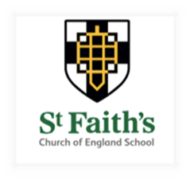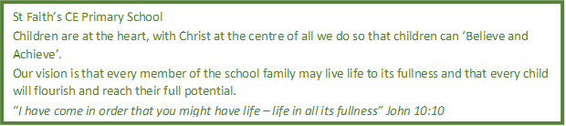

Dear Applicant,
Thank you for your interest in becoming the new Headteacher at St Faith’s Church of England Primary School.
Staff and governors have very strong aspirations for all children that come through our school, whatever their background and culture. We want and expect our children to achieve high standards and apply our school vision of “Believe and Achieve” every day.
Our recent OFSTED inspection rated us as good, with pockets of outstanding and we are looking for an ambitious Headteacher to build out these areas of excellence to be across all elements of the school.
COVID19 has been challenging for all schools and pupils but our leadership team have gone above and beyond to ensure learning has been as uninterrupted as possible, even when access to the school site was restricted.
We have a highly motivated and dedicated staff team who offer all our children the very best opportunities for becoming happy, successful and confident learners for life. Our committed and forward-thinking Governing board will support our new Headteacher in providing a safe, nurturing and stimulating environment for all children and staff.
St Faith’s is underpinned by its commitment to Christian values and this creates a truly special learning environment in which all are welcomed and encouraged to be the best version of themselves.
We are sure it will quickly become clear what a special place St Faith’s really is when you come and visit the school. With the current COVID-19 restrictions this visit may look a bit different to what we are used to but will still give you an opportunity to meet some of our staff and wonderful children in an appropriate and safe way.
We very much look forward to meeting you.

Yours sincerely,
Alice Cheshire and Ray Ingram
Co-Chairs of Governors

