Contents

Welcome from the Chair of Governors 2
Advert 3
Disability Confident Scheme 4
Use of Artificial Intelligence (AI) 4
Job Description 5
School culture 6
Person Specification 9
About the School 13
Our ethos, vision and values 13
Our Curriculum 17
School Improvement Plan 20
SEND 21
SEND Hub Information 21
Safeguarding 23
Pupils 23
Staff 23
Parents 23
Important documents 25
Recruitment Privacy notice 25
School recruitment and vetting checks policy 25
Letter from Lincolnshire County Council (LCC) 25
Letter from the Diocese 25
How to Apply 25

Welcome from the Chair of Governors


Thank you for your interest in the position of Headteacher at St George’s Church of England Community Primary School, a school based in Gainsborough, Lincolnshire, of which we are very proud.

In recent years, our children, staff, and wider community have flourished under the outstanding and dedicated leadership of our current Headteacher, Mrs Katie Barry.

As Mrs Barry moves on to pastures new, we are now seeking another dynamic and inspirational leader to guide St George’s into the next stage of its journey.

We are looking to appoint a personable, forward‑thinking, and motivational Headteacher who will continue to nurture our precious school community.

St George’s is a place where children and adults alike are encouraged to “Reach for the Stars”.

We are committed to high standards across all aspects of school life, particularly learning, achievement, behaviour, and pastoral support.

Strong, secure, and trusting relationships between all stakeholders underpin the care, ethos, and learning that characterise each day at St George’s.

We hope this recruitment pack gives you a sense of what makes our school and community so special. You can find further information on our website https://www.gainsborough-st-georges.lincs.sch.uk, and you are warmly invited to visit us.

To arrange a tour or ask any questions, please contact our School Business Manager, Mrs Cathy Brooks, using the details provided in the advert.

I look forward to meeting you.

Baptiste Velan,
Chair of Governors

February 2026

Advert

POST OF HEADTEACHER

School Group: Group 2 (NOR: 210)
Age Range of Pupils: 3-11
Post/Salary: Permanent Head, Leadership Spine L15-21 (£73,105-£84,699)
From: September 2026

We are looking for a personable, dynamic, inspirational Headteacher who will embrace the opportunity of leading our school located in Gainsborough.

The governing body will appoint a headteacher who:

- Is an excellent leader with high expectations of achievement and behaviour and will further develop an environment in which children flourish emotionally, socially and academically.
- Will use their innovative and enthusiastic leadership qualities to support our strong committed team and ensure its continued growth and development.
- Has proven experience of successful leadership.
- Will act in ways informed by our vision and values.
- Will forge trusting relationships with all our stakeholders.
- Has excellent organisational and interpersonal skills and the ability and desire to further our church school ethos and culture.
- Will enhance and develop collaboration between staff, parents, governors, developing effective partnerships with the church and wider community.

We can offer you:

- The opportunity to lead an excellent professional team.
- A committed, enthusiastic and engaged learning community.
- A firm commitment to your professional development and wellbeing.
- A welcoming, warm, caring and aspirational learning community.

Recruitment Pack and Application Form

You can view the Recruitment Pack and complete the Application Form.
You can also request a recruitment pack by emailing cathy.brooks@gainsborough-st-georges.lincs.sch.uk.
Please ensure that you address the points detailed in the job description and person specification in your application.
Please send your application to Baptiste Velan, Chair of Governors (baptiste.velan@gainsborough-st-georges.lincs.sch.uk).

School visits

If you’d like to come and meet us, please contact the School Business Manager, Mrs Cathy Brooks, to arrange a visit: cathy.brooks@gainsborough-st-georges.lincs.sch.uk
We are offering the following visit dates and times:

Tues 24th Feb | 10.00
Weds 25th Feb | 13.30
Thurs 26th Feb | 15.30

Closing Date for applications: Monday March 2nd 2026 12.00

Disability Confident Scheme

LCC is a member of the Disability Confident Scheme, which extends to Community and Voluntary Controlled schools. Under the scheme, all disabled applicants who meet the minimum requirements of the job as set out in the job description and person specification will be guaranteed an interview.

Use of Artificial Intelligence (AI)

Applicants are required to complete this application without the assistance of artificial intelligence (AI) tools. All responses must be written personally by the candidate to ensure authenticity and accuracy. Any applications found to contain AI-generated content may be removed from the recruitment process

Job Description

Post of Headteacher Job Description

(Please also refer to the Contractual Framework for Headteachers document STPCD 2025 and the Headteachers’ Standards 2020; these standards replace the national standards of excellence for headteachers 2015.)

Section 1: Ethics and professional conduct

Headteachers are expected to demonstrate consistently high standards of principled and professional conduct. They are expected to meet the teachers’ standards and be responsible for providing the conditions in which teachers can fulfil them.

Headteachers must uphold and demonstrate the Seven Principles of Public Life at all times. Known as the Nolan principles, these form the basis of the ethical standards expected of public office holders:
- selflessness
- integrity
- objectivity
- accountability
- openness
- honesty
- leadership

Headteachers uphold public trust in school leadership and maintain high standards of ethics and behaviour. Both within and outside school, headteachers:
- build relationships rooted in mutual respect, and at all times observe proper boundaries appropriate to their professional position
- show tolerance of and respect for the rights of others, recognising differences and respecting cultural diversity within contemporary Britain
- uphold fundamental British values, including democracy, the rule of law, individual liberty and mutual respect, and tolerance of those with different faiths and beliefs
- ensure that personal beliefs are not expressed in ways which exploit their position, pupils’ vulnerability or might lead pupils to break the law.

As leaders of their school community and profession, headteachers:
- serve in the best interests of the school’s pupils
- conduct themselves in a manner compatible with their influential position in society

by behaving ethically, fulfilling their professional responsibilities and modelling the behaviour of a good citizen
- uphold their obligation to give account and accept responsibility
- know, understand, and act within the statutory frameworks which set out their professional duties and responsibilities
- take responsibility for their own continued professional development, engaging critically with educational research
- make a positive contribution to the wider education system

Section 2: Headteachers’ standards

School culture

Headteachers:
- establish and sustain the school’s ethos and strategic direction in partnership with those responsible for governance and through consultation with the school community
- create a culture where pupils experience a positive and enriching school life
- uphold ambitious educational standards which prepare pupils from all backgrounds for their next phase of education and life
- promote positive and respectful relationships across the school community and a safe, orderly and inclusive environment
- ensure a culture of high staff professionalism

- Teaching
Headteachers:
- establish and sustain high-quality, expert teaching across all subjects and phases, built on an evidence-informed understanding of effective teaching and how pupils learn
- ensure teaching is underpinned by high levels of subject expertise and approaches which respect the distinct nature of subject disciplines or specialist domains
- ensure effective use is made of formative assessment.

- Curriculum and assessment
Headteachers:
- ensure a broad, structured and coherent curriculum entitlement which sets out the knowledge, skills and values that will be taught
- establish effective curricular leadership, developing subject leaders with high levels of relevant expertise with access to professional networks and communities
- ensure that all pupils are taught to read through the provision of evidence-informed approaches to reading, particularly the use of systematic synthetic phonics in schools that teach early reading
- ensure valid, reliable and proportionate approaches are used when assessing pupils’ knowledge and understanding of the curriculum.

4. Behaviour
Headteachers:
- establish and sustain high expectations of behaviour for all pupils, built upon relationships, rules and routines, which are understood clearly by all staff and pupils
- ensure high standards of pupil behaviour and courteous conduct in accordance with the school’s behaviour policy
- implement consistent, fair and respectful approaches to managing behaviour
- ensure that adults within the school model and teach the behaviour of a good citizen

5. Additional and special educational needs and disabilities
Headteachers:
- ensure the school holds ambitious expectations for all pupils with additional and special educational needs and disabilities
- establish and sustain culture and practices that enable pupils to access the curriculum and learn effectively
- ensure the school works effectively in partnership with parents, carers and professionals, to identify the additional needs and special educational needs and disabilities of pupils, providing support and adaptation where appropriate
- ensure the school fulfils its statutory duties with regard to the SEND code of practice.

6. Professional development

Headteachers:
- ensure staff have access to high-quality, sustained professional development opportunities, aligned to balance the priorities of whole-school improvement, team and individual needs
- prioritise the professional development of staff, ensuring effective planning, delivery and evaluation which is consistent with the approaches laid out in the standard for teachers’ professional development
- ensure that professional development opportunities draw on expert provision from beyond the school, as well as within it, including nationally recognised career and professional frameworks and programmes to build capacity and support succession planning

7. Organisational management
Headteachers:
- ensure the protection and safety of pupils and staff through effective approaches to safeguarding, as part of the duty of care
- prioritise and allocate financial resources appropriately, ensuring efficiency, effectiveness and probity in the use of public funds
- ensure staff are deployed and managed well with due attention paid to workload
- establish and oversee systems, processes and policies that enable the school to operate effectively and efficiently
- ensure rigorous approaches to identifying, managing and mitigating risk

8. Continuous school improvement
Headteachers:
- make use of effective and proportional processes of evaluation to identify and analyse complex or persistent problems and barriers which limit school effectiveness, and identify priority areas for improvement
- develop appropriate evidence-informed strategies for improvement as part of well-targeted plans which are realistic, timely, appropriately sequenced and suited to the school’s context
- ensure careful and effective implementation of improvement strategies, which lead to sustained school improvement over time.

9. Working in partnership
Headteachers:
- forge constructive relationships beyond the school, working in partnership with parents, carers and the local community
- commit their school to work successfully with other schools and organisations in a climate of mutual challenge and support

- establish and maintain working relationships with fellow professionals and colleagues across other public services to improve educational outcomes for all pupils

10. Governance and accountability
Headteachers:
- understand and welcome the role of effective governance, upholding their obligation to give account and accept responsibility
- establish and sustain professional working relationship with those responsible for governance
- ensure that staff know and understand their professional responsibilities and are held to account
- ensure the school effectively and efficiently operates within the required regulatory frameworks and meets all statutory duties.

Person Specification
Selection decisions will be based on the criteria outlined below. At each stage of the process an assessment will be made by the appointment panel to determine the extent to which the criteria have been met. When completing your application paperwork you should ensure that you address each of the selection criteria and provide supporting evidence of how you meet the criterion through reference to your work or relevant experience. These criteria will be assessed using evidence from your application form, formal interview, interview tasks and references.
 | Essential | Desirable | Assessed by
Qualifications and Experience

- Successful experience of working in a challenging and diverse community |  |  | A
- Qualified Teacher Status (QTS) |  |  | A
- Significant and successful senior leadership experience within a primary school |  |  | A/I/R
- Evidence of proactively pursuing continued professional development and being a lifelong learner |  |  | A
- Evidence of higher professional / academic qualifications (e.g. NPQH) |  |  | A
- Experience across the whole primary provision including the Foundation Stage |  |  | A/I
- Experience of working in or with church schools |  |  | A/I
Safeguarding Children

- Current safeguarding training and a good working knowledge of KCSIE |  |  | A
- Enhanced DBS clearance |  |  | A/R

- Ability to demonstrate commitment to safeguarding and promoting the welfare of children |  |  | A/I/R
- A proven track record in maximising rates of attendance |  |  | A/I/R
- Evidence of actively maintaining a safe and well-ordered school environment |  |  | A/R
- Current safer recruitment training |  |  | A
Qualities of Knowledge

- Have an excellent understanding of the primary curriculum across all Key Stages including the Foundation Stage |  |  | A/I/R
- Clear understanding of the SEND Code of Practice and proven experience of supporting children in overcoming barriers to learning |  |  | A/I/R
- A strong commitment to working with the local authority to develop the recently established SEND Hub. |  |  | A/I
- Ability to articulate a clear vision of how to take the school forward, building upon existing strengths and taking all members of the school community with them |  |  | A/I
- Lead by example with integrity, inspiration, resilience and creativity; drawing on their own experience and skills of staff and governors |  |  | A/I
- A commitment to embrace Christian ethos and continue to embed the church school values in school |  |  | I
- A person who will play a key part in the spiritual development of the school and wider community |  |  | A/I
- Able to manage own workload and that of others to allow an appropriate work/life balance with the support of the senior leadership team and governors |  |  | A/I
- Ability to continue and further develop the wider curriculum in order to nurture the “whole child” |  |  | A/I
- A person who understands the distinctive nature of a Church School |  |  | A/I
- Ability to provide constructive feedback to staff and children that promotes next step development whilst recognising achievement |  |  | A/I
Pupils and Staff

- Evidence of creating an environment which enables the personal, social and emotional development of each child in order to optimise learning potential |  |  | A/I
- Committed to aspirational educational standards for all pupils and staff |  |  | A/I
- Demonstrates the ability to be inspiring and motivating |  |  | I
- Evidence of identifying and developing emerging talent and leadership ability |  |  | A/I
- Values mutual support and respect, fostering strong working relationships and building effective teams |  |  | I/R
- Abreast of the latest educational developments and research (nationally and internationally) |  |  | I
Systems and Processes

- Evidence of understanding the impact of budgets, resources and financial planning on school sustainability. |  |  | A/I/R
- A proven track record of building positive relationship with all members of the school community. |  |  | A/I/R
The Self Improving System

- A commitment to proactively foster parental engagement. |  |  | A/I/R
- Experience of a SIAMs inspection at leadership level |  |  | A
- Able to maintain and develop opportunities for partnerships with parents, other schools, local churches and other community groups |  |  | A/I
- Experience of an OFSTED inspection at leadership level |  |  | A
- Ability to maintain and build on existing international links and relationships |  |  | A
- Evidence of encouraging the personal and professional development of all staff |  |  | A/I/R
- Able to build upon our last OfSTED inspection outcome |  |  | I
- Successful participation in collaborative partnerships with other schools and academies as part of the peer review process |  |  | A
- Welcomes support and challenge from the Governing Body and actively supports the governors to deliver their functions effectively |  |  | A
Personal Attributes

- Dedicated, child centred and with a sense of humour. |  |  | I/R
- A commitment to uphold and promote the school’s Christian ethos and life |  |  | A/I
- Evidence of church and community involvement |  |  | A/I
- Reflective - able to build on the firm existing base, valuing work already done |  |  | A/I
- Be approachable and accessible |  |  | I
- Be an excellent communicator and have strong interpersonal skills (written, verbal and aural) and resilience to engage the whole school community |  |  | A

A = Application
I = Interview Day
R = References

About the School

St George’s Church of England Primary School is situated in the uphill area of Gainsborough (North-East Ward); the school serves pupils aged 3-11; the Pupil Admission Number is 210.

Gainsborough is part of West Lindsey District Council and the wider Lincolnshire County Council. We are a Church of England Voluntary Controlled Primary School within the Diocese of Lincoln family of schools and have links with the parish church of St George’s within Gainsborough and Morton Team Parish.

Our classrooms are carefully resourced, and the children have lots of exciting equipment to help with their learning, including plenty of technology. Each class has its own web page.

Our school grounds are spacious and well appointed. We have a very big playing field with an athletics track on the playground, an outdoor classroom, a garden, a huge allotment, four fairytale huts and a trim trail climbing track. We also have two Woodland School learning spaces. Here, the children can learn new skills in a natural environment. They build dens, play in the mud kitchen, make bird houses and go on nature walks. They do sometimes get a bit messy, but they certainly enjoy their learning! For Key Stage 2 children we have Base Camp; in there you will find a challenging assault course, an outdoor gym, table tennis tables, a stage, a learning pavilion, a story-telling ark and a nature area.

We are very proud that Ofsted has graded the school as “Good” during its last three inspections with personal development graded as "Outstanding". This shows how well our children and staff are doing. You can see our Ofsted report 2024.

We are a Church of England school and are very proud of this. In our last church inspection, we were graded as "Outstanding" which shows how dedicated we are to promoting, celebrating and nurturing our children’s unique strengths. You can see our SIAMS report 2025.

Our ethos, vision and values

St. George’s Statement of Aims

St. George’s provides a caring, family atmosphere in keeping with the ethos of a Christian school. All children are regarded as of equal value. We provide a balanced and broad curriculum and strive to help all children achieve their potential. We aim to create a stimulating environment underpinned by good relationships between parents, staff and children.

St. George’s Vision Statement

In conjunction with pupils, parents, staff and Governors we created the following vision statement:

St. George's is a school which aims to promote social mobility. We give our community the roots to grow and the wings to fly.
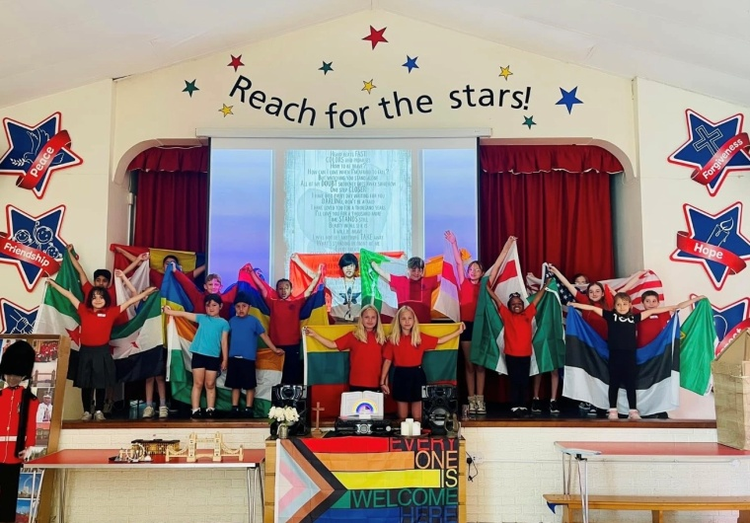
Our motto, which all the children can quote, links directly to this vision and is, simply, "Reach for the Stars!"

Our school reflects the essential features within the traditions of the Anglican Church and these will contribute to the pupils’ development by broadening and deepening their spiritual experience and understanding.

Theological Underpinning of our school vision

”Do your little bit of good where you are. It’s those bits of good put together that overwhelm the world.”
- Archbishop Desmond Tutu
Whilst the school promotes Christian values and attitudes including peace, forgiveness, trust, respect, hope and friendship, we welcome children of all faiths and none. The school provides a caring family atmosphere, in keeping with the ethos of a church school. It is also part of the local community and views education as a partnership between home and school, working with parents for the good of the children. Our vision is a true reflection of the day to day work that we do together as a school community to make our world a better place and to help our community to aspire.
We aim to create a stimulating environment in which we can care for every individual helping him or her to develop as a complete person and achieve full potential. St. George’s has a strong ethos of inclusion, welcoming all children from the community. Children with Special Educational Needs and/or Disability are not discriminated against.
Children will learn through experience, interest and understanding and will come to possess a wide range of educational knowledge and skills that have been soundly taught and encouraged.

British Values

At St George’s we actively teach our children about Fundamental British Values. We do this through our whole school curriculum, including PSHE/ RHE, collective worship and what we do in the daily life in school. By promoting British Values in school, we ensure young people leave our school prepared for life in modern Britain.

The Key British Values are:
- Democracy
- The Rule of Law
- Respect and Tolerance
- Individual Liberty
How democracy flows through St George’s

The ability to communicate is the most important area of learning. At St George’s, we empower our children by giving them the opportunities to make choices about the things that they believe to be important. Pupil voice is regularly used by the school to seek children’s views and that of others about aspects of school life. By valuing each other’s voice we demonstrate that we support democracy and liberty.
Presenting to peers why they should be considered for representing the class as a school council member or member of the food council;
Voting for school council members and respecting the decision of the majority;
Chattertime;
As a class identifying the rewards for filling stamp cards;
Listening patiently and respectfully while others are talking;
Pupil questionnaire to gain views;
School council make decisions, based on their class’ views.

How the Rule of Law flows through St George’s

We involve children in the setting of the class rules; helping the children to make decisions and choices that are acceptable to our St George’s family, the local community and beyond. The link between actions and consequences are developed in children’s understanding. Children are taught about safety from a variety of visitors and this in turn helps them to feel safe in their environment.
- Agree the consequence pyramid at the start of each school year and review throughout the year;
- Creating class rules;
- Discussing how our school rules make what we do fair;
- Thinking and talking about staying safe e.g. in water when swimming, bonfire night and road safety;
- Replicating school rules into other areas, residential visits and clubs;
- Following rules in games;
- Knowing consequences, positive and negative come with the choices we make;
- Online Safety knowledge.

How Individual Liberty flows through St George’s

Children are supported in developing their self-knowledge, self-esteem and self-confidence from the very start of them joining our Little Dragons nursery. We support each child being an individual, respecting themselves and being kind to themselves. Developing independence is an important part of understanding yourself.
The use of our school values to ensure that every child recognises how we can be a useful member of society;
- Work linked to our school vision “Do your little bit of good” to show how we can make a difference in the world through our choices;
- Whole school clear Behaviour and Relationships Policy fairly applied;
- Roles of responsibility in class and whole school;
- Positive links with the community and building the best community possible for Park Springs and Gainsborough;
- Zero tolerance of bullying; discriminatory language is challenged as are stereotypes.

How Respect and Tolerance flows through St George’s

Respect is one of our core Church School values and fundamental to the ethos of our school. Staff wear rainbow lanyards and the rainbow is everywhere in our school as a symbol that all are welcome in our St George’s family. We live in a multi- faith community where each person is respected and valued equally without regard to ability, gender, faith, heritage or race. Cultural appreciation and the development of cultural capital are embedded in our curriculum intent. Prejudicial or discriminatory behaviour is openly challenged and there is an ethos in St George’s that models, upholds and celebrates kindness, empathy and an understanding for others’ point of view.
- Understanding through finding out about different religions, celebrations and festivals;
- Understanding diversity and respect of cultures, race, gender and beliefs of others;
- Children understanding when behaviour towards others is not acceptable;
- Understanding the vocabulary around discrimination and the hurt this can cause;
- Collective worship in the local community religious buildings;
- Cultural Days every term where children can explore and celebrate the differences and recognise the similarities between themselves and children in different countries;
- Exploring the similarities and differences between ourselves and others through PSHE/RHE.

Safeguarding statement

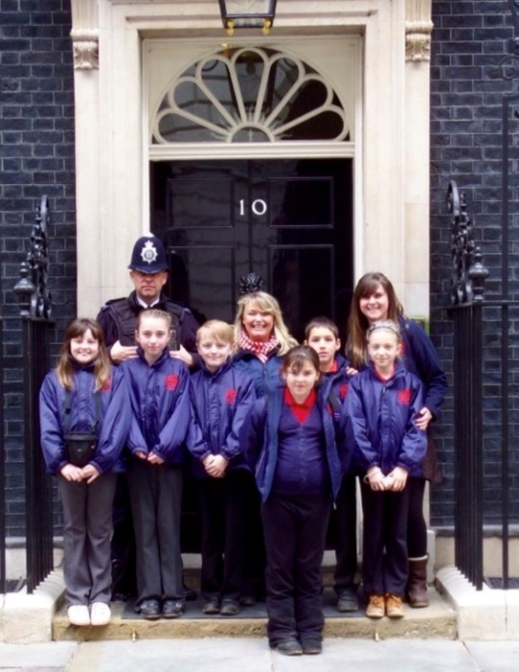
The Safeguarding policy applies to all adults, including volunteers, working in or on behalf of the school.

Safeguarding and promoting the welfare of children is everyone’s responsibility. Everyone who comes into contact with children and their families and carers has a role to play in safeguarding children. In order to fulfil this responsibility effectively, all professionals should make sure their approach is child-centred. This means that they should consider, at all times, what is in the best interests of the child.

Safeguarding includes the establishment and implementation of procedures to protect children from deliberate harm, however, safeguarding also encompasses all aspects of pupils' health, safety and well-being.

St George’s Primary School is committed to ensuring the welfare and safety of all children in school and all our staff, governors and volunteers have Safeguarding training.

"Do your little bit of good where you are. It's those little bits of good put
together that overwhelm the world."
Archbishop Desmond Tutu

Our Curriculum

Intent
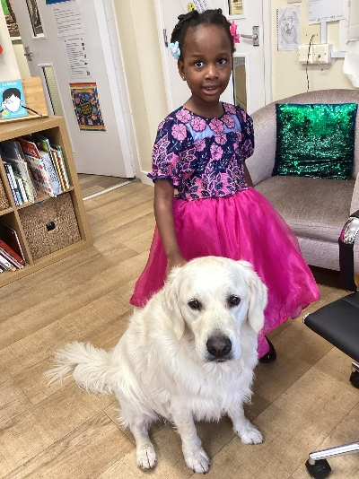
“Our curriculum promotes social mobility; we give our children the roots to grow and the wings to fly”.

“The roots to grow” refers to our curriculum equipping our children quite specifically with the knowledge and skills they will need to become successful. “The wings to fly” implies that our children will have the aspiration and confidence to reach their potential and will become positive citizens of the global community; making an impact, making a difference.

We have three curriculum drivers which are bespoke to our school. These are:
- Reach for the Stars – instilling ambition and aspiration into our children.
- Healthy Body, Healthy Mind – how to keep ourselves happy and healthy.
- The Natural World – developing love, respect and awe for the world in which we are living.

Underpinning our curriculum offer are our Christian Values of hope, trust, respect, friendship, peace and forgiveness.

Implementation

Giving our children the skills and knowledge they need to succeed has been carefully identified across every national curriculum subject and meticulously planned out across the children’s journey from nursery to Y6. Links are made across curricular areas, reading and writing happens in all subjects, knowledge is built upon day after day, month after month, year after year.

Every single day, all children in all classes, have “Daily Dashboard” lessons. This is where children, using proven metacognition strategies, learn, practise and rehearse key facts that they need to know. This is where their cultural capital is gradually built up, day by day. Separate subject-specific lessons are where they are able to learn new skills and implement the knowledge they have acquired. Slowly but surely, knowledge and skills are layered up on top of one another so that the children have a better understanding of the programmes of study.

Reading is high profile. Every member of classroom staff has been fully trained in our chosen synthetic phonics programme called Read, Write Inc. and can apply this knowledge to help children still learning how to read fluently. We are well resourced in terms of our phonics reading scheme, books to read for pleasure, non-fiction books and books to take home and keep. Reading is assessed and monitored closely. Writing is another area of high priority area. Every member of the classroom staff is a fully trained Talk for Writing practitioner. The strategies of T4W can be seen from nursery upwards and provide our children with the scaffold they need to bridge the gap from speaking to writing.

The curriculum is designed to challenge any stereotypes and to promote an ethos of tolerance and acceptance. We ‘adopted’ the rainbow as a symbol of family at our school. Children at St. George’s can articulate this well. In a family, everybody is welcome; there will be differences of opinion and times of challenge; but we celebrate those similarities and differences within our values of friendship and respect. We have worked hard to implement our Relationships and Health Education programme and are confident that it is working well and having the desired impact. We aspire for our children to be inclusive in their thinking and their actions and to stand up and question things if they do not seem right. We refer back to Archbishop Desmond Tutu frequently as a reference point for this.

Our curriculum also promotes the principle that ‘every learning journey should begin with an experience’. Every Key Stage 2 child will be taken to spend the day at a university before they leave our school. Outdoor education is pivotal to our curriculum offer; we have two woodland areas, our own allotment and BaseCamp (a large outdoor area which includes an assault course, a gym, table tennis tables, a stage, a pavilion, story throne, fairy tale hut, reading shed and nature area.) Unsurprisingly, our children love their learning at St. George’s!

We have our own school kitchen. We employ three chefs and provide food for other local schools, too. We place Food Education highly within our curriculum due to the poor health indicators within our community. We have a school Food Council and work with an outside agency called We Can Grow to help our children appreciate the Farm to Fork philosophy.

During Covid-19 we purchased a double modular unit to provide extra classroom space. Now we use one of these spaces as our ‘Community Room’. This has meant we now have a dedicated space to provide extra opportunities for our families. Three years ago, we started “Dragonflies” – a baby and toddler group. Through this, we are able to start to plug some of the gaps we see in our nursery children such as knowing some familiar songs, stories and rhymes, being independent, learning how to share. It is also a way of helping parents learn how best they can support their youngest children. It has been very successful and provides a fun, caring first-point-of-contact for some of our newest families. We have also just set up a parents’ art and crafts club. Whilst this focuses on art skills, its real purpose is to provide some joy and variety into our parents’ lives and to give them a space for their own wellbeing. Plans for the future include Family Learning and also our school chefs are going to offer a “Cooking on a Budget” course to our parents which has proved popular in the past. The Community Room is also the venue for our Free Food Stall which regularly offers a huge range of free food for our families and the wider community to benefit from.

Impact

Due to the careful sequence and layering up of our curriculum, and the very good teaching and learning provided, our children move from a low baseline to standards close to national norms. They also leave us with significantly more confidence and aspiration. The children’s knowledge and skills are built up across all curriculum areas and they are increasingly able to apply these skills in other contexts. Reading is seen as an important skill by our children and they are far better equipped to be able to access the KS3 curriculum. Where children are identified as falling behind there are a significant number of intervention strategies that we deploy and, as a result, all groups of learners make good progress from their starting points.

Website

Please visit our website which is full of information about the school https://www.gainsborough-st-georges.lincs.sch.uk/

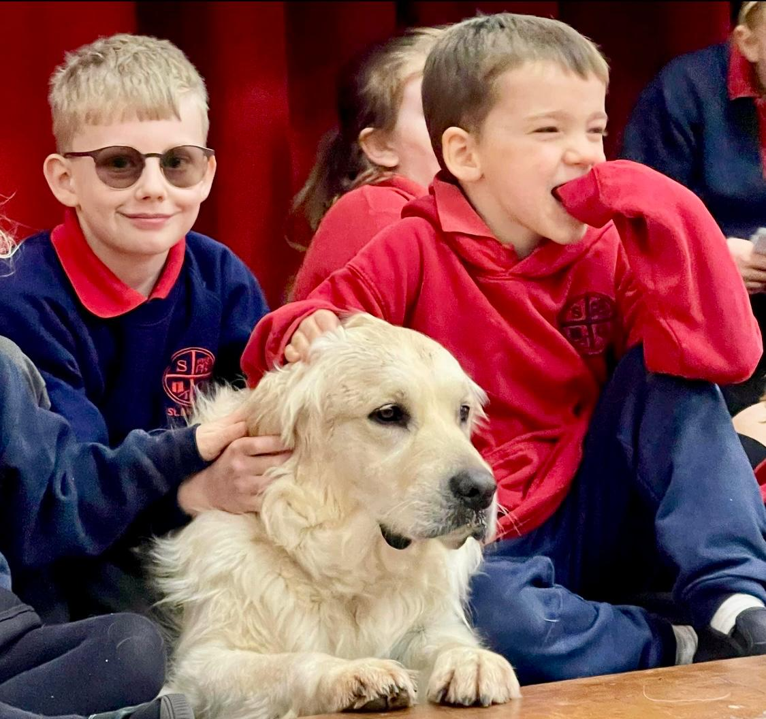

School Improvement Plan

Key Priorities:
- To improve spelling (consolidate phonics teaching and introduce Active Spelling).
- Successfully open our SEN Hub and integrate it into daily life at St. George’s.
- Successfully use metacognition strategies to better remember the four operation facts in maths and retain knowledge from across the curriculum.

Attainment

Please access the school website under Key Information for current and historical attainment data.

Attendance

Attendance continues to be a focus within school and remains high profile throughout school – last year whole school attendance was 92%. Current attendance to date at the end of Autumn 2 was 92.3%. Autumn 1 was 93.4% but due to a great deal of illness in Autumn 2 this dropped down 91.2% which affected the whole school figure. The number of Persistent Absentees, children whose attendance is below 90% is currently at 41 – 22%. This is a concern and we continue to try and address this through the numerous strategies we have in place to tackle poor attendance.

We continue to track attendance regularly; DHT and Senior Administrator meet every two/ three week to track attendance particularly those that drop below 90% - Persistent Absentees. Letters are sent and School Attendance Panel (SAP) meetings are held for cases of concern. We also send Notice to Improve letters to try to tackle some of the harder cases and put short timescales in place which are reviewed regularly. Last year we took one case of persistent absence to fine and when this was not paid have send this to LCC to consider for prosecution. Office staff continue to remain vigilant as always and chase attendance relentlessly throughout the week whether it be through daily texts, phone calls or letters. Any safeguarding concerns are recorded to ensure evidence is collected to show any patterns of poor attendance. Children with attendance concerns contribute to a high number of CPOMs entries. Home visits are completed regularly if needed by members of the safeguarding team. Our Attendance Governor has met with the DHT in Autumn 2 for a detailed update following an attendance review and has arranged to come in for attendance meetings this term to help support discussions with parents and to look at the procedures in place. We continue to put attendance on every Governors meeting to ensure it is kept high profile with Governors.

DHT has already contacted Alice McGowan, Safeguarding and Education Welfare Officer – LCC, last term for advice regarding some of our more complex cases and has our Targeted Support Meeting to go through attendance and groups on the 22nd January, an update will be shared with Governors at our next meeting.

Red Box assemblies are still popular with children and go ahead each half term, these are celebrated on Facebook, and we continue to have a variety of prizes to help keep the children’s interests. This year we gave books in Autumn 1 and selection boxes in Autumn 2. At the end of the year, we will have our big prizes where children can go into the draw if they are in the red boxes 4 times or more. Class attendance figures are published weekly on Dragon News and the winner is updated each week on our attendance board at the front of school.

SEND

At St Georges we value the abilities and achievements of all our pupils and are committed to providing each pupil the best possible environment for learning. We endeavour to make every effort to achieve maximum inclusion of all pupils whilst meeting pupils’ individual needs. We recognise the entitlement of all pupils to a balanced, broadly based curriculum and our intent is to make a difference for everyone in our school family regardless of ethnicity, background, needs or disabilities. Our SEND policy reinforces the need for teaching that is fully inclusive. The Governing Body and Senior Leadership Team will ensure that appropriate provision will be made for all pupils with SEND. Our SEND policy can be found on the school website.

SEND Hub Information
(See also letter in pack from LCC relating to establishing SEND Hubs in mainstream schools. It is essential that the successful candidate is committed to the development of this recent initiative in partnership with LCC)

In addition to the provision offered on our main school site, we are proud to also provide a specialist hub which caters for children with a primary need related to communication and interaction. The overarching aim of the Hub is to provide intensive support to develop the children’s communication, interaction, and learning skills.

Our Hub is tailored to support a small number of children, all of whom have an EHCP which outlines communication and interaction needs and associated cognition and learning difficulties.

Children who attend the Hub are fully part of our St. George’s family and, keeping in line with the animal class theme of the whole school, our Hub will be called; ‘Panda’ class. Children who attend the Hub will wear the school uniform, join in whole-school events, and take part in mainstream learning where it best supports their personal needs.

Admission to the Hub

Children who attend the Hub are on the roll of St. George’s mainstream school. Admission to the Hub is allocated through a rigorous induction process via the EHCP consultation panel – this is a commissioning agreement agreed by Lincolnshire County Council. Attendance at St. George’s school does not guarantee a place in our Hub nor does it increase a child’s chances of being granted a place. The Graduated Approach must be followed and applications made through the official channels.

The Hub is not suitable for children whose identified primary need is Social, Emotional, and Mental Health or have more severe learning needs. Hub places are reviewed, at least annually, in line with statutory requirements. Parents and the child’s case worker will be invited by the school to attend a review meeting. Children will be considered to reintegrate fully to their mainstream cohort if they have progressed to an extent where they would thrive in the mainstream learning environment. A thorough transition plan will be devised between school, parents, and the child’s case worker to ensure the child’s experience is smooth and successful.

The child’s placement in the Hub could be reviewed if the parent states that a change of provision is needed, if there is an evidenced-based perspective that the child’s need could be best met elsewhere, or if the child’s behaviour is a threat to the health and safety of staff and/or other children.

Attendance will be managed in line with our mainstream school policy which is written in conjunction with the DfE document – Working Together to Improve School Attendance, Aug 2024.

Staffing

The Hub will be led by a teacher who will be supported by two teaching assistants. The staff working in the Hub have previous experience of working with children and young adults with SEND and have attended training in specialist approaches to inform best practice. Staff in the mainstream will also visit the Hub to build relationships with the children – this will support the child when accessing learning or events within the mainstream school.

Curriculum

The curriculum the children will follow with be tailored to their individual needs, it will be highly specialised and flexible. Their sensory needs will be supported through specialised, individualised, and therapeutic approaches through both indoor and outdoor provision. Hub staff will also follow and make links to topics being taught in the corresponding year groups in the mainstream school.

Safeguarding

Safeguarding is a prominent feature of everyday life at St George’s. All staff are highly trained, alert and vigilant. We use CPOMs to record and manage any safeguarding concerns and actions and work relentlessly in multiagency teams for the safety and welfare of our children. Please see the website for our policies.

Pupils
We warmly encourage you to come and visit us and meet our wonderful children. We could not do them justice in a few words here but please visit our website to get a flavour of how fabulous they are and what wonderful things they achieve.

‘Pupils develop their character here. They take on responsibilities as members of the school and food councils. Pupils visit the local residential home to build relationships with its residents and play a part in the life of the community. Older pupils are buddies to younger pupils, supporting them through their school experiences. Pupils celebrate one another’s achievements. They applaud enthusiastically when the rewards bell rings in the dining hall signalling a pupil’s success.’
Ofsted January 2024

Staff

Each and every member of staff at St George’s goes the extra mile every day. They are committed, caring, vigilant and hardworking. Please visit us and meet them. Further details are on the website. ‘Staff are proud to work at this school. They value the training they access. Staff support one another and say that consideration is given to their well-being and workload.’
Ofsted Jan 2024

Parents

Our partnership with parents is of paramount importance to us and key to the success of our work with their children. Each year we use parental surveys to identity and explore areas of strength and areas of development and we have been pleased to see increased parental engagement with the school over the years. This helps us respond to feedback from parents and pupils. Please click on the link below to view the most recent results and actions on the Parents section of the website...
Please click to view the most recent results and actions.

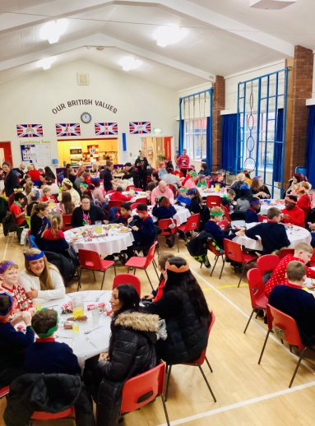
Staff make sure all kids are well behaved and are good at dealing with behaviour.’

‘My child was on a reduced timetable in his previous school. Since starting at St George’s he is managing full days with no issues. He is happy, his confidence is growing, he’s made good friends and everyone is so welcoming. This school has made a huge difference to mine and my child’s life in a short time.’

‘Staff are polite, helpful and encouraging.’


‘The school is very family orientated. All families are always looked after and are treated like family.’

‘The school is very family orientated. All families are always looked after and are treated like family.’

Important documents

Recruitment Privacy notice

School recruitment and vetting checks policy

Letter from Lincolnshire County Council (LCC)

Letter from the Diocese

How to Apply

Closing Date for applications: Monday March 2nd 2026 12.00 noon

Applications should be completed in line with the Person Specification in this pack and using the application form.

Disability Confident Scheme
LCC is a member of the Disability Confident Scheme, which extends to Community and Voluntary Controlled schools. Under the scheme, all disabled applicants who meet the minimum requirements of the job as set out in the job description and person specification will be guaranteed an interview.

Use of AI
Applicants are required to complete this application without the assistance of artificial intelligence (AI) tools. All responses must be written personally by the candidate to ensure authenticity and accuracy. Any applications found to contain AI-generated content may be removed from the recruitment process.

Applications should be submitted to Mr Baptiste Velan, Chair of Governors:
baptiste.velan@gainsborough-st-georges.lincs.sch.uk

Thank you for your interest in joining our St George’s family

