St Helena’s Church of England Primary School
Main Road, Willoughby, Alford, Lincolnshire, LN13 9NH

Our school is a rural village school attracting children from up to 15 miles away. We have 7 classes in the morning and 6 in the afternoon plus our Little Explorers’ Nursery. Our grounds include 2 playgrounds, Multi Use Games Area and an orchard. Parents are welcomed to school performances, art exhibitions, Sports Day and services in the Church. The Nursery and Reception class have their own well equipped outside play areas. In 2013 we built our own kitchen which provides hot, healthy and nutritious lunches for our pupils in our school hall.

We have an active School Association which provides a range of additional opportunities for the children such as Breakfast with Santa, Breakfast with a Lincoln City Football Player, Film Nights and School Fayres. The funds they raise help to finance books, theatre visits, help parent costs towards the residential and equipment for the school.

For more information please take a look at our website : www.st-helenascofe.lincs.sch.uk where you will find plenty of information including :
- Christian Values
- Policies
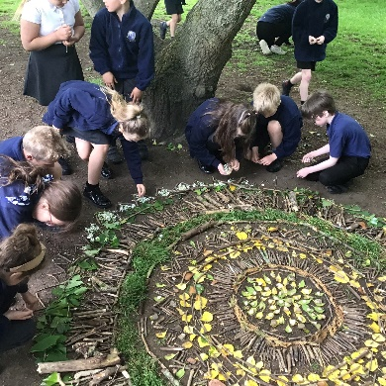
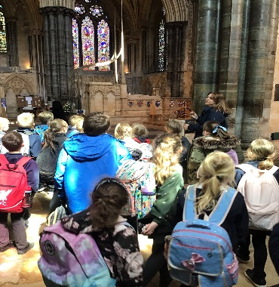
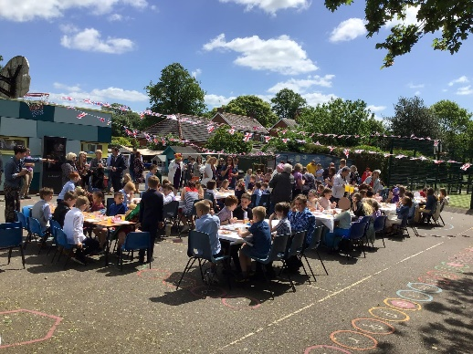
- Past newsletters
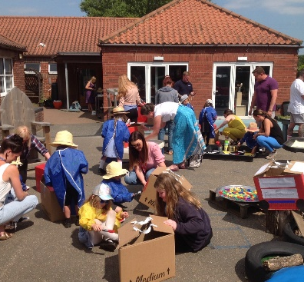
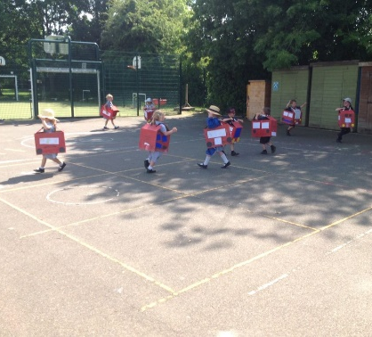
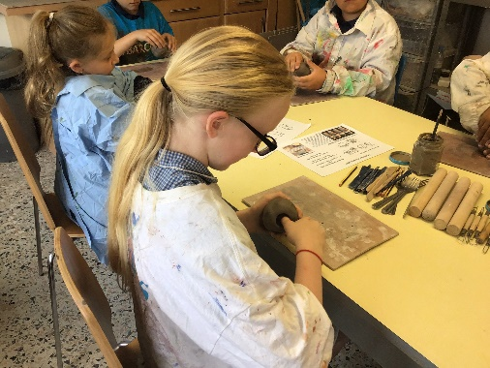

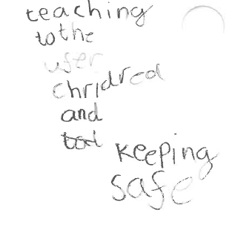
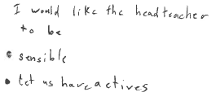
We asked our children what they think would make a good headteacher:
