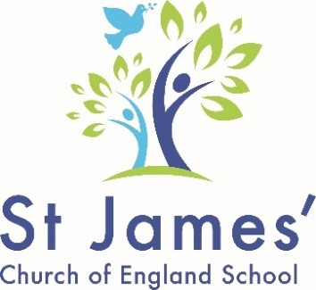

Headteacher Candidate Pack
For
St James’ Voluntary Aided Church of England
Infant and Nursery School
Leonard Street
Derby

‘The school’s highly inclusive ethos is at the heart of everything the school does.’ Ofsted 2018

Our Values-Grateful, Respectful, Our best, Welcoming

Contents
Application information 3
Welcome letter 5
Letter from Team Rector 7
Our Diocese- Derby Diocesan Board of Education 8
Our Local Authority- Derby City Local Authority 9
Headteacher job description 10
Headteacher person specification 14
Application Form 19

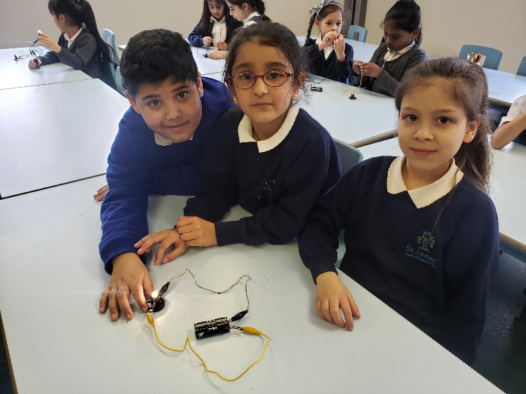
‘St James’ pupils leave as well-rounded individuals, empowered by their success.’ SIAMS Report 2015
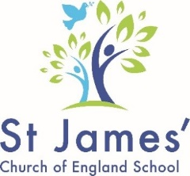

Application information

Advert
HEADTEACHER
St James’ Church of England Voluntary Aided Infant and Nursery School
Leonard Street, Derby DE23 8EG
ISR L8 – L14
Required for September 2021
Following St James’ Church of England Infant and Nursery School (Voluntary Aided) recent de-federation, the new governing body are seeking to appoint a headteacher excited to work with us as part of our community.
Our school serves a diverse and socially mixed community within the Arboretum ward of Derby.
We are looking for a candidate who will continue to deliver our four core values: being grateful, respectful, always trying our best, and being welcoming; and who will maintain and build on our OFSTED and SIAMS ‘Good’ rating.
As a Voluntary Aided Church of England school, the successful candidate will be expected to lead in ensuring that our school’s Christian ethos is maintained as an integral part of schools’ daily life.

The successful candidate will:
- Establish and sustain the school’s ethos, vision and strategic direction together with the governing body and through consultation with the school community
- Establish and oversee systems, processes and policies so the school can operate effectively
- Identify problems and barriers to school effectiveness, and develop strategies for school improvement that are realistic, timely and suited to the school’s context
- Make sure these school improvement strategies are effectively implemented
- Monitor progress towards achieving the school’s aims and objectives
- Allocate financial resources appropriately, efficiently and effectively
- Demonstrate the Church of England schools’ vision and values of “Educating for life in all its fullness” in everyday work and practice
- Work in partnership with St James Church (Walbrook Epiphany) and the Diocesan Board of Education
- Work in partnership with Derby City Local Authority as a Local Authority maintained school.
The successful candidate will be required to undergo a full enhanced DBS check, pre-employment checks, and must be eligible to work in the UK.
We can offer the successful candidate a positive, inclusive environment where staff and children work hard together developing good relationships and attitudes to learning.

Interviews will take place over two days, with tasks/presentation to be undertaken on 25th May 2021, and face to face interviews on 26th May 2021 (Covid restrictions permitting).

Should you wish to visit school during week beginning 19th April before making an application, please phone the school office on 01332 854984 and speak to Miss Hill.
Times available:
20.4.21 – pm 21.4.21 – pm 22.4.21 - pm
If you have any queries before you decide whether to apply, please call Maxine Bull on 01332 640354 or email Maxine.bull@derby.gov.uk leaving a name and contact telephone number.
To apply please download the documents and e-mail your completed application form, including your letter of application to Maxine.bull@derby.gov.uk (Maxine Bull, Professional Advocate for Children in Education (PACE), Derby City Council )
The closing date for applications is Wednesday 28th April at midday (12 noon). Any application forms received after the closing date will not be accepted.

‘Pupils are well behaved and respectful to others. They have a good understanding of the many cultures and faiths in the school, and they work and play alongside each other happily.’
Ofsted 2018

Welcome letter
15 April 2021

Dear Candidate,

Thank you for your interest in our school.

Our school de-federated on 1 February this year, and our newly formed Governing Body is now seeking to appoint a Headteacher.

Our School is in a unique community that is rich in cultural diversity, traditions, and multi faith groups. As a Voluntary Aided Church of England School, we aim to be part of this rich diversity, whilst maintaining our Christian ethos as a foundation through which we strive to provide the highest standard of education possible, in partnership with local and regional stakeholders.

The Headteacher with the help of staff and partners, will be committed to establishing, leading and maintaining the Christian character of the school in its day-to-day activities and in the curriculum. This will include meaningful engagement in acts of worship, promoting a school life that incorporates the values of the Christian faith and developing affirming relationships. We have qualified and are registered as an Attachment Aware and Trauma Informed school.

The successful candidate will be expected to maintain and develop our work in this area, raising awareness, promoting resilience, helping the most vulnerable children to recover from trauma, whist ensuring staff are better able to address our children’s needs.

St James Church of England Infant and Nursery School is close to Derby City centre and is located in the Arboretum ward of the City. We are a fully inclusive school; we actively celebrate the diversity of cultures that our families, and the wider community, bring to our school.

We are a small school with 91 children currently on roll. Our children speak no less than 21 different languages.76% of our children are EAL learners, with 32% eligible for Pupil Premium.

We are a ‘Good’ school. Our last Ofsted inspection was in November 2018.If you are interested in applying for this post, do please take a look at our website for more information about our school:
https://www.stjamesinfants.derby.sch.uk
Our most recent SIAMs report (2015), of which we are proud is also available via https://derby.anglican.org/en/education-department/download/3672_340ebbdacb2ef922b2194fa3d4b480d2.html

If you require further information about this post please contact Maxine Bull on 01332 640354 or email Maxine.bull@derby.gov.uk
If you would like to make an appointment to look round school during week beginning 19th April please contact Miss Hill on 01332 845984

Thank you, once again, for your interest in our school. We look forward to receiving your application

Edward Nkwelle and Karin Aberg
Co Chair of Governors

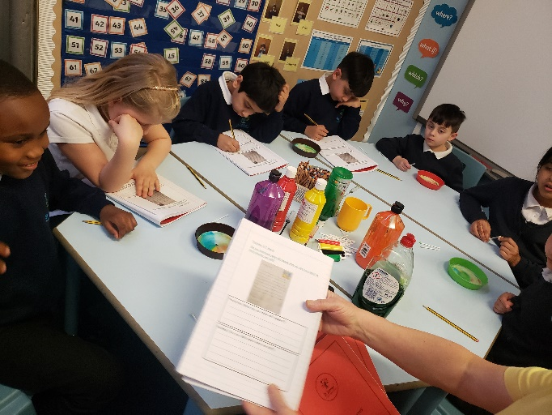

‘The behaviour of pupils is good…in classrooms, pupils are well behaved….. take pride in what they do and their desire to show their best. Breaktimes and lunchtimes are happy occasions.’ Ofsted 2018

Letter from Team Rector
The Reverend Andy Ward
The Parish Office
St Augustine’s Church
Upper Dale Road
Derby
DE23 6LY

Office Tel: 01332 270837
Rectory Tel: 01332 760846

Spring 2021
Dear Candidate,
Thank you for considering applying to be the headteacher of St James’ Infant and Nursery School, one of three Church of England schools in our parish.
The school and parish are situated in the inner city, an area which is host to most of Derby’s immigrant communities, particularly when they first arrive in the UK. As such the area is characterised by a vibrant and rich mix of religious and ethnic communities, including transient populations, asylum seekers and refugees. The school is situated in the poorest and most ethnically diverse local authority ward in the city, designated part of an Urban Priority Area. These factors can make working in our schools very challenging and hugely fulfilling – the people and the strong sense of community has a way of getting under your skin and results in us having some of the most dedicated and committed staff members and volunteers. This is a context with high levels of need, which means that those of us living and working here can make a big difference where it’s really needed!
As a parish we are keen to grow and develop our relationship with the school, and we look forward to working with the appointed headteacher to play our part in ensuring the Christian character of the school shines out as we serve the diverse religious and ethnic needs of the families who make up the school community. There is so much common ground in the values of the different faith groups represented, which enables us to promote mutual respect and understanding, strengthen social cohesion, and to work together for the common good.
St James’ is a lovely, warm, inclusive and welcoming school which gives a high priority to helping children to grow spiritually and emotionally as well as in academic learning and knowledge. I pray that as you consider your application you will discern whether you might be the right person to be appointed as our headteacher.

Andy Ward
Team Rector

Derby Diocesan Board of Education

"Offering our children and young people life in all its fullness" (John 10:10)
The Derby Diocesan Board of Education (DDBE) provides statutory functions and advice to the governing bodies of our 111 church schools.
We provide advice to governing bodies of schools regarding the planning of their places, religious education and worship, leadership and management, particularly in relation to school improvement, and the appointment of senior leaders and governors. We advise voluntary aided schools on land and buildings issues.
To find out more please visit our website-
Derby Diocesan Board of Education (anglican.org)

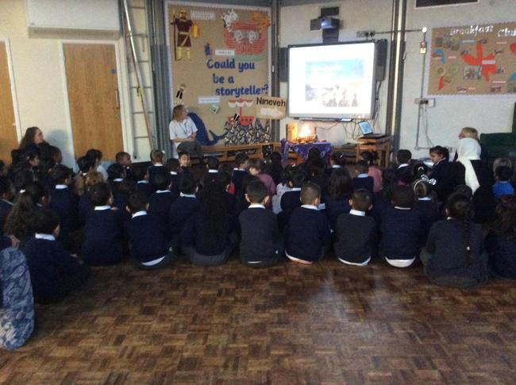
‘The partnership between the churches and the school is valued by everyone in this richly diverse religious community.’ SIAMS 2015

Derby City Local Authority

Derby City Council offer a range of services to schools.
The Education and Skills team include professional advocates for children in education (PACE) who work closely with maintained schools. Each school has a designated PACE and in addition the team carry out statutory functions linked to education.
Maintained schools and academies work in partnership through the Derby Primary Strategy Group.
Headteachers can access a variety of networks and training opportunities through local partnerships.
Schools Information Portal and Derby City Website include information about the local authority, education teams and services.
www.derby.gov.uk
https://schoolsportal.derby.gov.uk

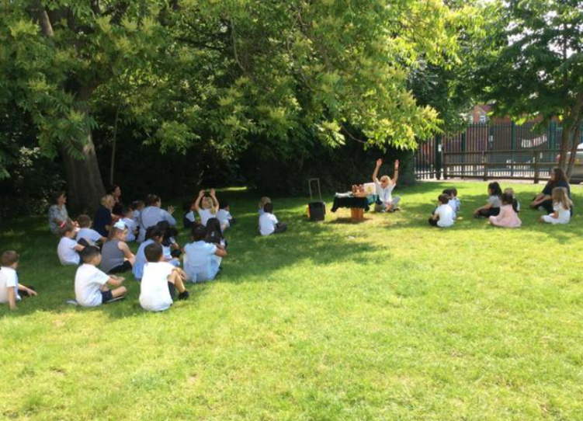
‘Leaders and staff are rightly proud of the inclusive ethos of the school….. pupils of all faiths, cultures and from different lands are warmly welcomed into the school, regardless of their needs or circumstances.’ Ofsted 2018

Job Description

St James’ Church of England Voluntary Aided Infant and Nursery School

Appointment of Headteacher

Job description

Salary: Group 1 L8-14
Contract type: Full time, permanent
Reporting to: Governing Body
Responsible for: All school staff

Main purpose
The headteacher will:
- Establish and sustain the school’s ethos, vision and strategic direction together with the governing body and through consultation with the school community
- Establish and oversee systems, processes and policies so the school can operate effectively
- Identify problems and barriers to school effectiveness, and develop strategies for school improvement that are realistic, timely and suited to the school’s context
- Make sure these school improvement strategies are effectively implemented
- Monitor progress towards achieving the school’s aims and objectives
- Allocate financial resources appropriately, efficiently and effectively
- Demonstrate the Church of England schools’ vision and values of “Educating for life in all its fullness” in everyday work and practice

Qualities
The headteacher will:
- Uphold public trust in school leadership and maintain high standards of ethics, behaviour and professional conduct
- Lead by example to develop a school culture where fairness, equitability, dignity and respect for others is the norm and is embedded within daily practises
- Serve in the best interests of the school’s pupils
- Lead by example with integrity, creativity, resilience and clarity to foster an open, transparent and equitable culture
- Understand that outcomes for pupils and supporting development of the local community are interdependent

‘The school’s highly inclusive ethos is at the heart of everything the school does.’
Ofsted 2018

Duties and responsibilities
School culture and behaviour
The headteacher will:
- Create a culture where pupils experience a positive and enriching school life
- Link the school values and vision with the Church of England schools’ vision and values of ‘Educating for life in all its fullness’
- Uphold educational standards in order to prepare pupils from all backgrounds for their next phase of education and life
- Ensure a culture of staff professionalism
- Encourage high standards of behaviour and attendance from pupils, built on rules and routines that are understood by staff and pupils and clearly demonstrated by all adults in school
- Use consistent and fair approaches to managing behaviour, in line with the school’s behaviour policy
- Promote and maintain a culture of high expectations for self and others

Teaching, curriculum and assessment
The headteacher will:
- Establish and sustain high-quality teaching across all subjects and phases, based on evidence
- Ensure teaching is underpinned by subject expertise
- Effectively use formative assessment to inform strategy and decisions
- Ensure the teaching of a broad, structured and coherent curriculum
- Establish curriculum leadership, including subject leaders with relevant expertise and access to professional networks and communities
- Use valid, reliable and proportionate approaches to assessing pupils’ knowledge and understanding of the curriculum
- Ensure the use of evidence-informed approaches to reading so that all pupils are taught to read
- Secure excellent teaching to achieve high standards of learning and attainment across EYFS and KS1, including preparation for transition to junior education settings
- Develop and maintain a collaborative learning culture within the school by actively engaging with local schools and other educational establishments to build more effective learning communities
- Create and maintain an effective partnership with parents and carers to support and improve pupils’ achievement and personal development

Additional and special educational needs (SEN) and disabilities
The headteacher will:
- Promote a culture and practices that enables all pupils to access the curriculum
- Have ambitious expectations for all pupils with SEN and disabilities
- Make sure the school works effectively with parents, carers and professionals to identify additional needs and provide support and adaptation where appropriate
- Make sure the school fulfils statutory duties regarding the SEND Code of Practice.

- ‘Phonics teaching is a strength of the school… Pupils’ progress is consistently good across different subjects and particularly in mathematics.’ Ofsted 2018

Duties and responsibilities continued:

Managing the school
The headteacher will:
- Ensure staff and pupils’ safety and welfare through effective approaches to safeguarding, as part of duty of care
- Develop and maintain effective strategies and procedures for staff recruitment, induction, professional development, and performance management
- Ensure effective planning, allocation, support, and evaluation of work undertaken by teams and individuals, ensuring clear delegation of tasks and responsibilities
- Ensure rigorous approaches to identifying, managing and mitigating risk
- Produce and implement clear, evidence-based improvement plans and policies for the development of the School and its facilities
- Acknowledge the responsibilities and celebrate the achievements of individuals, staff members and teams
- Manage own workload and facilitate an appropriate work/life balance culture within the staff team

Professional development
The headteacher will:
- Ensure staff have access to appropriate, high standard professional development opportunities
- Keep up to date with developments in education, taking account of national and local circumstances, policies and initiatives.
- Seek training and continuing professional development for all staff to meet CPD needs and to support the school’s shared vision and strategic plan
- Undertake continuous regular review of his/her own practice and achievements, set personal targets and take responsibility for their own personal development. To improve performance and delivery, they must consider feedback from others

Governance, accountability and working in partnership
The headteacher will:
- Understand and welcome the role of effective governance, including accepting responsibility
- Ensure that staff understand their professional responsibilities and are held to account
- Ensure the school effectively and efficiently operates within the required regulatory frameworks and meets all statutory duties
- Work successfully with other schools and organisations
- Maintain working relationships with fellow professionals and colleagues to improve educational outcomes for all pupils
- Build and develop relationships with partner schools

‘Vulnerable children are helped to grow in their self- esteem and cope with life and behave in a more appropriate way. Consequently, they feel valued and belong to the school family as part of the circle of love. All children thrive and succeed in this learning environment.’
SIAMS 2015

Duties and responsibilities

Strengthening and engaging with community
- Build and develop relationships with partner schools
- Build a school culture and curriculum which takes account of the richness and diversity of communities within and around the school
- Create and promote positive strategies for challenging prejudice and dealing effectively with any forms of disadvantage and discrimination
- Ensure a wide range of community-based learning experiences are available to the staff team and pupils of the school
- Collaborate with stakeholders including Diocese of Derby and other agencies in providing for the academic, spiritual, moral, social, emotional, and cultural well-being of pupils and their families
- Seek opportunities to invite parents and carers, community figures, business leaders or other organisations into the school to enhance and enrich the school and its value to the wider community
- Contribute to the development of the education system by, for example, sharing effective practice and working in partnership with other local schools to promote innovative initiatives
- Work with parents/carers to ensure that pupils have access to extended services, extra-curricular opportunities, homework support, and other social and educational experiences, e.g., through the Parent Staff Association and other local children’s service provisions
- Build a school culture and curriculum which takes account of the richness and diversity of the school’s communities
- As appropriate, organise or participate in joint community events that promote the ethos of St James Infants and Nursery School

Please note that this is illustrative of the general nature and level of responsibility of the role. It is not a comprehensive list of all tasks that the headteacher will carry out. The post holder may be required to undertake other duties appropriate to the level of the role

Notes:
This job description may be amended at any time in consultation with the postholder.

Last review date: 8 March 2021
Next review date:

Line manager’s signature: _______________________________________
Date: _______________________________________ Post holders signature: _______________________________________
Date: _______________________________________
“Leaders and staff are rightly proud of the inclusive ethos of the school….. pupils of all faiths, cultures and from different lands are warmly welcomed into the school, regardless of their needs or circumstances” Ofsted 2018
Person Specification
St James’ Church of England Voluntary Aided Infant and Nursery School

Headteacher Appointment

Person specification

Evidence assessed from A= Application, D= Documentation, I = Interview, T= Task
criteria | qualities  ESSENTIAL | Desirable
Qualifications  and training | - Qualified teacher status (A/D)  - Degree (A/D)  - A commitment to further Professional  Development (I) | - National professional qualification for headship (NPQH, SENCO) (A/D)  - Experience of teaching across all key stages. (A/I)
Experience  (including Leadership) | - At least three years of proven, successful senior leadership and management experience in a primary school, including nursery provision (A/I)  - Successful teaching of pupils within the primary phase  - Involvement in school self-evaluation and development planning including using data to bring about effective change and improve outcomes. (A/I)  - Demonstrable experience of successful line management and professional staff development to secure improvements (A/I)  - School budget management and financial responsibilities (A/I)  - Experience of raising standards in teaching, learning and pupil outcomes (A/I).  - Strategies for fostering school improvement, including establishing high expectations of pupil behaviour and attendance (A/I)  - Experience of the SEND Code of Practice (A/I)  - Experience of serving a school in a  disadvantaged community (A/I) | - Experience of working with Governors. (A/I)  - Significant recent and relevant experience as a Head Teacher, Deputy or Assistant Head Teacher(A/I)  - Previous experience of working in a faith-based teaching environment (A/I)  - Successful experience of raising achievement (A/I)  - Working with and engaging the involvement of external partners and the local community (A/I)  - Experience of leading Acts of Worship in a school setting
Skills and knowledge | - Understanding of high-quality teaching based on evidence, the ability to model this for others and support others to improve (A/I)  - Knowledge and understanding of reliable and proportionate approaches for assessing pupils’ learning. (A/I)  - Knowledge and understanding of performance management processes and managing effective professional development. (A/I)  - Knowledge and understanding of effective curriculum design to promote breadth, fun and enjoyment of learning (A/I).  - Strong financial planning and management skills with experience of making effective use of resources including the Pupil Premium (A/I).  - Knowledge and understanding of supporting EAL learners (A/I).  - Data analysis skills, and the ability to use data to set targets and identify weaknesses to maximise outcomes for pupils (A/I)  - Effective communication and interpersonal skills (A/I)  - Ability to communicate a vision and inspire others to translate this into practise (A/I)  - Ability to build effective working relationships (A/I)  - A clear understanding of and commitment to promoting and safeguarding the welfare of pupils and staff (A/I) | - Knowledge and understanding of Health and Safety requirements in schools. (A/I)  - Application of new technologies to teaching, learning and management. (A/I)  - Knowledge and understanding of HR policies and procedures. (A/I/T)  - Knowledge of the roles and responsibilities of the Governing Body, LA, the Diocese and of the requirements for accountability (A/I/T)
Personal qualities | - Commitment to uphold the 7 principles of public life (the Nolan principles), at all times (A/I)  - A commitment to securing best outcomes for all pupils, and promoting the ethos and values of the school(A/I)  - Ability to work under pressure and prioritise effectively(A/I/T)  - Commitment to maintaining confidentiality at all times(A/I)  - A commitment to building positive relationships with all stakeholders(A/I)  - Commitment to safeguarding and equality, ensuring that personal beliefs are not expressed in ways that exploit their position(A/I)  - A commitment to link our schools values and vision with the Church of England vision and values for schools of ‘Educating for Life in all its ‘Fullness’  - Ability to form appropriate relationships and maintain personal boundaries with pupils and the wider school community. (I/T)  - Have a sense of humour and an ability to reframe mistakes in order to learn and develop (I)  - Strong personal motivation and drive (I) | - Demonstrate flexibility and an ability to adapt to changing circumstances and new ideas (A/I)

Notes:
This job description may be amended at any time in consultation with the postholder.

Last review date: 8 March 2021
Next review date:

Line manager’s signature: _______________________________________
Date: _______________________________________

Post holders signature: _______________________________________
Date: _______________________________________

Application Form

Please fill in electronically the attached application form. In addition, include a letter that will support your application.
For this post you will also need to supply a 3rd referee.
Please provide the name and contact details of a third referee who is able to comment upon your personal qualities relating to leading a Church of England School. This reference may be written by your own church minister. If this is not possible, you may wish to ask someone connected with a church that has a relationship with your current school. This can be included at the end of your supporting letter.

Please email your application and letter to Maxine.bull@derby.gov.uk. If you do not receive a response to say that the application has been received by the closing date call 01332 640354, leave a message and contact number.

