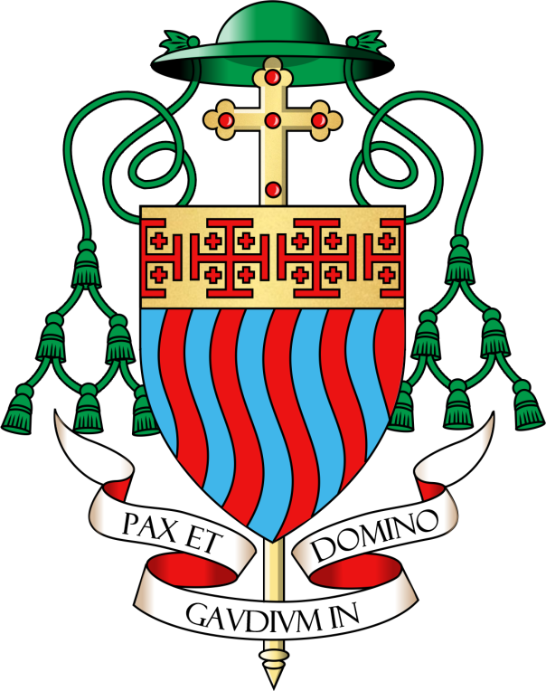 | DIOCESE OF ARUNDEL AND BRIGHTON
Person Specification - Head Teacher

ST JOHN THE BAPTIST CATHOLIC PRIMARY SCHOOL
Learning and Growing Together, Unique in God’s Eyes

ESSENTIAL CRITERIA

Qualifications and Experience

Qualified teacher status

Evidence of outstanding classroom practice and curriculum leadership

To have worked in at least two schools and have /Deputy/Assistant headship experience in a primary school for at least three years

Evidence of recent and relevant professional development in leadership and management

Experience of work with external partners and other agencies for the well being of all pupils and their families

Experience of providing support systems for pupils

Demonstrate an understanding of the importance of safeguarding, forming and maintaining appropriate relationships and personal boundaries with children and young people

Demonstrate resilience in the leadership role

Proven experience of implementing strategies for raising achievement and monitoring progress

Knowledge, Experience and Understanding of the Distinctive Nature of Teaching in a Catholic School

Senior leadership experience in a Catholic school or is able to demonstrate sound understanding of the aims, organisation, leadership and governance of a Catholic school

Is a practising and committed Catholic, involved in the life of the church at parish and school level.

Has a secure understanding of the distinctive nature of the Catholic school and Catholic education

Has an understanding of the leadership role in the spiritual development of pupils and staff

Understands the role of the governing body in a Catholic school in preserving and promoting the school’s Catholic ethos and character

Has an understanding of the school’s role in the parish and wider community and its contribution to community cohesion

Experience in leading acts of worship

Knowledge, Skills and Attributes

Ability to use data analysis and prepare reports to support school improvement, decision making and staff / governor accountability

Knowledge of strategic financial planning, budgetary management and principles of best value

Ability to lead and empower successful teams to secure school improvement

Ability and experience in supporting and developing staff effectively, including the ability to recognise achievement, monitor and evaluate work and address poor performance, and achieve work-life balance

Wide knowledge of the impact of current educational challenges and future trends

Ability to communicate effectively with a wide range of audiences

Proven experience of implementing strategies for monitoring progress and raising achievement

Ability to manage the school efficiently and effectively, including HR, finance and accommodation

Excellent organisational and interpersonal skills and flexible management style

Commitment to a curriculum which engages and enthuses children and leads to high achievement

Proven ability to manage behaviour and create a positive ethos

Commitment to the promotion of an inclusive school community

Desirable Criteria

Qualifications and Experience

Completion of the NPQH

Knowledge of the wider curriculum beyond school and the opportunities it provides for pupils and the school community

Evidence of continuing professional development relating to Catholic ethos, mission and religious education, e.g. CCRS

Evidence of participation in the faith life of the community

