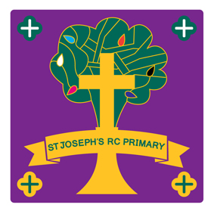
St Joseph’s RC Primary School
Huttock End Lane
Stacksteads
Bacup
Lancashire
OL13 8LD
Tel: 01706 873177
Email: head@st-josephs-bacup.lancs.sch.uk
Website: www.stjosephsbacup.co.uk
Acting Headteacher: Mrs J Cawtherley

14th September 2026

Dear Applicant,

Thank you for your interest in the post of Headteacher at St. Joseph’s R. C. Primary School. I welcome your application.

Our school is looking for that special leader who can build upon our current successes and drive our vision, routed in gospel values of love, service and community, forward. Our mission is to ensure that every child is known, valued and encouraged to grown into the person God created them to be.

As a Catholic school we welcome children of all faiths and of none. Our school community is united in our shared values and in our determination to work together to help every child to flourish.
We have the privilege of being a small school where we able to know each child and are able to meet their individual needs. We are so proud of them as they grow and mature and are prepared to make a positive difference in school and in the world.

In this pack, you will find details regarding our school's ethos, the job description, and the person specification. We highly encourage prospective candidates to visit the school prior to applying. To arrange a visit, please contact Mrs. Sanderson at the school.

The closing date for applications is Wednesday 7th October at noon. Shortlisting will take place on 15th October, and interviews will be held on Wednesday 21st October
We look forward to receiving your application.

Yours sincerely

Mrs J Williams
Chair of Governors

