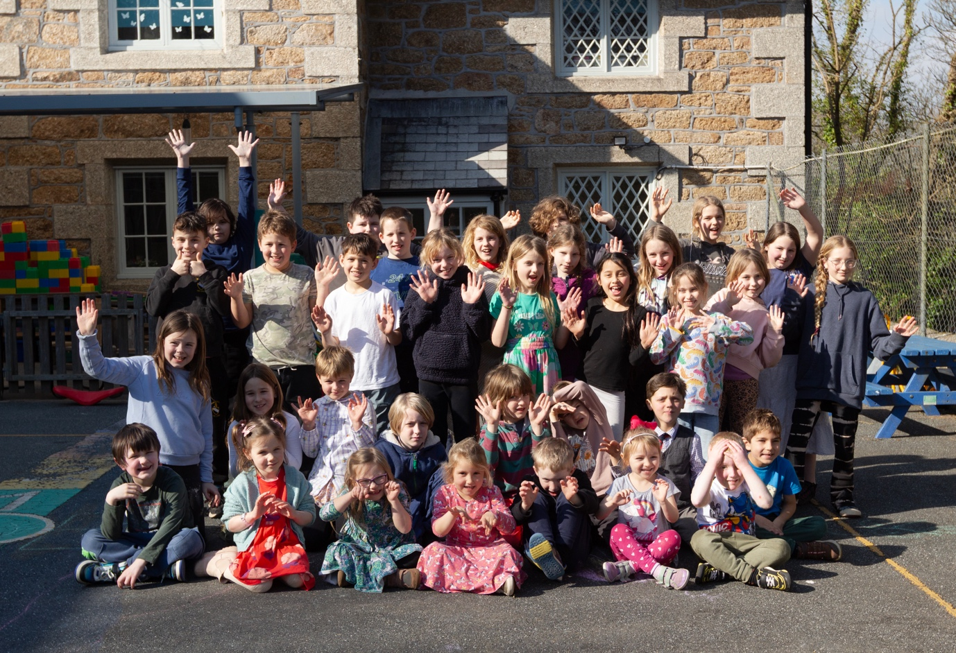

St Levan School

Applicant Pack

**A unique educational approach, in a unique learning environment,**

**looking for a unique leader.**

0.6 Headteacher with some teaching commitment.

L6 or L7 depending on experience (pro rata)

Closing date for applications:

21st April 2025

Start date:

1st September 2025

A small, thriving school which has recently had significant local authority investment. A school whose unique educational approach is to celebrate the individuality of each child whilst striving to enable them to become the optimum version of themselves academically, creatively and personally.

**About our School**

Staff

* 1 Headteacher
* 1 Secretary
* 2 Teachers
* 3 Teaching Assistants
* Specialist Teachers in Drama, PE and Music.

Pupil Numbers: 38

Mixed Year Classes

Key Stage 1 – Reception Year 1 and 2

Key Stage 2 – Year 3, 4, 5 and 6

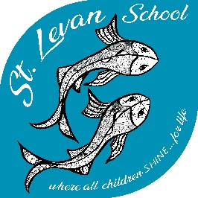

Welcome to St Levan

On behalf of the Governors of St Levan School I would like to thank you for your interest regarding the position of Headteacher at St Levan School. This post is 0.6 in the first instance and will have a teaching commitment.

St Levan is a small rural school located in West Penwith. The school is unique in its educational approach and attracts pupils from a wide area beyond our catchment. Families are attracted by the small classes, exemplary pupil behaviour, high quality teachers and support staff, and a family friendly inclusive ethos of the school. We are proud to work with families to also offer flexi-schooling arrangements. We are part of the Local Authority, to whom we are very grateful for a recent significant investment refurbishing the whole school.

The number of pupils at the school holds around our PAN (42), and we have 2 mixed age classes both with a class teacher and TA. An adaptable approach to class structure and teaching arrangements always ensures the best interests of all of our pupils is at the centre of everything we do, from the most-able, to those requiring greater support. As you will have seen from the advertisement, St Levan offers a unique educational experience. We offer a rich, broad and balanced curriculum with creativity at the heart of it, allowing pupils to have a strong voice and develop their individuality, becoming motivated, self-led learners. Our commitment to a creative approach is reflected in our timetabling whereby regular teaching from specialists in the extended curriculum offers pupils a rich and diverse experience, enhancing learning. There are several workshops throughout the year at the nearby Minack Theatre, and a week-long residency at St Levan with students from the Central School of Speech and Drama. With no school uniform, children are able to express their individuality on a daily basis.

Our School works closely with a number of local clusters, especially the Penwith Education Trust (PET). As well as for students, this partnership also provides a number of locally based CPD opportunities for Staff. St Levan also works closely with all of our local Secondary Schools in order to ensure a smooth transition for our KS2 pupils. As part of the wider community St Levan participates in a number of activities throughout the year. Friends of St Levan School organise an Annual Christmas Market attended not only by our whole school community but also many of the local community and beyond. We also participate in the Arts based Lafrowda Festival which takes place in the nearby town of St Just alongside our other local primary schools.

At St Levan we create a happy and safe environment where all children can thrive. Our children at St Levan are at the centre of everything we do which is encapsulated in our motto which says – St Levan – where all children SHINE… for life. A successful candidate will have an exceptionally dedicated and friendly team of teachers and support staff as well as the support of a committed Governing Body. We are looking for an enthusiastic, highly motivated and inspirational Headteacher with outstanding classroom practice who will join us in our shared vision to lead us on our continuing journey.

To assist your application I would like to draw your attention to the School website [www.st-levan.cornwall.sch.uk](http://www.st-levan.cornwall.sch.uk/) on which you will find an array of information about our School, including a short film illustrating a typical day at St Levan, and our strong pupil voice. Following our very recent OFSTED Inspection, in which we gained a ‘GOOD’ you will find our Report which positively highlights many of the aspects of our School that make it a unique learning environment. We are especially proud of gaining an ‘Outstanding’ in the area of Personal development, which we feel reflects the ethos at the heart of our school.

I hope this letter gives you a flavour of the School but in order to appreciate its unique qualities I am sure you will want to visit. I look forward to welcoming you and showing you around our school and would be delighted to discuss any points you may have regarding this post.

Yours faithfully

Sharon Brolly

Chair of Governors

On behalf of the Governing Body of St Levan School

**

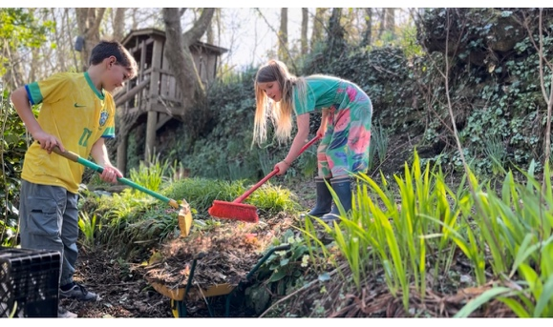

**An Ideal Candidate will be:**

* An inspirational educator who will support our distinctive and inclusive vision and ethos
* An outstanding teacher who models excellence throughout the school community and works collaboratively with the staff and governors
* Someone who is open to doing things differently but also an innovative and strategic thinker with the commitment, drive and ability to add value to a dedicated team
* Able to lead, motivate, challenge and inspire staff and pupils to have a love of learning and to achieve their best
* An excellent communicator with outstanding interpersonal and organisational skills

**What St Levan School will offer you:**

* Ofsted 'Good' with outstanding features.
* Two experienced and outstanding teachers, who both hold key areas of responsibility covering Safeguarding and SEND.
* SATS results in the top 1% country-wide.
* A recent refurbishment of the entire school, updated and improved for the 21st Century.
* A dedicated team of staff and governors, who work collaboratively promoting our distinctive and inclusive vision and ethos.
* An environment that puts everyone's wellbeing at the heart of our decision making and actively encourages a positive work / life balance.
* Healthy and wholesome home cooked lunches from locally sourced providers provided by our own independent cook.

**

****

‘Just everyone's so nice to each other and we don't have to wear school uniform.’

‘There are lots of reasons. One of the reasons for me is my teacher, she won't call herself the boss in any way. We're all equals. She just teaches us.’

**Student Voice**

What is special to you about

St Levan School?

**

‘Because

it’s small.’

**

‘It’s a small school and there aren’t lots of people, so it's just not as crazy like some other schools where there are lots of people.’

‘I’m in love with St Levan School because it feels like home.’

‘Because it's

just really nice.’

‘It's really good.

And it’s fun.’

‘I like coming

to St Levan.’

‘Because it's just a nice little school and because in a big school there's so many people and it's hard to make friends.’

‘It's a small school, and you don't have to wear any uniform.’

**

What qualities would you value

‘I'd like them to be really kind and funny but they can also be quite strict, but not very strict. We're not really strict here.’

‘Kind and

not strict.’

in a head teacher?

‘Someone who is very nice and interactive with children.’

‘Not strict.

Kind.’

**

‘They'd have to be kind. Really kind.’

‘Kind and

helpful.’

‘Good at coming up with... stuff. Just like my teacher.’

**