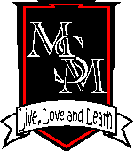
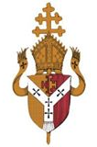

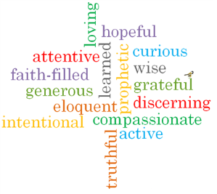

ARCHDIOCESE OF BIRMINGHAM

ST. MARGARET MARY’S RC PRIMARY SCHOOL
Perry Common Road, Erdington, Birmingham, B23 7AB

Head Teacher: Mr M. Aldred Tel: 0121 464 6355 Fax: 0121 464 8558
Chair of Governors: Fr. Simon Ellis E-mail: enquiry@stmgtmry.bham.sch.uk
Parish Priest: Fr. Simon Ellis Website: www.stmgtmry.bham.sch.uk
Twitter: @StMargMaryRC

School Vision statement for St Margaret Mary Roman Catholic Primary School, Birmingham

St Margaret Mary School is a Catholic School where the love of Jesus Christ is the foundation for all that we do. We hope that this love will guide, not only the religious aspects of the curriculum day, but will be a firm foundation for the whole life of the school.

At the centre of everything we do are our Gospel Virtues; these underpin all that we seek to undertake and achieve, and shape everything we do at St Margaret Mary Primary School.

In our school everyone is expected to behave well, to show courtesy and respect for others and indeed to welcome everyone into our community –regardless of their faith or culture - to “live, love and learn together in the light and example of the life of Christ” (School Mission Statement).

We believe that to make this vision a reality, we must:
- Follow the example of Christ and in so doing, treat our children, families and staff with dignity and respect.
- Help our children and families and each other know of God’s love for all of us and to learn about the message of Christ through the Gospels, including the Archdiocese of Birmingham’s ‘Gospel Virtues’
- Nurture all individuals to develop confidence in themselves and have high self-esteem and ensure that the children achieve their full potential in all areas of the curriculum.
- Encourage and motivate a highly skilled team of staff and continually develop our knowledge to ensure the best possible education for all of our children.
- Recognise the immense potential of working in partnership with the children’s families, the Parish and wider community in order to fulfil our wider ambitions for the children in our school.
- Support our children, their families and each other in the faith journey, in developing a knowledge and understanding of the traditions of the Catholic Church and especially in sacramental preparation.

Values Statement: All adults at St Margaret Mary Primary School have a commitment to the well-being of our children. We see our school as an inclusive community. The development of the whole child is at the heart of our mission as a Catholic school community.

As a Catholic school our values of compassion, care and respect rooted in the Gospel encompass those values identified by the Government as "British values". So we:
- enable students to distinguish right from wrong and to respect the civil and criminal law of England;
- encourage students to accept responsibility for their behaviour, show initiative, and to understand how they can contribute positively to the lives of those living and working in the locality of the school and to society more widely;
- enable students to acquire a broad general knowledge of and respect for public institutions and services in England;
- further tolerance and harmony between different cultural traditions by enabling students to acquire an appreciation of and respect for their own and other cultures;
- encourage respect for other people; and
- encourage respect for democracy and support for participation in the democratic processes.

