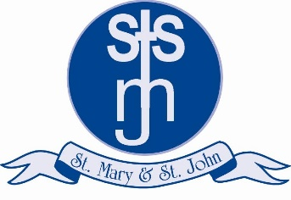
Are you looking for an exciting opportunity to lead an outstanding Catholic Primary School, where “in the light of Jesus, we learn to shine”?

St Mary & St John Catholic Primary School



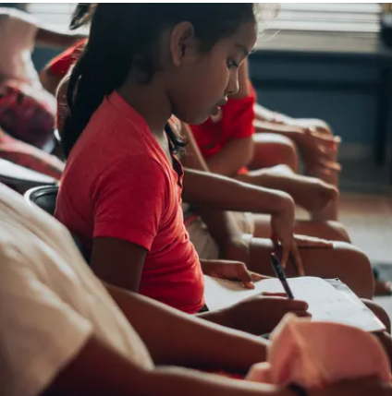
Our pupils would like a Headteacher
who ……

