

Headteacher Pack
St Mary & St Michael
Catholic Primary School
Sutton Street, London E1 0BD
January 2024

020 7790 4986 www.st-marymichael.towerhamlets.sch.uk

Contents

Welcome from the Chair of Governors 3
Recruitment Process Details 4
About us 5
Our School Mission Statement, Core Values and School Aims 6
Our Parish and Our Priest 7
Our Learning 8
Enrichment including after school clubs 8
Inclusion & SEND 8
Partnership working 9
Pupil Outcomes 10
Ofsted 11
The Catholic Schools Inspectorate 12
School Improvement Priorities 13
Financial Statement 14
Premises 14
Governors 15
Staffing Team 15
Headteacher Job Description 16
Person Specification 21

Welcome from the Chair of Governors
Dear Candidate,

Thank you for your interest in St Mary and St Michael Catholic Primary School. St Mary and St Michael is a much loved, successful school in the heart of Tower Hamlets. We currently have 423 children on roll coming from a wide variety of backgrounds, reflecting the borough’s multi-ethnic communities. Our communities are set in one of the poorest parts of London and so it is important that we provide a platform for our young children to explore the world and to aspire to their full potential. Our school is a happy vibrant place with an ethos of respect and tolerance. Our school has very strong links within the Parish and with St Mary & St Michael’s Church being next to the school, we are able to utilise this with the children attending Church for Prayer and Hymn.
St Mary and St Michael is a warm, welcoming and secure place for children to begin their school life. Our child-centred approach is underpinned by our core values of Compassion, Collaboration, Perseverance, Respect and Self Worth. We seek to inspire in every pupil a love of learning through a wide and balanced curriculum, specialised teaching, music, school trips and underpinning these is our understanding of religious life and the gospel values so that all children feel a valued member of God’s family. The school has a strong Catholic ethos which is at the heart of everything we do and believe in.
One of our strengths is our teacher and support staff, which has been stable and supportive, putting the children first in every way. Our last Ofsted rating was good with elements of outstanding which is down to the dedication of all our staff.
The position of Headteacher is set to become available starting September 2024. Currently, we have an Interim Head Teacher in place, who is a valuable member of the leadership team. We are actively searching for a dynamic individual to assume the role of Head Teacher, someone who can not only enhance the school's current strengths but also introduce fresh ideas to propel the institution towards achieving an outstanding status.
As Governors, we will encourage and support our Headteacher to take the initiative and assume full responsibility for school leadership, while helping ensure healthy and sustainable finances. We look forward to supporting and developing the successful applicant as he or she grows into the role at St Mary & St Michael Catholic Primary School.
We pride ourselves on being very friendly and welcoming school, so I hope you take advantage and pay a visit before deciding whether this is the school for you.
We look forward to hearing from you.

Yours sincerely

Mike Killington - Chair of Governors

Recruitment Process Details

To start: September 2024

Salary range: L22-L28 (£88,036 - £100,552)

No of Pupils on Role: 420+

Closing date for applications: 12 noon on 21st February 2024

Interview dates: 28th February 2024
(Candidates to be notified of attendance by 23rd February 2024)

A visit is essential and can be booked by contacting:
Joanna Hanna or Sarah Justin via email at admin@sm-sm.co.uk by calling on 020 7790 4986.

The Headteacher Job Description and Person Specification can be found at the back of this pack.
To apply for this role please complete the St Mary & St Michael application form, together with the recruitment monitoring form and the consent to obtain references form.
In addition to this application form you are required to respond to the Person Specification requirements for this role with evidence and examples of your experience. You are not at this stage expected to respond to all points as many can only be established at interview. Your response to this should be no longer than 2 A4 sheets in Calibri 11 font.
You are also required to provide a Personal Statement as to why you want to be our new Headteacher and what you think you would bring to the role. Your Personal Statement should be no longer than one A4 sheet in Calibri 11 font.
If you have any questions about the role or the process of application, please call Andrew Best on 07917 080201.
Please return your completed application to andy.best@fsed.co.uk
We are committed to ensuring equality and diversity is central to the operation of our school through the staff we employ and the provision that we make.
We are committed to safeguarding and promoting the welfare of children and young people, and expect all staff to share this commitment. An enhanced DBS check is required for all successful applicants.

About us
St Mary and St Michael 2 form of entry primary school with a strong Catholic ethos. This permeates all areas of school life and is at the heart of our philosophy of education. Our whole curriculum is rooted in a religious understanding of life, where the gospel values underpin our efforts to provide a quality education for all. In all that we do we aim to create a happy and secure environment, where children want to come to school in the knowledge that they feel unique and valued as members of God’s family.
We believe that children need to leave our school with the core skills and qualities that will equip them well for the next stage in their education as well as in life beyond school. Our aim is that children at St Mary and St Michael Primary School will become confident, lifelong learners. We can only do this successfully if we work together and have a positive partnership between home and school. We aim to create aspirational targets for our children, increasing their potential for achievement in life, whilst holding on to their Christian values and duty to care for all in God’s world.
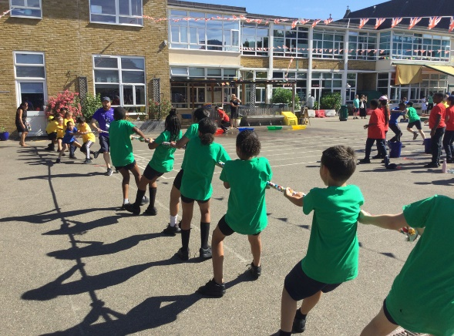
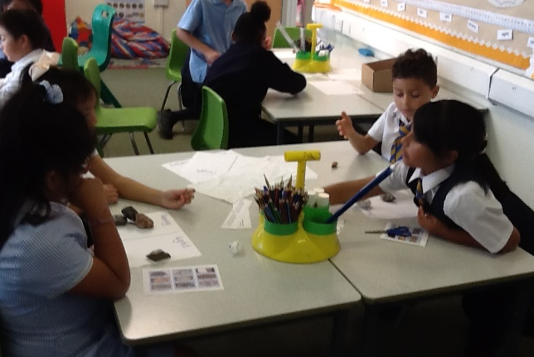
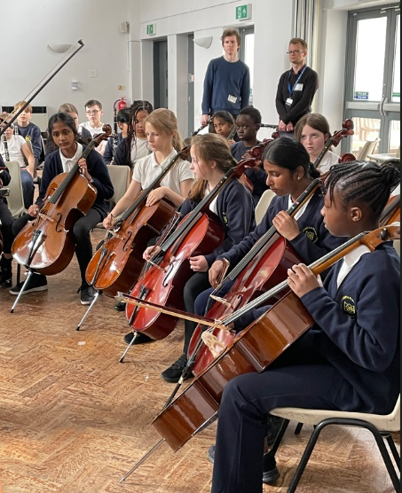
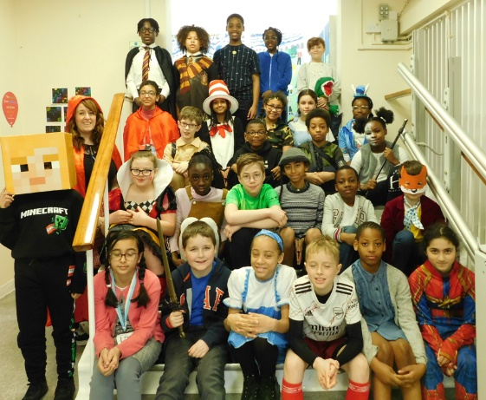
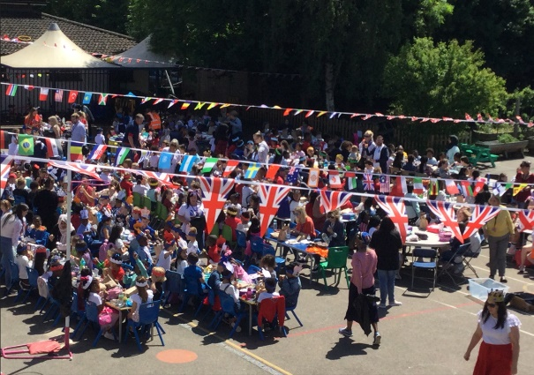

Our School Mission Statement, Core Values and School Aims
At St Mary and St Michael our mission statement is, ‘Learning together hand in hand with our friend Jesus.’ Our faith is at the heart of everything that we do.
At the heart of Catholic education in St Mary and St Michael lies the Christian vision of the human person. Religious education is never simply one subject among many, but the foundation of our entire educational process. The beliefs and values studied in Catholic religious education inspire and draw together every aspect of the life of our school.
As a Catholic school, we aim to provide the best possible education for each child, where the teachings of Christ inform all our efforts and the way we treat each other. We provide an orderly, safe environment in which effort and personal success are rewarded, special gifts are catered for and individual needs are met.
St. Mary & St Michael Catholic Primary School aims are:
- To have a broad and balanced curriculum which is innovative, creative and relevant; that develops the progression of skills, knowledge and practical abilities that will enable our pupils to become confident, independent life-long learners.
- To help pupils appreciate all forms of human achievement.
- To help pupils understand the world in which they live and to recognise the inter-dependence of individuals, groups and nations.
- To be responsible citizens who make a positive contribution to society, whilst holding on to their Christian values and duty to care for all in God’s world.

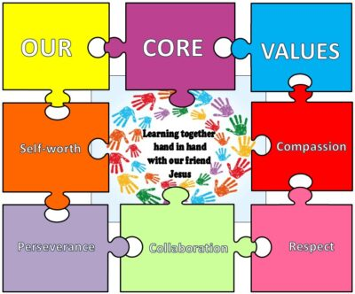

Our Parish and Our Priest
Our school and parish are part of the deanery of Tower Hamlets in the Diocese of Westminster which is one of the smallest dioceses in England and Wales in geographical area, but the largest in terms of Catholic population and priests. More information on The Diocese of Westminster is available on their website (www.rcdow.org.uk).
Father Keith Stoakes is the Parish Priest at St Mary and St Michael Church. He comes into school regularly to celebrate Mass with us and to support with our RE learning and the liturgical life of the school. He is also one of our school governors.

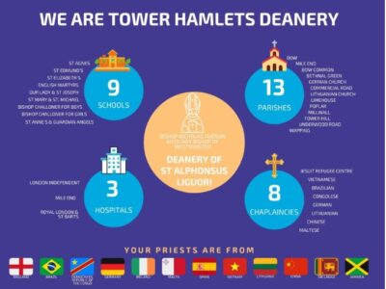

Our Learning
We believe that every child should leave St Mary & St Michael as a well-rounded, knowledgeable individual with a thirst for further knowledge and a love of learning.

To achieve this, we must ensure that all children have access to a broad, balanced curriculum with rich, engaging experiences. We must also ensure that all children are given opportunities to reach age-related expectations across all subjects.

More detail about our Curriculum and the way we teach can be found on our website under “Our Learning”.

Enrichment including after school clubs
We plan a wide range of experiences and creative skills into our curriculum delivery and so enrichment is an integrated part of day-to-day school life. We provide opportunities for our pupils to extend their understanding of the world and the way it works. In addition, there a range of after school clubs each term.

Inclusion & SEND
St Mary and St Michael is an inclusive school, where all children are welcomed and success are shared and celebrated. We are committed to ensuring all children are able to achieve their full potential by working in partnership with children and parents to meet the needs of any pupils with Special Educational Needs and Disabilities (SEND).
We believe that every child has the right to be the best that they can be and provide children with opportunities to develop their talents and abilities, enabling them to be successful learners and reach their full potential.
We endeavour to support learners in overcoming any barriers of learning that they may have.
At St Mary and St Michael we foster a person centred approach, which means that we make time to listen to children, seek their views and put them at the centre of SEN processes.
We acknowledge that parents and carers know their children best and we work closely in partnership with them.
Our Inclusion manager and SENCo is Frank Crawford.

Partnership working
Our work with external partners is key to our success. We recognise that we cannot deliver the curriculum, experiences and wide range of opportunities on offer without these partners.
Examples of these partnerships are THAMES Music, InCommon Intergenerational Project, Tower Hamlets Sports Foundation and Commercial Road Sports Cluster for pupils with SEND.
We subscribe to Tower Hamlets Education Partnership (THEP) who provide a range of CPD and LA Peer Review Clusters. In addition, the school is part of MCubed which is a collaboration of Tower Hamlets schools that work together in a number of areas. The Tower Hamlets Catholic Deanery Schools work closely together and deanery heads meet half termly.
We have partner businesses: Faraday, Chubb Insured who are reading partners and BDP Architects who run an architect project with Year 5.

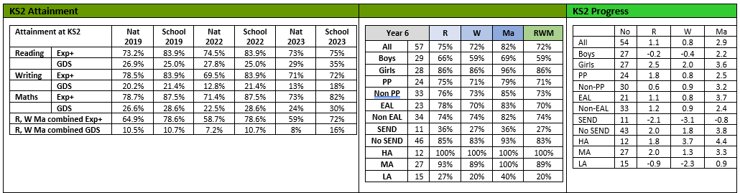
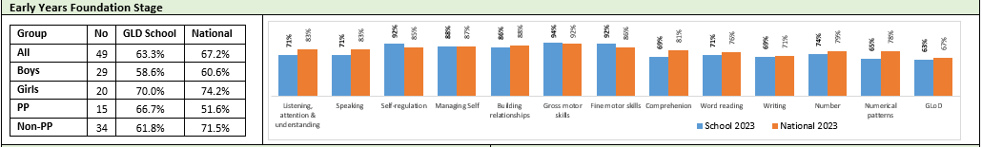
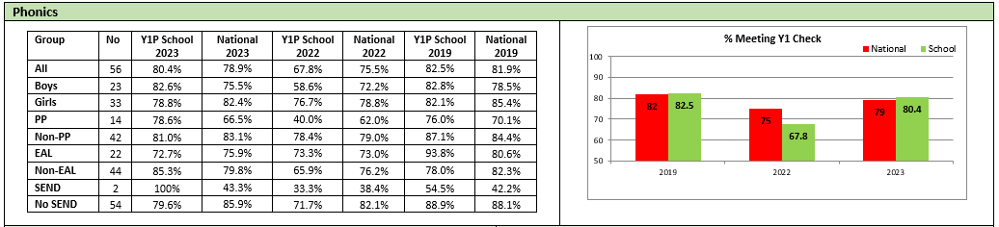
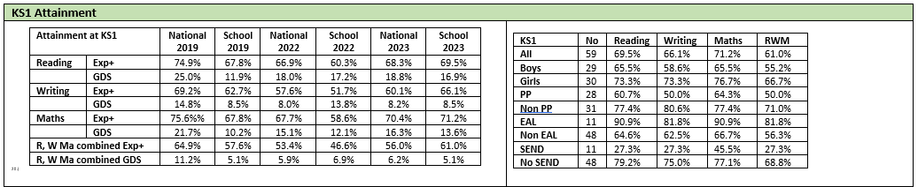
Pupil Outcomes

Ofsted
In March 2022 St Mary & St Michael had a “No formal designation inspection” which found Safeguarding to be Effective.
St Mary and St Michael continued to be a good school after the latest OFSTED Inspection in April 2023.
The Key findings said:
- Pupils enjoy attending this harmonious school. They like its strong sense of community, and feel safe and well supported.
- Leaders ensure that pupils experience a friendly and fun learning environment, and pupils appreciate this.
- Leaders give careful thought to teaching about character. For example, pupils are taught to be reflective, to consider others and show kindness and tolerance. In lessons and around the school, pupils are polite and articulate.
- Leaders ensure that all have access to a broad curriculum. They are ambitious for every pupil’s learning, including those with special educational needs and/or disabilities (SEND) and those from disadvantaged backgrounds.
- Leaders are ambitious for all. Their curriculum thinking reflects this, with clear and well sequenced aims for what pupils need to learn and by when.
- Teachers are knowledgeable about the wide range of subjects that they teach. They are clear about the knowledge and skills that pupils need to learn, and in the main ensure that teaching enables pupils to understand and remember subject content.
- Leaders prioritise reading. They ensure that staff are well trained to deliver the school’s chosen phonics programme. Pupils practise their reading using books at the right stage for them. Leaders ensure that all pupils read frequently, either to adults or each other. Staff check how well pupils are progressing in reading and provide support for pupils when this is needed.
- Behaviour is consistently positive. Pupils behave well and support one another. Disagreements between pupils are addressed carefully and pupils are given the chance to put things right. They learn to understand the views of others and trust staff to help them resolve difficulties.
- The provision for pupils’ wider development includes a focus on helping pupils to develop positive character traits. Staff model and teach the school values, especially compassion.
- Staff model and teach the school values, especially compassion. Pupils enjoy taking responsibility, for example through leading paired reading or acting as classroom monitors. They relish taking part in a range of wider opportunities, for example through sport and the choir, or the recent talk on finance by a speaker from a large investment bank.
- Staff are very positive about working here. They appreciate the support they receive with training and well-being.
What does the school need to do better:
- In some instances, teaching is not as successful in breaking down knowledge in a way that enables pupils to learn subject content. Sometimes, when pupils are finding things hard or have misconceptions, this is not addressed. This means that pupils are not able to move on confidently in their learning.
- Leaders’ aims for securing children’s readiness for Year 1 are less well embedded. In the Nursery and Reception classes, children are taught a broad curriculum. At times, the delivery of this curriculum does not focus enough on helping children to learn the knowledge identified.
- Teachers are clear about the long-term aims of the curriculum. However, in some instances, the knowledge that pupils need to learn is not taught in sufficiently small parts.
- Sometimes, the things that pupils are finding difficult to understand or remember are not identified accurately. This means that some pupils retain misconceptions or cannot link their learning to what comes later in the curriculum.
- Leaders need to improve their oversight of how the curriculum is delivered, including in the early years. This includes making sure that teaching helps pupils to build up their knowledge in manageable steps, and addresses misconceptions in a timely manner.

The Catholic Schools Inspectorate
The last inspection in February 2023 found:
Overall effectiveness: 2
Catholic Life of and Mission: 2
Religious Education: 2
Collective Worship: 2

Summary of key findings
What the school does well:
- The school provides an inclusive and supportive environment for its most vulnerable pupils.
- Induction and support for new staff.
- Pupils are religiously literate and confident in sharing their knowledge and understanding in religious education.
- There is a flourishing partnership between school and parish which fosters wonderful opportunities for the celebration of prayer and liturgy in the community.
- The celebration of the charism of the founders of the school enabling pupils to appreciate the school’s history and legacy.

What the school needs to improve:
- Develop pupil and staff knowledge and understanding of the principles of Catholic Social Teaching.
- Ensure that teachers are offered continued professional development opportunities to promote high quality teaching, learning and assessment in religious education.
- Regularly review the quality and impact of prayer and liturgy as part of the school’s cycle of self-evaluation and planned improvements.
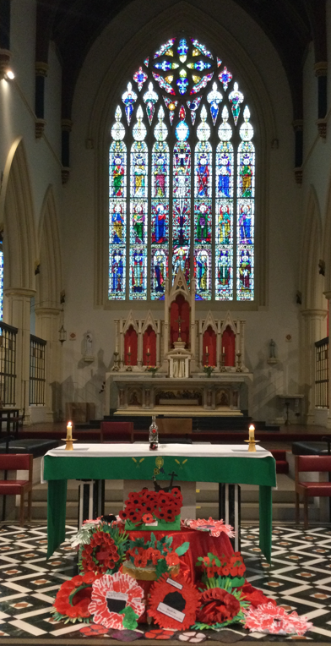
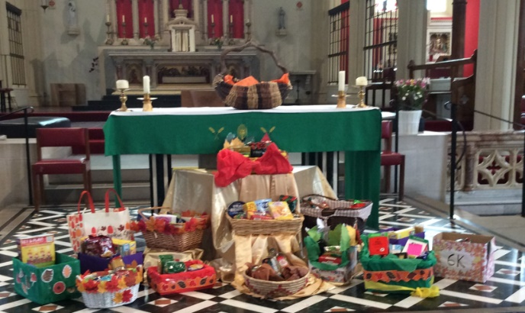

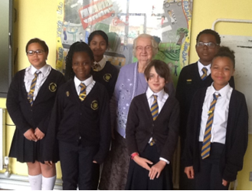

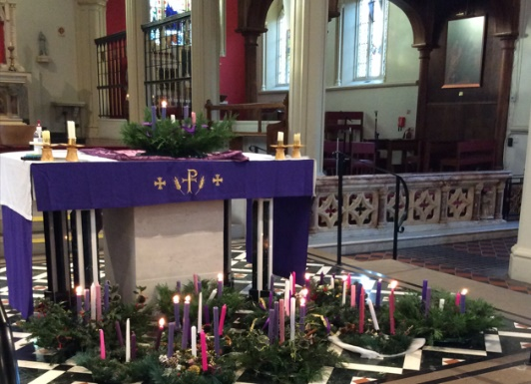

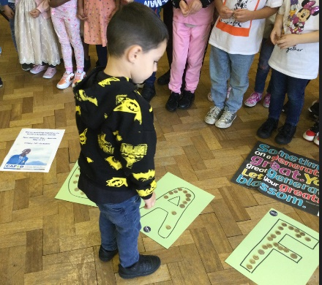

School Improvement Priorities
Areas for whole school development 23-24:
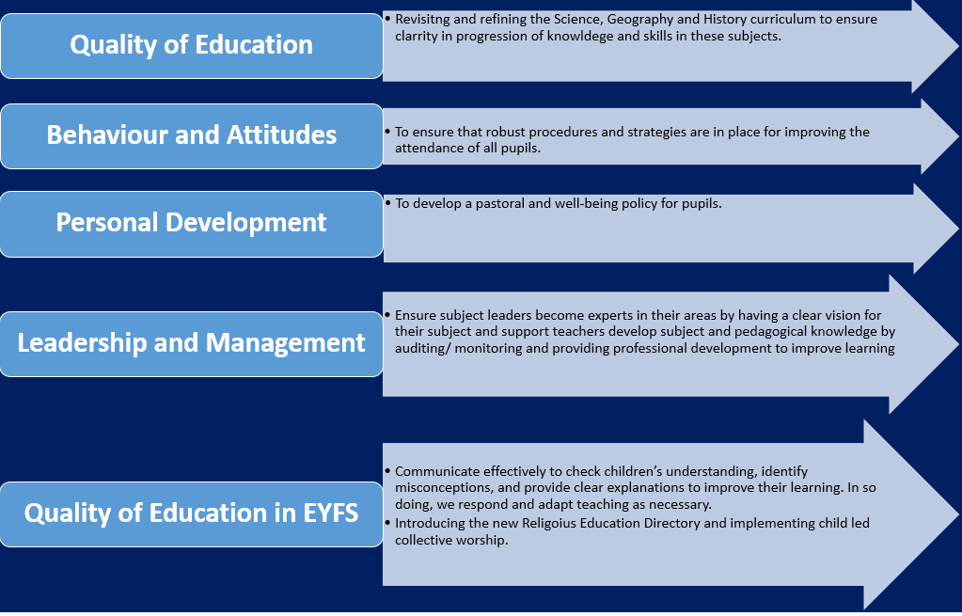

Financial Statement
St Mary and St Michael has been in a healthy financial position in recent years and will have a small carry forward at the end of year. Savings have been made by re-negotiating contracts, which is an ongoing activity. Projections for the next 3 years predict in-year deficits whilst we implement new service agreements and complete outstanding capital projects that are currently planned.

Premises
The school building is in a good state of repair with a small number of capital works planned over the next financial year. We have a large outside space for an Inner London school and are currently working with a charity to improve the garden area so that the children can use the space more effectively.

Governors
A second parent governor has just been appointed.
 |  |  | Date of current appointment | Date of  expiry | Category/  Appointed by | Term of office
1 | Sue-Helen | Steyn | Ex officio | Ex officio | Head / Ex officio | Ex officio
2 | Caroline | Kerrigan | 1/12/20 | 30/11/24 | Staff / Elected | 4 years
3 | Loretta | Nguete | 12/01/23 | 11/01/27 | Parent | 4 years
4 | Abena | Adjei | 19/10/20 | 18/10/24 | Parent | 4 years
5 | Ian | Jones | 30/11/22 | 29/11/26 | LA | 4 years
6 | Patrick | Donovan | 1/3/22 | 31/8/25 | Foundation | 3-4 years
7 | Michael | Killington ^{CHR}* | 1/3/22 | 31/8/25 | Foundation | 3-4 years
8 | Keith | Stoakes | 1/10/23 | 31/8/27 | Foundation/  RCDOW | 3-4 years
9 | Chris | Gresch | 1/11/23 | 31/8/27 | Foundation/  RCDOW | 3-4 years
11 | Caroline | Callender | TBC | TBC | Foundation (Parent)/ RCDOW | 3-4 years

Staffing Team
We have a well-qualified and very committed staff team who are led by:
Senior Leadership Team
Role and Responsibility | Member of Staff
Interim Headteacher | Sue-Helen Steyn
Acting Deputy Headteacher, Phase Leader Y1 – Y3 | Isabel Hamilton
Acting Assistant Headteacher, Phase Leader Y4 – Y6, RE Lead | Caroline Kerrigan
SENDCo | Frank Crawford
EYFS Phase Lead | Lillais Burke
Senior School Business Manager | Johanna Hannan

Headteacher Job Description
Salary range: L22-L28 (£88,036 - £100,552)

Key Areas of Responsibility
- Catholic Purpose and Identity of the School
- Leadership in Catholic Education
- Strategic Leadership
- Educational Excellence
- Managing the Organisation
- Safeguarding

- Catholic Purpose and Identity of the School
Key Area of Responsibility:

The Headteacher must understand the nature and purpose of Catholic education and know that his or her first responsibility is to establish and sustain the Catholic identity of the school and safeguard the teaching of the Church.

He or she must ensure that this Catholic identity is reflected in every aspect of the life of the school, in particular in the curriculum, the day-to-day organisation of the school, staff development, staff and pupil relationships and the partnership between school, home, parish, local community, other schools, the LA and other agencies. This duty provides the context for the proper discharge of all other duties and responsibilities.
- Leadership in Catholic Education
Key Area of Responsibility:
The Headteacher is the leader of a Catholic educating community and the discharge of this vital role requires a significant theological insight and vision of the development of a Catholic school.

Each Catholic Headteacher has responsibility to develop his or her understanding of this leadership role through regular reading and participation in appropriate courses, together with frequent reflection. The Headteacher must provide professional leadership and management for the school. This will promote a secure foundation from which to achieve high standards in all areas of the school’s work. To gain this success a Headteacher must establish high quality education by effectively managing teaching and learning and using personalised learning to realise the potential of pupils. The Headteacher must establish a culture that promotes excellence, equality and high expectations of all pupils.

- Strategic Leadership
Key Area of Responsibility:
The strategic vision and development of the Catholic school, stems from the educational mission of the Church, which is reflected in the school’s mission statement. The Headteacher, working with the governing body and others, is expected to draw on the person, life and teachings of Jesus Christ to create a shared vision and strategic plan, which inspires and motivates pupils, staff and all other members of the community. The vision uses Gospel values, core educational values and is inclusive of stakeholders’ values and beliefs.

The Headteacher must:
  - Understand and communicate the mission of the Catholic school and promote Gospel values in policy, practice and relationships and ensure that the Religious Education programme is given full regard both in terms of classroom religious education and in the whole Catholic life of the school.
  - Ensure that the vision for the school is clearly articulated, shared, understood and acted upon effectively by all.
  - Be aware of their own strengths, weaknesses and areas for their own professional development and how their leadership behaviours impact on others so that they can maximise their impact as a leader.
  - Have a focus on improvement, setting tough objectives and take on challenges in order to achieve and be accountable for high performance throughout the school.
  - Demonstrate resilience and emotional maturity when faced with the demands of the job, especially when faced with adversity and setbacks, so that they do not lose sight of their personal and organisational values.
  - Draw upon their experience in education and their own lives to make sense of issues as they occur and to create strategic solutions and be able to explain them to others.
  - Recognize opportunities and implement change so that the school continues to improve in both the short and in the long term and have the ability to bring about such change with the minimum of disruption.
  - Inspire and influence pupils, colleagues, governors and the community, articulating a compelling vision to create an energising learning environment for all and to be able to modify their approach to create the desired impact and outcomes.

- Educational Excellence
Key Area of Responsibility:
In a Catholic school the search for excellence is expressed in learning and teaching which responds to the needs and aspirations of its pupils and acknowledges their individual worth as children of God. The Headteacher, supported by the governing body, has a central responsibility for raising the quality of teaching and learning and for pupil achievement. This implies enabling pupils to achieve their God-given potential, setting high expectations and monitoring and evaluating the effectiveness of learning outcomes. A successful learning culture will enable pupils to become effective, enthusiastic, independent learners, committed to life-long learning.

This requires the Headteacher:
- To develop their vision in the light of Gospel values and the teachings of the Catholic Church so as to identify the priorities which lead to improvements in teaching and learning, leading in turn to improved outcomes for all pupils.
- To determine and organise the curriculum so there are real, relevant and planned opportunities to embed purposeful links and connections with religious education, collective worship, liturgy, prayer and provision for pupils’ spiritual, moral, social and cultural development.
- To be able, as the leading professional in the school, to identify excellence in teaching and be able to demonstrate how teaching can be improved and sustained so that learning and achievement for all pupils is maximised.
- To ensure strategies for inclusion, diversity and access to a diverse, flexible and relevant curriculum that are based on our equality as children of God, which compels us to care for the well-being of one another, including those with Special Educational Needs, with English as an additional language and more able pupils, drawing on the Gospel values of truth, justice, tolerance and service.
- Make sure the school fulfils statutory duties regarding the SEND Code of Practice
- To have a passion for learning and to communicate this to others so establishing a climate of learning and teaching throughout the school and ensuring that every pupil has the opportunity to succeed.
- To recognise the need to build partnerships locally, regionally and nationally in order to achieve goals raise standards and improve the education system.
- To be aware of their impact on the governing body, local parishes and the local community and to use this influence wisely to improve outcomes in the school.
- to promote the notion of ‘vocation’ in your work, articulating and demonstrating your headship as a calling to do God’s work.

- Managing the Organisation
Key Area of Responsibility:
Headteachers need to provide effective organisation and management of the school and seek ways of improving organisational structures and functions based on rigorous self-evaluation. Headteachers should ensure that the school and the people and resources within it are organised and managed to provide an efficient, effective and safe learning environment. These management responsibilities imply the re-examination of the roles and responsibilities of those adults working in the school to build capacity across the workforce and ensure resources are deployed to achieve value for money. Headteachers should also seek to build successful organisations through effective collaborations with others.

This requires the Headteacher:
- To work with the chair of governors to enable the governing body to meet its responsibilities in relation to specific requirements of governance in a Catholic school in terms of the trust deed, admissions, personnel and financial matters.
- To monitor, evaluate and review the work of the school to determine its effectiveness as a Catholic school.
- To have overall responsibility and accountability for safeguarding and promoting the welfare of pupils within the school.
- To deploy the resources available to ensure the school’s goals are achieved and to ensure that the systems and processes used to achieve this are subject to regular review and evaluation.
- To take responsibility for the school’s performance and present that performance in a form appropriate to a range of audiences, including governors, the Diocese of Westminster Education Service, the LA, the local community, OFSTED and others, to enable them to play their part effectively.
- To effectively analyse and use data and break down problems and challenges in a systematic way in order to provide clear direction and management.
- To be able to make interventions where needed and hold others to account in order that expectations are met and school improvement is sustained.
- To demonstrate a genuine commitment to developing others in a way that helps them achieve their potential and motivates them to perform at their best.

- Safeguarding
Key Area of Responsibility:
Fulfil personal responsibilities, and secure compliance by those working in school, for safeguarding as set out in the Children’s Act, Statutory Guidance and by the Local Children’s Safeguarding Board. These include:
- Operating a culture of listening to children and taking account of their wishes and feelings, both in individual decisions and the development of services;
- Operating clear whistleblowing procedures;
- Sharing information, with other professionals;
- Take responsibility as the designated professional lead for Safeguarding;
- Operating safe recruitment practices;
- Ensuring appropriate supervision and support for staff, including undertaking Induction, safeguarding training and reviews of practice;
- Establish, operate and monitor clear policies for dealing with allegations against people who work with children.
This job description details the principal responsibilities of the post holder but will be subject to variation according to any subsequent legislation that requires implementation. Additionally, it is assumed that you will be familiar with and, if currently a Head, a practitioner of the National Standards for Headteachers.
This Job Description forms part of the contract of employment of the person appointed to this post.
St Mary & St Michael Catholic Primary School is committed to safeguarding and promoting the welfare of children and young people, and expects all staff to share this commitment. An enhanced DBS check is required for all successful applicants.

Person Specification
 | Assessed by  A – application  I - Interview | Essential (E)  Desirable (D) | Evidence
QUALIFICATIONS  - Practising Catholic  - First degree/teaching certificate and QTS  - Recent professional development relevant to senior management  - Have had or are undertaking further study relevant to headship (e.g. NPQH, Diploma or Higher Degree)  - Hold the Catholic Certificate in Religious Studies or equivalent, be engaged in a course of study to achieve it or be willing to undertake it | A  A  A  A  A | E  E  E  D  E | - Reference from their Parish Priest  - Relevant certificates  - References from headteachers and other education professionals
SAFEGUARDING, SAFER RECRUITMENT AND SELECTION  In addition to the candidates’ ability to perform the duties of the post, the recruitment process will also explore issues relating to safeguarding and promoting the welfare of children including:  - Motivation to work with children and young people  - Ability to form and maintain appropriate relationships and personal boundaries with children and young people  - Emotional resilience in working with challenging behaviours; and attitude to use of authority and maintaining discipline  - Able to demonstrate commitment to safeguarding and promoting the welfare of children and young people and expects all staff and volunteers to share this commitment | A, I  A, I  A, I | E  E  E | - Enhanced DBS  - References
CATHOLIC PURPOSE AND IDENTITY OF THE SCHOOL  - Be able to articulate the distinctive nature and purpose of Catholic education and be committed to developing the Catholic ethos of the school  - Be aware of the requirements of the RE Curriculum Directory and Inspection Framework  - Has experience in leading Acts of Worship | A, I  I  I | E  E  E
EXPERIENCE  - Is currently in a successful position of leadership either as a Deputy or Head.  - Has a proven record as an outstanding teacher and demonstrates a strong commitment to Catholic education.  - Has experience of monitoring and developing high quality teaching and learning.  - Can demonstrate personal contribution and impact in other schools. This should be evidenced by raised and improving standards  - Has experience of the development and implementation of whole school policies and an under- standing of how policies will take account of the distinctive Catholic ethos.  - Has proven and successful experience of working in partnership within the school community and with other external stakeholders  - Can demonstrate evidence of their continued personal and career development | A  A  A, I  A, I  A, I  A, I  A | E  E  E  E  D  D  E
PERSONAL QUALITIES  - Demonstrates energy, resilience, good communication skills and a sense of humour.  - Is visible and approachable to pupils, staff, parents, carers and governors.  - Has the ability to build and lead effective teams, respecting contributions made by individual members of staff.  - Has the ability to maintain a reflective strategic overview whilst meeting the operational needs of the school.  - Can explain convincingly how they react when faced with continual challenges.  - Understands the importance of maintaining personal and organisational values when faced with uncertainty and adversity.  - Can develop the school and manage change through forward thinking, motivation and dynamic leadership  - Can inspire, motivate, support and empower pupils, staff and governors.  - Can demonstrate empathy and tolerance.  - Can make effective use of the skills and abilities of the staff and Governors to optimise the school’s success.  - Is committed to the promotion of the common good and meeting the needs of those who are disadvantaged and marginalised.  - Can listen effectively and communicate professionally both orally and in writing with all those with an interest in the school.  - Is able to listen to, reflect and act on feedback. | A, I  A, I  A, I  A, I  I  A, I  A, I  A, I  A, I  A, I  A, I  A, I | E  E  E  E  E  E  E  E  E  E  E  E
KNOWLEDGE, UNDERSTANDING AND SKILLS  - Understands the leadership styles appropriate for use in a Catholic school.  - Can implement strategies that ensure the well-being, progress and attainment of all pupils.  - Can maintain high standards of discipline, attendance and behaviour.  - Understands how to manage teams and can demonstrate that they understand other points of views and can persuade others to their perspective by articulating a compelling vision.  - Manages own workload and that of others to allow an appropriate work life balance.  - Plan and provide staff performance management systems with annual appraisals and targets  - Can recognise where performance is poor and has the confidence and proven ability to insist on and to encourage higher standards  - Understands the statutory role of governors in a Voluntary Aided school and is able to work with the Governing Body to enable it to meet its responsibilities by providing information, objective advice and support.  - Understands data analysis, presentation and interpretation.  - Understands how the school’s human, financial and environmental resources can be used to achieve the school’s goals and secure value for money  - Understands how to manage effective financial control systems.  - Is committed to equal opportunities throughout the school.  - Can develop and maintain good relationships with the Diocese, the local parish and the Local Authority.  - Understands recent educational developments and legislative changes and their significance for the management and leadership of the school. | I  I  A, I  A, I  A, I  A  A, I  A  A, I  A, I  A  A, I  A, I  A, I  A, I | E  E  E  E  E  E  E  E  E  D  E  E  E  E
LEADERSHIP OF CURRICULUM  - Understands curriculum management in a Catholic school, including the use of assessment outcomes.  - Monitor the quality and of curriculum delivery and balance  Inspire staff to investigate new ideas and share their expertise  Develop the curriculum in response to school needs and national and diocesan initiatives, ensuring all training needs are met.  - Keep up to date with educational developments and respond through school improvement planning and resourcing.  - Ensure a broad balance of curriculum provision and range of teaching styles to meet varied learning needs of pupils.  - Ensure the curriculum is well resourced and quality assured.  - Monitor standards through curriculum data, outcomes for children and classroom observations.  - Ensure that the curriculum provides continuity, progression and challenge. | A, I  A, I  A, I  A, I  A  A, I  A, I  A, I  A, I | E  E  E  E  E  E  E  E  E
Appointment to this post is subject to a satisfactory enhanced DBS check. This post is exempt from section 4(2) of the Rehabilitation of Offenders Act, 1974, as the duties give you access to persons who are under the age of 18. Applicants are not entitled to withhold information about convictions which would be regarded as spent for other purposes.

