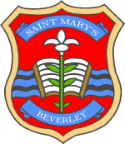
St Mary’s CE Primary School
‘Nurturing Success’
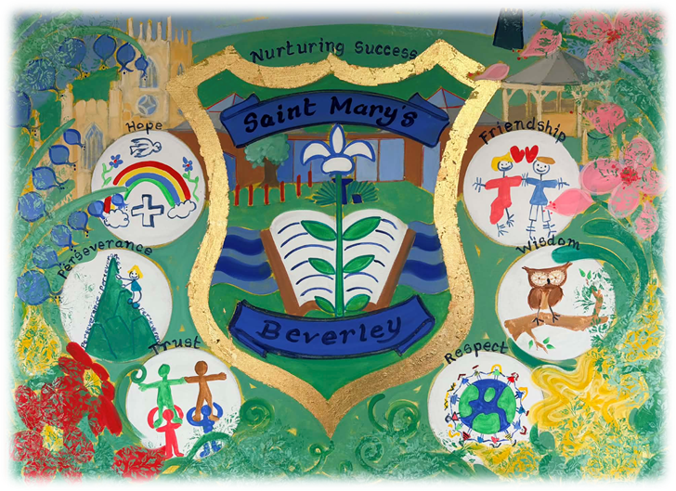

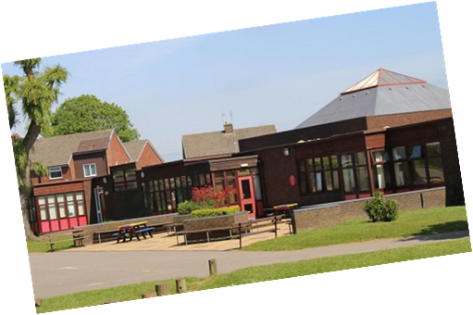

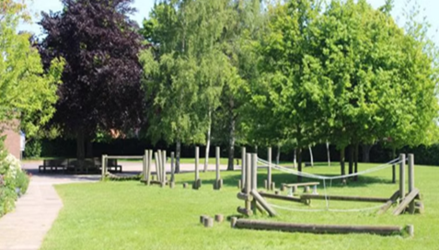

Headteacher Recruitment Pack

July 2026

St Mary’s CE Primary School

From the Chair of Governors
Dear Applicant,
On behalf of all members of the school community, I would like to thank you for your interest in applying for the post of Headteacher at St Mary’s. I hope that this pack and our website will give you a feel for our wonderful school and that it will encourage you to apply for this exciting and rewarding position.
We are seeking to recruit an inspirational and dynamic successor who has the vision and skills to build upon the school’s success. They will be supported by an enthusiastic highly skilled staff, supportive parents and an active governing body.
St Mary’s is a school where everyone feels valued, we are welcoming and friendly with children who are eager to learn. We aim to offer a broad education rooted in the school’s Christian ethos and are proud of our strong links with the local church.
If you are considering applying, I would encourage you to visit the school to see the pupils and staff at work. Please contact Samantha Beasley, School Business Manager, via email to arrange a visit on s.beasley@stmarysbeverley.eriding.net If you feel that this might be the school for you to lead, then we would love to hear from you.
Yours faithfully
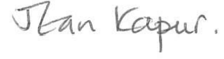
Mrs Jean Kapur

St Mary’s CE Primary School

Welcome to our School
Our vision at St Mary’s Primary School
At St Mary’s, we are committed to nurturing every child (and every adult) as a unique individual to be the best that they can be, within a safe, friendly and welcoming community rooted in Christian values.
Our vision at St Mary’s Church of England Primary School is based upon Philippians 4 of the Bible.
Whatever is true, whatever is honourable, whatever is just, whatever is pure, whatever is pleasing, whatever is commendable, if there is any excellence and if there is anything worthy of praise, think about these things. Keep on doing the things that you have learned and received and heard and seen in me, and the God of peace (shalom) will be with you. Philippians 4
This passage provides the basis for our desire to celebrate and nurture every child and every adult in our community to be the best that they can be. It means valuing truth and integrity, seeking excellence and celebrating it, and rooting our community in the Christian values (Respect, Friendship, Trust, Perseverance, Wisdom and Hope) which are found in the Bible. We seek to provide education of the highest quality, which develops the whole person (including their spirituality) bringing ‘shalom’ - peace, completeness, wholeness, and well-being.
Our mission is to provide an education of the highest quality through a rich, broad and balanced curriculum which focuses on the development of the whole person. We want children to develop as happy, confident and articulate individuals who will love learning throughout their lives.
The school has a special relationship with St Mary’s Church which both sides value and support. We have regular school services in church and weekly visits from the vicar. In addition, we have church-school clubs and a worship committee led by the children (with a little help from the vicar and RE coordinator).
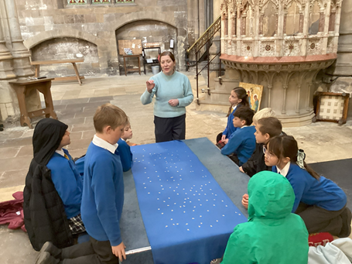
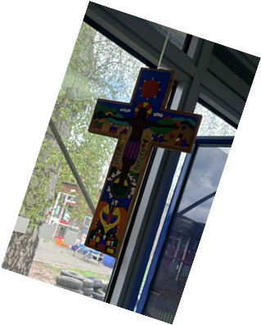

St Mary’s CE Primary School

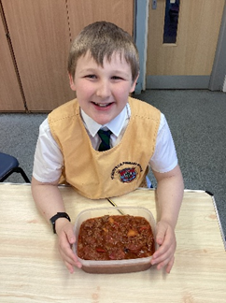
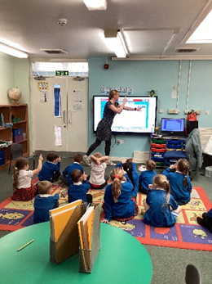
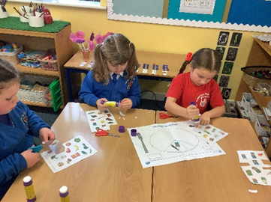
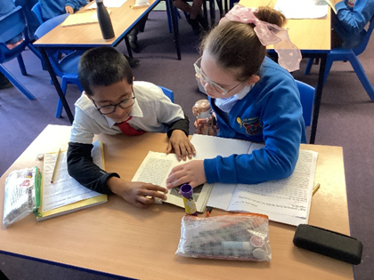
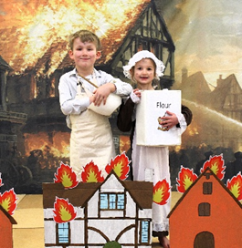
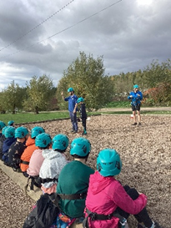
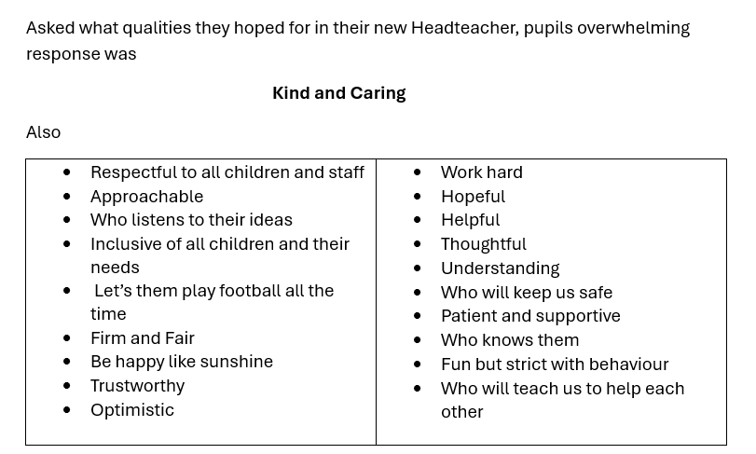

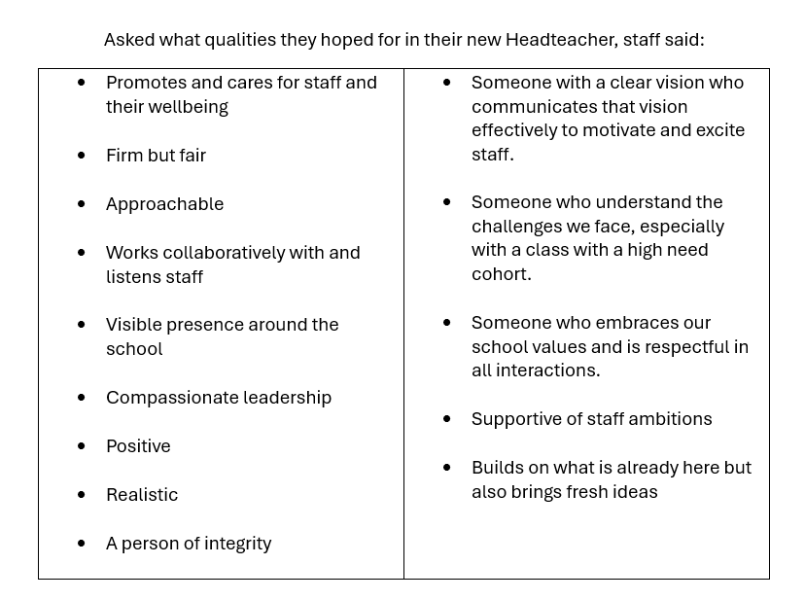

St Mary’s CE Primary School

York Diocese
Leaders and staff work with York Diocese to develop a shared understanding of Spirituality and how this can be woven into the school’s provision.

York Diocesan Board of Education supports 122 Church of England schools and academies in the area from the Humber to the Tees. We have a dedicated team of professionals who offer a wide range of expertise and can help schools access further assistance.
The Education team aims to:
- Be available as a ‘one-stop shop’ for pastoral and professional support;
- Work with a range of agencies to promote school improvement;
- Promote excellence and Christian distinctiveness;
- Provide and facilitate professional development and governor training;
- Help schools and academies network, collaborate together and share best practice;
- Offer a Total Property Management scheme in association with DBE Services Ltd;
- Guide schools on matters concerning trusts;
- Work with schools exploring Academy conversion;
- Involvement in recruitment processes for new Headteachers/Heads of School;
- Support Headteacher appraisal;
- Represent Church of England education to the wider church community and more widely to the public;
- Maintain contact with the local authorities and the Regional Directors at the DfE.

The Rt Revd Barry Hill, Bishop of Whitby and Chair of the Diocesan Board of Education, said:
“Supporting children and young people to be all they are called to be is at the heart of who we are as the Diocese of York.

Together with the Church of England as a whole, it is a vision for education which is deeply Christian, with Jesus' promise of 'life in all its fullness' at its heart, and as such is for the common good of the whole community. It is a holistic vision, where education, like the faith in which it is rooted, is about wisdom, knowledge and skills, but also about hope and aspiration, about how we live well together in community with dignity and respect for all.
Of course a vision this encompassing is only possible by working in partnership, both between teachers, staff, trusts and governors, and in developing ever closer links between schools, churches and households. By working closely together we can achieve far more than apart. I am delighted that you are considering applying to be a Headteacher in the Diocese and know that, if appointed, you will join the diocesan family of schools dedicated to supporting you as you lead deeper into this vision so that together all our schools and communities can be places where the love of God is reflected through all we are.”

Mari Palmer, Diocesan Director of Education, said:

”As a diocese, we are here to help celebrate and strengthen the Christian ethos in our schools. We understand that each school is unique and our aim is to get to know our schools on an individual basis in order to foster the local parish and community links as far as possible.
As such, our Education Team offers a range of support to our headteachers from both a school distinctiveness and effectiveness point of view, as well as providing a range of training and development opportunities for staff and governors to access over the course of each year. In a rapidly changing educational landscape, we are more and more involved in wider school development, particularly as schools change from one school status to another.
I do hope that you feel able to apply for the position and we would look forward to welcoming you as part of our diocesan family here in the Diocese of York”.

St Mary’s CE Primary School

Job title: Headteacher of St Mary’s CE Primary School
Job purpose:
- to provide vision, leadership and direction for the school
- with the governing board, to be responsible for creating and maintaining a productive learning environment which is engaging and fulfilling for all pupils, promoting the highest possible standards, and fostering the continuous improvement of the quality of learning offered by the school
- to preserve and develop the Christian ethos of the school.

Accountable to: The governing board
Accountable for: The standards, progress and well-being of all pupils and all staff and for all resources
Responsibilities:
Ethics and Professional Conduct
- To maintain high standards of ethics and behaviour and develop a culture of staff professionalism.
- To promote effective relationships with all pupils, staff, governors, parents, other schools, the local community, the local authority and other external bodies to enhance the positive image of the school and the development of the education system as a whole.

School Culture and Ethos
- To treat everyone fairly and equitably, with dignity and respect so as to create and maintain a shared school culture and positive climate which motivates pupils, staff and all other members of the school community.
- To nurture success in all children and staff.
- To create a culture of high expectations and aspirations that lead to an excellent education for all pupils.
- To demonstrate an uncompromising drive for excellence in all aspects of the school’s life so that all pupils achieve the highest levels of learning and personal development.
- Working with all stakeholders, including York Diocese, to create a vision for the school that provides direction for all aspects of the life of the school.
- To ensure that parents, pupils, staff and governors are committed to the school’s vision of excellence.
- Establish effective curriculum leadership, developing subject leaders with high levels of relevant expertise with access to networks and communities.
- To establish a positive ethos throughout the school so that pupils take pride in their school, their work and their behaviour.
- To provide support, professional development, guidance and challenge to all staff, embracing opportunities to engage critically with educational research in order to provide the very best for all pupils.
- To ensure that staff have access to high-quality professional development opportunities that align to individual needs and that of the whole school development planning process.

Leadership and Management
- To be responsible for the day-to-day management, organisation and administration of the school, modelling effective work-life balance and managing the workload of others.
- To ensure the rigorous implementation of well-focused improvement plans, based on robust self-evaluation.
- To monitor and evaluate standards of teaching, learning, resource usage and management effectiveness and implement appropriate strategies for change.
- To lead and manage change effectively.
- To work with the governing body to enable it to meet its responsibilities and present to it, on a regular basis, an accurate account of the school’s performance.
- To establish and maintain the policies and procedures that ensure the safety of all pupils, staff members and visitors to the site.
- To ensure that the school fulfils all statutory duties, including those relating and not limited to attendance, safeguarding, finances, sustainability, curriculum, equality and health and safety.

Curriculum, Teaching and Assessment
- To ensure that statutory requirements for the curriculum are met, that curriculum provision is appropriate and relevant to the needs of all pupils and provides equal opportunity for all.
- To ensure that the curriculum is ambitious, promotes and sustains a thirst for knowledge and understanding and a love of learning.
- To ensure that excellent teaching within a broad and balanced curriculum, accompanied by effective provision for spiritual, moral, social and cultural development, assists all pupils to prepare for life in modern Britain.
- To understand what good and outstanding teaching and learning looks like and to be able to communicate this effectively to all staff and governors.
- To ensure that assessment is appropriate and proportionate, and that assessment information is used effectively by leaders and governors to improve teaching and the curriculum.
- To ensure that all pupils achieve well so that the proportions making or exceeding expected progress are close to, or above, national figures
- To ensure that parents and carers are regularly provided with sufficient information to understand how well their children are doing and what they can do to help improve learning.

Behaviour
- To be responsible for establishing and maintaining the processes and policy that secure the safeguarding and welfare of every child.
- To maintain a culture where respect for others and courtesy are the norm.

Church school
- To confidently articulate, live out and promote a vision for the school rooted in distinctively Christian values.
- To articulate an explicitly Christian vision that impacts positively upon standards of achievement, the distinctively Christian character of the school and the well-being of the whole school community.
- To work closely with the local Churches and the Diocese to promote an understanding of the Christian faith and respect for other faiths and cultures.

St Mary’s CE Primary School

The selection panel will be looking for evidence that the candidate has demonstrated their ability to fulfil the following criteria through the Application, References and Interview.

Headteacher Specification | Essential (E) or  Desirable (D) | Application (A), Interview (I), Reference (R)
Qualifications and Experience
Qualified teacher status.  NPQH qualification  Successful senior leadership experience. | E  D  E | A  A  A, I, R
Culture and ethos
To confidently articulate, support and promote the vision of the school which is rooted in distinctive Christian values  Sustain the school’s ethos and strategic direction in partnership with those responsible for governance and through consultation with the school community  Create a culture where pupils experience a positive and enriching school life  Uphold ambitious educational standards which prepare pupils from all backgrounds for their next phase of education and life  Promote positive and respectful relationships across the school community and a safe, orderly and inclusive environment  Ensure a culture of high staff professionalism  Establish and sustain high expectations of behaviour for all pupils, built upon relationships, rules and routines, which are understood clearly by all staff and pupils based on the school’s behaviour policy  Implement consistent, fair and respectful approaches to managing behaviour  Ensure that adults within the school model and teach exemplary behaviour  Forge constructive relationships beyond the school, working in partnership with parents, carers and the local community  Establish and maintain working relationships with fellow professionals and colleagues across other public services to improve educational outcomes for all pupils | E  E  E  E  E  E  E  E  E  E  E | A, I, R  A, I, R  A, I, R  A, I, R  A, I, R  A, I, R  A, I, R  A, I, R  A, I, R  A, I, R  A, I, R
Curriculum and teaching
Establish and sustain high-quality, expert teaching across all subjects and phases, built on an evidence-informed understanding of effective teaching and how pupils learn  Ensure teaching is underpinned by high levels of subject knowledge and approaches which respect the distinct nature of subject disciplines or specialist domains  Ensure effective use is made of formative assessment  Ensure a broad, structured and coherent curriculum entitlement which sets out the knowledge, skills and values that will be taught  Establish effective curricular leadership, developing subject leaders with high levels of relevant expertise with access to professional networks and communities  Ensure that all pupils are taught to read through the provision of evidence-informed approaches to reading, particularly the use of systematic synthetic phonics in schools that teach early reading  Ensure valid, reliable and proportionate approaches are used when assessing pupils’ knowledge and understanding of the curriculum  Establish and sustain culture and practices that enable all pupils to access the curriculum and learn effectively  Ensure the school works effectively in partnership with parents, carers and professionals, to identify the additional needs and special educational needs and disabilities of pupils, providing support and adaptation where appropriate  Ensure the school fulfils its statutory duties with regard to the SEND code of practice | E  E  E  E  E  E  E  E  E  E | A, I, R  A, I, R  A, I, R  A, I, R  A, I, R  A, I, R  A, I, R  A, I, R  A, I, R  A, I, R
Organisational effectiveness
Ensure staff have access to high-quality, sustained professional development opportunities, aligned to balance the priorities of whole-school improvement, team and individual needs  Ensure the protection and safety of pupils and staff through effective approaches to safeguarding, as part of the duty of care.  Prioritise and allocate financial resources appropriately, ensuring efficiency, effectiveness and probity in the use of public funds  Ensure staff are deployed and managed well with due attention paid to wellbeing  Establish and oversee systems, processes and policies that enable the school to operate effectively and efficiently  Ensure rigorous approaches to identifying, managing and mitigating risk  Develop appropriate evidence-informed strategies for improvement as part of well-targeted plans which are realistic, timely, appropriately sequenced and suited to the school’s context  Ensure careful and effective implementation of improvement strategies, which lead to sustained school improvement over time  Understand and welcome the role of effective governance, upholding their obligation to give account and accept responsibility  Ensure that staff know and understand their professional responsibilities and are held to account  Ensure the school effectively and efficiently operates within the required regulatory frameworks and meets all statutory duties | E  E  E  E  E  E  E  E  E  E  E | A, I, R  A, I, R  A, I, R  A, I, R  A, I, R  A, I, R  A, I, R  A, I, R  A, I, R  A, I, R  A, I, R
Safeguarding
Demonstrate a commitment to safeguarding and the welfare of pupils and staff.  Form and maintain appropriate relationships and personal boundaries.  Possess emotional resilience in working with challenging behaviours.  Use appropriate authority and discipline. | E  E  E  E | A, I, R  A, I, R  A, I, R  A, I, R

St Mary’s CE Primary School

Why come to Beverley?
We hope you want to come to Beverley because you are drawn to our lovely school and feel you have the gifts and skills to nurture success in students and staff alike. However, there are many other good reasons why you might like to apply for this position.
Beverley is widely recognised as one of East Yorkshire’s most desirable places to live, combining architectural heritage, strong community values, and excellent local amenities.
Beverley is a beautiful town with extraordinary architecture including our church - St Mary’s and the grandeur of Beverley Minster. The town’s Georgian streets, traditional markets, and independent retailers create an attractive and vibrant place to live. Alongside this heritage, Beverley benefits from modern services, well-maintained public spaces, and a comprehensive range of shops and facilities.
Situated on the edge of the Yorkshire Wolds, Beverley provides convenient transport links to Hull, York, Leeds, and the wider region. Rail and road connections support commuting, business travel, and leisure, while the proximity to the coast and countryside offers varied opportunities for recreation.
Newcomers to Beverley consistently remark on the town’s welcoming atmosphere. A wide range of community groups, cultural organisations, churches, and voluntary networks provide opportunities to build connections and participate in local life. The town’s scale ensures that new residents can quickly become familiar with their surroundings and feel part of the community.
Beverley is home to a thriving arts and music scene, and extensive green spaces including the Westwood Pasture. These assets contribute to a high quality of life and make the town an attractive place to live and work.
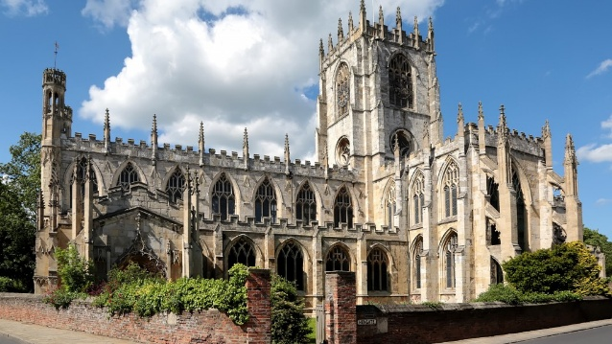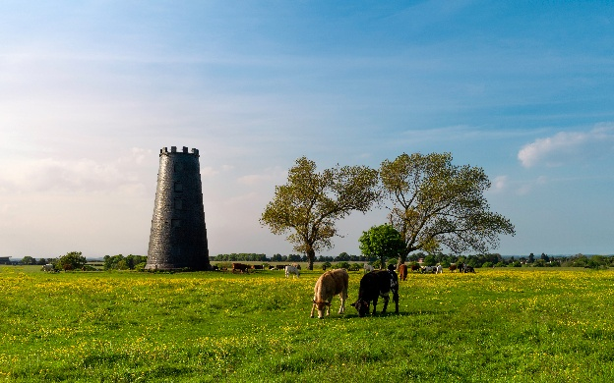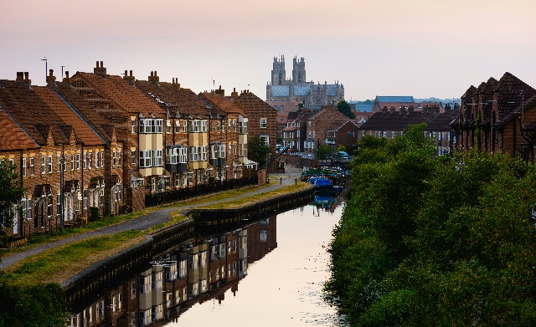

Thanks to Rev Lumley for use of their Beverley images in this pack
School Contact Details
St Mary’s CE (VC) Primary School
Eden Road
Beverley
East Riding of Yorkshire
HU17 7HD
Telephone: 01482 868149
Email: s.beasley@stmarysbeverley.eriding.net
Website: www.stmaryscofeprimarybeverley.co.uk
Number on roll: 384 (April 2026) https://get-information-schools.service.gov.uk/Establishments/Establishment/Details/118030
Headteacher Group: Group 3, L13 – L19 (£69,596 - £80,655)
Last Ofsted report: Good (September 2023)
Last SIAMS Report: Excellent (June 2019)

The Recruitment Process

Application forms are available at www.eastriding.gov.uk/jobs and a video from our children can be found at the top of this website page (please note the video starts automatically): https://www.stmaryscofeprimarybeverley.co.uk/about-1
To arrange to visit the school, week commencing 5th October 2026, please contact Samantha Beasley, School Business Manager on s.beasley@stmarysbeverley.eriding.net

Closing date: Monday 12th October at 12:00pm
Shortlisting: Wednesday 14th October 2026
Interviews: Wednesday 21st October 2026 (in school)
Thursday 22nd October 2026 (off site)
Start date: 1st January 2027, or as soon as possible thereafter

