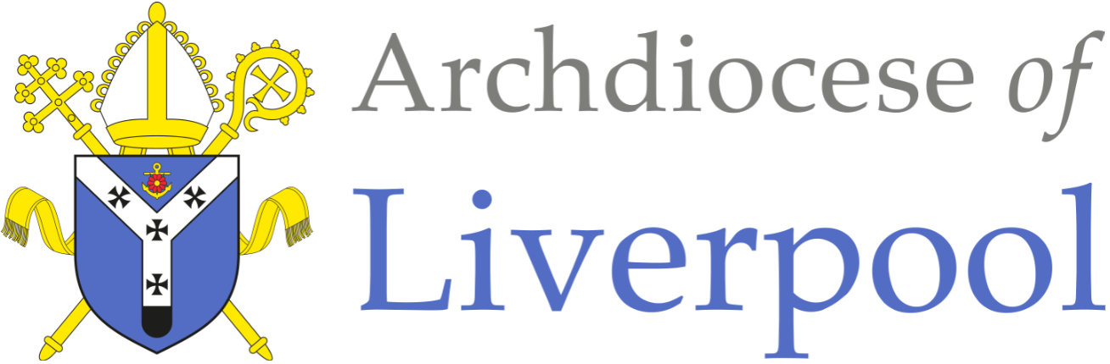

Person Specification
Headteacher
St Oswald’s Catholic Primary School

Essential Criteria | Criterion No. | Attribute | Stage Identified
Faith Commitment | E1  E2  E3  E4 | A practising Catholic (fulfilling the requirements of the Diocesan Briefing Note)  Secure understanding of the distinctive nature of the Catholic school and Catholic education  Understanding of the leadership role in spiritual development of pupils and staff  Experience of leading school worship | A/I/R  A/I/R  A/I/R  A/I
Qualifications | E5  E6  E7 | Qualified teacher status  Degree  CCRS/CTC (or equivalent) or commitment to obtaining the certificate | A/CC  A/CC  A/CC/I
Professional Development | E8  E9  E10  E11  E12 | Evidence of appropriate professional development for the role of headteacher  Evidence of professional development relating to Catholic ethos, mission and religious education  Evidence of recent leadership and management professional development  Evidence of working with other schools/organisations/ agencies  Evidence of appropriate safeguarding training | A  A/I/CC  A  A/I/CC  A/I/CC

School Leadership and Management Experience | E13  E14  E15  E16  E17  E18  E19  E20  E21 | Ability to articulate and share a vision for education within the context and mission of a Catholic school  Ability to inspire and motivate staff, pupils, parents and the governing body to achieve the aims of Catholic education  To have experience as an effective headteacher, deputy headteacher, assistant headteacher or head of school in a catholic school  To have taken a key role in school self-evaluation and development planning  An understanding of the relationship between the headteacher and the governing body in a Catholic school  Experience of working constructively with parents, the Parish and the wider school community  Experience of monitoring staff performance  Thorough knowledge and understanding of current educational issues  Demonstrate a willingness to support the governing body’s commitment to wellbeing | A/I/R  A/I/R  A/I/R  A/I/R  A/I/R  A/I/R  A/I/R  A/I/R
Experience and Knowledge of Teaching | E22  E23 | Awareness of the requirements of the Religious Education Curriculum Directory and secure knowledge of the National Curriculum  Secure knowledge of statutory requirements relating to the curriculum and assessment and to have knowledge and understanding of effective provision in all three key stages of the primary school | A/I  A/I
Professional Attributes | E24 | To have excellent written and oral communication skills in English (which will be assessed at all stages of the process)  Be able to demonstrate an ambitious and inclusive approach to education for all pupils. | A/I
Application Form and Supporting Statement | E25  E26 | The form must be fully completed and legible  The supporting statement should be clear, concise (within the required word count of 1,400 words) and related to the specific post | A  A

Desirable Criteria | Criterion No. | Attribute | Stage Identified
Faith Commitment | D1 | Involvement in home parish community | A/I
Qualifications | D2 | National Professional Qualification for Headship (NPQH) | A/CC
Curriculum | D3 | Work around the wider curriculum and the impact on children | A/I
Teaching | D4 | An inspiring and motivating teacher with excellent classroom practice | A/I/R
Leadership | D5  D6  D7 | Inspiring and empowering leader to teaching staff, non teaching staff and the children of the school  Understanding of budget planning, staff deployment and effective use of resources  Understanding of the management of extended provision including Nursery, After School and Breakfast Club | A/I/R  A/I  A/I

Key – Stage Identified
A | Application Form
I | Interview
R | References
CC | Checking Certificates

