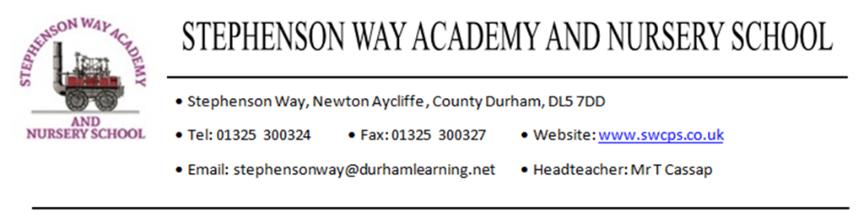Stephenson Way Academy &

Nursery School

Head Teacher L20- L25 (£79,475 - £89,830)

Permanent Position Commencing January 2026

An exciting career opportunity has arisen within Tudhoe Learning Trust for a Head Teacher looking to further develop their career and take on a new challenge. Stephenson Way Academy & Nursery School, Newton Aycliffe is one of the seven schools within the trust and is a friendly and welcoming school.

We are seeking to recruit an experienced and ambitious senior leader to join our team and drive our development plan. This role will suit a senior leader looking to widen their existing experience and expertise within a primary school, with potential scope for further career development as our trust continues to grow.

The successful applicant will be able to:

* Demonstrate a successful tenure as a senior leader of a primary school for a minimum of 3 years.
* Provide strategic vision and leadership to grow a culture of excellence and continual improvement.
* Demonstrate clarity of thought and direction to drive school improvement.
* Be wholly committed to pupil and staff achievement with high expectation.
* Safeguard all pupils and ensure a safe working and learning environment.
* Manage school budgets effectively ensuring best value and outstanding service delivery.
* Maintain an inclusive working and learning environments for all.
* Live Trust values and promote our ethos.

Employee benefits include: –

* Teachers Pension Scheme
* Simplyhealth
* Cycle to work scheme
* Onsite parking
* Employee Assistance Programme
* Extensive CPD and upskilling opportunities

Closing date for applications is **12 noon** on **13th June 2025** and the selection process will consist of a structured panel interview and a presentation **w/c 23rd June 2025**

***For a confidential conversation regarding the role, school or Trust please contact our CEO Jim Smith, on 01388 811765***

Applications will only be considered on Trust application forms. An application pack for the post is available via the Trust website. Application forms should be returned to the Trust HR Manager via email at [recruitment@tudhoelearningtrust.co.uk](mailto:recruitment@tudhoelearningtrust.co.uk).

Tudhoe Learning Trust is committed to providing opportunity for all and creating a balanced and diverse workforce that represents the communities it serves. Applications from all communities are positively welcomed. Applicants who identify themselves as disabled will receive an interview provided, they meet minimum criteria. The Trust is committed to promoting the welfare of and safeguarding all children in its schools and expects all staff and volunteers to share this commitment.

*All positions are subject to the completion of checks, including an Enhanced DBS clearance. In line with Keeping Children Safe in Education (KCSIE) guidelines 2024, an online search will also be carried out for short-listed candidates prior to interview. This is to identify any incidents or issues that are publicly available online, which the school may explore with applicants at interview. This is a safeguarding check to assess if the individual is suitable to work with young and/or vulnerable learners.*

